Chapter 11
Product Control

Lesson Goal
After completing this lesson, the student shall be able to describe the various options available in controlling hazardous materials products in the event of an incident.
Objectives
Upon successful completion of this lesson, the student shall be able to:
1. Describe product control. [NFPA® 472, 7.3.1.1, 7.3.1.2, 7.3.2.1, 7.3.2.2, 7.3.5.1(1-9, 11, 16, 17) 7.4.3(5)]
2. Explain damage assessment and predicting behavior. [NFPA® 472, 7.2.2.5, 7.2.2.6]
3. Describe plugging and patching. [NFPA® 472, 7.3.5.1 (13-14)]
4. Identify cargo tanks. [NFPA® 472, 7.4.3(9-11), 7.4.4]
5. Identify pressurized containers. [NFPA® 472, 7.2.2.2(3), 7.4.3(1-2)]
6. Identify characteristics of drums. [NFPA® 472, 7.4.3(3)]
7. Explain overpacking. [NFPA® 472, 7.3.5.1(12), 7.4.3(4)]
8. Describe specialized product control techniques. [NFPA® 472, 7.3.5.1(10, 15, 18-19), 7.4.3(7)]
9. Control a leak using a dome cover clamp. [NFPA® 472, 7.4.3(8); Skill Sheet 11-1]
10. Contain a leak from a fusible plug using an “A” kit. [NFPA ®472, 7.4.3(1); Skill Sheet 11-2]
11. Contain a leak from a fusible plug using a “B” kit. [NFPA® 472, 7.4.3(1); Skill Sheet 11-3]
12. Control a chlorine leak from fusible plug threads using an “A” kit. [NFPA® 472, 7.4.3(1); Skill Sheet 11-4]
13. Control a leak from fusible plug threads using a “B” kit. [NFPA® 472, 7.4.3(1); Skill Sheet 11-5]
14. Control a chlorine leak from a cylinder sidewall using an “A” kit. [NFPA® 472, 7.4.3(1); Skill Sheet 11-6]
15. Control a leak from a cylinder sidewall using a “B”
kit. [NFPA® 472, 7.4.3(1); Skill Sheet 11-7]
16. Control a chlorine leak from a valve blowout using an “A” kit. [NFPA® 472, 7.4.3(1); Skill Sheet 11-8]
17. Control a leak from a valve blowout using a “B” kit. [NFPA® 472, 7.4.3(1); Skill Sheet 11-9]
18. Control a chlorine leak from a valve gland using a “C” kit. [NFPA® 472, 7.4.3(1); Skill Sheet 11-10]
19. Control a chlorine leak from valve inlet threads using an “A” kit. [NFPA® 472, 7.4.3(1); Skill Sheet 11-11]
20. Control a leak from valve inlet threads using a “B” kit. [NFPA® 472, 7.4.3(1); Skill Sheet 11-12]
21. Control a chlorine leak from a valve seat using an “A” kit. [NFPA® 472, 7.4.3(1); Skill Sheet 11-13]
22. Control a leak from a valve seat using a “B” kit. [NFPA® 472, 7.4.3(1); Skill Sheet 11-14]
23. Control a chlorine leak from a valve stem blowout using an “A” kit. [NFPA® 472, 7.4.3(1); Skill Sheet 11-15]
24. Control a leak from a valve stem blowout using a “B” kit. [NFPA® 472, 7.4.3(1); Skill Sheet 11-16]
25. Contain a drum leak from a bung. [NFPA® 472, 7.4.3(3); Skill Sheet 11-17]
26. Control a drum leak from a chime. [NFPA® 472, 7.4.3(3); Skill Sheet 11-18]
27. Control a drum leak from a forklift puncture. [NFPA® 472, 7.4.3(3); Skill Sheet 11-19]
28. Control a drum leak from a nail puncture. [NFPA® 472, 7.4.3(3); Skill Sheet 11-20]
29. Overpack a drum using the slide-in method. [NFPA® 472, 7.4.3(4); Skill Sheet 11-21]
30. Overpack a drum using the rolling slide-in method. [NFPA® 472, 7.4.3(4); Skill Sheet 11-22]
31. Overpack a drum using the slip-over method. [NFPA® 472, 7.4.3(4); Skill Sheet 11-23]

Instructor Information
This is the lesson covering product control. This lesson describes the various ways in which hazardous materials products may be contained or controlled during hazardous materials operations.

Important instructor information is provided in shaded boxes throughout the lesson plan. Carefully review the instructor information before presenting the lesson.

This lesson includes skill evaluation checklist(s) that assess student ability to perform various kinds of product control operations. These checklist(s) will allow students to meet the requirements of learning objectives 9-31.

Methodology
This lesson uses lecture, discussion, and skills evaluation checklists. The level of learning is application.
Outline Contents

Section | Outline Pages | Text Pages
Section I: Introduction to Product Control | 7 | 502
Section II: Damage Assessment and Predicting Behavior | 13 | 506
Section III: Product Containment: Plugging and Patching | 26 | 516
Section IV: Cargo Tanks | 35 | 522
Section V: Pressurized Containers | 47 | 528
Section VI: Drums | 55 | 535
Section VII: Overpacking | 58 | 536
Section VIII: Specialized Product Control Techniques | 62 | 540
Section IX: Skill Sheets | 68 | 545
Section X: Summary and Review | 79 | 544

Audiovisuals
- Visuals 11.1 to 11.66 (PowerPoint® Presentation)
Evaluation
- Chapter 11 Quiz
- Chapter 11 Test
- Skill Evaluation Checklists 11-1 to 11-23
Presentation Tools
Interactive Objects allow instructors to present information a piece at a time by clicking on hot spots in a larger image.

Each object is labeled in the Lesson Outline and indicated in the PowerPoint® presentation by a RED arrow in the top left corner of the image. This lets instructors know to use the mouse to explore all of the information on the slide.


After all of the information is displayed a reset arrow will appear in the bottom right corner of the image. Instructors can use this to remove the text and quiz students on content just covered or simply move on to the next slide.

To move to the slide after an interactive object, select the Click for next slide arrow on the left side of the slide.

Videos are used as discussion starters or to illustrate a concept or process discussed in the chapter.

These are labeled in the Lesson Outline and indicated in the PowerPoint® presentation by the Click image to play arrow on the left side of the slide.

Section I: Introduction to Product Control

introduction to product control
pp. 502-506 Objective 1 – Describe product control.

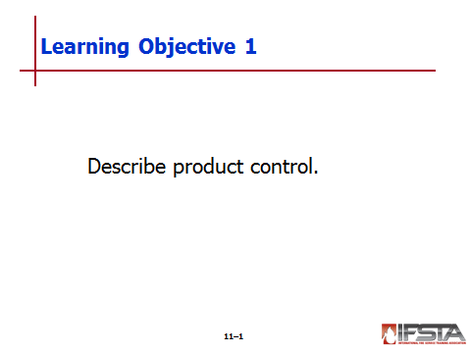
Product Control

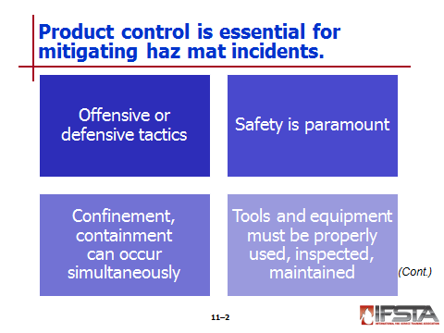
Essential for mitigation of haz mat incidents

Allows emergency response crews to make educated decisions on PPE selection and response tactics
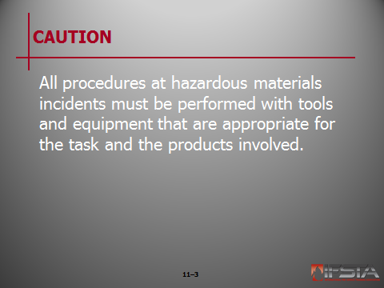
CAUTION: All procedures at hazardous materials incidents must be performed with tools and equipment that are appropriate for the task and the products involved.

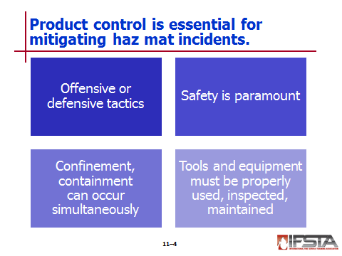
Tactics often defensive or offensive

Defensive

Typically do not involve direct contact

Typically no work performed on container

Product isolated outside container

Offensive

May involve direct contact

Tech works to contain product to container

Regardless of tactic, safety is paramount

Confinement and containment may occur simultaneously

Tools and equipment must be used, inspected, and maintained per AHJ’s SOPs and manufacturer’s recommendations and specifications

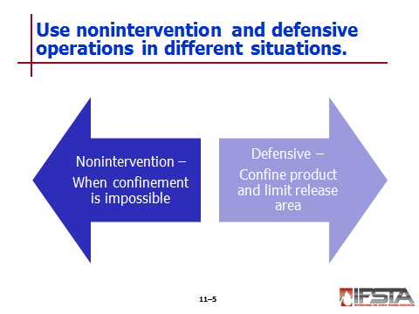
Nonintervention

Used when impossible to approach container to stop leak or get close enough to attempt containment

First priority – Safety

Decisions must be balanced with public safety considerations

Determined as necessary by risk-based response

Defensive Operations

Emergency response personnel will work to confine product’s release and limit physical size of release area

Special consideration – Environmental protection

May include any means available to limit size of release area

Techniques

Gas or vapor leaks

Ventilation

Dispersion

Dissolution

Blanketing

Liquid leaks on a surface

Diking

Absorbing

Neutralization

Diverting

Solidification

Emulsification

Retaining

Applying gels

Adsorption

Dilution

Gelation

Liquid leaks in water

Booming

Diverting

Damming

Absorption

Dispersion

Solid spills on surface – Blanketing/covering
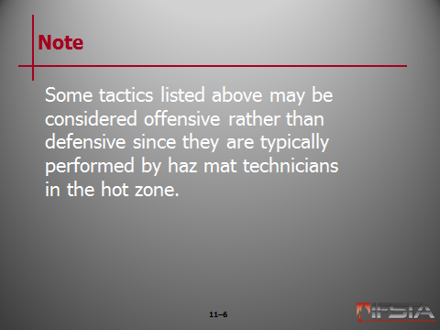
Note: Some tactics listed above may be considered offensive rather than defensive since they are typically performed by haz mat technicians in the hot zone.

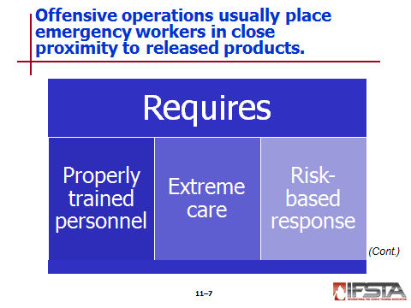
Offensive Operations

Usually hands-on operations that place emergency responder in very close proximity to released product

Only performed by properly trained personnel

Require extreme care

Require risk-based response

Definitive product identification

Research and response information

Response evidence

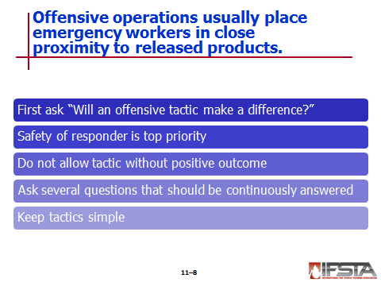
First question – “Will an offensive tactic make a difference?”

Safety of emergency responder must remain top priority

Tactic that will not have positive outcome must not be allowed

Questions that should be continuously answered

What is the material? What do we know about it?

Are the correct resources and equipment available, based on the chemical and physical properties, to help mitigate the situation?

Why is the material leaking?

What is the risk versus benefit to the entry team for an offensive operation?

What hazards can be realized if offensive actions are not taken?

What stresses caused the breach in the container and is the stress likely to continue? Can we change or remove the stressors?

Is the material stable and can it be continuously monitored?

Will the offensive operations have a positive outcome?

Keep tactic simple – If offensive operation is warranted, some mitigation and control tactics may include

Closing or tightening valves, plugs, caps, or lids

Using clamps and automatic plugs to suppress dome cover leaks

Patching or plugging small holes

Applying inflatable devices or other equipment for larger splits, gouges, or tears

Uprighting or repositioning container so that material is below breach

Decreasing container pressure

Suppressing fire

Suppressing and dispersing vapors

Transferring the product

Venting and burning

Sparging (scrubbing)

Flaring

Neutralizing an acid or base
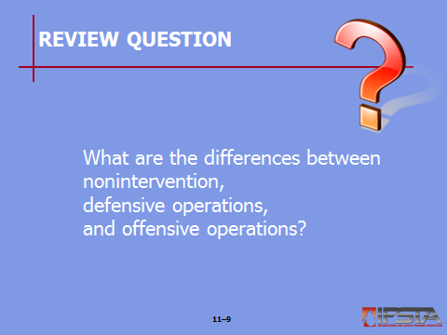
Review Question: What are the differences between nonintervention, defensive operations, and offensive operations?
See pp. 502-506 of the manual for answers.

Section II: Damage Assessment and Predicting Behavior

Damage Assessment and predicting behavior
pp. 506-516 Objective 2 – Explain damage assessment and predicting behavior.

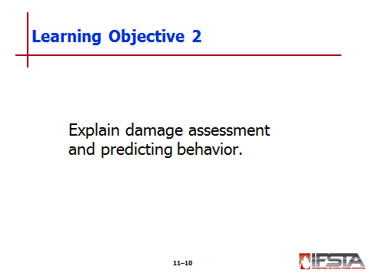
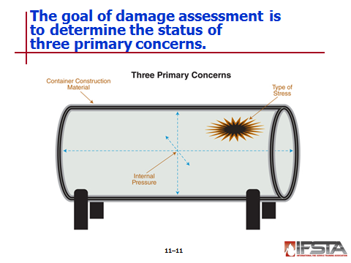
Damage Assessment and Predicting Behavior

Technicians must be prepared to act when container’s construction and safety features are compromised

Goal of damage assessment – Determine status of three primary concerns

Container construction material

Type of stress to which container has been subjected

Internal pressure of container
Note: The standards published in 49 CFR 100-199 cover both container shipping requirements and construction requirements. Many of these were discussed briefly in Chapter 10.

Requires additional training

May require specialist

General goal – Assess situation to minimize risk

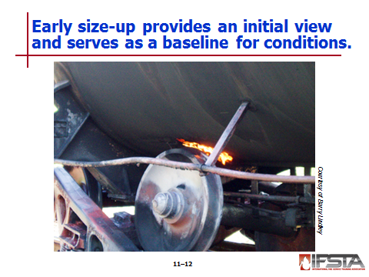
Early Size-Up

Gives response team initial view of problem

Serves as baseline to determine if conditions are improving or worsening

Information gathered critical to successful incident mitigation

May only be performed by personnel wearing appropriate PPE

Items to consider and identify

Number of containers involved

Condition of containers and any visible stressors

Container markings for product identification

Orientation of containers to determine stability for offensive operations

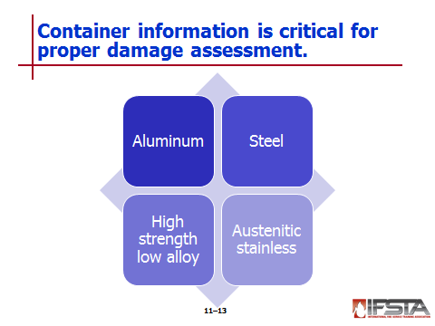
Container Information

Critical for proper damage assessment

Aluminum containers

Tend to be relatively light and can withstand impact stress well

Do not react with hydrocarbons

Cannot be subjected to substantial internal pressures

Do not plug well

Can be easily gouged and weakened

Will not withstand friction

Steel

Considered ferrous metal

If strong, will not be ductile

If strengthened, ductility reduced

Easy to examine for

Elongation

Heat stress

Fractures

Easiest of all metals to plug

Mild steel

Can often withstand dents

Does bend and distort easily

Will chemically react with many materials

When welded, weakest point will be at either side or welded seam

When inspecting – Smaller radius of bend or dent, more likely metal has been weakened and may fail

When small diameter bends or dents happen, fractures occur on inside of container opposite damaged portion which will not be visible on inspection

Smaller bend or dent in container, greater reduction in overall thickness of metal

High strength low alloy

Very high carbon content

Extremely strong and abrasion resistive

Issued in construction of many pressure vessels

Limitations

Reacts with corrosives

Fractures easily

Difficult to plug

Austenitic stainless

Iron based with content of chromium or nickel

Very corrosion resistive

Does not fracture

Abrasion resistant

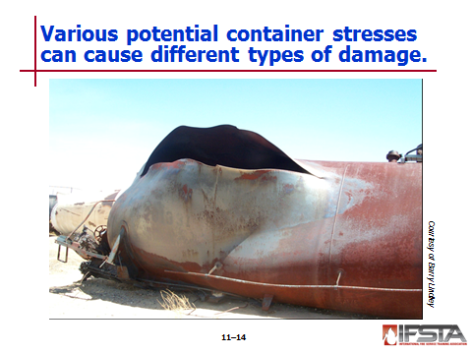
Potential Container Stress

Can include

Changes in temperature that may affect product or container

Physical damage that would disfigure or weaken container

Chemical reactions such as polymerization or mismatched chemicals or containers

Excessive product weight

Increased product vapor pressure in damaged tank

Unusual stresses – May cause disintegration of container

Acid reactions

BLEVE due to increased vapor pressure

Stress may cause

Runaway cracking

Opening of closures

Punctures

Splits

Tears

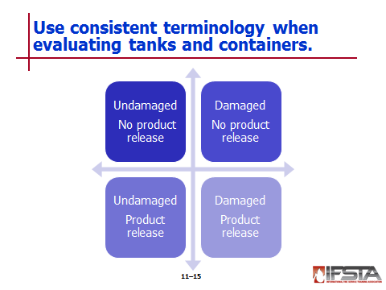
Types of Container Damage

When evaluating condition of tanks and containers, use consistent terminology

Undamaged, no product release

Damaged, no product release

Damaged, product release

Undamaged, product release
Instructor Note: Refer students to the info box titled “U.S. Federal Railroad Administration Research” on p. 511 of the manual. Discuss with students the concerns specific to railroads.

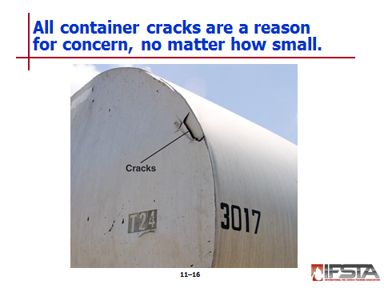
Cracks

Reason for concern, no matter how small

Require off-loading as soon as possible

If accompanied by dent, score, or gouge, stabilize tank without moving container

If depth of fracture cannot be determined, consider container critical and likely to fail

Fillet welds

Often used to attach ancillary items to tank

If cracked, not critical issue unless crack extends to container

In tank car welds used to attach brackets or reinforcement plates, not critical unless crack extends into base metal

Research being done into damage tolerance of crack growth in welded stub sills

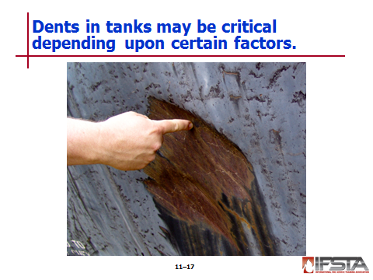
Dents

If run parallel to long axis of container, can be critical based on manufacture date

May be considered critical if associated with gouges and cracks

Pressurized tanks constructed before 1966 of either 212-B or 515-B grade steel

Considered to be in critical condition if dent of less than 4 inches (102 mm)

Same true for pressurized container built during or after 1966 that uses TC-128 steel and has dent with inside radius of less than 2 inches (51 mm)

Massive dents in heads of tank generally not serious unless gouges or cracks present

Small dents in head of tank not exceeding 12 inches (305 mm) in diameter, in conjunction with cold work in bottom of dent are marginal if they show radius of curvature less than 4 inches (102 mm) for tanks built before 1967

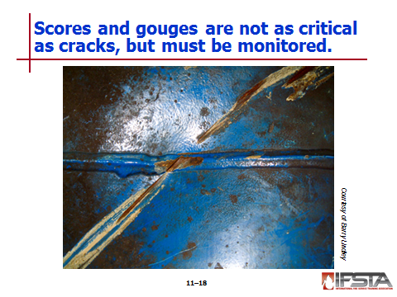
Scores and gouges

Not critical as crack, but must be monitored

Not critical – If crosses welded seam and metal removed is no more than weld reinforcement, and no base metal is removed, vessel

Critical

If removes base metal on welded seam

Those that cross a weld and affect heat-sensitive zones

If cross welded bead of pressurized container and come in contact with base metal

Most dangerous – Longitudinal score that runs length of container

Cannot ignore – Circumferential scores; could constitute longitudinal notch

Tanks should be uploaded in place when internal pressure exceeds half allowable internal pressure

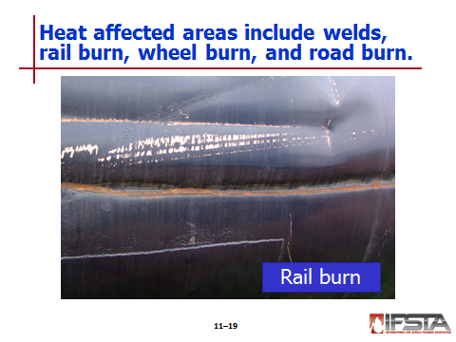
Heat affected areas: Welds, rail burn, wheel burn, and road burn

Heat affected zone – Area of base metal container which has its microstructure altered by welding or other heat-intensive operations

Heating then recooling of base metal will change properties immediately adjacent to heated area

Extent of property change will be different with each base metal

Mechanical stresses can lead to heat-affected areas

Burn damage similar to gouge

If depth of burn or gouge exceeds 1/8 inch (3.2 mm), consider off-loading container

Critical – If burn crosses welded bead of pressurized container and comes in contact with base metal

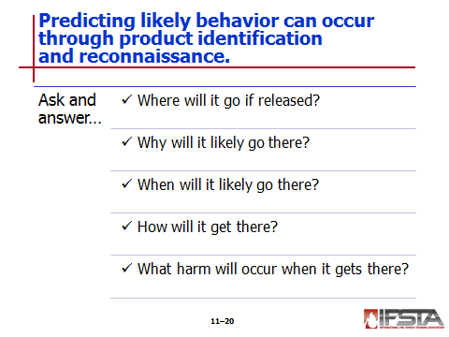
Predicting Likely Behavior

Part of understanding what is involved and what may happen during operation

Can be determined through product identification and reconnaissance of area and containers involved

Ask and answer following questions

Where is the hazardous material or container likely to go if released during the emergency?

Why is the hazardous material likely to go there?

When is the hazardous material likely to go there?

How will the hazardous material get there?

What harm will occur when the hazardous material gets there?

Must obtain as much information as possible

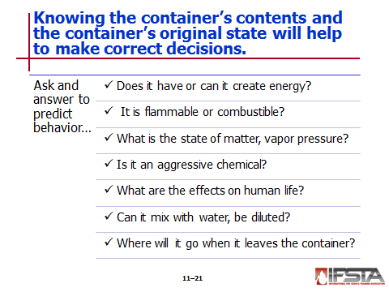
Knowing contents ensures decisions can be based on chemical and physical properties of product or products involved and quantities involved

Determining following properties can help emergency responders in predicting likely behavior

Does the hazardous material have energetic properties or can it create energy as a condition?

Is the product flammable or combustible?

What is the state of matter and what is its vapor pressure?

Is the product an aggressive chemical?

What effects will this product have on human life?

If the product leaves its container, can it mix with water? Can it be diluted?

Where will the material go when it leaves its container?

To determine condition of container, essential to know what it was like in original state

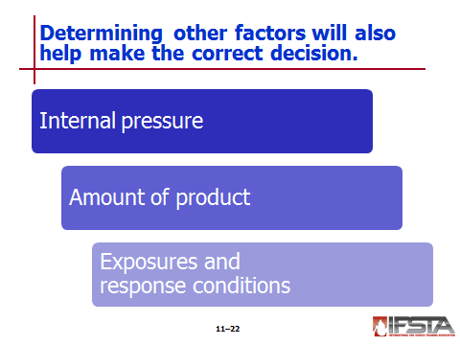
Internal pressure

Determined after involved products

May cause failure when tank placed under thermal or chemical stress or has been damaged

If tank fails while offensive operation underway, results may be devastating

Can be deciding factor in whether tank can be plugged or patched

In some cases, may have to be reduced before offensive operation can begin

Determining may be difficult

Type will provide first clue

Environmental conditions must be considered

Pressure gauges should be read

Advanced methods

Attach pressure gauge to vapor valve

Determine product temperature and estimate vapor pressure; use reference source to provide temperature/pressure curves

Amount of product

May need to be determined

Can be checked with thermal imager (noninsulated tanks)

Can be checked with built in level device

Consider exposures and response conditions

What effect on life and the environment will the product have if no offensive actions are taken?

What will the effects be if there is nointervention?

Is the container located indoors or outdoors?

What are the weather conditions and what effects will they have on the product?

Is it daytime or nighttime?

Is visibility an issue?
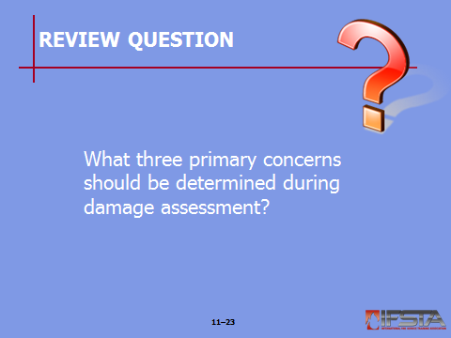
Review Question: What three primary concerns should be determined during damage assessment?
See pp. 506-516 of the manual for answers.

Section III: Product Containment: Plugging and Patching

product containment: plugging and patching
pp. 516-522 Objective 3 – Describe plugging and patching.

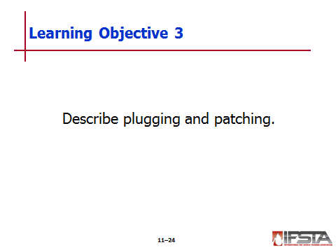
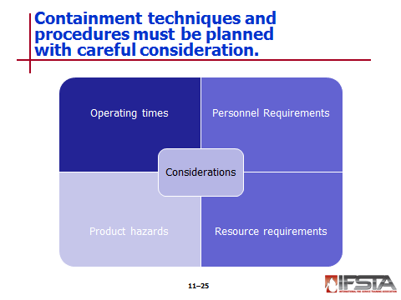
Product Containment: Plugging and Patching

If offensive operation necessary, technician must identify containment techniques that can be used to restrain product within container

Containment techniques and procedures vary in complexity

Regardless of method, must be planned carefully with consideration for

Operating times

Personnel requirements

Product hazards

Resource requirements

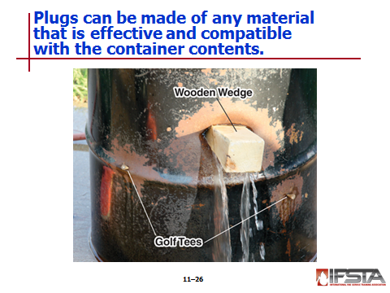
Plugging

Equipment

Can be simple as long as it is effective

Commercially available, but may also be homemade

Plug must be larger than opening and must be compatible with container and contents

Simplest method – Insert compatible material inside hole

May work best if wrapped with lightweight material before being inserted in hole

Lightweight cloth

Light gauge rubber gasket material

May require use of compatible caulk or putty in addition to plug

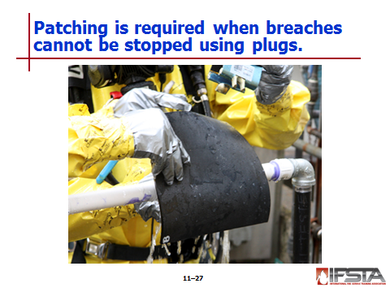
Patching

Often required when breach in container too large to be plugged

May be more complex based on

Damage to container

Whether protruding edges of breach are on side to be patched

Type and equipment based on reconnaissance of affected area

May include use of straps or pneumatic equipment

May include use of two- or three-part epoxy compatible with both chemical and material being patched

May be improvised; may require creativity

Easiest to use – Prefabricated patches

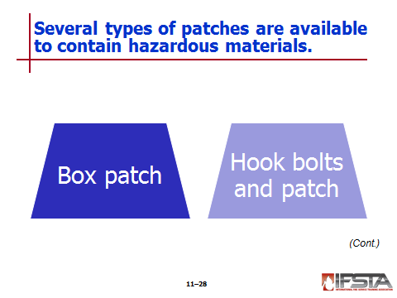
Box patch

Used when protruding edges of breach located on side of container where patch is to be attached

Must be made of material compatible with both container and product

Should be lined with gasket material

Once in place over breach, use shoring straps or other means to hold box in place

Methods used depend on container’s

Size

Location

Orientation

Hook bolts and patch

Usually fabricated from round stock

Come in variety of diameters and shapes

Manufactured in orientation so that head of bolt will pass through hole into container and hook to inside of container as fastened by bolt or nut on outside

May be manufactured in shape of T, L, or J

May include wood or steel strong backs for additional strength

Directions for use

Insert head end of bolt through container fully

Rotate head end so that it cannot be pulled back through hole

Insert pad or gasket through stock of bolt along with plank or strong back

Tighten nut on threaded end of bolt to secure patch

May be used with variety of patches and in various combinations

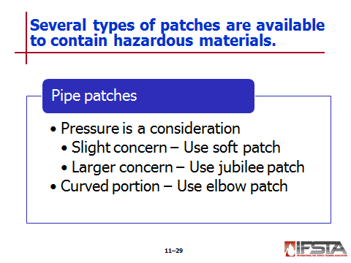
Pipe patches

May require different types of patches depending on conditions

Variety of items can assist

Pipe wraps

Bar clamps

Other clamps

Must be mindful of compatibility with product

Pressure

Consideration when patching

Of slight concern – Use soft patch

Combination of gasket material and wooden plugs or wedges inserted into hole

Insert plug or wedge into pipe far enough to control leak

Increase pressure if plug or wedge inserted too far

Cut or trip excess soft patch material outside pipe

Cover damaged area with gasket material secured in place using

String

Wire

Tape

If larger concern – Use jubilee pipe patch

Modification of commercial hose clamp

Usually manufactured of commercial sheet metal

Rolled into needed diameter

Tabs bent on each edge form a flange

Holes drilled into flange to allow patch to be secured to pipe

To install

Place piece of rubber or other gasket material over breach

Install and secure patch over rubber

Patch should be large enough to cover and overlap damaged area by at least 2 inches (51 mm) on all sides

Tighten bolts to secure patch in place

Elbow patch

Can be used to secure hole on curved portion of pipe

Constructed of woven-type cloth that incorporates resin hardener

Cloth shaped to contour pipe and then covered with multiple layers of PVC

May be possible to repressurize pipe once resin has hardened and patch is secure

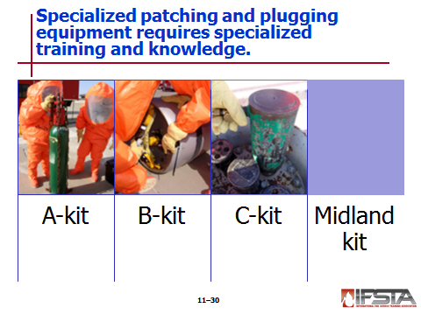
Specialized Plugging and Patching Equipment

Equipment varies and requires specialized training and knowledge of product

A-kit

Chlorine Institute’s Emergency Kit “A”

Designed for use with compressed gas cylinders

Can be used to contain and control leaks in and around cylinder valve and in side wall of chlorine cylinders

B-kit

Chlorine Institute’s Emergency Kit “B”

Designed for use with chlorine ton containers

Can be used to contain and control leaks in and around ton container valves

Can control leaks in side walls of container

C-kit

Chlorine Institute’s Emergency Kit “C”

Manufactured to design specifications of Chlorine Institute

Contains devices to stop leaks at safety valve or angle valves of

Standard DOT 105J500W chlorine tank cars

DOT MC311 cargo tanks

DOT 51 portable tanks in chlorine service

Equipped with variety of hand tools

Contains specific tools to help contain leaks in and around angle valves and pressure relief devices

Can only be used by trained personnel

Midland kit

Created by Midland Manufacturing

Specifically used with pressurized tank cars

Packaged in three individual containers

Designed to assist in mitigating leaks in valves from

Chlorine tanks

Liquid petroleum gas tanks

Anhydrous ammonia tanks

Can only be used by personnel specially trained with this equipment and on large tank cars
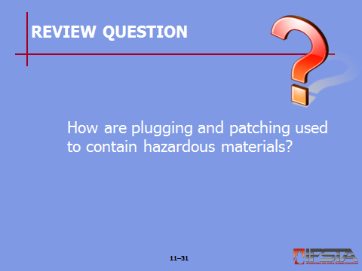
Review Question: How are plugging and patching used to contain hazardous materials?
See pp. 516-522 of the manual for answers.

Section IV: Cargo Tanks

cargo tanks
pp. 522-528 Objective 4 – Identify cargo tanks.

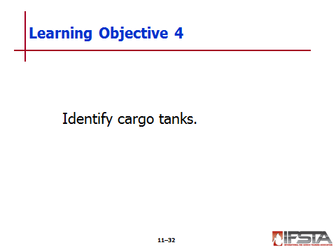
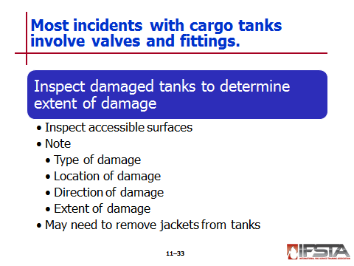
Cargo Tanks

Major incidents occur infrequently

Majority of problems with cargo tanks involve issues with valves and fittings

If involved in incident, damaged cargo tank must be inspected thoroughly to determine extent of damage

Inspect all accessible surfaces

Note

Type of damage

Location of damage

Direction of damage

Extent of damage

Jacketed cargo tanks may be difficult to inspect without removing jacket

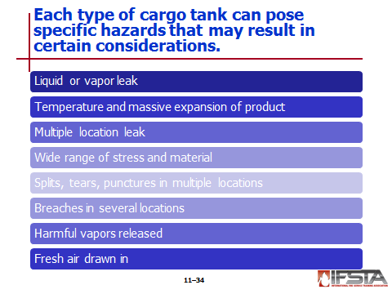
Methodology of Leak Control

Certain cargo tanks can pose specific hazards

MC 306/DOT 406

MC 307/DOT 407

MC 312/DOT 412

Considerations

Leak may be liquid or vapor

Liquid leaks may pose serious issues based on temperature and massive expansion of product

Leaks may occur in multiple locations

Stress involved and material of container may be far ranging

Splits, tears, or punctures may be present in multiple locations

Tanks may be breached in several locations

Harmful vapors may be released from leaks

Fresh air may be drawn into tank

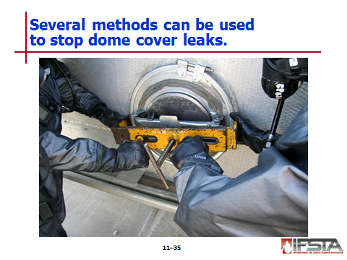
Dome cover leaks

Several methods to stop

Wooden wedges

Commercially available devices

If 306/406 tank dome is leaking

Dome cover clamp may be used

Number of types available

Requires specially trained technician

Most gaskets in this area will leak even when new

Observe any conditions that indicate reactivity with container or any other products or materials

If more than one dome is leaking, evaluate situation and determine order clamps will be installed
Instructor Note: This information correlates with Skill Sheet 11-1. More information is found at the end of this lesson outline.

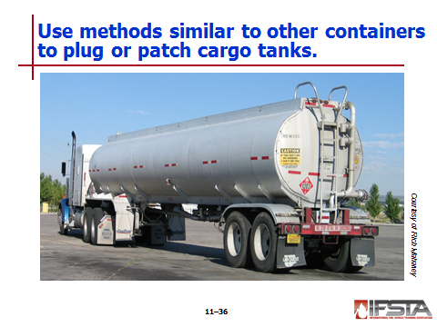
Addressing breaches in cargo tanks

May include

Irregular shaped holes

Punctures

Splits or tears

Leaking valves and caps

Leaking manway gaskets

Leaking piping

Similar to plugging or patching drum or other type of pressure cylinder

Product volume may be more substantial

Use different-sized wooden plugs in association with lead wool or putty

All products must be compatible with product and container

Cargo straps may be used in conjunction with pneumatically operated air bags

Ensure tank is stable and properly shored before beginning

Requires proper PPE and constant air monitoring
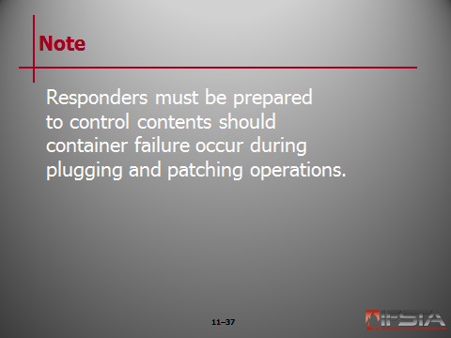
Note: Responders must be prepared to control contents should container failure occur during plugging and patching operations.

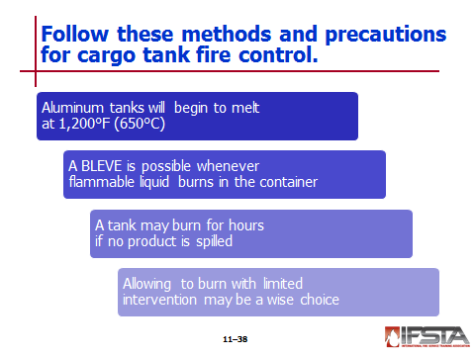
Methods and Precautions for Fire Control

Aluminum tanks

Commonly used in MC 306/DOT 406

Will begin to melt at approximately 1,200°F (650°C)

If breached and product ignites, liquid will act as heat sink and fire will burn at liquid level

As liquid and vapors consumed, exposed aluminum shell will melt and fail

BLEVE

Possibility whenever flammable liquid burning in container

Precautions should be taken to prevent

If no product spilled, tank may burn for hours

May be wise to allow fire to burn with limited intervention on tank

Exposures should be considered

Roadway incidents – Bridges and overpasses

Priorities

Protection of life

Protection of exposures

Confinement of any product that may have escaped from tank but has not ignited

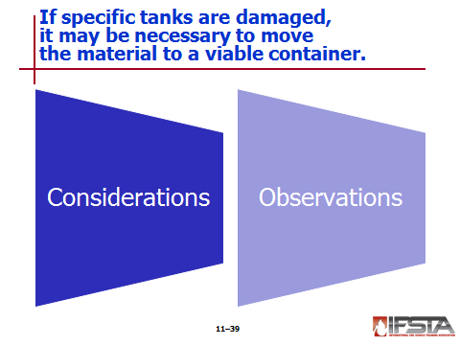
Product Removal and Transfer Considerations

If MC 306/DOT 406, MC 307/Dot 407, or MC 312/Dot 412 damaged, may be necessary to remove product into viable container

As much product as possible should be removed before cargo tank uprighted

Dangerous to attempt to upright damaged cargo tank that still has product in it

Options depend on

Type of product

Containers involved

Container stress

Orientation of container

Incident-specific variables

May be performed by specialized contractors

Emergency responders will maintain command; must be specially trained

When off-loaded

Tank and area should be surveyed to determine safe method for transferring product

Can help reduce stress and lessen chance of total failure

Observations when transferring

Location of additional leak points if any

Size and compatibility of transfer container

Recirculation of product

Cooling and heating of products

Availability of proper tools and equipment to complete job

Increases to scene size and control area

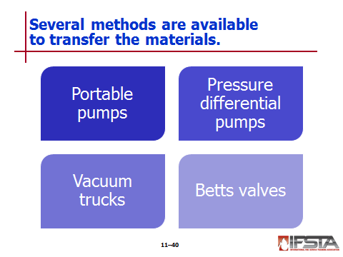
Available methods

Portable pumps

Variety of sizes

Used to move liquids

May be powered by

Electric

Gasoline

Diesel

Power take-off (PTO)

Water

Air

Type and size should be based on

Product being transferred

Capacity of receiving container

Lift and flow capacities needed at scene

Pressure differential pumps

Used to create pressure differential between two tanks to transfer vapors and gases

Vapor compressor creates positive pressure differential to move product by

Pulling vapors from receiving tank

Compressing them

Forcing them into damaged tank car

Increased pressure in damaged tank pushes product into receiving tank

Consider how much pressure damaged container can take

May be used in tandem with portable pumps to increase speed and efficiency of transfer

Vacuum trucks

Have mounted vacuums

Can handle variety of products

Flammables

Corrosives

Betts valves

Emergency unloading fixture equipped with internal self-closing stop valve

Designed to allow emergency responders to unload overturned tank through capped 3 inch (76 mm) NPT cleanout without spillage of product

Permits removal of clean-out cap and product discharge through proper hoses to level of clean-out cap

Can be used in off-loading operations of MC 307/DOT 407 highway cargo tanks

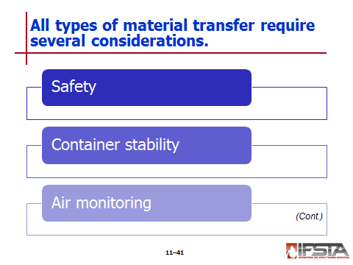
Safety considerations

Safety primary concern

Only personnel involved should be in general area of transfer operation

Personnel should wear PPE

Equipment used in transfer must be compatible with materials involved

Container stability

Container should be shored and stabilized before transfer operation started

Bracing must be in place

Container may shift during transfer operations

Air monitoring

Should be ongoing

Portable and gas-powdered equipment may be ignition source

LEL readings should be constantly monitored

Priorities – Elimination of

All ignition sources

Use of vapor suppression

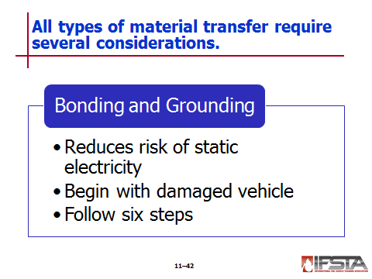
Bonding and grounding

Reduces risk of static electricity

When two materials in contact, electrons may move from one material to the other

When materials separated, balance disrupted

May result in flash fire or explosion

Bonding – Conductor used to connect objects together

Grounding

Means of connecting objects to ground

Can eliminate differences between objects and ground

To safely perform, begin with damaged vehicle

Tank and all appliances bonded and connected to receiving tank

Place all bonding cables on clean surfaces free of paint or grease

Do not use cables with alligator clips

Steps

Verify safety of the atmosphere

Establish a ground field as per departmental SOP/SOG

Connect the ground wire from the damaged tank to the grounding post

Connect the bonding cable from the damaged container to the receiving container

Connect the ground wires from the receiving container to a grounding post

Verify continuity and resistance throughout the process
Note: Refer to Chapter 6 for more information on monitoring for grounding and bonding.

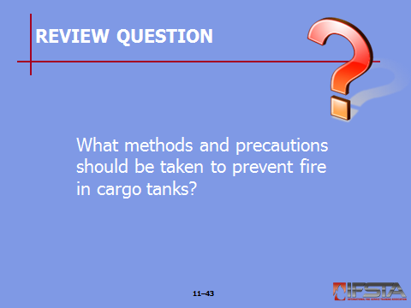
Review Question: What methods and precautions should be taken to prevent fire in cargo tanks?
See pp. 522-528 of the manual for answers.

Section V: Pressurized Containers

pressurized containers
pp. 528-534 Objective 5 – Identify pressurized containers.

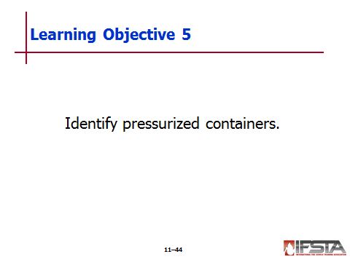
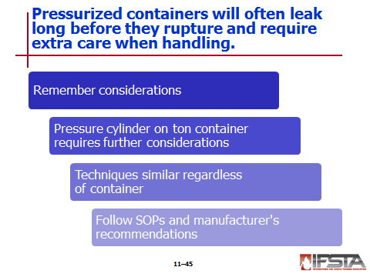
Pressurized Containers

Manufactured with materials that can withstand high pressures

Will often leak long before they rupture

Require extra care

Considerations

Pressure and pressure changes

Availability and proper use of appropriate PPE

Configuration and condition of container

Internal and external temperature of container

Size of container

Presence of autorefrigeration

Possibility of BLEVE

Expansion ratios of gases involved

Availability and use of thermal imaging camera to assist in locating leak points

Invisible fires that some gaseous products create

Conditions that would indicate reactivity with container or other products in proximity

Anytime pressure cylinder on ton container involved

Locate leaking container by looking for escaping vapor

Ask for approval from plant operator to close connecting valves if container is connected to additional piping or processing unit

Techniques similar regardless of container involved

Manufacturer recommendations and specific department operating procedures should always be followed
Instructor Note: Refer students to the information box titled “Recovery Vessels” on p. 529 of the manual. Discuss with students the applications of a recovery vessel.

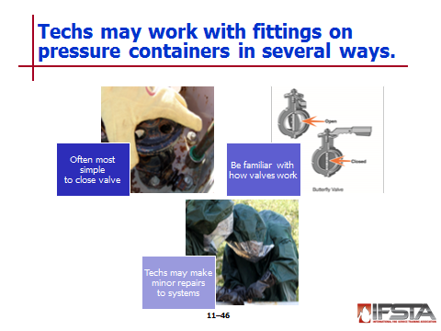
Working with Fittings on Pressure Containers

Simplest way to contain leak – Close valve

Doing so without knowledge of entire pumping system can have devastating effect

Understand exactly which one is being closed and which system it will affect

Must be performed in concert with facility personnel

How valve operates – Stems

If stem runs in line with pipe, open

If stem runs across pipe, closed

Technician may make minor repairs to different systems

Should not be attempted unless under guidance of facility operators

May include tightening of loose plugs or replacement of missing plugs

Requires proper PPE

Requires monitoring of air, confined space considerations, and possibility of oxygen-deficient atmosphere

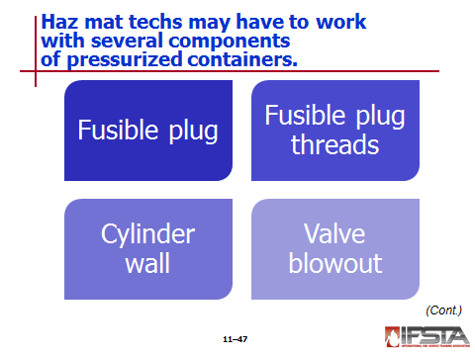
Fusible Plug

Commonly found safety devices found in pressurized vessels

Components that commonly leak and require attention

Tools needed

Wrenches

Clamps

Set screws

Blocks

Gasket material

Once equipment in place, ensure that leak has been controlled

Use products compatible with materials involved
Instructor Note: This information correlates with Skill Sheets 11-2 and 11-3. More information is found at the end of this lesson outline.

Fusible Plug Threads

Used when not possible to tighten or replace fusible plug

Tools needed

Hacksaw

Files

Wrenches

Clamps

Set screws

Blocks

Gasket material
Instructor Note: This information correlates with Skill Sheets 11-4 and 11-5. More information is found at the end of this lesson outline.

Cylinder Wall

Patch applied around cylinder if sidewall breached

Tools needed

Screws

Wrenches

Yokes

Chains

Patching equipment

Gaskets

Scrapers
Instructor Note: This information correlates with Skill Sheets 11-6 and 11-7. More information is found at the end of this lesson outline.

Valve Blowout

Secure valve opening by driving drift pin into opening – Stay clear once applied in case it dislodges

Assemble and apply hood device assembly
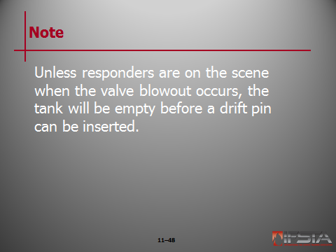
Note: Unless responders are on the scene when the valve blowout occurs, the tank will be empty before a drift pin can be inserted.

Instructor Note: This information correlates with Skill Sheets 11-8 and 11-9. More information is found at the end of this lesson outline.

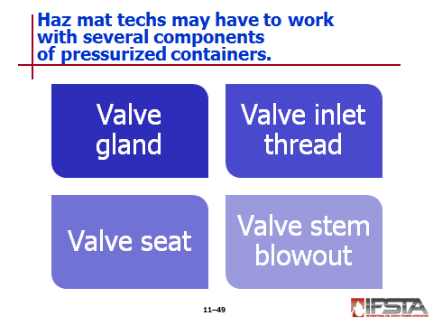
Valve Gland

May be possible to tighten packing nut to prevent further leakage

Before tightening, use assembly on cylinder or appropriate wrench to ensure valve stem closed

Packing nut should be tightened firmly but not over tightened

If leak persists, attach hood assembly
Instructor Note: This information correlates with Skill Sheet 11-10. More information is found at the end of this lesson outline.

Valve Inlet Thread

May be possible to tighten valve assembly onto cylinder to stop leak

Attach wrench to valve assembly

Using even pressure, tighten valve slowly until leak stops

If leak persists, attach hood assembly
Instructor Note: This information correlates with Skill Sheets 11-11 and 11-12. More information is found at the end of this lesson outline.

Valve Seat

Will not seat properly if foreign matter lodged

Opening and closing valve may be enough to dislodge matter

If disconnected from process and can be safely reconnected, reconnect and attempt to open and close valve stem

If cylinder cannot be safely reconnected, apply outlet cap and gasket

If leak persists, attach hood assembly
Instructor Note: This information correlates with Skill Sheets 11-13 and 11-14. More information is found at the end of this lesson outline.

Valve Stem Blowout

Repair similar to steps used for valve blowout

Drive drift pin into valve body

Apply hood assembly
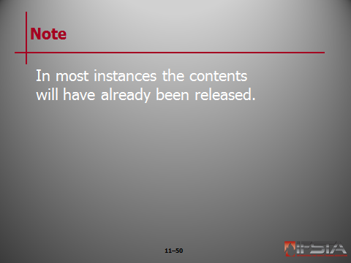
Note: In most instances the contents will have already been released.

Instructor Note: This information correlates with Skill Sheets 11-15 and 11-16. More information is found at the end of this lesson outline.

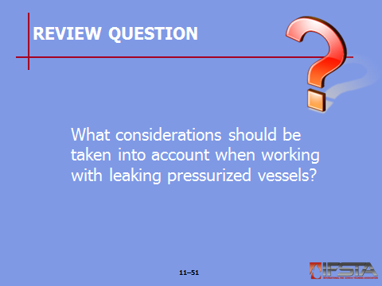
Review Question: What considerations should be taken into account when working with leaking pressurized vessels?
See pp. 528-534 of the manual for answers.

Section VI: Drums

drums
pp. 535-536 Objective 6 – Identify characteristics of drums.

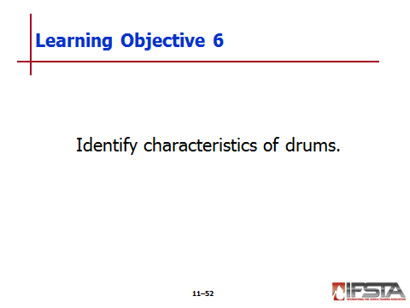
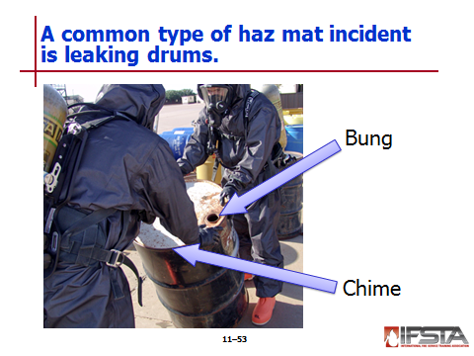
Drums

Leaking fairly common

Typical low-pressure metal drums

Flat pieces of metal rolled onto tubes with two capped ends

Chime runs around outer edge of each head

Various access holes found; closed with right-handed screw called bung

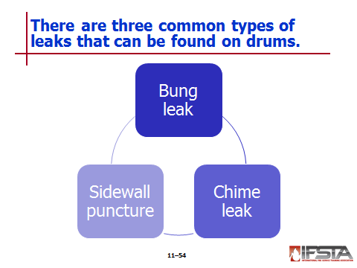
Bung Leaks

Common occurrence

Correction may be as simple as righting drum

Require product identification

If concern flammable product, require vapor suppression activities

Attempting repair

Drum must be upright or leak positioned at highest point

Bung wrench used to tighten bung and stop leak

Drum should be overpacked if necessary
Instructor Note: This information correlates with Skill Sheet 11-17. More information is found at the end of this lesson outline.

Chime Leaks

Simplest correction – Upright barrel or drum

Drum wrap or epoxies may be used

Steps

Stop leak

Overpack barrel

Seal barrel

Properly mark barrel
Instructor Note: This information correlates with Skill Sheet 11-18. More information is found at the end of this lesson outline.

Sidewall Punctures

More challenging to remedy

Can be small or large

Require check for reactivity indications

If concerns flammable product, acceptable LEL levels should be maintained

Steps

Orient barrel so that leak at highest point

Stop leak using available equipment

Trim plugging material

Cover patched area with tape or other appropriate material

Overpack barrel

Seal barrel

Properly mark barrel
Instructor Note: This information correlates with Skill Sheets 11-19 and 11-20. More information is found at the end of this lesson outline.

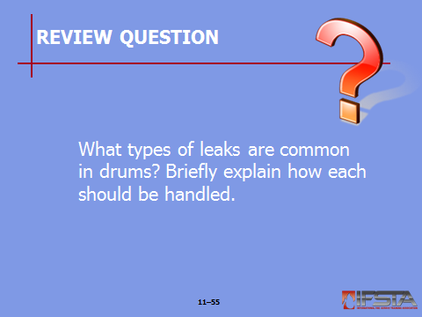
Review Question: What types of leaks are common in drums? Briefly explain how each should be handled.
See pp. 535-536 of the manual for answers.

Section VII: Overpacking

overpacking
pp. 536-540 Objective 7 – Explain overpacking.

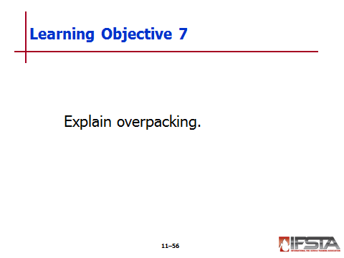
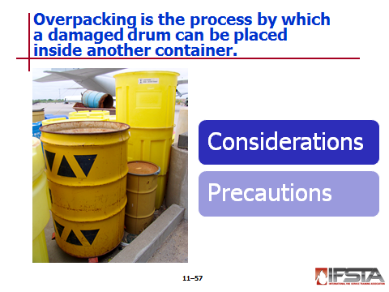
Overpacking

Process by which damaged drum can be placed inside another container

Overpack drums

Usually constructed of steel or plastic

Come in sizes ranging from 5 to 119 gallons (19 L to 450 L)

Commonly used for liquids and solids

Considerations

Drums that have been involved in transportation accident or that have been buried or abandoned for long period of time may be compromised

Weakened drums may breach when overpacked or handled

Depending on product, weights may be over 800 lbs (363 kg)

Drums that contain liquid and have deteriorated to point of being unmovable may need contents off-loaded

Leaking barrels should be temporarily repaired before overpacking

Drums may be overpressurized

Precautions

Wear appropriate PPE whenever handling or overpacking drums

Keep fingers outside of drums

Use drum upender or dolly to move drums whenever possible

Maintain safe body positioning when moving a drum

Stay uphill of drum

Chock drums in place to prevent movement

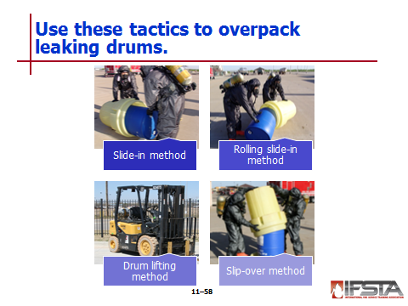
Tactics

Slide-in method

Accomplished by sliding drum on side into overpack drum

May include use of 2X4 planks or pipes

Drum to be overpacked laid on side with pipes perpendicular to barrel

Drum rolled onto pipes

Pipes assist with rolling drum into overpack
Instructor Note: This information correlates with Skill Sheet 11-21. More information is found at the end of this lesson outline.

Rolling slide-in method

Drum and overpacked positioned end-to-end at 30° angle

Both rolled together in same direction

Portion of drum enters overpack; responder finish sliding
Instructor Note: This information correlates with Skill Sheet 11-22. More information is found at the end of this lesson outline.

Drum lifting method

Completed with assistance of mechanical equipment

Drum lifted into upright position

Overpack placed under drum

Drum lowered into overpack

Slip-over method

Recovery drum placed over top of leaking drum

Both drums tilted onto ground and then uprighted with leaking drum inside recovery drum

Ensure drum bung openings orientated towards lid when uprighted
Instructor Note: This information correlates with Skill Sheet 11-23. More information is found at the end of this lesson outline.

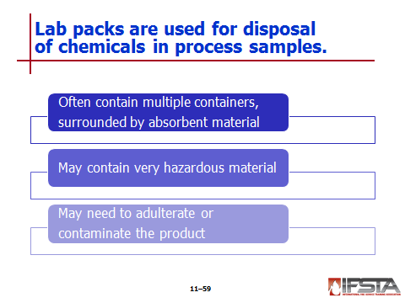
Lab Packs

Used for disposal of chemicals in process samples

Often contain multiple container or compatible product surrounded by absorbent material

May contain

Radioisotopes

Shock-sensitive products

Highly volatile chemicals

Highly corrosive chemicals

Highly toxic chemicals

May be necessary to adulterate or contaminate product

Pouring product directly into absorbent material of lab pack to ensure product cannot be reused

Requires compatibility between product and absorbent material
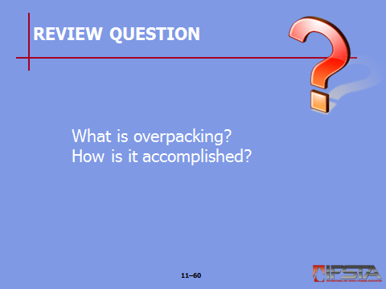
Review Question: What is overpacking? How is it accomplished?
See pp. 536-540 of the manual for answers.

Section VIII: Specialized Product Control Techniques

specialized product control techniques
pp. 540-543 Objective 8 – Describe specialized product control techniques.

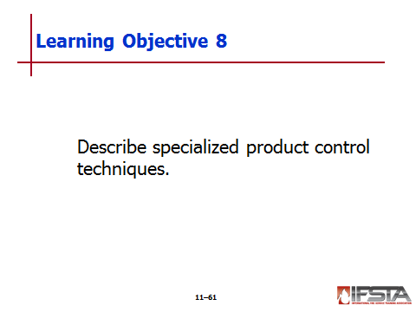
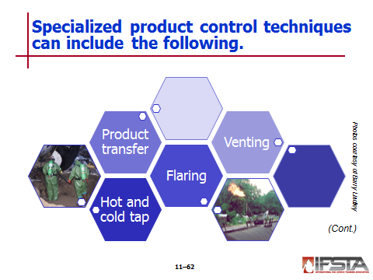
Hot and Cold Tap

Tapping – Process used to attach nozzle or outlet on ton container’s tank or piping to assist with removal or transfer of product

Hot tapping

Technique in which welding or cutting operations conducted to attach nozzle or outlet while container or pipe still contains product

Used only in emergency situations when removal of chemical from container cannot be accomplished through normal means due to

Lack of container integrity

Damage to valves or piping

Cold tapping

Similar to hot tapping

Nozzle or outlet strapped to container or piping

Product Transfer

Technique that can be used to off-load chemical or product from damaged container into receiving container

May be conducted for overloaded containers

Requires special care when involving rail cars

Considerations when working with railway containers and following conditions exist

Container is damaged and cannot be safely moved or rerailed

Rail tank is sound, but damage to bolsters will not allow car to be rerailed

Topography will preclude container from being rerailed

Container is overloaded

Damaged valves cannot be repaired

Variety of options

Tools and equipment vary

Requires care to be taken

Flaring

Technique used to reduce amount of product in container

May be effective at reducing volume of gases or liquid through flare pipe or other outlet

Offers beneficial results

Reduces quantity of chemical

Decreases internal pressure of container

Requires care to ensure flaring operation will not ignite other materials

Can be performed on various containers

Two types

Vapor flaring – Burning of vapor of compressed flammable gas at outlet of flare stand

Liquid flaring – Burning of liquefied flammable gas or flammable liquid at end of horizontal flare pipe

Venting

Process in which product released into atmosphere in order to reduce pressure within container

Typically associated with nonflammable products

If concerns toxic product, may be released after processed to reduce toxicity

Requires extreme care

Should be conducted only after consulting with

Shipper

Environmental specialists

Other container specialists

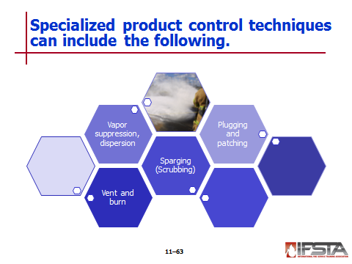
Vent and Burn

Highly specialized process

Used to create

when all other options unavailable or will not work

Conducted by placing controlled openings in container with use of explosives

Should be considered only shaped charges strategically around container to open container and burn off liquefied flammable compressed gas or flammable lids

Should be used solely as last resort

Sparging (Scrubbing)

Process where gas is bubbled through liquid

Gas absorbed in solution

Examples

Quick way of reducing pressure in vessel or process

Should only be performed by trained personnel

Vapor Suppression and Dispersion

Vapor suppression

Action taken to reduce emission of vapors at haz mat incident

Uses fire fighting foams; Class B foams most commonly used

Dispersion

Viable option when vapors cannot be suppressed

Action taken to direct or influence course of airborne hazardous materials

May use pressurized streams of water

Create turbulence

Increases rate of mixing with air

Reduces concentration of hazardous material

Requires confinement and analyzing of runoff water

Applying Large Plugging and Patching Devices

Commercially available

Used for patching holes in larger containers

Pneumatically inflatable bags

Can be used on various-sized containers

Used in association with ratched or strapping devices

Can be inflated to control or stop leak on variety of container sizes and materials

Usually made of nylon-type material

May have reinforcement on edges
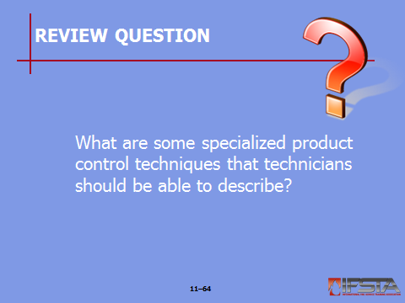
Review Question: What are some specialized product control techniques that technicians should be able to describe?
See pp. 540-543 of the manual for answers.

Section IX: Skill Sheets

SKILL SHEETS
pp. 545-546 Objective 9 – Install a clamp on the dome of an MC-306/DOT-406 cargo tank.

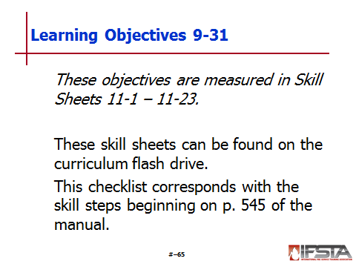
Skill Sheet 11-1

For this skill sheet, students will perform the skills to install a clamp on the dome of an MC-306/DOT-406 cargo tank

This skill sheet can be found in the Skills Evaluation Checklist 11-1 on the curriculum flash drive

This checklist corresponds with the information on pp. 523-524 of the manual
pp. 547-548 Objective 10 – Contain a leak from a fusible plug using an A-kit.

Skill Sheet 11-2

For this skill sheet, students will perform the skills to contain a leak from a fusible plug from an A-kit

This skill sheet can be found in the Skills Evaluation Checklist 11-2 on the curriculum flash drive

This checklist corresponds with the information on p. 532 of the manual
pp. 549-550 Objective 11 – Contain a leak from a fusible plug using a B-kit.

Skill Sheet 11-3

For this skill sheet, students will perform the skills to contain a leak from a fusible plug using a B-kit

This skill sheet can be found in the Skills Evaluation Checklist 11-3 on the curriculum flash drive

This checklist corresponds with the information on p. 532 of the manual
pp. 551-552 Objective 12 – Control a chlorine leak from fusible plug threads using an A-kit.

Skill Sheet 11-4

For this skill sheet, students will perform the skills to control a chlorine leak from fusible plug threads using an A-kit

This skill sheet can be found in the Skills Evaluation Checklist 11-4 on the curriculum flash drive

This checklist corresponds with the information on p. 533 of the manual
p. 553 Objective 13 – Control a leak from fusible plug threads using a B-kit.

Skill Sheet 11-5

For this skill sheet, students will perform the skills to control a leak from fusible plug threads using a B-kit

This skill sheet can be found in the Skills Evaluation Checklist 11-5 on the curriculum flash drive

This checklist corresponds with the information on p. 533 of the manual
pp. 554-555 Objective 14 – Control a chlorine leak from a cylinder sidewall using an A-kit.

Skill Sheet 11-6

For this skill sheet, students will perform the skills to control a chlorine leak from a cylinder sidewall using an A-kit

This skill sheet can be found in the Skills Evaluation Checklist 11-6 on the curriculum flash drive

This checklist corresponds with the information on p. 533 of the manual
pp. 556-557 Objective 15 – Control a leak from a cylinder sidewall using a B-kit.

Skill Sheet 11-7

For this skill sheet, students will perform the skills to control a leak from a cylinder sidewall using a B-kit

This skill sheet can be found in the Skills Evaluation Checklist 11-7 on the curriculum flash drive

This checklist corresponds with the information on p. 533 of the manual
pp. 558-560 Objective 16 – Control a chlorine leak from a valve blowout using an A-kit.

Skill Sheet 11-8

For this skill sheet, students will perform the skills to control a chlorine leak from a valve blowout using an A-kit

This skill sheet can be found in the Skills Evaluation Checklist 11-8 on the curriculum flash drive

This checklist corresponds with the information on p. 533 of the manual
p. 561 Objective 17 – Control a leak from a valve blowout using a B-kit.

Skill Sheet 11-9

For this skill sheet, students will perform the skills to control a leak from a valve blowout using a B-kit

This skill sheet can be found in the Skills Evaluation Checklist 11-9 on the curriculum flash drive

This checklist corresponds with the information on p. 533 of the manual
p. 562 Objective 18 – Control a chlorine leak from a valve gland using a C-kit.

Skill Sheet 11-10

For this skill sheet, students will perform the skills to control a chlorine leak from a valve gland using a C-kit

This skill sheet can be found in the Skills Evaluation Checklist 11-10 on the curriculum flash drive

This checklist corresponds with the information on pp. 533-534 of the manual
p. 563 Objective 19 – Control a chlorine leak from valve inlet threads using an A-kit.

Skill Sheet 11-11

For this skill sheet, students will perform the skills to control a chlorine leak from valve inlet threads using an A-kit

This skill sheet can be found in the Skills Evaluation Checklist 11-11 on the curriculum flash drive

This checklist corresponds with the information on p. 534 of the manual
pp. 564-565 Objective 20 – Control a leak from valve inlet threads using a B-kit.

Skill Sheet 11-12

For this skill sheet, students will perform the skills to control a leak from valve inlet threads using a B-kit

This skill sheet can be found in the Skills Evaluation Checklist 11-12 on the curriculum flash drive

This checklist corresponds with the information on p. 534 of the manual
pp. 566-567 Objective 21 – Control a chlorine leak from a valve seat using an A-kit.

Skill Sheet 11-13

For this skill sheet, students will perform the skills to control a chlorine leak from a valve seat using an A-kit

This skill sheet can be found in the Skills Evaluation Checklist 11-13 on the curriculum flash drive

This checklist corresponds with the information on p. 534 of the manual
pp. 568-569 Objective 22 – Control a leak from a valve seat using a B-kit.

Skill Sheet 11-14

For this skill sheet, students will perform the skills to control a leak from a valve seat using a B-kit

This skill sheet can be found in the Skills Evaluation Checklist 11-14 on the curriculum flash drive

This checklist corresponds with the information on p. 534 of the manual
pp. 570-571 Objective 23 – Control a chlorine leak from a valve stem blowout using an A-kit.

Skill Sheet 11-15

For this skill sheet, students will perform the skills to control a chlorine leak from a valve stem blowout using an A-kit

This skill sheet can be found in the Skills Evaluation Checklist 11-15 on the curriculum flash drive

This checklist corresponds with the information on p. 534 of the manual
p. 572 Objective 24 – Control a leak from a valve stem blowout using a B-kit.

Skill Sheet 11-16

For this skill sheet, students will perform the skills to control a leak from a valve stem blowout using a B-kit

This skill sheet can be found in the Skills Evaluation Checklist 11-16 on the curriculum flash drive

This checklist corresponds with the information on p. 534 of the manual
pp. 573-574 Objective 25 – Contain a drum leak from a bung.

Skill Sheet 11-17

For this skill sheet, students will perform the skills to contain a drum leak from a bung

This skill sheet can be found in the Skills Evaluation Checklist 11-17 on the curriculum flash drive

This checklist corresponds with the information on p. 535 of the manual
p. 575 Objective 26 – Control a drum leak from a chime.

Skill Sheet 11-18

For this skill sheet, students will perform the skills to control a drum leak from a chime

This skill sheet can be found in the Skills Evaluation Checklist 11-18 on the curriculum flash drive

This checklist corresponds with the information on p. 536 of the manual
p. 576 Objective 27 – Control a drum leak from a forklift puncture.

Skill Sheet 11-19

For this skill sheet, students will perform the skills to control a drum leak from a forklift puncture

This skill sheet can be found in the Skills Evaluation Checklist 11-19 on the curriculum flash drive

This checklist corresponds with the information on p. 536 of the manual
p. 577 Objective 28 – Control a drum leak from a nail puncture.

Skill Sheet 11-20

For this skill sheet, students will perform the skills to control a drum leak from a nail puncture

This skill sheet can be found in the Skills Evaluation Checklist 11-20 on the curriculum flash drive

This checklist corresponds with the information on p. 536 of the manual
p. 578 Objective 29 – Overpack a drum using the slide-in method.

Skill Sheet 11-21

For this skill sheet, students will perform the skills to overpack a drum using the slide-in method

This skill sheet can be found in the Skills Evaluation Checklist 11-21 on the curriculum flash drive

This checklist corresponds with the information on p. 538 of the manual
p. 579 Objective 30 – Overpack a drum using the rolling slide-in method.

Skill Sheet 11-22

For this skill sheet, students will perform the skills to overpack a drum using the rolling slide-in method

This skill sheet can be found in the Skills Evaluation Checklist 11-22 on the curriculum flash drive

This checklist corresponds with the information on p. 538 of the manual
pp. 580-581 Objective 31 – Overpack a drum using the slip-over method.

Skill Sheet 11-23

For this skill sheet, students will perform the skills to overpack a drum using the slip-over method

This skill sheet can be found in the Skills Evaluation Checklist 11-23 on the curriculum flash drive

This checklist corresponds with the information on p. 538 of the manual

Section X: Summary and Review

SUMMARY AND REVIEW

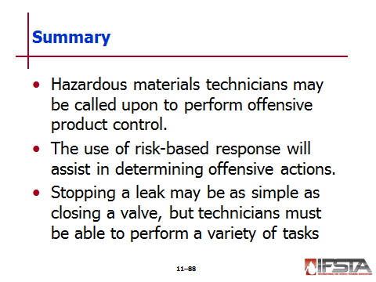
Chapter Summary

Hazardous materials technicians may be called upon to perform offensive product control.

The use of risk-based response will assist in determining offensive actions.

Stopping a leak may be as simple as closing a valve, but technicians must be able to perform a variety of tasks.

Review Questions

What are the differences between nonintervention, defensive operations, and offensive operations? (502-506)

What three primary concerns should be determined during damage assessment? (506-516)

How are plugging and patching used to contain hazardous materials? (516-522)

What methods and precautions should be taken to prevent fire in cargo tanks? (522-528)

What considerations should be taken into account when working with leaking pressurized vessels? (528-534)

What types of leaks are common in drums? Briefly explain how each should be handled. (535-536)

What is overpacking? How is it accomplished? (536-540)

What are some specialized product control techniques that technicians should be able to describe? (540-543)

