Chapter 9
Decontamination

Lesson Goal
After completing this lesson, the student shall be able to discuss the various types of decontamination, explain how to determine if decontamination is effective, and describe special considerations for decontamination.
Objectives
Upon successful completion of this lesson, the student shall be able to:
1. Explain the process of selecting a method of decontamination. [NFPA®472, 7.3.4(2)]
2. Describe various decontamination methods. [NFPA® 472, 7.3.4(1)]
3. Identify equipment and limitations for various types of technical decontamination. [NFPA® 472, 7.3.5.1(1-2, 7, 17), 7.4.5(1-2)]
4. Compare methods of mass decontamination. [NFPA® 472, 7.4.5(3)]
5. Explain how to assess decontamination effectiveness. [NFPA® 472, 7.5.2]
6. Describe implementation of decontamination. [NFPA® 472, 7.3.4(1)]
7. Identify special considerations for decontamination.
8. Perform mass decontamination operations involving ambulatory and nonambulatory victims. [NFPA® 472, 7.4.5(3); Skill Sheet 9-1]
9. Perform technical decontamination operations in support of entry operations. [NFPA® 472, 7.4.5(1); Skill Sheet 9-2]
10. Perform technical decontamination operations involving ambulatory and nonambulatory victims. [NFPA® 472, 7.4.5(2); Skill Sheet 9-3]
Instructor Information
This is the lesson covering decontamination. This lesson describes both technical and mass decontamination. The lesson also covers effectiveness of decontamination and special considerations for decontamination.

Important instructor information is provided in shaded boxes throughout the lesson plan. Carefully review the instructor information before presenting the lesson.

This lesson includes skill evaluation checklists that assess student ability to perform both technical and mass decontamination. These checklists will allow students to meet the requirements of learning objectives 8-10.

Methodology
This lesson uses lecture, discussion, and skills evaluation checklists. The level of learning is application.
Outline Contents

Section | Outline Pages | Text Pages
Section I: Method Selection | 5 | 394
Section II: Decontamination Methods | 6 | 395
Section III: Technical Decontamination | 8 | 396
Section IV: Mass Decontamination | 20 | 406
Section V: Assessing Decontamination Effectiveness | 24 | 408
Section VI: Decontamination Implementation | 26 | 410
Section VII: Special Considerations | 39 | 419
Section VIII: Skill Sheets | 42 | 422
Section IX: Summary and Review | 44 | 420

Audiovisuals
- Visuals 9.1 to 9.39 (PowerPoint® Presentation)
Evaluation
- Chapter 9 Quiz
- Chapter 9 Test
- Skill Evaluation Checklists 9-1 to 9-3
Presentation Tools
Interactive Objects allow instructors to present information a piece at a time by clicking on hot spots in a larger image.

Each object is labeled in the Lesson Outline and indicated in the PowerPoint® presentation by a RED arrow in the top left corner of the image. This lets instructors know to use the mouse to explore all of the information on the slide.


After all of the information is displayed a reset arrow will appear in the bottom right corner of the image. Instructors can use this to remove the text and quiz students on content just covered or simply move on to the next slide.

To move to the slide after an interactive object, select the Click for next slide arrow on the left side of the slide.

Videos are used as discussion starters or to illustrate a concept or process discussed in the chapter.

These are labeled in the Lesson Outline and indicated in the PowerPoint® presentation by the Click image to play arrow on the left side of the slide.

Section I: Method Selection

method selection
pp. 394-395 Objective 1 – Explain the process of selecting a method of decontamination.

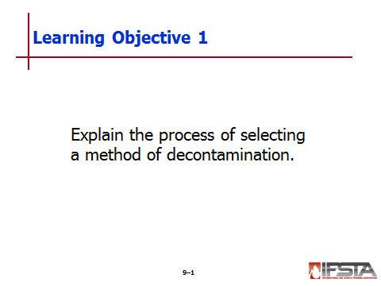
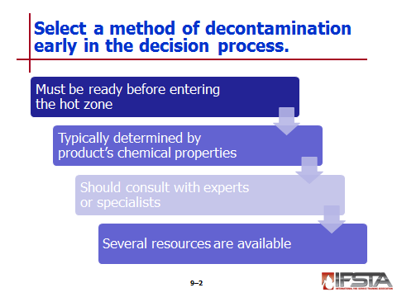
Method Selection

Should be done early in decision making process

Must be available and ready to be implemented before responders enter hot zone

Typically determined by chemical product’s properties and available

May include consultation with experts or specialists familiar with chemicals

Can be complicated task

Safety of emergency responders, civilians at stake

Methods must be compatible with product, protective clothing, equipment

Influenced by activities on scene

Resources

Technical references such as Safety Data Sheets (SDSs)

Chemical assistance agencies such as CHEMTREC in the United States, CANUTEC in Canada, and SETIQ in Mexico

Local or regional poison control centers

National Response Center
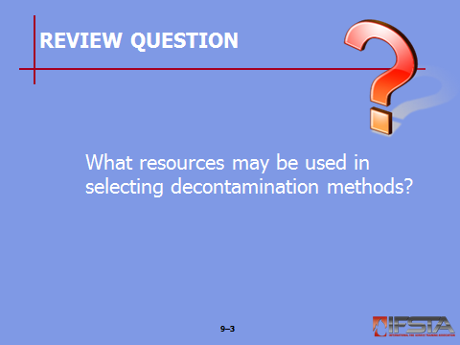
Review Question: What resources may be used in selecting decontamination methods?
See pp. 394-395 of the manual for answers.

Section II: Decontamination Methods

decontamination methods
pp. 395-396 Objective 2 – Describe various decontamination methods.

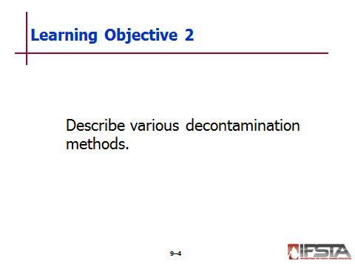
Decontamination Methods

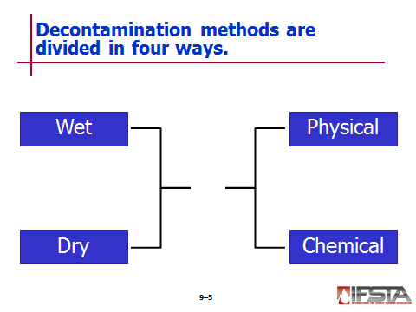
Wet or dry methods

Wet – Usually involves washing contaminated surface with solutions or flushing with hose stream or safety shower

Dry – Using methods such as scraping, brushing and absorption

Physical or chemical methods

Physical

Removing contaminant from contaminated person without changing material chemically

Contaminant is then contained for disposal

Chemical – Used to make contaminant less harmful by changing it through some kind of chemical process

Most effective is often as simple as removing outer clothing or PPE that has been contaminated

Flushing contaminated surface with water is effective at removing harmful substance or sufficiently diluting it to safe level
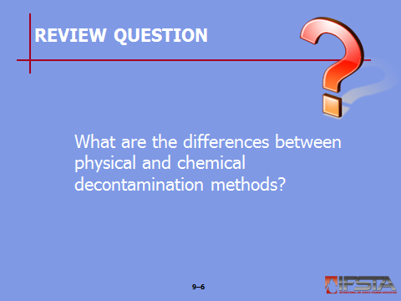
Review Question: What are the differences between physical and chemical decontamination methods?
See pp. 395-396 of the manual for answers.

Section III: Technical Decontamination

technical decontamination
p. 396 Objective 3 – Identify equipment and limitations for various types of technical decontamination.

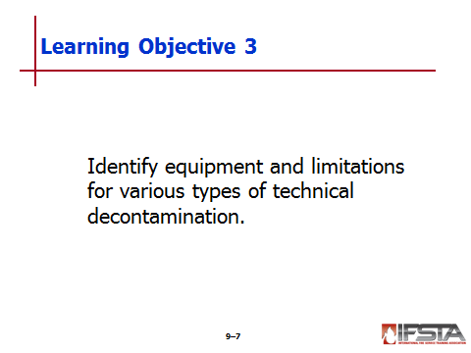
Technical Decontamination

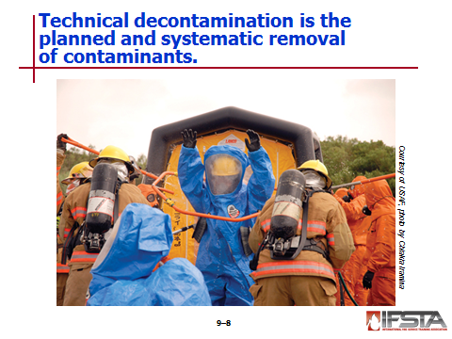
Planned and systematic removal of contaminants from personnel and/or equipment

Uses chemical or physical methods to thoroughly clean or neutralize contaminants from primarily entry team personnel’s PPE and equipment

May also be used on incident victims in non-life-threatening situations

Usually conducted within formal decon line or corridor

Type and scope determined by involved contaminants

Resources for procedures

Emergency Response Guidebook (ERG)

Emergency response centers

NIOSH Pocket Guide

Poison control centers

Preincident plans

Safety data sheets (SDSs)

Technical experts

WISER

Other books, reference sources, computer programs, data bases

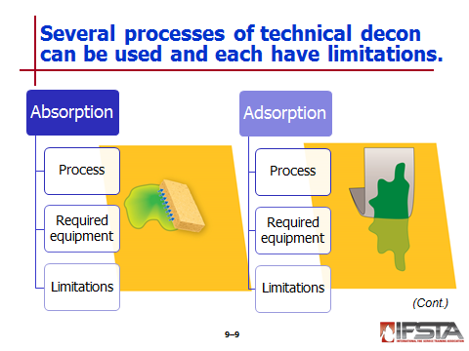
Absorption

Process of soaking up chemical spill

Uses sand or other absorbent material

Does not change chemical properties of compound or its hazards

Simply moves compound from one medium to another

Can be helpful when attempting to decontaminate equipment or machinery that may not be able to withstand other decon processes

Creates much less waste than other processes

Not generally used for decontamination of responders or their protective equipment

Required equipment

Must be compatible with material being absorbed

Ranges from absorbent pads and booms to particulate material

Limitations

Does not change chemical properties of product

Hazard still exists and end result will be hazardous waste
Instructor Note: Remind students that there is one exception to this rule. If an acid spill is cleaned up with an absorbent material such as soda ash, the end result will be a neutralized product.

Adsorption

Adherence of chemical to surface of another medium

Allows for liquid to adhere to solid adsorbent material

Useful for removing liquid product floating on another liquid

Required equipment

Adsorbent materials

Often round or pelletized form

Have high heat stability and small pores resulting in higher surface area

Examples

Activated carbon or charcoal

Silica

Aluminum gel

Earth clay

Limitations

May produce high heat

May cause spontaneous combustion

Must be disposed of properly

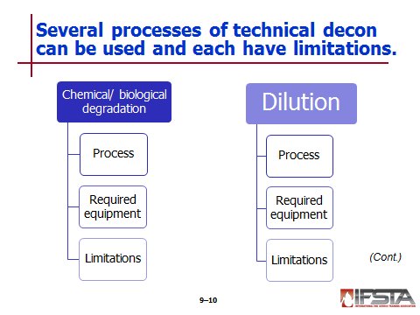
Chemical/Biological Degradation

Process in which product is altered or degraded with help of nonreactive substance into material that is less hazardous

May be natural process or physical process

Chemical – Substance may be used to attack or alter properties of another chemical

Biological – Enzymes or microbial agents may be used to reduce hazards of biological agent

Required equipment

Can be used as additive in washing solutions to aid in degrading harmful products

Examples

Isopropyl alcohol

Sodium hydroxide

Sodium carbonate

Calcium oxide

Limitations

Complicated process

May be difficult to find specific information for different agents that may be needed

May be difficult to determine correct concentrations

Heat may be by-product of reaction

Should not be used for protective clothing or response equipment

Should never be used on skin

Dilution

Process where solvent is used to lessen concentration and hazards of contaminant

Works best on products that may be water soluble or miscible

Very effective means, in conjunction with washing, for decontaminating emergency responders, victims, and equipment

Required equipment

Water

Pumps

Hoses

Other means of moving water

Limitations

Process may create large cleanup effort in contaminated runoff

Viscous substances may be very difficult to dilute

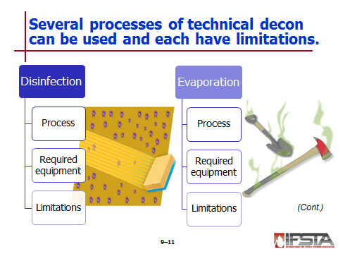
Disinfection

Process where a significant percentage of pathogenic organisms are killed or controlled

Disinfectants – Substances applied to nonliving objects in order to kill or eliminate microorganisms

Required equipment

Varies based on situation – Either wide-spectrum or specific

Air disinfectants – Eliminate microorganisms suspended in air

Alcohols – Disinfect skin

Aldehydes – Eliminate spores or fungi

Oxidizing agents – Attack cellular structure of microorganisms

Phenolics – Used in household disinfectant soaps and hand washes

Limitations

Only effective when

Can contact surface

Remains wet for extended period of time

Not all will offer residual activity

Once dry, stops working

Evaporation

Process where liquid portion of chemical product is allowed to evaporate

End result may be total elimination of chemical or solid waste that may be dissolved or suspended in solution

May occur with or without emergency responder intervention

Advantage – Reduces amount of hazardous waste that will need to be removed

Required equipment – Very little need for responder intervention

Limitations

Vapors can be dangerous and not easily controlled

May not be feasible method of decon due to length of time for product to evaporate

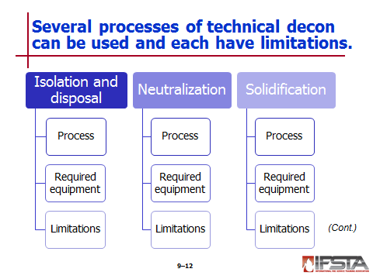
Isolation and Disposal

Two-part process that may work in tandem with other methods

Isolation – Act of segregating contaminated equipment in effort to reduce exposure

Disposal – Final step in process

Simplest form of decontamination

Required equipment – Variety of bags and drums that will be used to contain contaminated items

Limitations

Risk of cross contamination with isolation

May create sizable amount of hazardous waste

Can be costly

Neutralization

Can be considered form of chemical degradation

Used in association with acids and bases

Main objective – Bring pH of chemical as close to neutral as possible

Typically used to decontaminate equipment

Required equipment

Chemicals must be specific to contaminant in question

Care should be taken

Chemicals used can present own hazards

Litmus paper to check pH levels

Limitations

Entirely product specific

No one chemical can be used to neutralize all

Difficult to perform

Wastewater must be collected and disposed of

Emergency responder must have specific product information and rely on help of product experts

May produce exothermic reaction

Should never be used on human skin

Solidification

Agent is applied to liquid spill and combines with liquid either chemically or physically to form solid

Usually conducted by contractors to prepare hazardous substance for disposal

Limits spread of contaminant and allows for easier handling

Required equipment – Commercially available products such as Oilbond®

Uses

Most helpful – Hydrocarbon spills

Also work – Aromatics, chlorinated solvents

Limitations

May not alter hazards of target chemical

Reaction may produce heat or other dangerous by-products

May produce more hazardous waste than original target chemical

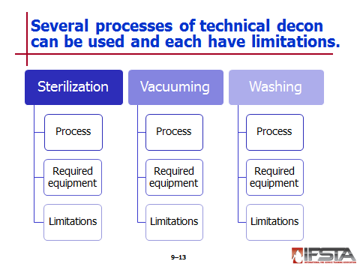
Sterilization

Results in destruction of all forms of microbial life

Required equipment – Chemicals, steam, heat, or radiation

Limitations

May be impossible or impractical to complete on scene or emergency or in decon lines

Best completed at facilities that can ensure complete and successful process

Vacuuming

Process of using high efficiency particulate air (HEPA) filters to remove dust, particulate, or other solid hazards from personnel and equipment

Advantages

Removes particulate down to three microns

By isolating only particulate being removed, may reduce overall waste to be disposed of

Required equipment – Specialized vacuums that must be compatible with materials being vacuumed

Limitations

Can be time consuming

Equipment may be costly

Filters must be changed frequently

Exhaust air must be monitored to ensure that no product is bypassing filters

Washing

Includes use of solutions, solvents, and other surfactants that will help reduce adhesion between contaminant and material being cleaned

Required equipment

Water supply

Variety of solutions

Limitations

Wastewater must be contained and disposed of properly

May not be adequate for viscous substances

May not have positive effect if products are not miscible
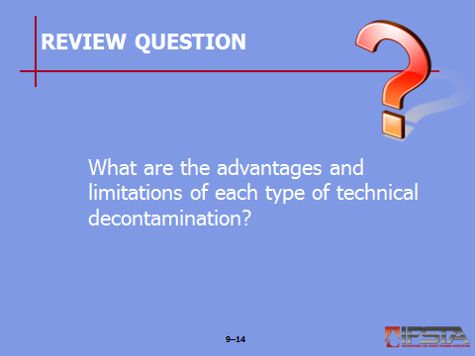
Review Question: What are the advantages and limitations of each type of technical decontamination?
See pp. 396-405 of the manual for answers.

Section IV: Mass Decontamination

mass decontamination
pp. 406-408 Objective 4 – Compare methods of mass decontamination.

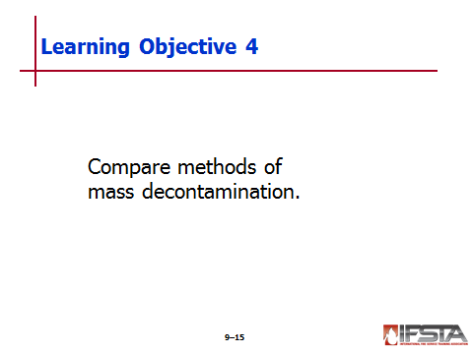
Mass Decontamination

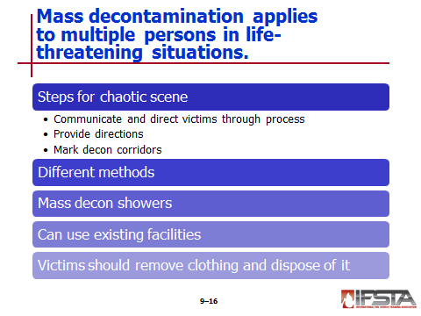
Process of rapidly reducing or removing contaminants from multiple persons in potentially life-threatening situations

Initiated when number of victims and time constraints do not allow establishment of in-depth decontamination process

Steps to combat chaos if present on scene

Communicate with victims to direct them to decon gathering areas and through decon process

Hand signals

Signs with pictures

Apparatus public address systems

Megaphones

Other methods

Provide directions that are

Clear

Easily understood

Short

Specific

Mark decon corridors with

Barrier tape

Traffic cones

Other highly visible means

Methods – Each has own advantages and limitations

Dilution

Isolation

Washing

Mass decon showers

High volume, low pressure water stream

Delivered in fog pattern

Showering time is incident specific – May be

As long as two to three minutes when ideal

Shortened when large numbers involved

May include use of existing facilities

Fire sprinklers

Public fountains

Chlorinated swimming pools

Swimming areas

Recommended that victims remove clothing before showering

As much as possible, from head to toe

At least down to undergarments

Clothing should be isolated for later disposal

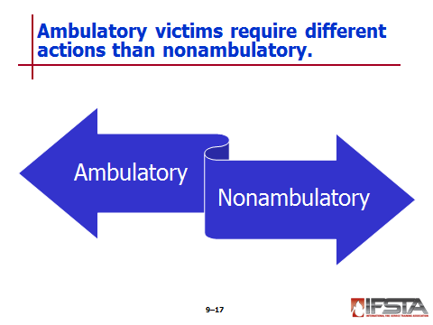
Ambulatory Victims

Those who are able to understand directions, talk, and walk unassisted

Should be directed to area of safe refuge within isolation perimeter to await prioritization for decontamination

Factors influencing priority – Victims

With serious medical symptoms

Closest to point of release

Reporting exposure to hazardous material

With evidence of contamination on clothing or skin

With conventional injuries

Nonambulatory Victims

Civilians or responders who are unconscious, unresponsive, or unable to move unassisted

May be more seriously injured than ambulatory patients

May have to remain in place if sufficient personnel are not available to remove them from hot zone
Instructor Note: This information correlates with Skill Sheet 9-1. More information is found at the end of this lesson outline.

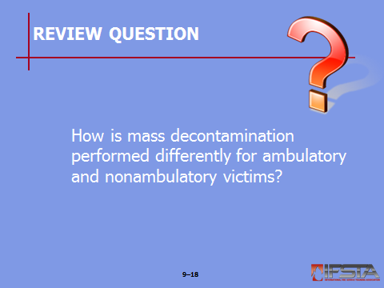
Review Question: How is mass decontamination performed differently for ambulatory and nonambulatry victims?
See pp. 406-408 of the manual for answers.

Section V: Assessing Decontamination Effectiveness

assessing decontamination effectiveness
pp. 408-409 Objective 5 – Explain how to assess decontamination effectiveness.

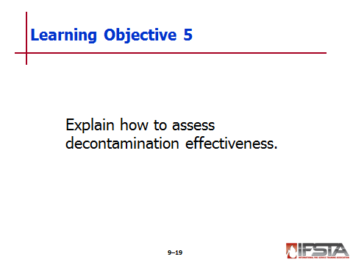
Assessing Decontamination Effectiveness

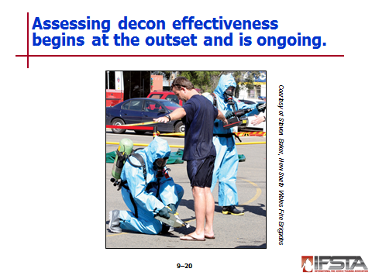
Required by OSHA in U.S.

Should be conducted at start of process and as ongoing assessment

May be done through use of monitoring and detection devices or visually

Should include check of each individual; may be brief if large numbers of people are involved

Should be done as individual exits decon corridor

Redirect through decon if

Contamination is detected

Victims complain of symptoms or effects

Effectiveness called into question

Tools and equipment

Store in decon area until emergency phase is completed

After being decontaminated, check to ensure all contamination removed before being placed back in service

If ineffective, must be changed

Testing effectiveness of decontamination process

Visual inspection – Using natural or ultraviolet light; look for visible stains if possible

Wipe sampling – Subject is wiped with cloth swab which is then sent out for analysis

Permeation testing – Sample is sent to lab for analysis

Cleaning solution analysis

Evaluates cleaning solution effectiveness during final rinse

If contaminants found in rinse water, additional cleaning and rinsing may be necessary
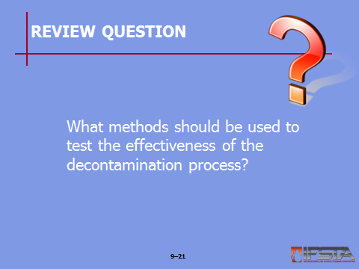
Review Question: What methods should be used to test the effectiveness of the decontamination process?
See pp. 408-409 of the manual for answers.

Section VI: Decontamination Implementation

decontamination implementation
pp. 410-419 Objective 6 – Describe implementation of decontamination.

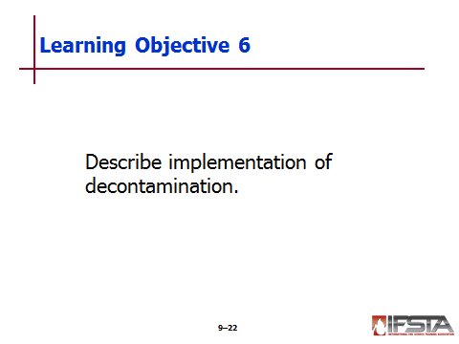
Site Selection – Factors

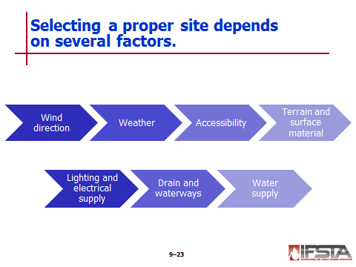
Wind direction

Should be upwind of hot zone

If improperly located downwind, wind currents will blow mists, vapors, powders, and dusts toward responders and victims

Can be predicted by local weather service during long-term operations

Weather – During cold weather, should be protected from blowing winds

Accessibility

Must be away from hazards, but adjacent to hot zone

Should be as close as possible to actual incident due to time factors

Travel time in hot zone

Time allotted to work in hot zone

Travel time back to decontamination site

Decontamination time

Terrain and surface material

Should be flat or sloped toward hot zone to allow contaminants to drain toward or into hot zone

If not possible, may have to place barrier to ensure confinement of unintentional release

Other considerations

Diking around site prevents accidental contamination escaping

Best if site has hard, nonporous surface to prevent ground contamination

When hard-surfaced driveway, parking lot, or street is not accessible

Use impervious covering on ground

Salvage covers or plastic sheeting will prevent contaminated water from soaking into earth

Covers or sheeting should be used to form corridor regardless of surface

Lighting and electrical supply

Should be adequate to reduce potential for personnel injury

If permanent lighting is unavailable or inadequate, portable lighting will be required

Portable generators may be necessary

Drains and waterways

Should not be located near storm and sewer drains, creeks, ponds, ditches, and other waterways unless approved for use as contaminated system

Construct dike to protect storm drain opening

Protect all environmentally sensitive areas if possible

Never delay decon to protect the environment if the delay will increase injury to those affected

Water supply – Must be available if wet decon is used

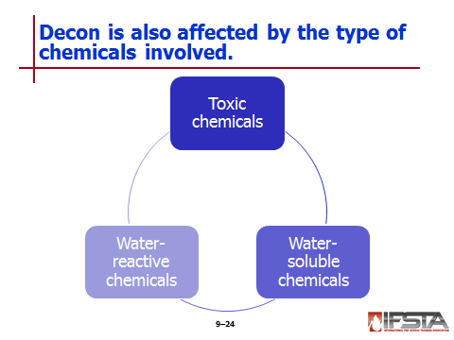
Factors Affecting Decontamination

Based on products being decontaminated, amount of wash or rinse stations may vary

Chemical factors affecting decontamination

Toxic chemicals

Pose significant health risk to entry personnel and others

Should be thoroughly removed if post skin absorption hazard

Require that all surfaces be completely decontaminated

Water soluble chemicals

Should be washed or diluted; may also remove other chemicals

Results in surfactants and contaminants in waste water

Water reactive chemicals

Difficult to remove from garments or equipment

May already be reacting

Best removed by brushing, blowing, or vacuuming

May require water dilution

May require copious amounts of water

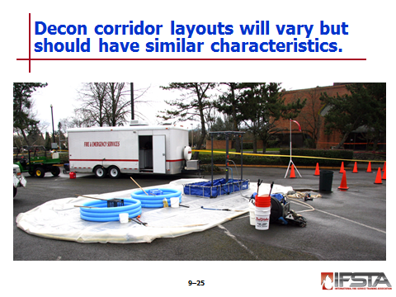
Decontamination Corridor Layout

Will vary and be specific to products in question

Should be

Established in such configuration that will bridge space between hot and warm zone

Wide enough to accommodate operation

As long as needed to provide adequate room

Separated for humans and equipment/vehicles

Placed on base of sheet plastic that is

Water resistive

One continuous piece

May include berm to assist with containment – Can be created with use of charged fire hose inflated with either air or water

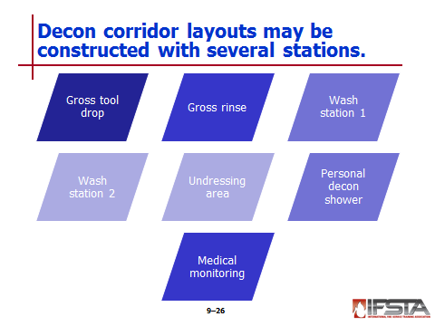
Typical decon corridor construction

Gross tool drop – Containment for temporary storage of contaminated tools and equipment

Gross rinse – Liquid retention pool along with showering nozzle or wand

Wash Station 1

Liquid retention pool

Buckets with approved cleaning solutions

Brushes for washing and scrubbing

Nozzles or wands for rinsing

Wash Station 2

Liquid retention pool

Buckets with approved cleaning solutions

Brushes for washing and scrubbing

Nozzles or wands for rinsing

Undressing area – Chairs and containers for removed PPE and clothing

Personal decon shower – May be at site or off site

Medical monitoring – Area where staff can monitor vitals and conditions of all exiting
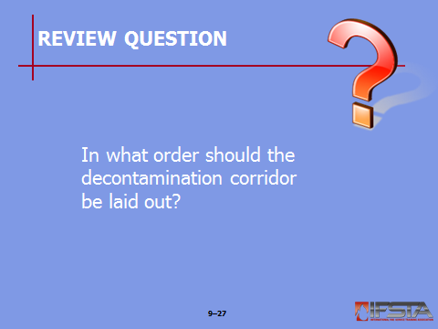
Review Question: In what order should the decon corridor be laid out?
See p. 413 of the manual for answers.

Instructor Note: This information correlates with Skill Sheets 9-2 and 9-3. More information is found at the end of this lesson outline.

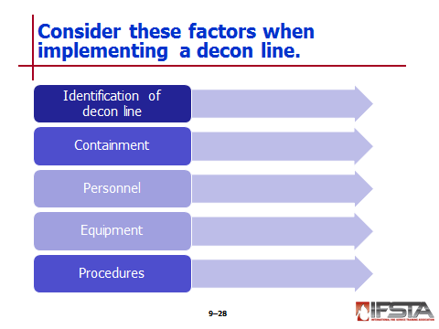
Identification of the decontamination line

Should be separated from surrounding warm zone

Should be visible and stand out

Ensures that responders in need of decontamination do not waste time looking if air supply is diminishing

May be identified by

Cones

Barrier tape

Barricades

Brightly colored tarps

Containment

Required so that wastewater can be disposed of properly

Includes containment device at each wash/rinse station

May include

Use of pools with elevated platform on which to stand

Can include plastic sheathing with berm

Should include containment of loose items such as tools and clothing articles – In separate containers

Personnel

Must be in adequate amounts to perform work needed

Should be at least one person assigned to each station; two if staffing allows

Should include supervisor assigned to oversee operation; should not be working part of decon line

Equipment

Must include CPC in proper size and style for all decon line members

Must include respiratory equipment

Essential equipment necessary

Tarps, plastic sheeting, or containers – For creation of equipment drop

Base cover – Should be large enough to contain entire decontamination effort

Containment pools – Contain water runoff from washing and rinsing operations

Isolation steps – Keep responders elevated with feet out of water runoff

Showers – Should supply adequate flow of water

Brushes – Used to scrub CPC

Solution containers – Used to hold variety of decontamination solutions

Containers for discarded items – May include trash cans, half barrels, or heavy bag-lined cardboard boxes

Rescue devices – Used to decontaminate nonambulatory victims; can be easily cleaned and reused

Water transport – Required to transfer water from apparatus to decon site

Procedures

Must be conducted in orderly manner

Procedures should address normal operations as well as emergency situations

Prioritizing entry

Air levels

Level of contamination

Medical emergencies

Compromise of PPE integrity

Should contain provisions for medical evaluation along with proper hydration

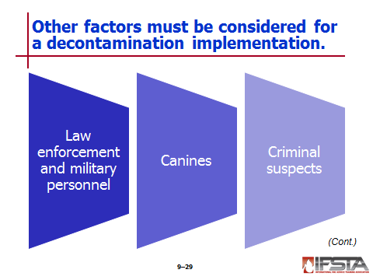
Other Implementation Considerations

Law enforcement and military personnel

May be a unique challenge – Often carry weapons and will not surrender them to civilian personnel

May require haz mat trained law enforcement officer

Require special decontamination for weapons, ammunition, and other equipment

May require separate corridor under supervision of protected law enforcement officers

Canines – May require special precautions and procedures for decontamination

Criminal suspects

Must be supervised by law enforcement throughout process

May require handcuffs be removed and decontaminated

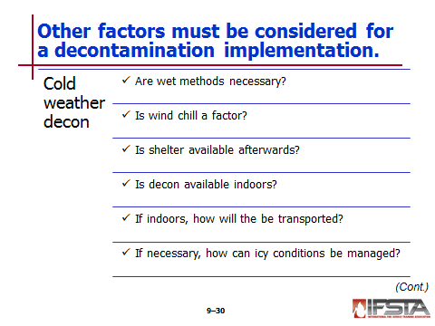
Cold Weather Decontamination

Can be difficult to execute safely

If temperatures are 64°F (18°C) or lower, answering the following questions will provide information on how best to protect victims

Are wet methods necessary, or can disrobing and dry methods accomplish effective decon?

Is wind chill a factor?

Is shelter available for victims during and after decon?

Is it possible to conduct decon indoors?

If decon will be conducted indoors, how will victims be transported?

If decon must be conducted outside in freezing temperatures, how will icy conditions be managed?
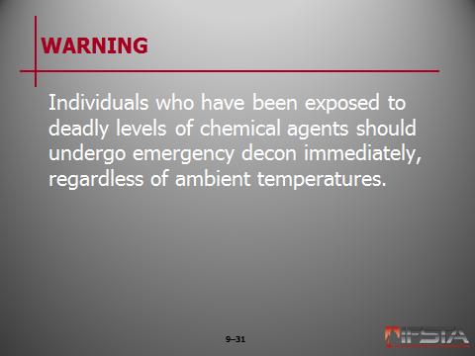
WARNING!: Individuals who have been exposed to deadly levels of chemical agents should undergo emergency decon immediately, regardless of ambient temperatures.

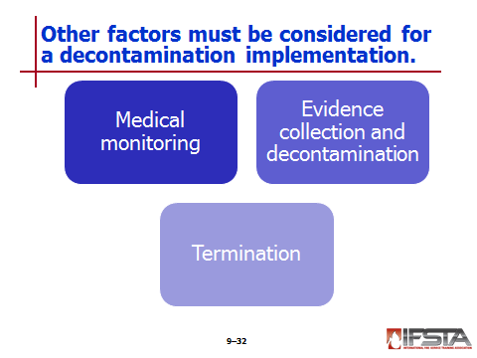
Medical Monitoring

Must be provided to any personnel who have been working in CPC and those who have been decontaminated

Should include assessment of vital signs at several intervals after decon; all findings should be thoroughly documented

Should include

Body temperature

Pulse

Respiratory rate

Blood pressure

Auscultation of lung sounds

Evaluation of body weight

Mental status

Other tests or evaluations as required by the AHJ

Evidence Collection and Decontamination

Will be performed under direction of law enforcement

Must be appropriately packaged

Exterior of packaging will be decontaminated as passes from hot zone to cold zone

Must include chain of custody documented in writing

Termination

Debriefing – Should be held as soon as practical

Return of personal items – May be function of law enforcement

Delayed health effects – Information should be provided to exposed persons

Reports and documentation – May be required by emergency response plans and/or SOPs

Exposure report – Required of all responders who may have been exposed; information might include

Activities performed

Product involved

Reason for being there

Equipment failures or malfunction of PPE

Hazards associated with product

Symptoms experienced

Monitoring levels in use

Circumstances of exposure

Follow-up examinations – May be required

Records and reports – Follow OSHA standard 29 CFR 1910.1020
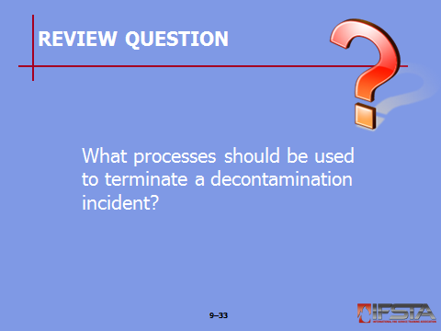
Review Question: What processes should be used to terminate a decontamination incident?
See pp. 418-419 of the manual for answers.

Section VII: Special Considerations

special considerations
pp. 419-420 Objective 7 – Identify special considerations for decontamination.

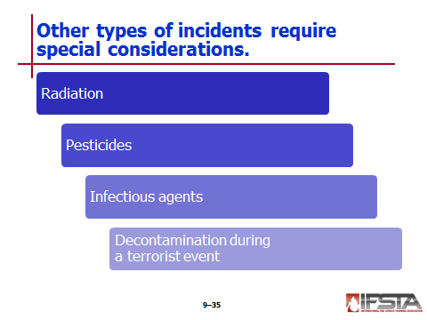
Radiation

Requires special consideration during mitigation and decontamination

Requires practice of time, distance, shielding tactic

May require assistance of technical experts, hospitals, universities, and/or the Department of Energy

Decontamination

Should be stand-alone decon line separate from others

Should be equipped with own containment devices

Procedures

Monitor victims with detector

Isolate clothes and equipment

Wash and rinse victim thoroughly

Have victim take personal shower, washing methodically

Monitor victims again in areas of direct contact

Pesticides – May

Require recommendations from pesticide manufactures

Require resources such as the Hotline at Texas Tech University and CHEMTREC

Infectious Agents – May

Offer special challenges

Only be destroyed by sterilization

Require assistance from state health department or Centers for Disease Control

Decontamination During a Terrorist Event

Often require outside help from technical specialists – Know agencies before incident takes place

May include large numbers of victims – Requires mass emergency decon

Remove clothing first

Set up corridor using fog streams from aerial device or multiple pumping apparatus

Contain water runoff, but put life safety before environmental protection
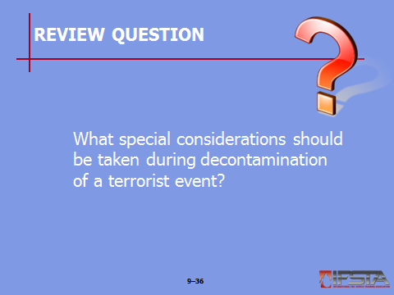
Review Question: What special considerations should be taken during decontamination of a terrorist event?
See pp. 419-420 of the manual for answers.

Section VIII: Skill Sheets

skill sheets
pp. 422-425 Objective 8 — Perform mass decontamination operations involving ambulatory and nonambulatory victims.

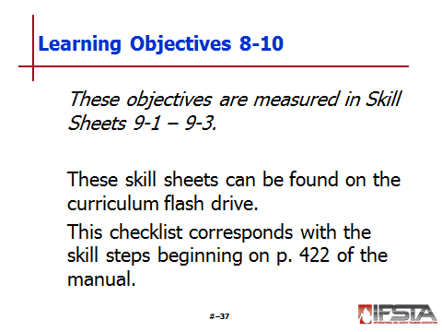
Skill Sheet 9-1

For this skill sheet, students will perform the skills to perform mass decontamination operations involving ambulatory and nonambulatory victims

This skill sheet can be found in the Skills Evaluation Checklist 9-1 on the curriculum flash drive

This checklist corresponds with the information on pp. 407-408 of the manual
p. 426 Objective 9 — Perform technical decontamination operations in support of entry operations.

Skill Sheet 9-2

For this skill sheet, students will perform the skills to perform technical decontamination operations in support of entry operations

This skill sheet can be found in the Skills Evaluation Checklist 9-2 on the curriculum flash drive

This checklist corresponds with the information on p. 413 of the manual
pp. 427-429 Objective 10 — Perform technical decontamination operations involving ambulatory and nonambulatory victims.

Skill Sheet 9-3

For this skill sheet, students will perform the skills to perform technical decontamination operations involving ambulatory and nonambulatory victims

This skill sheet can be found in the Skills Evaluation Checklist 9-3 on the curriculum flash drive

This checklist corresponds with the information on p. 413 of the manual

Section IX: Summary and Review

SUMMARY AND REVIEW

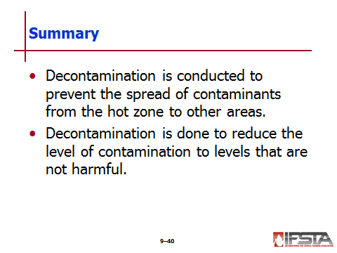
Chapter Summary

Decontamination is conducted to prevent the spread of contaminants from the hot zone to other areas.

Decontamination is done to reduce the level of contamination to levels that are not harmful.

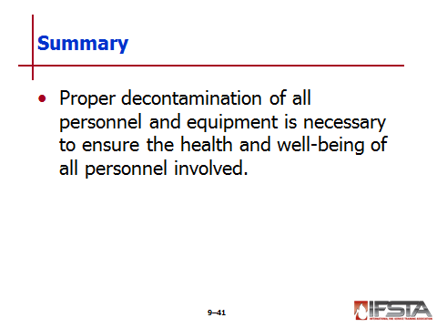
Proper decontamination of all personnel and equipment is necessary to ensure the health and well-being of all personnel involved.

Review Questions

What resources may be used in selecting decontamination methods? (394-395)

What are the differences between physical and chemical decontamination methods? (395-396)

What are the advanatages and limitations of each type of technical decontamination? (396-405)

How is mass decontamination performed differently for ambulatory and nonambulatory victims? (406-408)

What methods should be used to test the effectiveness of the decontamination process? (408-409)

In what order should the decontamination corridor be laid out? (413)

What processes should be used to terminate a decontamination incident? (418-419)

What special considerations should be taken during decontamination of a terrorist event? (419-420)

