Chapter 4
Chemistry and Hazards of Hazardous Materials and Weapons of Mass Destruction

Lesson Goal
After completing this lesson, the student shall be able to describe the basic chemistry of common hazardous materials and weapons of mass destruction. Students will also be able to explain the hazards associated with these materials.
Objectives
Upon successful completion of this lesson, the student shall be able to:
1. Define atoms.
2. Describe the basic arrangement of the periodic table of elements.
3. Explain the four significant families of elements.
4. Describe matter. [NFPA® 472, 7.2.2.2(10, 36, 44)]
5. Explain the concept of bonding. [NFPA® 472, 7.2.2.2(24, 25)]
6. Explain the various types of reactions. [NFPA® 472, 7.2.2.2(7-8, 23, 37)]
7. Describe common families of hazardous materials. [NFPA® 472, 7.2.2.2(2, 4, 9, 13, 27, 31, 41, 42)]
8. Identify special hazards of chemicals and weapons of mass destruction. [NFPA® 472, 7.2.2.2(4, 5, 26, 30, 33, 40, 52)]
9. Define radiation. [NFPA® 472, 7.2.1.4, 7.2.2.2(20)]
Instructor Information
This is the lesson covering chemistry and hazards of hazardous materials and weapons of mass destruction. This lesson describes various types of reactions. The lesson also covers types of radiation.

Important instructor information is provided in shaded boxes throughout the lesson plan. Carefully review the instructor information before presenting the lesson.

Methodology
This lesson uses lecture and discussion. The level of learning is comprehension.
Outline Contents

Section | Outline Pages | Text Pages
Section I: Atoms | 5 | 146
Section II: Periodic Table of Elements | 6 | 146
Section III: Four Significant Families | 9 | 147
Section IV: Matter | 16 | 156
Section V: Bonding | 24 | 164
Section VI: Reactions | 30 | 170
Section VII: Common Families of Hazardous Materials | 41 | 176
Section VIII: Special Hazards of Chemicals and Weapons of Mass Destruction | 54 | 186
Section IX: Radiation | 71 | 194
Section X: Summary and Review | 77 | 198

Audiovisuals
- Visuals 4.1 to 4.89 (PowerPoint® Presentation)
Evaluation
- Chapter 4 Quiz
- Chapter 4 Test
Presentation Tools
Interactive Objects allow instructors to present information a piece at a time by clicking on hot spots in a larger image.

Each object is labeled in the Lesson Outline and indicated in the PowerPoint® presentation by a RED arrow in the top left corner of the image. This lets instructors know to use the mouse to explore all of the information on the slide.


After all of the information is displayed a reset arrow will appear in the bottom right corner of the image. Instructors can use this to remove the text and quiz students on content just covered or simply move on to the next slide.

To move to the slide after an interactive object, select the Click for next slide arrow on the left side of the slide.

Videos are used as discussion starters or to illustrate a concept or process discussed in the chapter.

These are labeled in the Lesson Outline and indicated in the PowerPoint® presentation by the Click image to play arrow on the left side of the slide.

Section I: Atoms

Atoms
p. 146 Objective 1 – Define atoms.

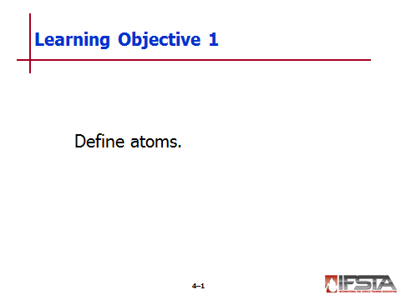
Definitions

Atom – Basic building block of any substance

Makes up every element and compound

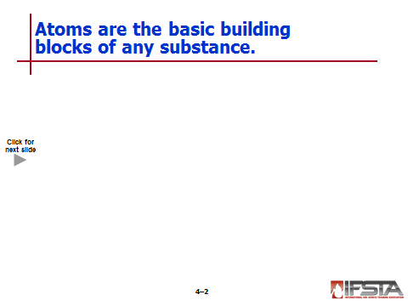
Consists of several different parts
Interactive slide; use mouse to show all information

Nucleus – At center of atom

Protons – Part of nucleus; positively charged

Neutrons – Part of nucleus; negatively charged

Electrons – Orbit the nucleus

Shells – Place where electrons reside

Elements

Differ from one another by number of protons in nucleus

Some have equal number of protons and neutrons

Atomic number – Number of protons; always equals number of electrons

Atomic mass – Weight of atom; determined by number of neutrons and protons present in nucleus
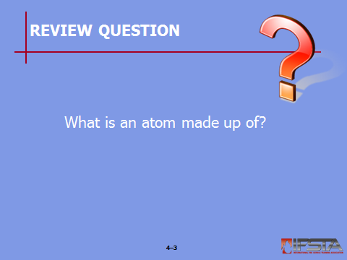
Review Question: What is an atom made up of?
See p. 146 of the manual for answers.

Section II: Periodic Table of Elements

periodic table of elements
pp. 146-147 Objective 2 – Describe the basic arrangement of the periodic table of elements.

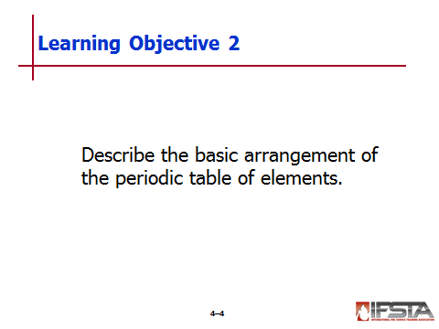
Periodic Table of Elements

Tool for organizing and displaying the elements in a way that provides basic information about their characteristics

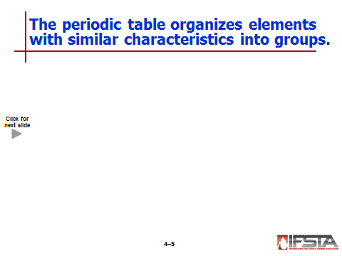
First 92 elements found in nature; remainders are manmade
Interactive slide; use mouse to show all information

Continues to evolve as new elements are created and named

Can be used quickly to obtain wealth of information about any of the elements

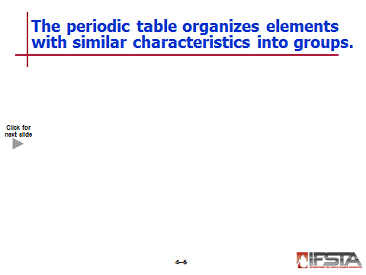
Organization
Interactive slide; use mouse to show all information

Arranged horizontally by order of increasing atomic number

Horizontal rows called periods

Vertical rows called groups or families

Groups have similar chemical properties

Categories – Metals, nonmetals, metalloids

Each element identified by

Name

Symbol

Atomic number

Atomic weight

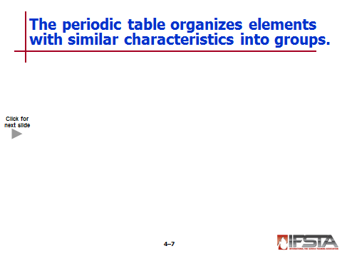
Diagonal line divides metals and nonmetals
Interactive slide; use mouse to show all information

Metals located on left side

Nonmetals located on right side

Metalloids and semiconductors straddle the line

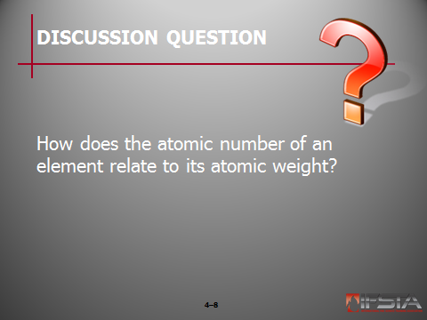
Ask Students: How does the atomic number of an element relate to its atomic weight?

Briefly discuss answers with students. Explain that – for the most part – as the atomic number increases, so does the atomic weight. Technicians can generally assume that elements lower on the periodic table will be solids and those higher on the table will be gases.

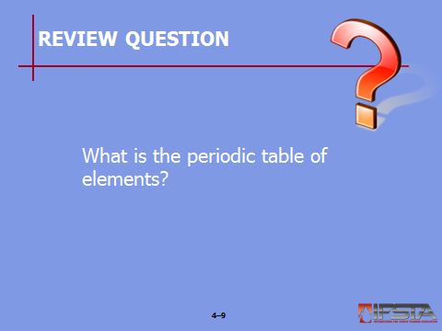
Review Question: What is the periodic table of elements?
See p. 146 of the manual for answers.

Section III: Four Significant Families

four significant families
pp. 147-156 Objective 3 – Explain the four significant families of elements.
Instructor Note: Explain to students that the four families discussed in this section are those most important to Technicians. These families are the most predictable, and Technicians can make generalizations about these families prior to checking reference sources.

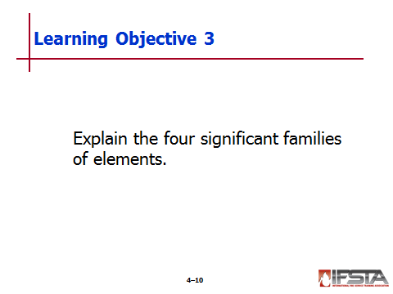
Group I – The Alkali Metals

Include

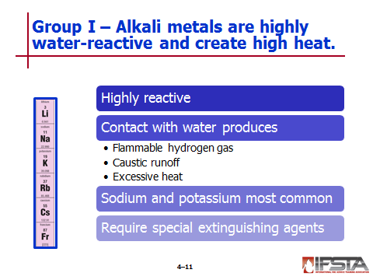
Lithium
Interactive slide; use mouse to show all information

Sodium

Potassium

Rubidium

Cesium

Francium

Highly reactive; reactivity increases with elements lower down column

Produce flammable hydrogen gas, strong caustic runoff, and excessive heat when coming in contact with water

Most common – Sodium and potassium

Very water-reactive, enough to ignite the hydrogen spontaneously if exposed to moist air

Small pieces of sodium will move quickly on top of water, while larger pieces will explode

Usually stored under kerosene or in vacuum-packed containers to prevent exposure to air or water

Contact between these metals and water separates or disassociates the water molecules, allowing other compounds to be formed from individual elements

Reaction with water is so violent that it generates enough heat to melt metal, ignite by-products, and ignite nearby combustibles

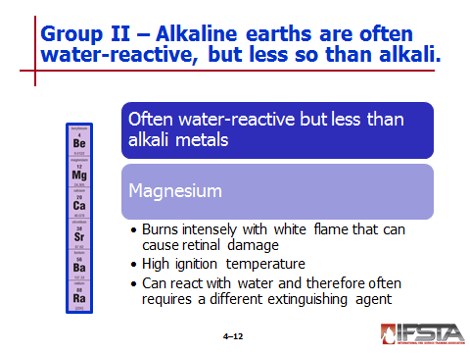
Require special extinguishing agents
Interactive slide; use mouse to show all information

Group II – The Alkaline Earths

Include

Beryllium

Magnesium

Calcium

Strontium

Barium

Radium

Often water-reactive, though less so than alkali metals

Magnesium

Burns very intensely with such bright white flame that staring at it can cause retinal damage

Has ignition temperature of 1202°F (650°C); does not ignite easily

Risk of ignition increases in proportion with amount of surface area exposed to air

Powder can explode on contact with water depending on how oxidized the metal is

Very water-reactive when burning

Water as extinguishing agent intensifies fire

Solid blocks on fire can be flooded with large amounts of water, but most fires require application of special extinguishing agents

Group VII – The Halogens

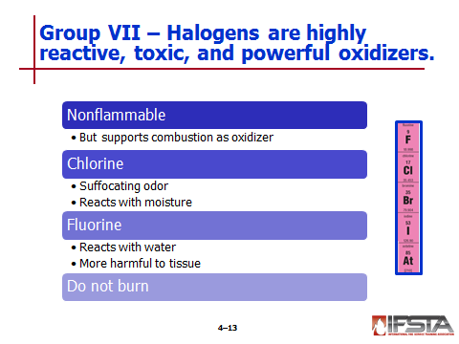
Include
Interactive slide; use mouse to show all information

Fluorine

Chlorine

Bromine

Iodine

Astatine

Highly reactive and toxic

Nonflammable, but powerful oxidizers that support combustion

Chlorine – Most common

Easy to recognize by suffocating odor

Gas reacts with moisture in respiratory system to form corrosive hydrochloric acid and hypochlorous acid

Reacts similarly with moisture on skin; chemical protective clothing more appropriate than structural fire fighting clothing

Fluorine

Reacts with water to form hydrofluoric acid and hydroflourous acid

Even more destructive to human tissue

Do not burn – Such powerful oxidizers that fires can burn intensely in presence even when no oxygen is present

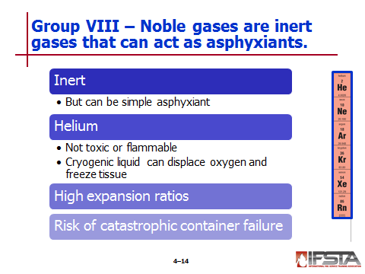
Group VIII – The Noble Gases
Interactive slide; use mouse to show all information

Include

Helium

Neon

Argon

Krypton

Xenon

Radon

Inert gases – nonreactive but simple asphyxiants that are often stored and transported as cryogenic liquids

Helium

Not toxic or flammable

Will not react with other materials

Uncontrolled release can still cause significant problems

Displaces oxygen when expands to fill enclosed space

Can asphyxiate anyone who is unable to get an adequate supply of fresh air

Often transported as cryogenic liquid – those colder than -130°F (-90°C)

Can cause immediate and severe damage to human tissue due to extreme cold

Have high expansion ratios; create significant risk of oxygen displacement

Risk of catastrophic container failure in event of fire or other scenario where product temperature is elevated beyond capacity of pressure-relief devices
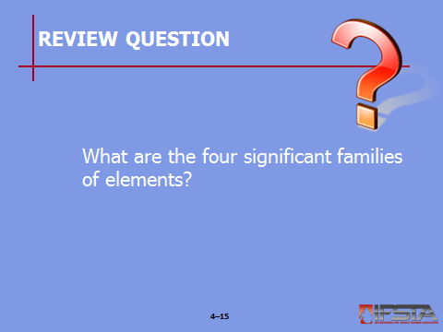
Review Question: What are the four significant families of elements?
See p. 147 of the manual for answers.

Section IV: Matter

matter
pp. 156-164 Objective 4 – Describe matter.

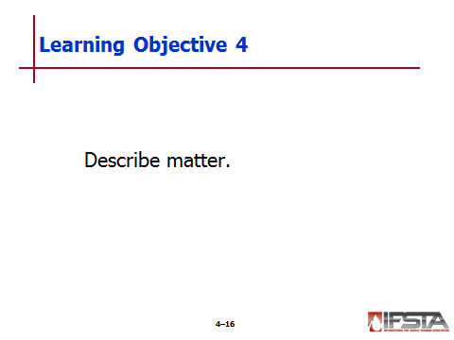
Matter

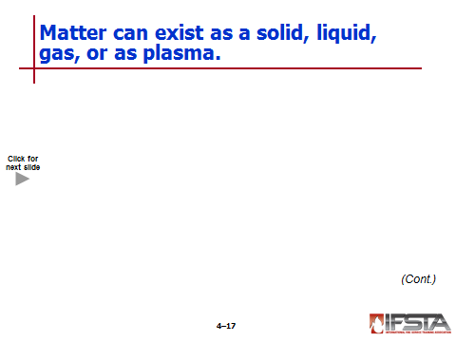
Three primary states – Solid, liquid, gas
Interactive slide; use mouse to show all information

Fourth state – Plasma

Begins as gas

Gas is modified at atomic level by application of energy, often in form of electricity

Extra energy applied to gas causes some electrons to break away from atoms, leaving atmosphere of free electrons and positively and negatively charged particles

Result – Glowing gaseous mass called plasma

Some can exist in different states

Can exist in multiple states at same hazardous materials incident
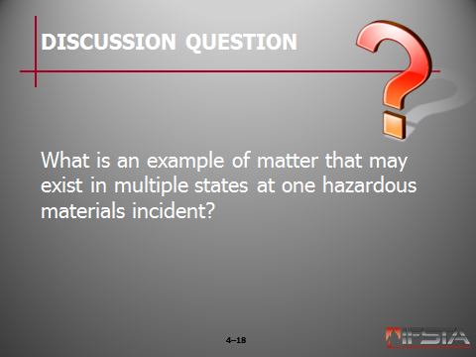
Ask Students: What is an example of matter that may exist in multiple states at one hazardous materials incident?

Briefly discuss answers with students. Discuss the ways in which matter may change from state to state during the course of a hazardous materials incident.

Can be classified into mixtures and pure substances

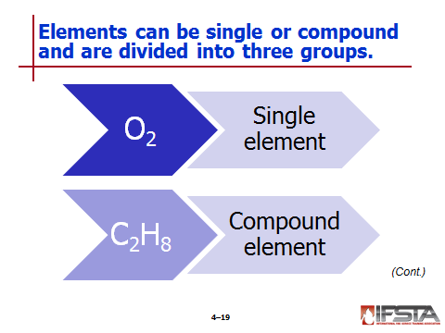
Elements

Single element

Cannot be broken down into anything simpler

Represented by single capital letter or capital letter followed by lowercase letter

Compound element

Comprised of two or more elements chemically bonded to form molecule

Can be broken down to release simpler substances

Represented by formulas showing multiple elements

May contain numbers – Indicates that more than one atom of same element is present

Exception – Elements

Can exist as diatomic molecules

Must be recognized as elements

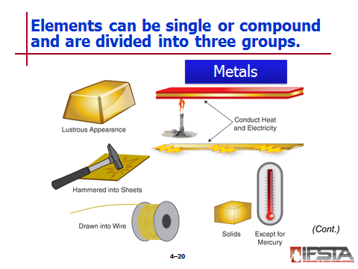
Metals and nonmetals

Metals

Have characteristic lustrous appearance

Good conductors of heat and electricity

Can be hammered to form sheets

Can be drawn into wires

Most are solids in natural states

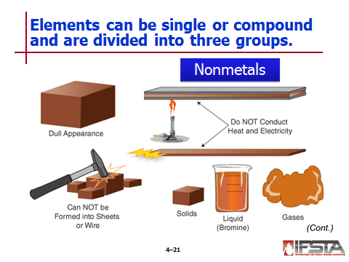
Nonmetals

Typically do not have lustrous appearance

Not good conductors of heat and electricity

Cannot be formed into sheets or wire

Either solids or gases

Separated on periodic table

Some do not fit classic profile of either
Instructor Note: It is important to remind students that any discussion of metals and nonmetals must be considered a generalization because exceptions sometimes apply. It is essential to check reference sources at a hazardous materials incident rather than rely solely on one’s knowledge of chemistry.

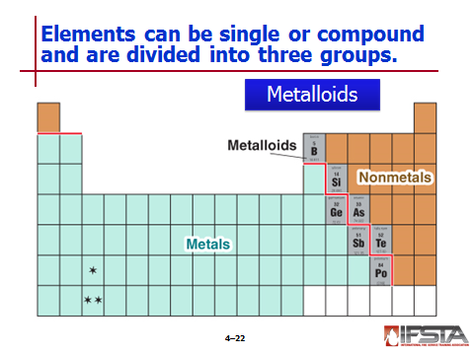
Metalloids

Elements that have properties between obvious metals and obvious nonmetals

Can donate or receive and have properties common to both metals and nonmetals

Can form alloys with metals

Compounds

Substances that are made up of two or more elements
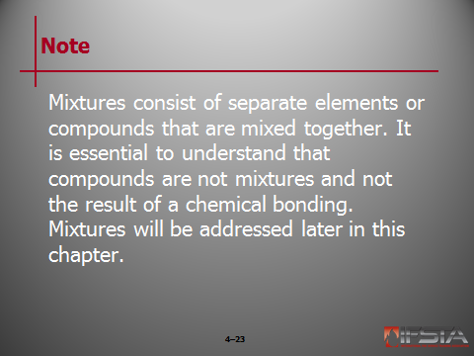
Note: Mixtures consist of separate elements or compounds that are mixed together. It is essential to understand that compounds are not mixtures and not the result of a chemical bonding. Mixtures will be addressed later in this chapter.

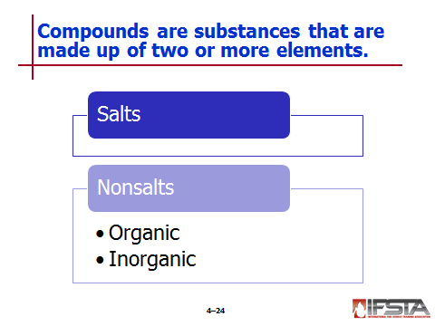
Salts

Comprised of metal element bonded to one or more nonmetal elements

Most are solids

Generally do not burn with flame, though some may undergo smoldering combustion

Most dissolve in water or react with water

Many are very toxic

Most will conduct electricity when dissolved in water

Many can stimulate combustion

Formed through ionic bonding

Metals give up electrons

Nonmetals accept electrons

Binary salts

Comprised of metal and nonmetal as long as nonmetal is not oxygen

Naming – Metal will always be named first with nonmetal following; nonmetal name will be altered to end in different suffix

Can have wide-ranging hazards

May be reactive with water

Nonsalts

Organic – Comprised of hydrocarbon and hydrocarbon derivatives

Inorganic

Most are liquids and gases with very few being solid

Tend to be toxic and poisonous

Many have corrosive and/or flammability properties

Naming – One nonmetal will fall first with suffix “ide”

Hazards are far ranging

Highly water reactive

Highly toxic

Flammable

Oxidizing capabilities

Corrosive properties

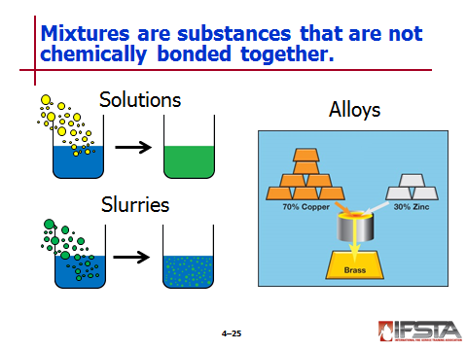
Mixtures

Consist of two or more substances that are physically mixed, but not chemically bonded to one another

Common examples

Can vary from one sample to another

Solutions

Mixture in which all ingredients are completely dissolved

Often assumed to be liquids because many are; solids and gases can also be solutions

Some are easily separated into component parts

Most do not separate easily

Heat normally increases solubility

Heat decreases solubility with gases dissolved into liquids

Slurries

End result when material cannot totally dissolve in water

Suspension of insoluble particles, usually in water

Pourable mixture of solid and liquid

Examples

Alloys

Mixture of two or more metals

Create material stronger or better for particular application than one metal alone

Examples

Brass: 70% copper (Cu) and 30% zinc (Zn)

Bronze: 90% copper (Cu) and 10% tin (Sn)

Solder: 70% lead (Pb) and 30% tin (Sn)

Titanium alloy: 90% titanium (Ti), 5% aluminum (Al), and 5% vanadium (V)

Duraluminum: 94% aluminum (Al), 4% copper (Cu), and 1% magnesium (Mg)

Sometimes contain small percentage of nonmetal elements

Review Question: What is an example of matter that can exist in different states?
See p. 157 of the manual for answers.

Section V: Bonding

bonding
pp. 164-170 Objective 5 – Explain the concept of bonding.

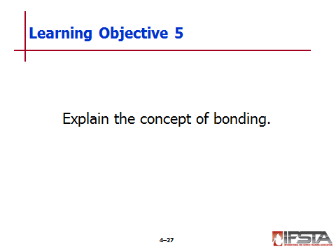
The Octet/Duet Rule

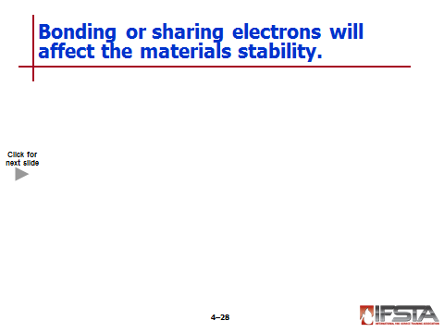
All atoms must have equal number of protons and electrons to be electrically neutral
Interactive slide; use mouse to show all information

An atom must have a completely filled outer shell to be stable

Two electrons on hydrogen and helium

Eight electrons on all others

Exceptions to bonding process – Noble gases

Already have filled outer shell

Inert and have no reason to react with other elements

Inert does not necessarily mean harmless; are simply asphyxiants

Not normally available to bond

Most elements are available to bond or share their electrons because their outer shells are not filled to the maximum

Elements must bond or share with others to create filled outer shell

Duet rule – Hydrogen only has one shell, it must obtain one more electron for a total of two

Octet Rule – All others will attempt to achieve eight electrons on their outer shells

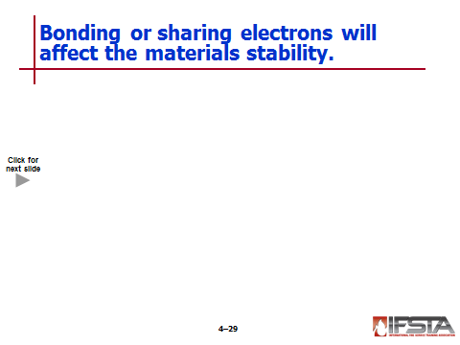
Stability of Elements and Compounds
Interactive slide; use mouse to show all information

Stability

Elements possessing filled outer shells

It is this need that causes elements to react (bond) with one another chemically

Unstable compounds

Very sensitive to heat, shock, friction, or contamination and often decompose violently

Do not need to mix with other chemicals or be contaminated by other chemicals to react

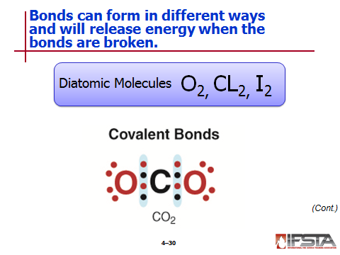
Diatomic Molecules (Compounds)

Gases that exist as a compound of two identical atoms

Not limited to gases

Covalent bond – When electrons are shared between atoms

Ionic bond – When electrons are transferred from one atom to another

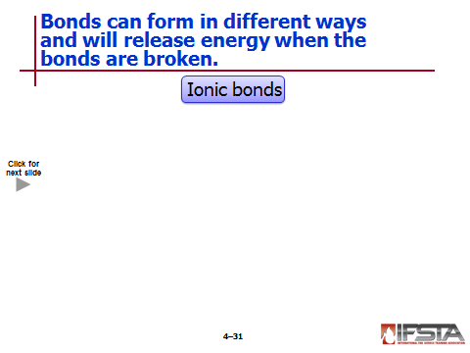
Ionic Bonds
Interactive slide; use mouse to show all information

Formed by transfer of electrons from a metal element to a nonmetal element

Example – Sodium chloride

Sodium “donates” the one electron on its outer shell, essentially shedding its outer shell and exposing a filled shell beneath it

Chlorine “accepts” the donated electron from the sodium atom, ending up with a filled outer shell

While two elements are now stable, they are no longer electrically balanced

Sodium has one more proton than electrons

Chlorine has one electron more than protons

Atoms that have gained or lost electrons are no longer atoms; they are ions

Cation – An ion with more protons than electrons has a net positive charge

Anion – An ion with more electrons than protons has a net negative charge

Oppositely charged ions attract each other, forming the bond that holds them together

Results in a salt

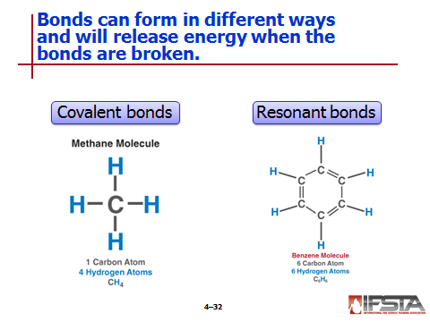
Covalent Bonds

Formed between two or more nonmetal elements

Elements involved share electrons rather than transfer them

Their outer shells overlap to the point that electrons seem to belong to each atom at the same time

Results in a nonsalt

Many covalent compounds are comprised of nonmetal elements only

Some may be organic metallic compounds

The majority consist solely of carbon, hydrogen, and oxygen in various combinations

Of those that contain others, most are limited to nitrogen, phosphorus, sulfur, silicon, and the halogens

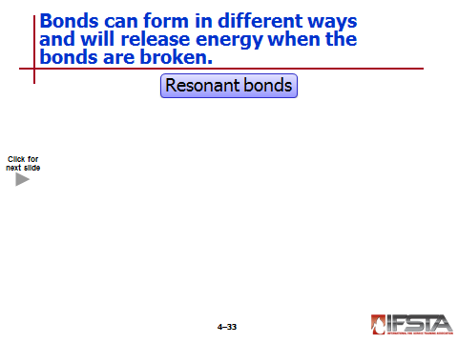
Resonant Bonds
Interactive slide; use mouse to show all information

Resemble covalent bonds in that electrons are shared between elements

Electrons rotate or alternate very rapidly between carbon atoms

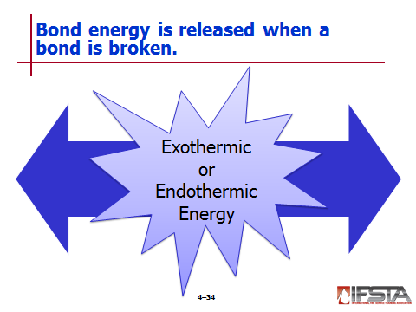
Bond Energy

Amount of energy stored in a bond; measure of strength of connections between atoms in a chemical bond

Released when bond is broken

Amount of energy released will depend on number and type of elements that comprise bond and what causes bond to be broken

Some can release tremendous amount of energy when bonds are broken

Most are exothermic (generate heat) and some are enough to ignite a fire

Others are endothermic (absorb heat)

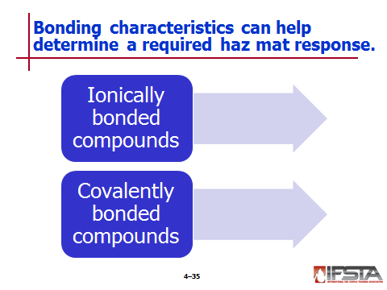
Bonding in Haz Mat Response

Characteristics of ionically bonded compounds

Are solid

Have limited to no vapor

Do not have flash point

Do not have lower explosive limit

Do not polymerize

May form caustic or basic solutions

May be air or water reactive

Are generally not seen by infrared spectroscopy and/or PID

Characteristics of covalently bonded compounds

Are solids, liquids, and gases

Produce vapors

Have flash points

Have lower explosive limits

Can polymerize

May be seen by infrared monitoring spectroscopy and/or PID
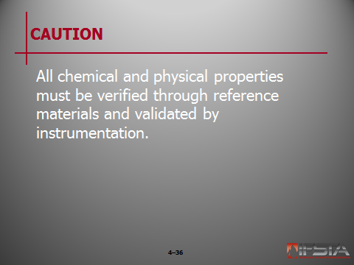
CAUTION: All chemical and physical properties must be verified through reference materials and validated by instrumentation.

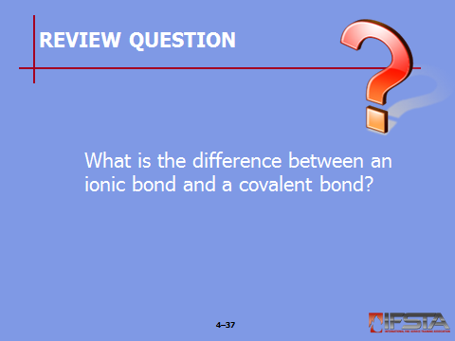
Review Question: What is the difference between an ionic bond and a covalent bond?
See pp. 166-168 of the manual for answers.

Section VI: Reactions

reactions
pp. 170-176 Objective 6 – Explain the various types of reactions.

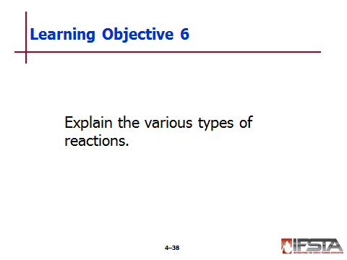
Reactions

Require energy changes in order to occur

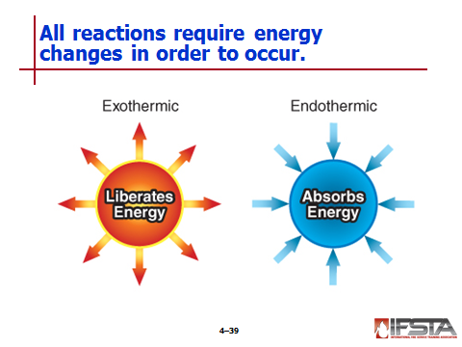
Majority liberate energy as heat and sometimes heat, light, and sound (exothermic)

In minority, energy is absorbed into products (endothermic)

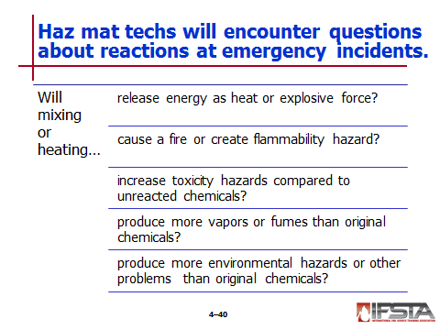
Questions that arise

Will the mixing or heating of these chemicals cause the release of large amounts of energy as heat or with explosive force?

Will the mixing or heating of these chemicals cause a fire or will it generate a greater flammability hazard than that found with the same chemicals without a chemical reaction?

Will the mixing or heating of these chemicals increase the toxicity hazards at the scene compared to the toxicity of the unreacted chemicals?

Will the mixing or heating of these chemicals form products with more vapors and/or fumes than the original chemicals?

Will the products formed by the mixing or heating of these chemicals create additional environmental hazards or problems beyond those from the unreacted chemicals?

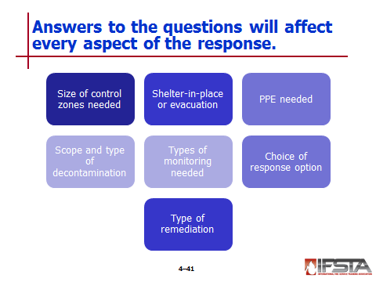
The answers to these questions will determine every aspect of emergency response including

Size of the control zones needed – especially the size of the Hot Zone

Whether a shelter-in-place or civilian evacuation is appropriate

Choice of PPE needed for a safe response

Scope and type of decontamination used

Type of air and environmental monitoring needed

Choice of response option chosen to yield a positive impact on situation

Type of remediation that will be needed to limit both long- and short-term environmental damage

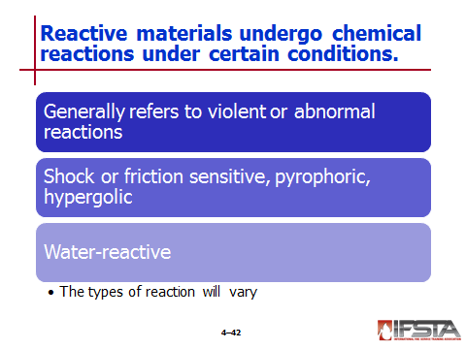
Reactive material

One that can undergo chemical reaction under certain specified conditions

Generally used to refer to substance that can undergo violent or abnormal reaction in presence of water, air, or under normal ambient conditions

Could be shock or friction sensitive, pyrophoric, or hypergolic in nature

Water-reactive materials

React on contact with water; may react mildly or severely

Defined by gases they give off – Toxic, corrosive, or flammable

Results of reactions can be explosive and may result in very corrosive solution

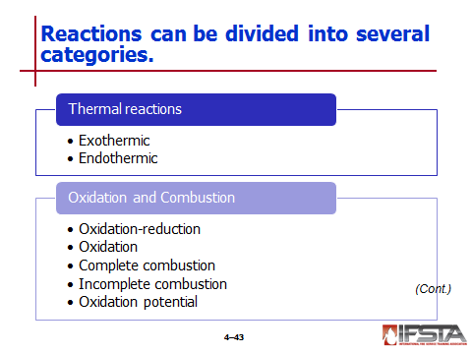
Exothermic and Endothermic Reactions

Exothermic reaction

Can be most dangerous because of potential for fire or explosion

Slows and eventually stops as heat is removed

Endothermic reaction

Requires separate source of heat to maintain

Slowed by adding heat

Oxidation and Combustion

Oxidation-reduction reaction

Electrons are transferred from one atom, compound, or molecule to another

Involves simultaneous loss and gain of equal number of electrons

Neither reaction can happen without the other

Reducing agent – Substance that loses electrons

Oxidizing agent – Substance that gains electrons

Strong – Substances that either give up or gain electrons easily

After transfer has taken place

Oxidizing agent has been reduced

Reducing agents has been oxidized

Oxidation

Chemical combination of oxygen (or another oxidizer) with another substance

Can vary in speed from very slow to very fast

Complete combustion – Oxidation-reduction reaction with adequate oxygen to produce a substance that will not burn

Incomplete combustion – Oxidation-reduction reaction in which inadequate oxygen supply results in substance that is flammable and will propagate combustion process

Oxidation potential – Material’s propensity to give up oxygen atoms, making them available to react with other substances

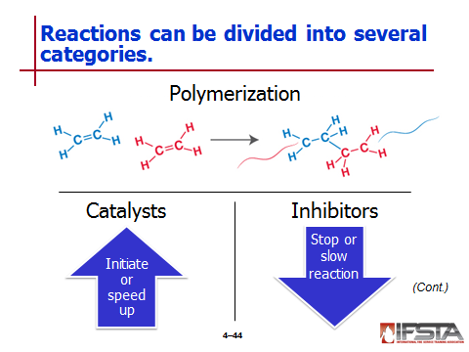
Polymerization

Special chemical reaction in which small compounds called monomers react with themselves to form larger molecules called polymers

Ethylene

Most common of all monomers

In natural state has double bond between two carbon atoms; not as stable as single bond

Prone to polymerization on its own

Creating polyethylene

Manufacturers initiate chemical reaction through careful application of heat, pressure, and catalyst

Reaction breaks one bond between carbon atoms, leaving single bond in place of double bond and open bond on either side

Open bonding sites create very unstable situation that nature does not allow to exist for very long

Incomplete molecules combine to create more stable compounds

Different polymers can be created by varying monomer used and rate of reaction

Because polymers are not as dense as monomers, they take up more space

Reaction generates heat

Heat and overpressurization can cause catastrophic container failure in uncontrolled or runaway polymerization
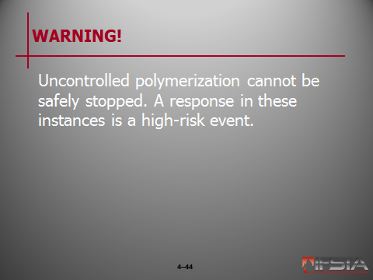
WARNING! Uncontrolled polymerization cannot be safety stopped. A response in these instances is a high-risk event.

Catalysts

Initiates polymerization process

Substances added to other products either to initiate or to speed up chemical reactions

Not used up in reaction

May sometimes be recovered and reused

If used improperly, can increase speed of reaction beyond point where container can withstand buildup of pressure and heat

Inhibitors

Sometimes referred to as stabilizers or negative catalysts

Added to other products to stop or slow reaction such as to prevent uncontrolled polymerization

Have limited shelf life; will not stop or slow reaction indefinitely

If allowed to degrade, to escape, or to drop below necessary concentration, the resulting polymerization may cause catastrophic container failure

If not added where needed, can cause disaster

Different amounts may be found in storage tanks and shipments of same product

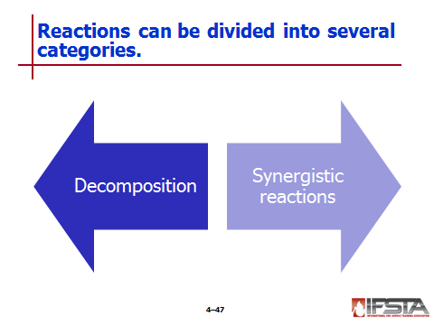
Decomposition

Sometimes referred to as analysis or breakdown reaction

One of most common types of chemical reactions

When occurs, compound is broken down into smaller components

Often undesired chemical reaction that can be extremely violent or not even noticeable depending on chemical

Example – Electrolysis of water

Synergistic Reactions

Interaction between two or more individual compounds that produce effect different from original starting materials

Will make end product greater as whole than individual compounds

Usually thought of as two or more items working together in tandem, but effects may not always be desired

Example – Mixing household bleach and household ammonia to create chloramine

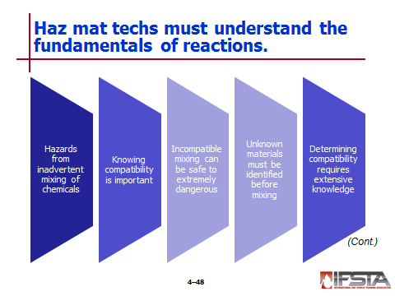
The Fundamentals of a Reaction

Many hazardous situations involve inadvertent mixing of chemicals

Knowing compatibility of materials being mixed is important

If materials incompatible, results could range from formation of innocuous gas or liquid to violent explosion to one involving very toxic reaction products

Unknown materials must be identified before compatibilities can be determined

Determining compatibility of more than two reactants is very difficult and requires extensive knowledge of chemistry
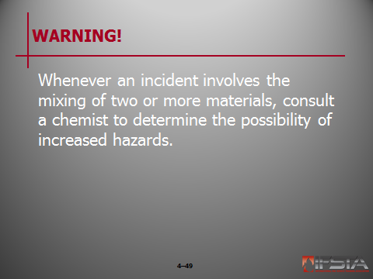
WARNING! Whenever an incident involves the mixing of two or more materials, consult a chemist to determine the possibility of increased hazards.

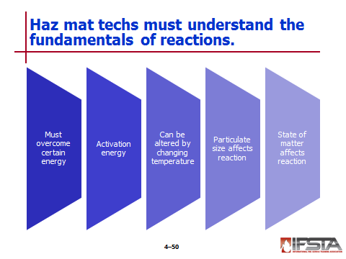
For chemical reaction to occur, certain amount of energy must be overcome

Activation energy

Minimum amount of energy needed to start chemical reaction

If chemical reaction is stopped from reaching, reaction may stop or slow down

Inhibitors increase by slowing down polymerization process

Catalysts decrease, speeding up reaction

Chemical reaction may be altered by changing temperatures of chemicals involved

If cooling occurs, reaction will likely slow down

If temperature of chemical compounds increases, reaction rate will increase as well

Rough rule of thumb – For every 50°F (10°C) a compound’s temperature increased, reaction rate will double

Particulate size affects chemical reaction – The smaller the particle, the faster the reaction and vice versa

State of matter can affect reaction

In most cases – Solid has much slower reaction rate than liquid

Gases have faster reaction rates – Depending on density, concentration
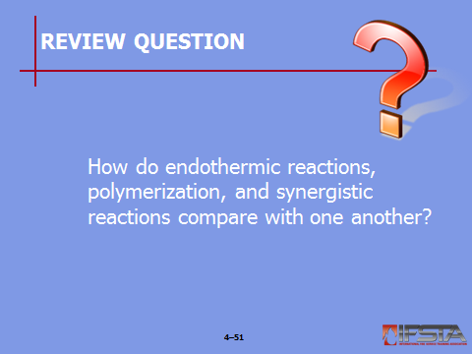
Review Question: How do endothermic reactions, polymerization, and synergistic reactions compare with one another?
See pp. 171-174 of the manual for answers.

Section VII: Common Families of Hazardous Materials

common families of hazardous materials
pp. 176-186 Objective 7 – Describe common families of hazardous materials.

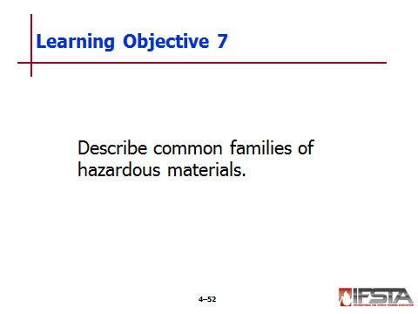
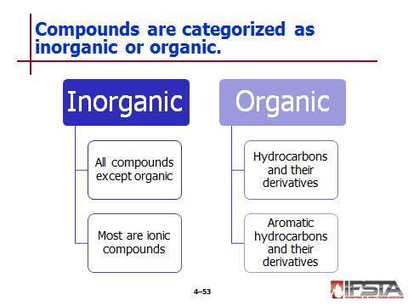
Inorganic Compounds

Inorganic chemistry

Concerned with properties and behavior of inorganic compounds

Covers all chemical compounds except organic compounds

Many can be considered ionic compounds that are joined by ionic bonding

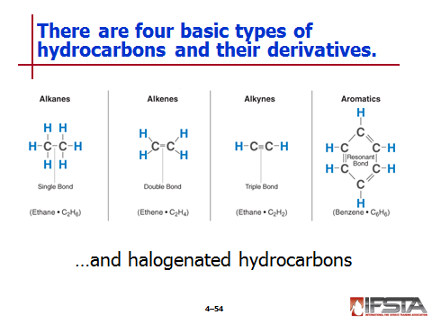
Organic Compounds

Hydrocarbons and their derivatives

Hydrocarbons – Compounds that consist solely of hydrogen and carbon

Hydrocarbon derivatives – Compounds derived from hydrocarbons

Characteristics

All hydrocarbons are either flammable or combustible, depending on flash point

All are toxic to some degree

All are insoluble in water and will float on the surface

Properties directly related to molecular size

Chemical behavior affected by types of bonds between carbon atoms

Four basic types

Alkanes

Most relatively stable

Have single bonds between carbon atoms

Examples

Alkenes

Less stable than alkanes

Prone to polymerization

Have at least one double bond between carbon atoms

Example

Alkynes

Highly unstable

Have explosive potential

Have at least one triple bond between carbon atoms

Example

Aromatics

Have a ring structure with resonant bonds

Example

Most very stable even though they appear to have three double bonds because the electrons actually resonate between carbon atoms in resonant bonds

Fairly toxic

Some carcinogenic

Typically burn with sooty smoke that often gives appearance of spider web

Important to remember that these are only generalizations

Halogenated hydrocarbon

Alkane, alkene, alkyne, or aromatic that contains halogen

Typically more toxic than parent materials

Many do not have flash points because halogen suppresses flashing of materials

Some may have explosive ranges

When combust, release toxic acid gases and potentially other extremely toxic materials such as phosgene
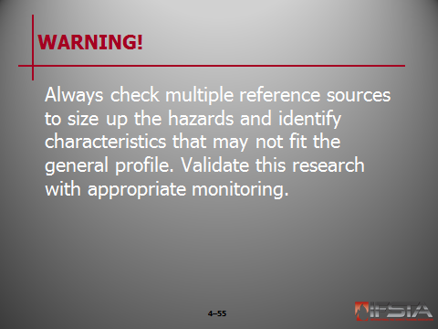
WARNING! Always check multiple reference sources to size up the hazards and identify characteristics that may not fit the general profile. Validate this research with appropriate monitoring.

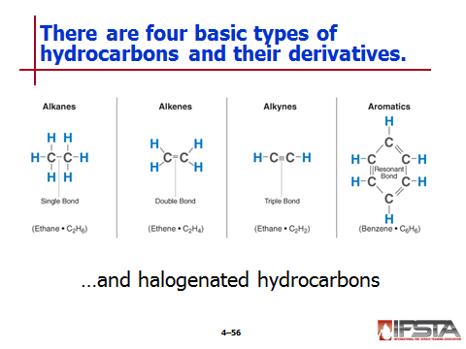
Aromatic hydrocarbons and their derivatives

Have benzene-like structure

Examples

Benzene

Toluene

Xylene

Styrene

Cumene

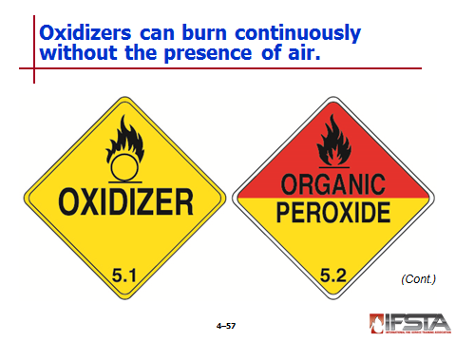
Oxidizers

Can be broken down into different families

Some are stable while others can be very unstable

Do not burn, but can make fire burn hotter and faster

Have ability to burn continuously without air being present because they produce oxidizing capabilities

May be explosive

Inorganic peroxides

Can act as both oxidizer and corrosive

Example – Hydrogen peroxide

May have ability to not only combust, but may even explode in absence of air

Organic peroxides

Unique elements

Typically contain both O-O which supplies oxygen and part that can act as fuel in molecular structure

Just small amount of heat may be needed to create fire or explosion

Common uses – Catalysts and/or initiators for polymerization reaction

May be liquids or solids

May be dissolved in solvent

Often shipped refrigerated and stored in cold storage cabinets
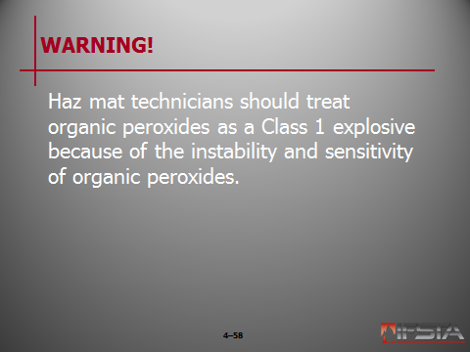
WARNING! Haz mat technicians should treat organic peroxides as a Class 1 explosive because of the instability and sensitivity of organic peroxides.

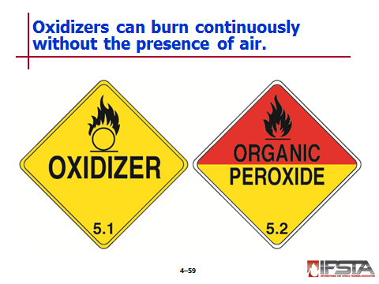
Chlorates and perchlorates

Unstable molecules containing excess oxygen

Not flammable, but will decompose rapidly when subjected to heat

When decomposed, release oxygen and support rapid burning in any nearby combustible material

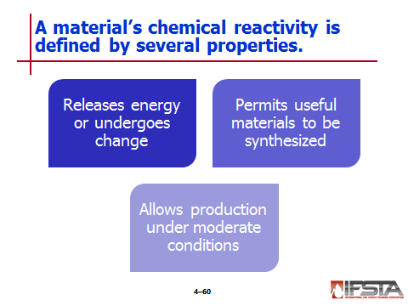
Reactive Materials

Chemical reactivity

Material’s propensity to release energy or undergo change either on its own or in contact with other materials

Highly desirable trait that permits wide variety of useful materials to be synthesized

May allow products to be made under moderate conditions of pressure and temperature, saving energy and reducing risks of working with high pressure and temperature equipment

Reactivity – Tendency of material or combination of materials to undergo chemical change under right conditions

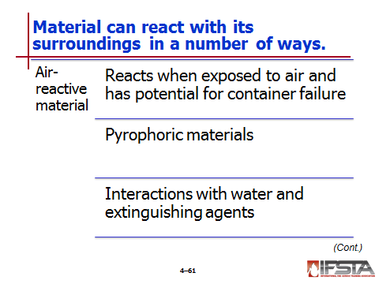
Air-reactive materials

Ignite, decompose, or otherwise release energy when exposed to air

Can react quite violently

Have potential of container failure due to overpressurization

Pyrophoric materials

Those that react in dry air; those that react with moist air may be water-reactive

May also be reactive to moist air

Should be assumed to also be water-reactive until determined otherwise

When air-reactive but not water-reactive, may be stored under water to prevent contact with air

If also water-reactive, must be stored under some other substance

When burning, any extinguishing agent that excludes air should be effective
Instructor Note: Remind students that some pyrophoric materials are also water-reactive. It is vitally important that hazardous materials technician check available reference sources to determine appropriate extinguishing agents for the substance(s) involved.

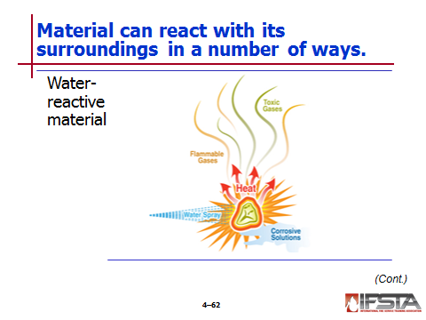
Water reactive

Tendency of material to react, or chemically change, upon contact with water

Reactions range from mild to severe

Reactions and by-products will vary depending on materials involved

Consequences

Flammable gases

Hydrogen gas often created when hydrogen atoms that are liberated from water molecules are separated by reaction

Other possibilities – Acetylene gas, methane gas

Heat

Water reactions exothermic

Reaction that generates own heat and flammable gases while liberating extra oxygen upon contact with water has all four parts of fire tetrahedron in place

May create extra risk of steam explosion if water used as extinguishing agent

Corrosive solutions – When metals react with water, frequently combine with oxygen and hydrogen from water molecules to form highly caustic solutions

Toxic gases – Many reactions produce gases that are irritating or toxic

When present, must consider all different ways substances may come in contact with moisture; can cause serious injury

Fires some of most challenging to handle

If small, may be able to control with specially formulated dry powders

May be extinguished with dry sand
Instructor Note: Refer students to the safety box on p. 184 of the manual titled “Extinguishing Metal Fires.”
Discuss the risks of using ordinary extinguishing agents on combustible metal fires.

May be effectively extinguished with automatic flooding systems that fill area with inert gas

Best course for large fires – Isolate area, protect exposures, allow fire to burn until all fuel has been consumed

Using water not always out of the question

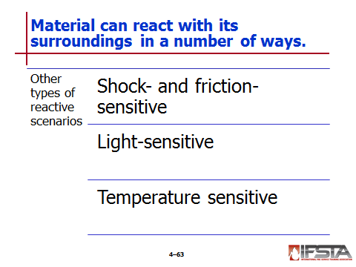
Shock- and friction-sensitive materials

Potentially explosive materials

Can be extremely sensitive to heat or shock

May decompose violently if struck or heated

Examples

Light-sensitive chemicals

Have ability to change composition if exposed to natural light

Changes will lead to less stable substance that may be more dangerous than original compounds

Examples

Temperature sensitive

May decompose based on temperature

If not stored properly, may break down and decompose

May react mildly or violently

Some very sensitive to high temperatures, some to low temperatures

Self-Accelerating Decomposition Temperature (SADT)

Temperature above which decomposition of unstable substance continues unimpeded, regardless of ambient or external temperature

Means lowest temperature at which self-accelerating decomposition may occur for substance in packaging as used in transport

Maximum safe storage temperature

Maximum safe temperature at which a product can be stored

Well below SADT

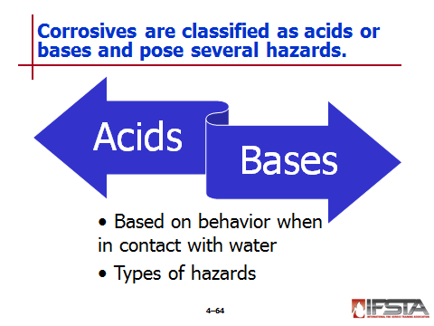
Corrosives

Classified as acids or bases based on chemical behavior when in contact with water

Acid – Those compounds that release hydronium ions when dissolved in water (called dissociation)

Bases

Release hydroxide ions when dissolved in water

Cannot see – Detect by measuring pH

Have variety of hazards

Human tissue

Acid – Causes tissue to harden even as it eats away at tissue, limiting damage to some degree

Base – Softens and dissolves tissue, creating far more penetrating and severe injuries

In both, damage continues until corrosive is thoroughly flushed from body

Often produce immediate irritation
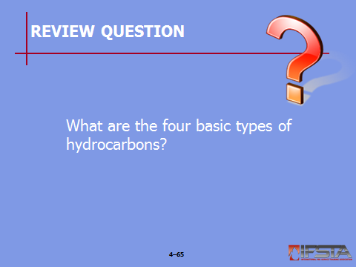
Review Question: What are the four basic types of hydrocarbons?
See pp. 178-179 of the manual for answers.

Section VIII: Special Hazards of Chemicals and Weapons of Mass Destruction

special hazards of chemicals and weapons of mass destruction
pp. 186-194 Objective 8 – Identify special hazards of chemicals and weapons of mass destruction.

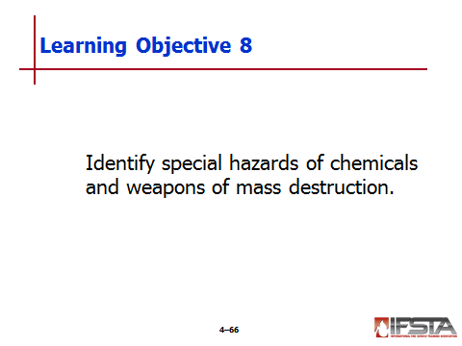
Chemical Warfare Agents

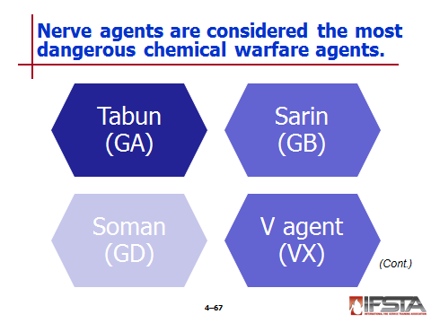
Nerve agents

Similar to organophosphate pesticides in chemical makeup and way in that they attack nervous system and cause uncontrolled muscular contracts

100 to 500 times more potent than pesticide formulated materials

Exposure to even minute quantities can kill very quickly

Considered most dangerous of chemical warfare agents

Common ones

Tabun (GA)

Sarin (GB)

Soman (GD)

V agent (VX)
Note: “G” stands for Germany, the country where the first three agents were developed. “V” stands for venom.

Liquids at ambient temperatures

Generally clear and colorless; can vary with impurities

May have slight odors due to impurities

G agents

Volatile and nonpersistent

Less volatile than water

Sometimes made more persistent by adding various thickeners

Vapors of all four agents – Heavier than air

Vapors will not travel far under normal conditions

Vapor hazard can increase if liquid exposed to high temperatures, spread over large area, or aerosolized

Usually enter body through inhalation of vapors

Also toxic by eye absorption, skin absorption, or ingestion

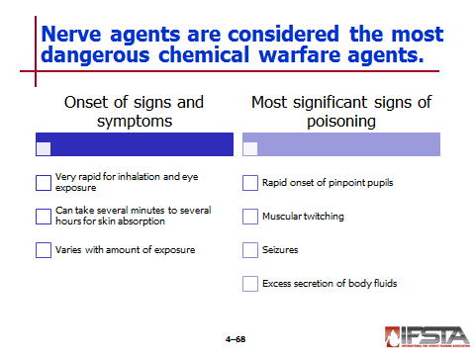
Onset of signs and symptoms

Very rapid for inhalation and eye exposure

Can take several minutes to several hours for skin absorption

Varies with amount of exposure

Most significant signs of poisoning

Rapid onset of pinpoint pupils

Muscular twitching

Seizures

Excess secretion of body fluids
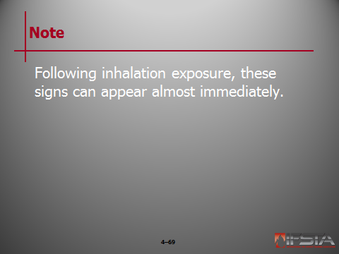
Note: Following inhalation exposure, these signs can appear almost immediately.

Instructor Note: Refer students to the information box titled “SLUDGEM and DUMBELLS” on p. 188 of the manual. Discuss with students the acronyms often used to remember the symptoms of exposure to chemical warfare agents.

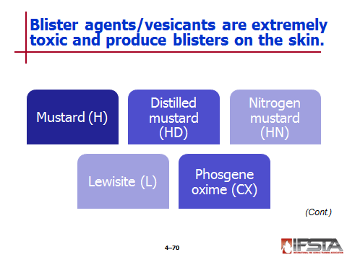
Blister agents/vesicants

Also known as mustard agents or vesicants

Extremely toxic chemicals that produce characteristic blisters on exposed skin

Common types

Mustard (H)

Distilled mustard (HD)

Nitrogen mustard (HN)

Lewisite (L)

Phosgene oxime (CX)

Mustards

Oily liquids that vary greatly in color, depending on purity

May be odorless or may smell like mustard, onion, or garlic

Lewisite

Oily liquids that vary greatly in color, depending on purity

Reportedly smells like geraniums

Phosgene oxime

Colorless crystalline solid

Can also be found as yellowish-brown liquid

Has intense, irritating odor

All are relatively persistent; can take several days or weeks to evaporate

Difficult to remove during decontamination due to oily consistency

Extremely toxic

Many are carcinogenic

Primary routes of entry – Inhalation and absorption

Can easily penetrate clothing and are quickly absorbed through skin

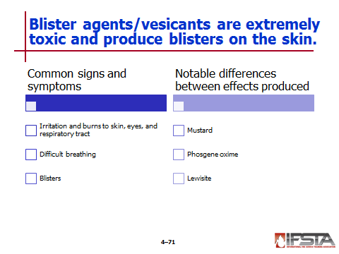
Common signs and symptoms

Irritation and burns to skin, eyes, and respiratory tract

Difficult breathing

Blisters

Notable differences between effects produced

Mustard

causes tissue damage almost immediately after exposure

Clinical effects delayed from two to twenty-four hours, with four to eight hours being most common

Phosgene oxime

Causes immediate pain or irritation to skin, eyes, and lungs

Skin lesions look more like gray hives than blisters

Causes more severe tissue damage than other blister agents

Lewisite

Effect felt within seconds to minutes after exposure

Irritation to eyes, skin, and mucous membranes may initially resemble effects of riot control agents

Pain is more severe and will not decrease upon moving patient to fresh air

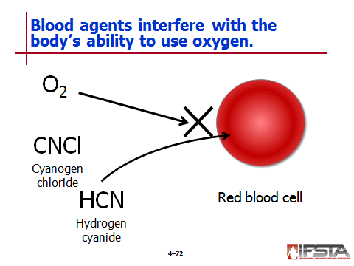
Blood agents

Interfere with body’s ability to use oxygen either by preventing red blood cells from carrying oxygen to other cells in the body or by inhibiting ability of cells to use oxygen for producing energy required for metabolism

Most common

Hydrogen cyanide

Cyanogen chloride

Very volatile, nonpersistent, colorless liquids under pressure

Produce odor of bitter almonds or peach kernels; at least 40% of population is genetically unable to smell odor

Primary route of entry – Inhalation

Can be absorbed through skin or eyes

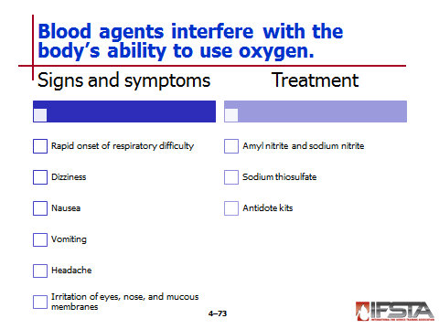
Cause rapid onset of respiratory difficulty, ranging from initial gasping and rapid breathing to subsequent respiratory arrest if exposed to higher concentrates

Other signs and symptoms

Dizziness

Nausea

Vomiting

Headache

Irritation of eyes, nose, and mucous membranes

Can produce seizures

Exposure to cyanide may cause abnormally red skin

Specific treatment

Amyl nitrite and sodium nitrite to draw cyanide out of cells of body

Sodium thiosulfate to detoxify cyanide and help remove from body

Packaged together in cyanide antidote kits

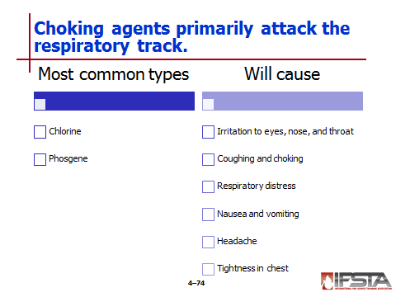
Choking agents

Those that primarily attack respiratory tract

Two most common cited in terrorism training

Chlorine

Phosgene

Will cause

Irritation to eyes, nose, and throat

Coughing and choking

Respiratory distress

Nausea and vomiting

Headache

Tightness in chest

Severe exposure can result in potentially fatal pulmonary edema

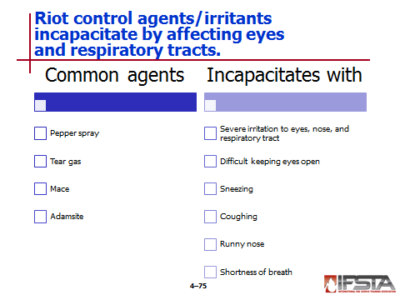
Riot control agents/irritants

Also known as irritants, irritating agents, or harassing agents

Cause temporary incapacitation by irritating eyes and respiratory system

Common agents

Pepper spray

Tear gas

Mace

Adamsite

Solids, dispersed as fine powder or aerosol

Some are sold in small containers as personal defense devices

Some contain dye to visually mark sprayed assailant

Quickly incapacitate person with

Severe irritation to eyes, nose, and respiratory tract

Difficult keeping eyes open

Sneezing

Coughing

Runny nose

Shortness of breath

Adamsite may cause nausea and vomiting

Exposure can trigger asthma attacks or other secondary problems

Primary route of entry – Inhalation; can also be absorbed through skin and eyes

Onset of symptoms usually occurs within seconds

Decontamination often limited to flushing eyes and washing parts of body affected

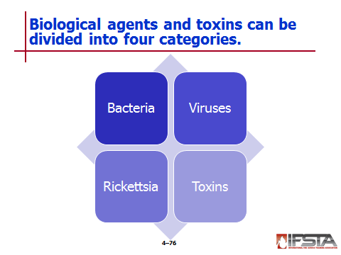
Biological Agents and Toxins

Bacteria

Single-celled living organisms capable of independent growth

Do not require living host in which to replicate

Many can be cultured in lab

Some have ability to form spores that can survive for long periods of time in conditions that would otherwise kill bacteria

Can produce extremely potent toxins inside body

Examples

Anthrax

Brucellosis

Cholera

Plague

Tularemia

Viruses

Not capable of basic metabolic functions necessary for independent growth

Require living cells in which to replicate

Examples

Smallpox

Venezuelan equine encephalitis (VEE)

Viral hemorrhagic fever (VHF)

Rickettsia

Microorganisms that have many characteristics of bacteria

Grow only within living cells

Example – Q fever

Toxins

Nonliving chemical compounds

Potent poisons produced by variety of living organism including bacteria, plants, and animals

Produce effects similar to those caused by chemical agents

Biological toxins – Far more toxic than industrial chemicals

Examples

Botulinum toxin (botulism)

Ricin

Saxitoxin

Staphylococcal enterotoxin B

Trichothecene mycotoxins

Can enter body through most normal routes of entry

Toxins not contagious; some bacteria and virus are

Pneumonic plague

Smallpox

Viral hemorrhagic fevers

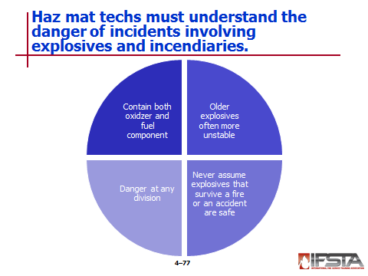
Explosives and Incendiaries

Any substance or article designed to function by explosion or that, by chemical reaction within itself, is able to function in similar manner

Range from being very sensitive to shock, heat, friction, or contamination to being relatively insensitive

Understanding the danger

Explosives are dangerous because they contain both oxidizer and fuel component

Older explosives should be met with extreme caution; often more unstable than those recently manufactured

Never safe to assume that explosives that survived flame impingement or transportation accident are unscathed

Danger at any division

Six divisions of explosives identified in U.S. Code of Federal Regulations, Title 49

Divisions established based on how explosives behave under normal conditions of transport

Responders must remember that all divisions will react very differently when exposed to fire

Many responders have been killed or injured because they underestimated hazard potential of relatively insensitive explosives

When explosives threatened by fire, little difference between six divisions

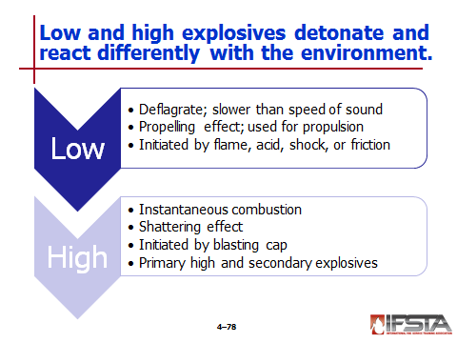
Types of explosives

Low explosives

Those that deflagrate – Very rapid combustion at rate slower than speed of sound

Examples

Black powder

Smokeless powder

Solid rocket fuel

Have “propelling” effect rather than “shattering” effect

Used primarily for propulsion

Can be initiated by simple flame or acid/flame reaction

Can be initiated by shock or friction

High explosives

Those that detonate – Instantaneous combustion, with speeds ranging from 3,300 to 29,900 feet (1 006 to 9 114 mps) per second

Have shattering effect

Must be initiated by shock of blasting cap

Categories – Based on sensitivity to shock, friction, flame, heat, or any combination of these factors

Primary high explosives
            - Extremely sensitive and very hazardous to handle
            - Mostly used to initiate secondary explosives
            - Examples – Blasting caps, safety fuses filled with black powder, mercury fulminate, lead styphnate, lead azide

Secondary explosives

Much less sensitive, but far more powerful than primary explosives

Do the bulk of work after being initiated by shock from primary explosive

Examples – Dynamite, nitroglycerine, TNT, cylconite, and pentaerythrital tetranitrate

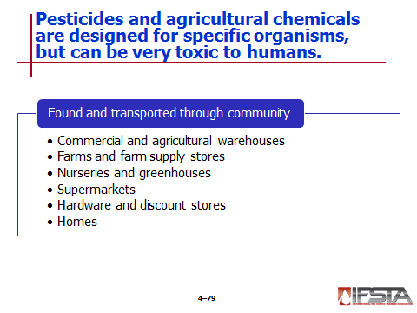
Pesticides and Agricultural Chemicals

Designed to kill specific target organisms, but can be very toxic to both humans and environment

Some so toxic that available only to trained and licensed applicators

Majority found throughout community

Commercial and agricultural warehouses

Farms and farm supply stores

Nurseries and greenhouses

Supermarkets

Hardware and discount stores

Homes

Transported throughout community in everything from large rail cars to small pickup trucks
Instructor Note: Remind students that pesticide is an umbrella term for a family of chemicals designed to kill specific target organisms.
Refer students to Tables 4.13 and 4.14 on p. 195 of the manual for some of the different kinds of pesticides.

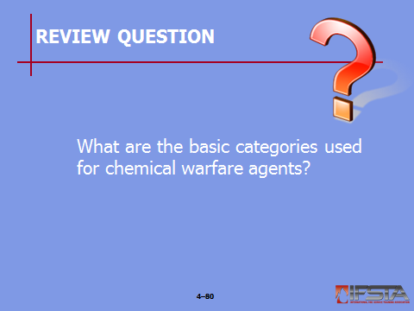
Review Question: What are the basic categories used for chemical warfare agents?
See p. 186 of the manual for answers.

Section IX: Radiation

radiation
pp. 194-198 Objective 9 – Define radiation.

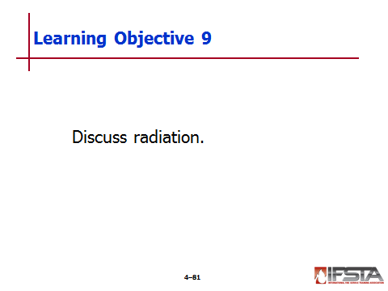
Radiation

Incidents uncommon because of strict requirements governing use and transportation

Radioactive material – Any material having specific activity greater than 0.002 microcuries per gram (Ci/g)

Most incidents present minimal risks to emergency responders – Take precautions against unnecessary exposures

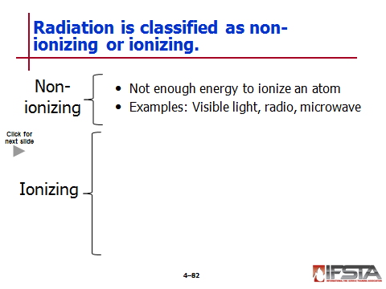
Non-ionizing
Interactive slide; use mouse to show all information

Any type of electromagnetic radiation that does not carry enough energy to ionize an atom or molecule

Will not completely remove electron from atom

Has only sufficient energy to excite electron into higher energy state

Examples

Visible light

Microwaves

Radio waves

Ionizing

Four primary types

Alpha particles

Relatively large particles that can travel only few inches in air

Stopped by shielding as light as a thin sheet of paper

Cannot penetrate intact skin

May enter body through inhalation, ingestion, or contamination of open wound

Internal hazard only

Beta particles

Much smaller than alpha particles, and far more penetrating

Can travel several yards in air

Can be inhaled or ingested like alpha particles

Require heavier shielding, such as wood or metal

Gamma rays

Electromagnetic waves of high energy and short wavelength

Strong penetrating power, able to travel considerable distances and through heavy objects

Travels at the speed of light

Can penetrate intact skin, causing skin burns and severe internal damage

Requires dense shielding such as lead, concrete, or several feet of water

Neutron particles

Considerably larger than beta particles but smaller than alpha particles

Normally associated with nuclear power plants

Becoming more common in medical treatment

Very strong penetrating power

Presents health hazards similar to that of other forms of radiation

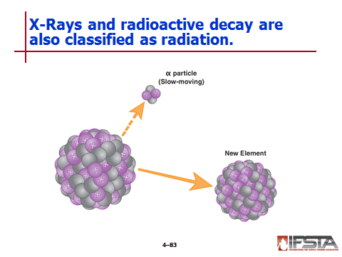
X-Rays

Small chance of encounter at haz mat incident

Similar to gamma rays, though not as hazardous

Of little concern to emergency responders since produced by machines

Rarely a by-product of natural radioactive decay

Radioactive decay

Spontaneous breakdown of atomic nucleus resulting in release of energy and matter from nucleus

Radioisotopes

Has unstable nucleus that does not have enough energy to hold together

Strive to be stable; constantly undergoing changes to maintain stability

During process release energy and matter from their nucleus and quite often may transform into new element

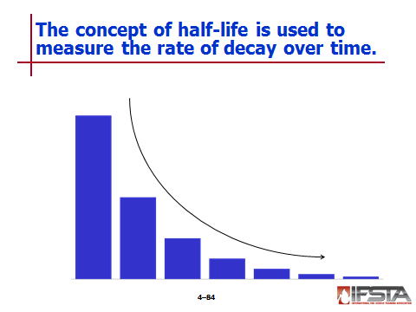
Half-life

Measure of how long it takes for one half of given amount of radioactive material to decay

As rule, radioactive isotope decreases to less than 1% of original value after seven half-lives

Knowing this information can help technicians determine how long area must be sealed off and whether incident can be allowed to self-mitigate

Majority of materials have extremely long half-lives, from several thousand to several billion years

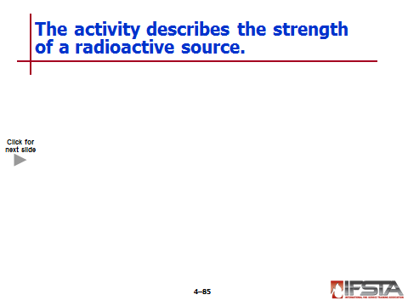
Activity
Interactive slide; use mouse to show all information

Strength of radioactive source

Rate at which number of atoms will decay and emit radiation in one second

International System (SI) units

Becquerel (Bq)

Quantity of radioactive material in which one atom transforms per second

Very small unit

Curie (Ci)

Used for activity of particular source material

Quantity of radioactive material in which 3.7 x 10¹⁰ atoms disintegrate per second
Note: These numbers are used to illustrate the principle and do not reflect any real material.

Gamma curie – Activity of material in which numbers of gamma-ray photons emitted per second
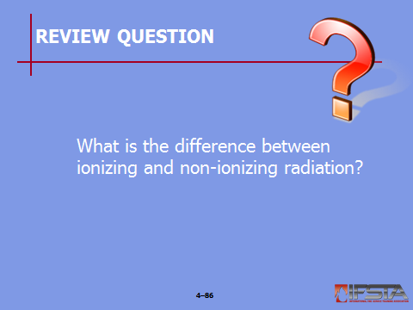
Review Question: What is the difference between ionizing and non-ionizing radiation?
See pp. 194-195 of the manual for answers.

Section X: Summary and Review

SUMMARY AND REVIEW

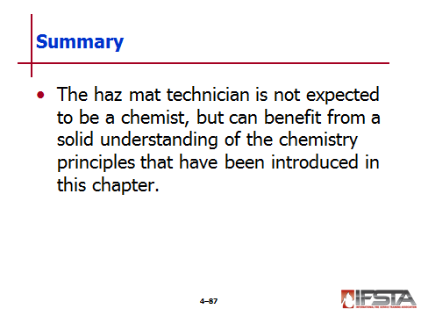
Chapter Summary

The haz mat technician is not expected to be a chemist, but can benefit from a solid understanding of the chemistry principles that have been introduced in this chapter.

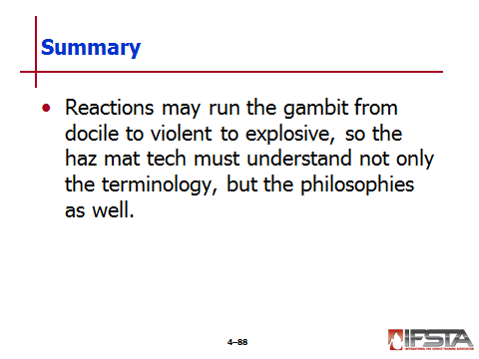
Reactions may run the gambit from docile to violent to explosive, so the haz mat tech must understand not only the terminology, but the philosophies as well.

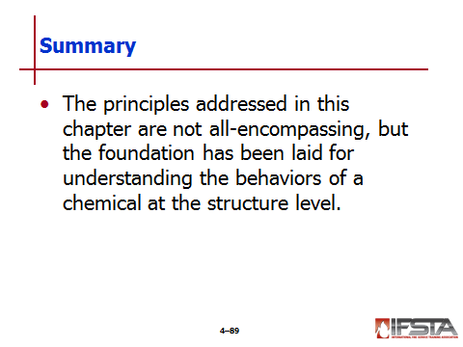
The principles addressed in this chapter are not all encompassing, but the foundation has been laid for understanding the behaviors of a chemical at the structure level.

Review Questions

What is an atom made up of? (146)

What is the periodic table of elements? (146)

What are the four significant families of elements? (147)

What is an example of matter that can exist in different states? (157)

What is the difference between an ionic bond and a covalent bond? (166-168)

How do endothermic reactions, polymerization, and synergistic reactions compare with one another? (171-174)

What are the four basic types of hydrocarbons? (178-179)

What are the basic categories used for chemical warfare agents? (186)

What is the difference between ionizing and non-ionizing radiation? (194-195)

