Chapter 2
Scene Management

Lesson Goal
After completing this lesson, the student shall be able to describe the roles within an incident command system, explain the branch structure of a hazardous materials incident, discuss response priorities and models, and develop an IAP and site safety plan.
Objectives
Upon successful completion of this lesson, the student shall be able to:
1. Explain various roles within an Incident Command System (ICS). [NFPA® 472, 7.4.1]
2. Describe the Haz Mat Branch structure.
3. Identify the hazardous materials incident levels.
4. Explain response priorities.
5. Explain each of the response models.
6. Describe the development of an Incident Action Plan (IAP) and a Site Safety Plan (SSP). [NFPA® 472, 7.2.3.4, 7.3.5.2, 7.3.5.2.1, 7.3.5.2.2, 7.3.5.4, 7.5.1]
7. Describe forms and logs necessary for scene management. [NFPA® 472, 7.6.3(3), 7.6.3(6), 7.6.3(8)]
8. Perform the duties of an assigned function within the ICS. [NFPA® 472, 7.4.1; Learning Activity 2-1]
9. Complete emergency response plan reports. [NFPA® 472, 7.6.3(2); Learning Activity 2-2]
10. Develop a site safety and control plan. [NFPA® 472, 7.3.5.2; Learning Activity 2-3]

Instructor Information
This is the lesson covering scene management at a hazardous materials incident. This lesson describes the roles within the incident command system, including the branch structure of a haz mat incident. The lesson also covers incident levels, response priorities and models, and details Incident Action Plans and site safety plans.

Important instructor information is provided in shaded boxes throughout the lesson plan. Carefully review the instructor information before presenting the lesson.

This lesson includes three learning activities. These activities are developed for the student to complete emergency response plan reports, perform ICS duties, and develop a site safety and control plan. These activities cover learning objectives 8-10.

Methodology
This lesson uses lecture, discussion, and learning activities. The level of learning is application.
Outline Contents

Section | Outline Pages | Text Pages
Section I: Incident Management Systems | 5 | 76
Section II: Haz Mat Branch | 8 | 78
Section III: Hazardous Materials Incident Levels | 17 | 83
Section IV: Response Priorities | 21 | 86
Section V: Response Models | 23 | 86
Section VI: Development of an Incident Action Plan/Site Safety Plan | 29 | 90
Section VII: Forms and Logs | 58 | 106
Section VIII: Learning Activities | 62 | 110
Section IX: Summary and Review | 63 | 108

Audiovisuals
- Visuals 2.1 to 2.60 (PowerPoint® Presentation)
Evaluation
- Chapter 2 Quiz
- Chapter 2 Test
- Learning Activities 2-1 to 2-3
Presentation Tools
Interactive Objects allow instructors to present information a piece at a time by clicking on hot spots in a larger image.

Each object is labeled in the Lesson Outline and indicated in the PowerPoint® presentation by a RED arrow in the top left corner of the image. This lets instructors know to use the mouse to explore all of the information on the slide.


After all of the information is displayed a reset arrow will appear in the bottom right corner of the image. Instructors can use this to remove the text and quiz students on content just covered or simply move on to the next slide.

To move to the slide after an interactive object, select the Click for next slide arrow on the left side of the slide.

Videos are used as discussion starters or to illustrate a concept or process discussed in the chapter.

These are labeled in the Lesson Outline and indicated in the PowerPoint® presentation by the Click image to play arrow on the left side of the slide.

Section I: Incident Management Systems

incident management systems
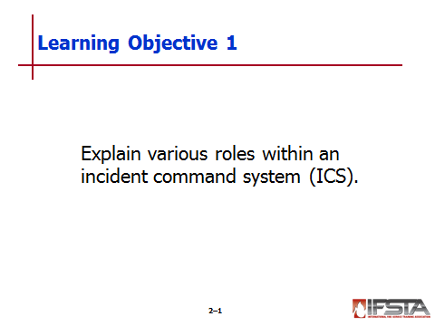
pp. 76-78 Objective 1 – Explain various roles within an incident command system (ICS).

Incident Management Systems

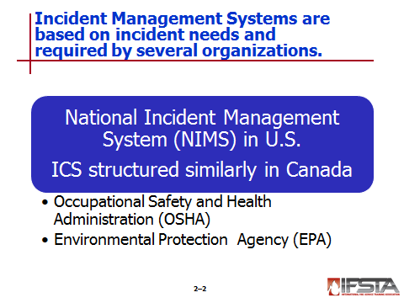
Required by Occupational Safety and Health Administration (OSHA) and Environmental Protection Agency (EPA)

In U.S. – National Incident Management System (NIMS)

Structure based on incident’s needs
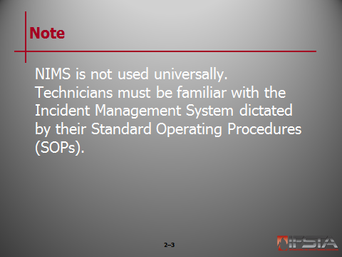
Note: NIMS is not used universally. Technicians must be familiar with the Incident Management System dictated by their Standard Operating Procedures (SOPs).

Incident Command

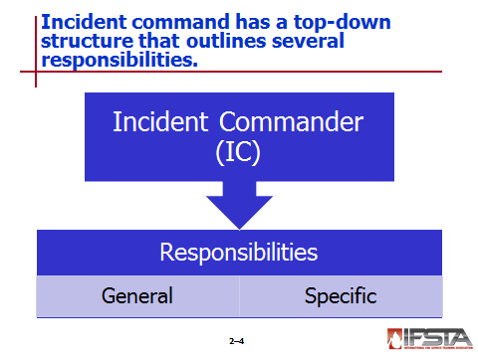
Structure – Top-down

Incident Commander (IC)

Bears all responsibility of managing incident unless responsibility is transferred by assigning staff to other functional areas

Operations Section

Planning Section

Logistics Section

Finance/Administration Section

Responsible if Sections go unassigned

Manager of incident

Responsible for directing and coordinating all aspects of response

Responsible for all actions taken by every responder at emergency scene

General responsibilities

Establish site safety plan

Implement site security and control plan to limit number of personnel operating in control zones

Designate Safety Officer

Identify materials or conditions involved in incident

Implement appropriate emergency operations

Ensure that all emergency responders wear appropriate personal protective equipment (PPE) in restricted zones

Establish decontamination plan and operation

Implement post-incident emergency response procedures

Specific responsibilities

Assume and announce Command and establish effective operating position

Rapidly evaluate situation by conducting thorough and complete size-up

Initiate, maintain, and control communication process

Identify incident objectives, develop IAP, and assign resources that are consistent with local SOPs

Develop effective Incident Command organization

Provide strategies and tactics

Review, evaluate, and revise IAP

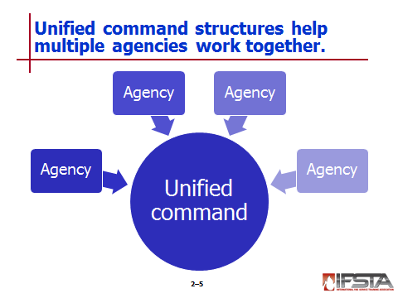
Unified Command

Most efficient and safest means of operation at incidents where multiple agencies and jurisdictions are expected to work together

Concept – All agencies that are functionally involved in incident contribute to process

Representatives help

Determine strategies and overall incident objectives

Plan jointly for tactical objectives

Structure should consist of key officials from each jurisdiction

IAP falls under authority of single individual
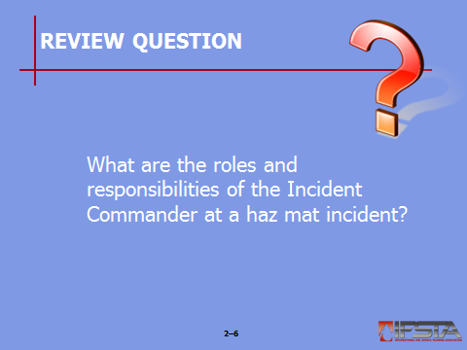
Review Question: What are the roles and responsibilities of the Incident Commander at a haz mat incident?
See p. 77 of the manual for answers.

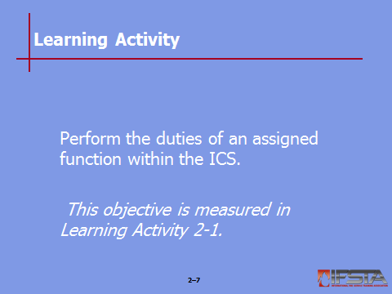
Learning Activity 2-1: Have students complete Learning Activity 2-1 “Perform the duties of an assigned function within the ICS.”

Section II: Haz Mat Branch

haz mat branch
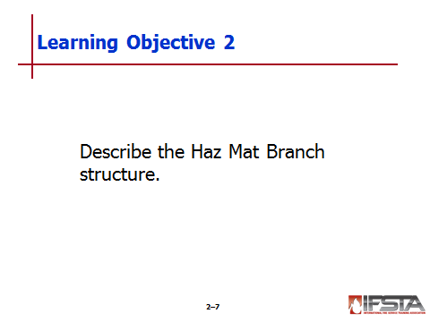
pp. 78-83 Objective 2 – Describe the haz mat branch structure.

Haz Mat Branch

Established at many haz mat incidents

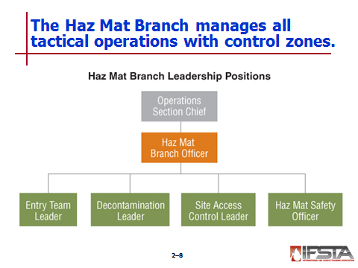
Manages all tactical operations carried out within control zones

Coordinates all work conducted by technical specialists

Manages all operations

Site safety

Rescue

Entry operations

Decontamination

Containment or confinement activities

Sampling

Medical monitoring

May not include all positions for every incident

Should be staffed with personnel trained to Technician Level

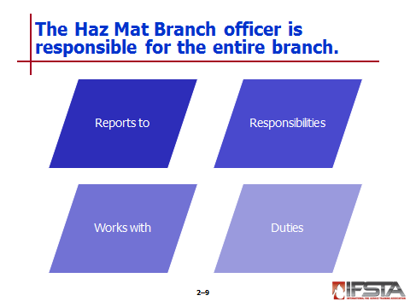
Haz Mat Branch Officer

Reports directly to Operations Section Chief

Responsible for Haz Mat Branch

Works closely with all other leaders assigned to Haz Mat Branch

Entry Team Leader

Decontamination Leader

Site Access Control Leader

Haz Mat Safety Officer

Coordinates technical specialists working incident

Should be trained to Technician level

Duties

Developing control zones and access control points

Evaluating and recommending public protection actions in conjunction with Operations Section Chief

Developing site safety plan

Developing IAP

Should work with other key positions to develop public protective actions

May work with research officer and other technical specialists to

Ascertain weather data

Monitor hazard site to develop IAP

Conducts safety meeting with entire Haz Mat Branch

Must maintain thorough and appropriate documentation of all activities

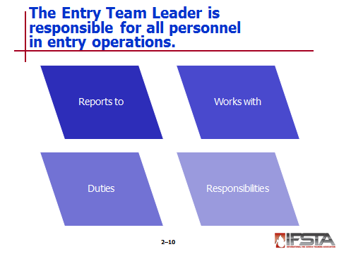
Entry Team Leader

Reports to Haz Mat Branch Officer

Responsible for all personnel assigned to entry operations

Directs any rescue operation within hot zone

Responsible for all movement within hot zone by response personnel

Must also consider movement of any contaminated victims

Must work closely and communicate with other members of Haz Mat Branch and other Branches

Must be allowed to recommend actions to mitigate any situation that may be occurring in hot zone

Responsibilities

Communicating all actions to Haz Mat Branch Officer

Monitoring, recording, and maintaining entry and exit logs that outline air use, PPE, and time in hot zone

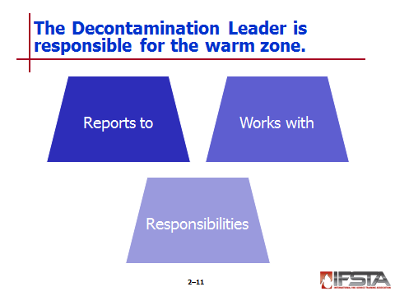
Decontamination Leader

Reports directly to Haz Mat Branch Officer

Works closely with

Safe Refuge Area Manager

Medical Branch

Entry Leader

Responsible for warm zone

Responsibilities

Supervising all operations and personnel inside warm zone

Executing all decontamination requirements and guidelines outlined in IAP

Controlling movement of all individuals within warm zone

Coordinating transfer of contaminated patients requiring medical attention to Medical Branch

Maintaining documentation on any contamination

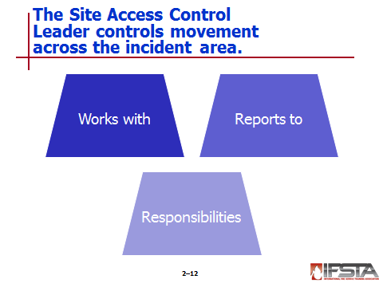
Site Access Control Leader

Works closely with Entry and Decontamination Team Leaders

Reports directly to Haz Mat Branch Officer

Responsibilities

Controlling all movement through various routes and corridors of haz mat incident site

Controlling contamination

Keeping appropriate records

Helping establish control zones and creating safe refuge area

Appointing Safe Refuge Area Manager

Tracking movement of all persons passing through contamination control lines

Ensuring that all persons leaving restricted areas have received proper decontamination

Coordinating with Medical Branch to ensure that both responders and victims receive appropriate medical observation

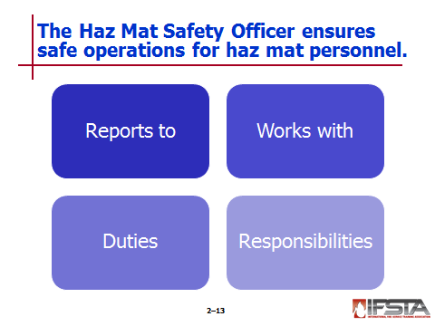
Haz Mat Safety Officer

Required by federal law at all hazardous materials incidents

May be more than one based on incident complexity

Reports directly to Incident Safety Officer

Works in conjunction with Haz Mat Branch Officer and Entry Leader

Coordinates safety-related activities that have direct effect on Haz Mat Branch operations

Advises Haz Mat Branch Officer on all aspects of health and safety

Can stop or prevent any action they deem unsafe

Should be involved in preparation and implementation of site safety plan

Must advise Haz Mat Branch Officer if deviating from site safety plan

Ensures protection of all Haz Mat Branch personnel from physical, environmental, or chemical hazards or exposures

Responsible for maintaining documentation

Medical records for Haz Mat Branch personnel

Exposure records, PPE logs, and other documentation required by AHJ
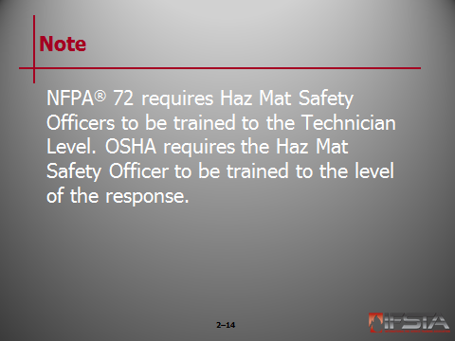
Note: NFPA® 72 requires Haz Mat Safety Officers to be trained to the Technician Level. OSHA requires the Haz Mat Safety Officer to be trained to the level of the response.

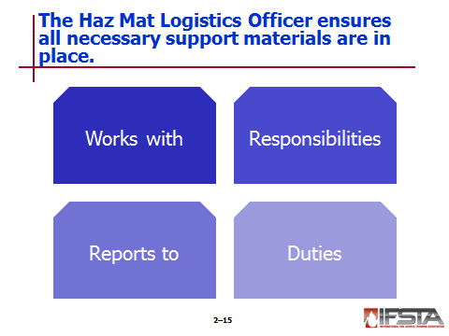
Haz Mat Logistics Officer

Works in conjunction with Logistics Section Chief

Responsible for ensuring that all materials needed to support Haz Mat Branch are in place

Maintains ongoing inventory of resources needed to control incident

Reports directly to Haz Mat Branch Officer

Works closely with other leaders assigned to Haz Mat Branch

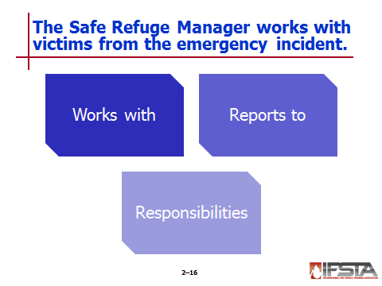
Safe Refuge Manager

Works closely with

Entry Leaders

Decontamination Leaders

Medical Officers

Reports directly to Site Access Control Leader

Responsibilities

Evaluating and determining priority of victims for treatment

Collecting information from victims

Helping to prevent victims from spreading contamination

May interview victims leaving scene and relay pertinent information to IC

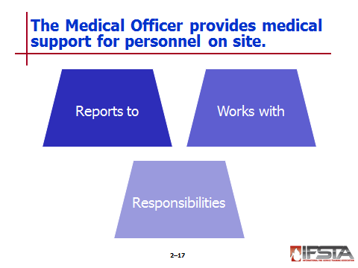
Medical Officer

Reports directly to Haz Mat Branch Officer

Works closely with

Decontamination Leader

Safe Refuge Manager

Hazardous Materials Safety Officer

Responsibilities

Medical evaluation and monitoring of personnel operating at site

Treatment of personnel exposed to products at incident

Triage, as necessary

Maintenance of medical records for both responders and victims

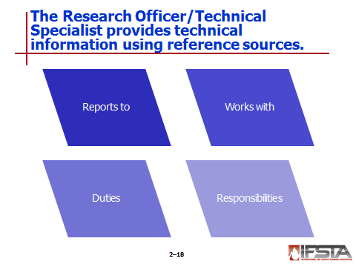
Research Officer/Technical Specialist

Reports directly to Planning Section Chief but may work under Haz Mat Branch Officer

Works in conjunction with

Planning Section Chief

Incident Safety Officer

Provides technical information assistance to Haz Mat Branch using variety of reference sources

Facility representatives

Technical references

Computer databases

Chemical Transportation Emergency Center (CHEMTREC)

Other responsibilities

Interpret environmental monitoring information

Analyze samples obtained in hot zone

Determine PPE compatibility

Assist in projecting potential environmental effects of release

Review Question: How do duties of members of the haz mat branch compare with one another?
See pp. 79-83 of the manual for answers.

Section III: Hazardous Materials Incident Levels

hazardous materials incident levels
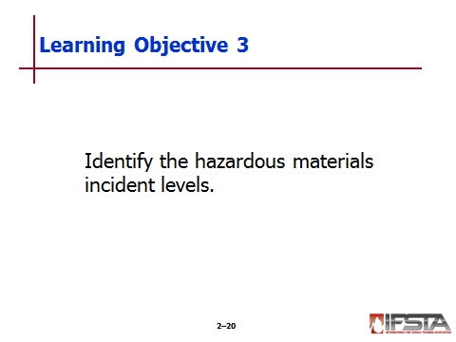
pp. 83-85 Objective 3 – Identify the hazardous materials incident levels.

Hazardous Materials Incident Levels

Identified after initial scope determined

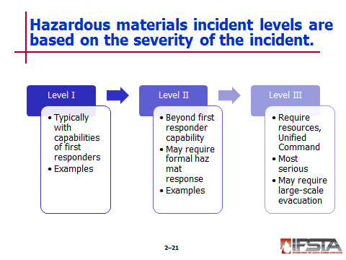
Range

Level I – Least serious

Level III – Most serious

Identified based on severity

Level of involvement

Resources needed

Level I

Typically within capabilities of fire or emergency services organization or other first responders having jurisdiction

Least serious

Easiest to handle

May pose serious threat to life or property, although not usually

Requires only limited evacuation

Examples

Spill or leak requiring limited-scale evacuation

Any major accident, spillage, or overflow of flammable liquids

Spill or leak of unfamiliar or unknown chemicals

Accident involving extremely hazardous substances

Rupture of underground pipeline

Fire that is posing boiling liquid expanding vapor explosion (BLEVE) threat in storage tank

Level II

Beyond capabilities of first responders on scene

May be beyond capabilities of first response agency/organization having jurisdiction

May require services of formal haz mat response team

Dike and confine within contaminated areas

Perform plugging, patching, and basic leak control activities

Sample and test unknown substances

Perform various levels of decontamination

Examples

Spill or leak requiring limited-scale evacuation

Any major accident, spillage, or overflow of flammable liquids

Spill or leak of unfamiliar or unknown chemicals

Accident involving extremely hazardous substances

Rupture of underground pipeline

Fire that is posing boiling liquid expanding vapor explosion (BLEVE) threat in storage tank

Level III

Require resources from state/provincial agencies, federal agencies, and/or private industry

Require Unified Command

Most serious of all hazardous materials incidents

May require large-scale evacuation

Will not be managed by one agency

Requires collective effort from several resources/procedures

Specialists from industry and governmental agencies

Sophisticated sampling and monitoring equipment

Specialized leak and spill control techniques

Decontamination on large scale

Incident examples

Those that require evacuation extending across jurisdictional boundaries

Those beyond capabilities of local hazardous material response team

Those that activate federal response plan

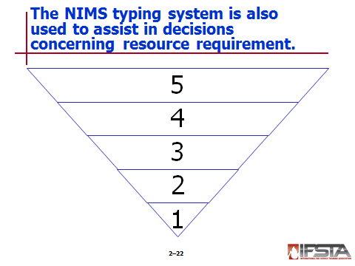
NIMS Incident Typing System

Created by NIMS to assist in decisions concerning resource requirements

Includes five incident levels
Instructor Note: Refers students to Table 2.2 on p. 85 for a detailed discussion of the five incident levels that have been incorporated into the NIMS response protocols.

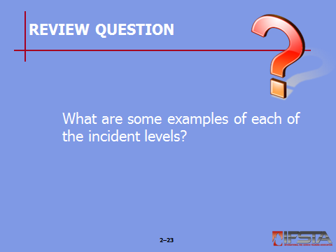
Review Question: What are some examples of each of the incident levels?
See pp. 83-84 of the manual for answers.

Section IV: Response Priorities

response priorities
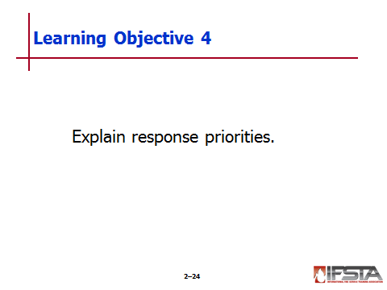
p. 86 Objective 4 – Explain response priorities

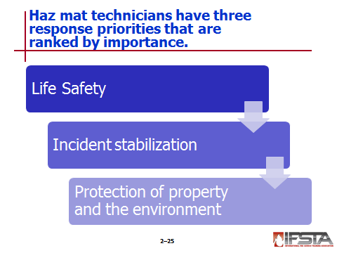
Life Safety

First priority at any incident

Must be consideration from moment incident is responded until termination

Weighing life safety of responders versus life safety of public must be based upon careful risk/benefit analysis

Risk to rescuers

Ability of rescuers to protect themselves

Probability of rescue

Difficulty of rescue

Capabilities and resources of on-scene forces

Possibilities of explosions or sudden material releases

Available escape routes and safe havens

Constraints of time and distance

Incident Stabilization – Next consideration if no immediate threat to responders or civilians

Protection of Property and the Environment

Can be addressed when first two priorities are satisfied

Can be done by stabilizing incident
Instructor Note: Remind students that these priorities can be changed if the situation calls for it, but generally, they should be considered in the order presented.

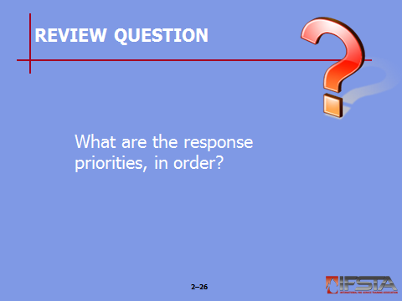
Review Question: What are the response priorities, in order?
See p. 86 of the manual for answers.

Section V: Response Models

Response Models
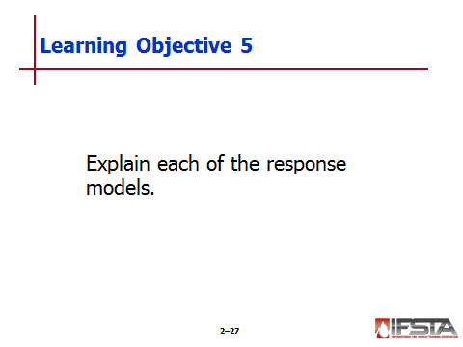
pp. 86-90 Objective 5 — Explain each of the response models.

Response Models

Most contain elements of basic four-step problem-solving formula developed by Professor George Polya

Step 1: Understand the problem

Step 2: Devise a plan

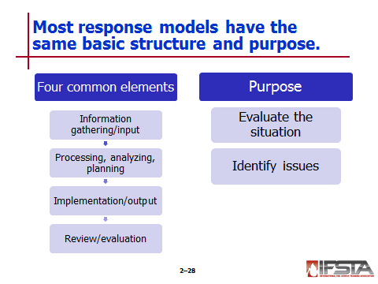
Step 3: Carry out the plan

Step 4: Look back

Most will contain four common elements

Information gathering or input stage

Processing, analysis, and/or planning stage

Implementation or output stage

Review or evaluation stage

Purpose of Response Models

Assists IC and his/her staff in evaluating the situation and associated issues that may impact outcome of incident and safety of responders

Identify as many underlying issues as possible to complete mission in organized, productive, and safe manner

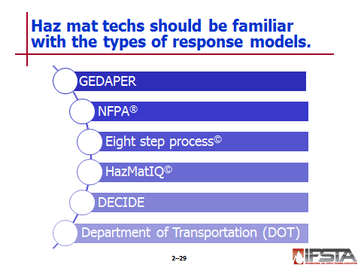
Types of Response Models

GEDAPER

G – Gather information

E – Estimate potential course and harm

D – Determine strategic goals

A – Assess tactical options and resources

P – Plan of action implementation

E – Evaluate operations

R – Review the process

NFPA®

Recommends use of risk-based response to haz mat incident or emergency

Utilizes risk management matrix that evaluates two factors

Severity focuses on

Health

Fire

Reactivity

Radioactivity

Probability evaluated by assessing

Chemical and physical properties – Physical state, vapor pressure, routes of exposure, and ability to become airborne

Container – Pressure, stability, stresses and/or rate or release

Environment – Topography, wind direction, dispersion factors

Proximity to hazard

Cause

Eight step process©

Developed by Gregory G. Noll, Michael S. Hildebrand, and James G. Yvorra

Tactical decision-making model that focuses on haz mat/WMD incident safe operating practices

Steps

Site management and control

Identify the problem

Hazard assessment and risk evaluation

Select protective clothing and equipment

Information management and resource coordination

Implement response objectives

Decontamination

Terminate the incident

HazMatIQ©

Four-step decision-making response model used by major fire and law enforcement agencies across US

Propriety risk-based response system that will assist responders through four-step process

A quick chemical size-up using supplied charts

A streamlined chemical hazard research process

Meter selection

PPE selection

DECIDE

D – Detect presence of hazardous material

E – Estimate likely harm without intervention

C – Choose response objectives

I – Identify action options

D – Do best option

E – Evaluate progress

Department of Transportation (DOT)

Devised response model that is eight-step approach to incident size-up and safety

Good for lower levels of haz mat response but may not be practical for Technician-Level responder

Steps

Approach cautiously from upwind, uphill, or upstream

Secure scene

Identify hazards

Assess situation

Obtain help

Decide on site entry

Respond

Above all, do not assume that gases or vapors are harmless because of lack of smell
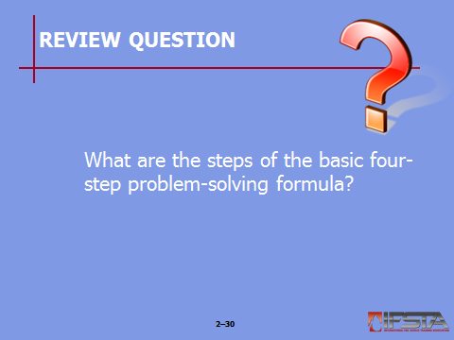
Review Question: What are the steps of the basic four-step problem-solving formula?
See p. 86 of the manual for answers.

Section VI: Development of an Incident Action Plan/Site Safety Plan

development of an incident action plan/site safety plan
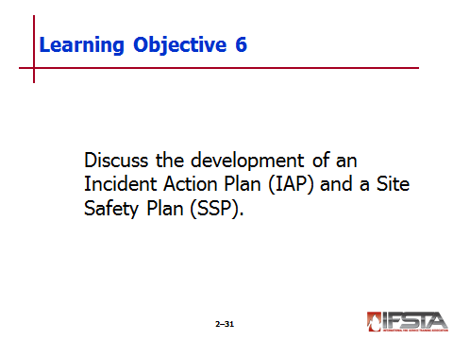
pp. 90-106 Objective 6 – Describe the development of an incident action plan (IAP) and a site safety plan (SSP).

Incident Action Plan

Plan put in place for disposition of incident

May be written or unwritten

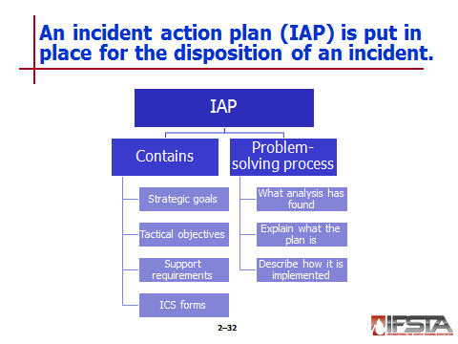
Contains overall strategic goals and tactical objectives along with support requirements for given operation period

Organized course of events that addresses all phases of incident within given time

Consist of several ICS forms bundled together that document actions developed by IC, general staff, or other members present at planning meeting

Specifies

Incident objectives

Strategies

Tactics

Resources

Personnel

Organization

Communications plan

Medical plan

Other pertinent information needed

Must be updated following each formal planning meeting conducted by Planning Section

Must be approved by IC prior to distribution

Must be developed for each operational period after initial action phase

Must include certain ICS forms

Incident briefing including site sketch (ICS Form 201)

Incident objectives (ICS Form 202)

Organizational assignment list (ICS Form 203)

Division assignment list (ICS Form 204)

Incident radio communications plan (ICS Form 205)

Medical plan (ICS Form 206)

Site safety plan (ICS Form 208 HM)

Ties together entire problem-solving process by

Stating what analysis has found

Explaining what the plan is

Describing how it shall be implemented

Must assess effectiveness when

Plan is established

Resources committed

Gather information to improve plan if necessary

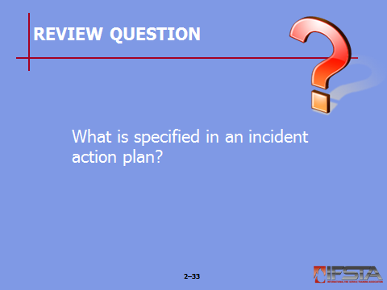
Review Question: What is specified in an incident action plan?
See p. 90 of the manual for answers.

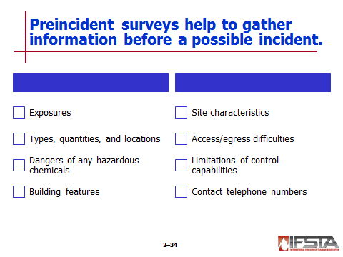
Preincident Surveys

Gather information about incident before potential becomes reality

Can deliver various information

Exposures

Types, quantities, and locations of hazardous materials in given area

Dangers of any hazardous chemicals within the preplanned area

Building features

Site characteristics

Possible access/egress difficulties

Inherent limitations of organization’s control capabilities

Contact telephone numbers of responsible parties and site experts

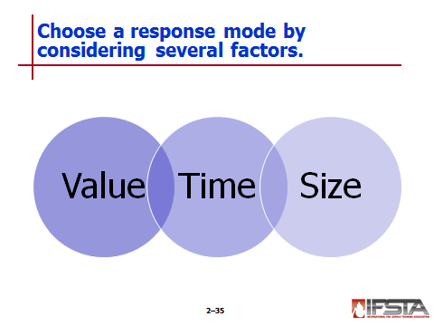
Response Modes

Selection based on

Risk to responders

Level of training

Balance between resources required and those available

May change during course of incident

Affected by three incident-based elements

Value

Relates directly to incident priorities of life safety, incident stabilization, and property conservation

Stated in terms of yes (there is value) or no (there is no value)

Once determined, degree can be assessed

Civilian life hazard – High value

No life hazard, but environmental or property harm – Low value

No life hazard or environmental or property harm – No value

Time

May be limited window to intervene before incident escalates

In some cases, reaction and response times of responders may determine strategic mode selection

Size

Most frequently drives need to conduct protective action concurrently with incident control operations

Resource requirements driven by tactical requirements

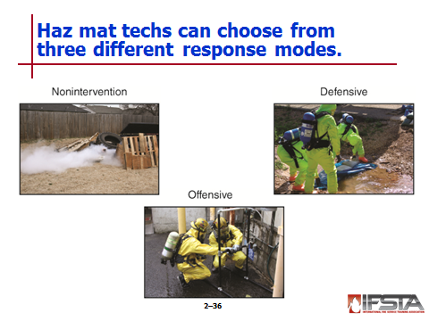
Nonintervention – Allows incident to run course on its own

Operations in which responders take no direct actions on the actual problem

Only safe strategy in many types of incidents

Best strategy in certain types of incidents when mitigation is failing or otherwise impossible

Selected when one or more circumstances exist

Facility or local emergency response plan (LERP) calls for it based on preincident evaluation of hazards present at site

Situation is clearly beyond capabilities of responders

Explosions are imminent

Serious container damage threatens massive release

In these situations, responders should

Withdraw to safe distance

Report scene conditions to telecommunications center

Initiate the Command system

Call for additional resources as needed

Isolate hazard area and deny entry

Commence evacuation where needed

Defensive – Provides confinement of hazard to given area

Operations in which responders seek to confine emergency to given area without directly contacting hazardous materials involved

Selected when one of two circumstances exists

Facility or local emergency response plan calls for it based on precincident evaluation of hazards present at site

Responders have training and equipment necessary to confine incident to area of origin

In these operations, responders should

Report scene conditions to telecommunications center

Initiate the Command system

Call for additional resources as needed

Isolate hazard area and deny entry

Establish and indicate zone boundaries

Commence evacuation where needed

Control ignition sources

Use appropriate defensive control tactics

Protect exposures

Perform rescues when safe and appropriate

Evaluate and report incident progress

Perform emergency decontamination procedures

Offensive – Actions to control incident

Operations where responders take aggressive, direct action on material, container, or process equipment involved in incident

May result in contact with material and therefore require responders to wear appropriate chemical-protective clothing and respiratory protection

Predominately conducted by hazardous materials technician
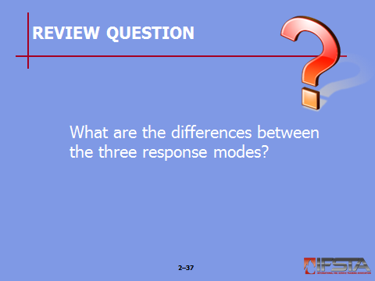
Review Question: What are the differences between the three response modes?
See pp. 92-94 of the manual for answers.

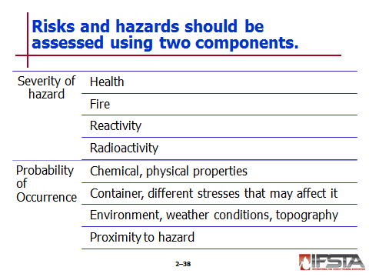
Risk Identification and Hazard Assessment

Two components – Severity of hazard and probability of occurrence

Uses categories to assess severity

Health

Fire

Reactivity

Radioactivity

Consider to assess vulnerability

What may be vulnerable

How exposure could occur

Evaluate to assess likelihood of exposure

Chemical and physical properties of product or chemical

Container and different stresses that may affect it

Environment, including weather conditions and topography

Proximity to hazard

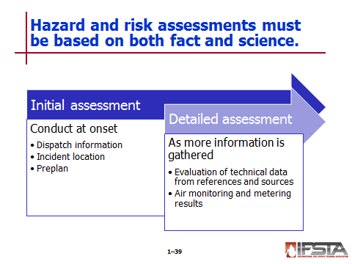
Initial hazard and risk assessment – Must be based on fact, science

Conducted at onset of incident

May include

Dispatch information

Incident location

Preplan information

Beneficial information

Potential for fire, reactivity, or radioactivity

Probability of exposure based on

Chemical’s physical state

Location of incident

Situation presented

Status of release

Detailed hazard and risk assessment

Used as more information is gathered and better detail is evaluated

Based on greater technical data and physical information

Should include evaluation of technical data from relevant sources and references in conjunction with air monitoring and metering results

Should be reevaluated and revised if necessary

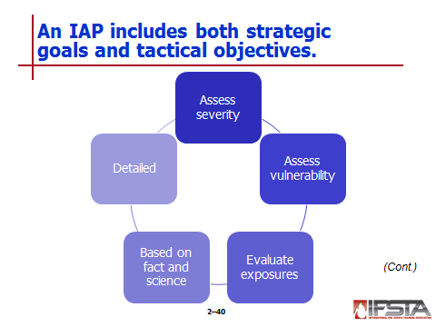
Strategic Goals and Tactical Objectives

Strategies – Broad in nature; define what needs to be accomplished

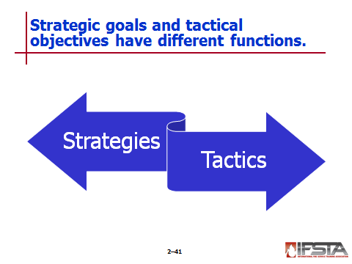
Instructor Note: Discuss with students the SMART modeling process for the development of strategies. SMART stands for:
Specific
Measurable
Action orientated
Realistic
Time sensitive

Tactics

Created after strategies are in place

Operational tasks used to accomplish strategies

Measureable in time and performance

Should be evaluated to ensure that they will meet strategic goals

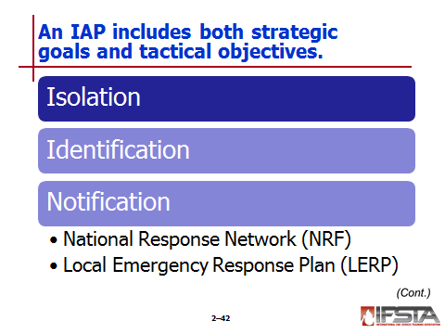
Isolation perimeter

May be

Comprised of inner and outer perimeter

Expanded or reduced in size

Easier to reduce than extend

Must be determined by IC through risk assessment or size-up
Note: From a risk-management perspective, it is better to encompass a larger are that can be reduced in size once incident site conditions have been assessed for risks such as secondary devices, unidentified hazardous materials, and atmospheric monitoring.

Used to control access and egress from incident site

Identification

In some cases, relatively simple task

May not ever be achieved

Safest and most effective means of planning mitigation activities

May be achieved by gaining information from any of the following means

Information from occupancies and preincident surveys

Container shapes

Transportation placards, labels, or markings

Technical markings such as CAS numbers, NFPA® 704 markings, and signal words

Written resources

Monitoring and detection devices

Serves very beneficial purpose during planning process

Allows planning team to make critical decisions on chemical protective clothing and respiratory protection along with decontamination procedures

Notification

May include

Incident-level identification

Public emergency information/notification

Better to dispatch more resources than necessary in initial response to ensure appropriate weight of attack to combat incident conditions

Involves contacting law enforcement whenever terrorist or criminal incident is suspected

Involves notifying other agencies that incident has occurred

In U.S., process is detailed in National Response Framework (NRF)

Incidents are handled at lowest geographic, organizational, and jurisdictional level

When local agencies need additional assistance, they must contact state authorities to request help

LERP

First resource if necessary to request outside assistance

Local response agency should be closely tied to community’s Emergency Operations Center (EOC)

If local assets are insufficient, requests will be made to state EOC

If necessary, federal assistance can be requested through the Department of Homeland Security

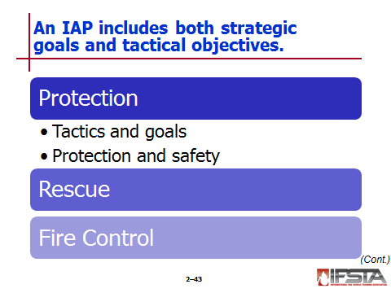
Protection

Overall goal of ensuring safety of responders and public

Goals include measures taken to protect property and environment

Goals are accomplished through various tactics

Identifying and controlling materials and hazards

Avoiding contact with hazardous materials

Maximizing distance between people and hazardous areas

Using and wearing appropriate PPE

Using time, distance, and shielding, when appropriate

Conducting rescues

Providing decontamination

Providing emergency medical care and first aid

Ensuring victims and responders stay upwind, upstream, and uphill of hazardous materials

Taking any other measures to protect responders and public, including conducting evacuations and sheltering in place

Protection and safety of responders first priority at any incident; measures include

Staying uphill, upstream, and upwind of hazardous materials

Wearing appropriate PPE

Using time, distance, and shielding for protection

Decontaminating responders when necessary

Ensuring accountability of all personnel

Tracking and identifying all personnel working at incident

Working as part of team or buddy system

Assigning safety officers

Putting evacuation and escape procedures in place

Rescue

May be one of most difficult tasks to accomplish due to complex nature of incident

Victims may be found in variety of locations

Tools and equipment differ for each scenario

Evaluation must be made based on viability of victims

Note: The fireground risk assessment analysis will work well in a haz mat situation: risk a lot in a calculated manner to save a lot, risk little to save little.

If deemed necessary, safety should be paramount

Must include

Communications

Coordination

Efficient and effective use of buddy system

Fire control

Strategy of minimizing damage, harm, and effect of fire at haz mat incident

If fire is present in addition to release, incident is more complicated

Must include

Risk and hazard assessment

Decision made whether to extinguish fire and how

Best course of action may be to protect exposures and let fire burn until fuel is consumed

Withdrawal may be safest and best tactical option if threat of container failure, BLEVE, or other explosion

When containers or tanks of flammable liquids are exposed to flame impingement

Deploy water streams for maximum effective reach to prevent BLEVE or other violent container failure

Best achieved – Direct stream at areas of direct flame impingement on tank as well as along tank’s top, cooling tank’s vapor space

Gas-fed fires burning around relief valves should not be extinguished unless turning off supply can stop leaking product

Increase in intensity of sounds or fire issuing from relief valve indicates pressure within container is increasing and container failure may be imminent

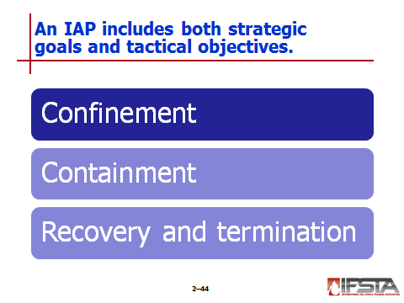
Confinement

Examples – Diking, damming, diverting, and retaining

Actions taken to control flow of liquid hazardous materials away from point of release

May include use of earthen materials or materials carried on response vehicles to construct curbs that direct or divert flow away from gutters, drains, storm sewers, flood-control channels, and outfalls

May direct flow into location to capture and retain material for later pickup and disposal

May include construction of dams that permit surface water to pass over while holding back hazardous material

Require that any construction materials used must be disposed of in accordance with applicable regulations

Containment

Goal – To stop or limit escape or contain release either in original container or by transferring to new container

Generally considered offensive actions

Recovery and termination – Last strategic goals

Recovery – Returning incident scene and responders to preincident level of readiness

Termination – Documenting incident and using information to evaluate response

Major goals

Return operational area to safe condition

Debrief personnel before they leave scene

Return equipment and personnel of all involved agencies to condition they were in before incident

On-scene recovery – Directed toward returning scene to safe condition

On-scene debriefing – Gathers information from all operating personnel

Hazard communication briefing – Providing information to personnel concerning signs and symptoms of overexposure to hazardous materials

Must be thoroughly documented

Each person must receive and understand instructions and sign document stating facts

Information provided to responders before leaving scene

Identity of material involved

Potential adverse effects of exposure to material

Actions to be taken for further decontamination

Signs and symptoms of exposure

Mechanism by which responder can obtain medical evaluation and treatment

Exposure documentation procedures

Operational recovery – Actions necessary to return resource forces to preincident readiness

Financial effects

Can be far greater than any other emergency activity

Requires proper documentation of costs through use of forms

Conclusion

IC must ensure that strategic goals have been accomplished and requirements of laws have been met

Documentation, analysis, and evaluation must be completed

Procedural actions – Critiques and after-action analysis
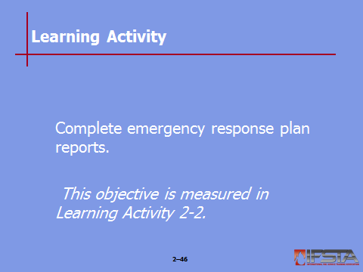
Learning Activity 2-2: Have students complete Learning Activity 2-2 “Complete emergency response plan reports”.

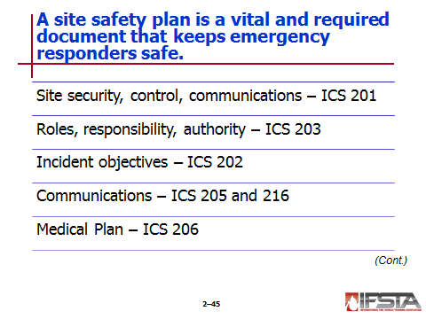
Site Safety Plan

Vital document for safety of emergency responders, and requirement under OSHA 29 CFR 1910.120

Depth and detail may change based on size and scope of incident and products involved

Only parts may be needed, depending on incident

OSHA has developed template that includes 13 chapters

Specific elements should line up with NIMS ICS forms

Site security, control, and communications – ICS Form 201 develops site map and/or sketch and should include

Orientation of site with compass points indicated

Natural and man-made topographical features

Prevailing wind direction

Command post location

Staging area

Access control points

Decontamination corridor

Drainage points

Roles, responsibilities, and authority – ICS Form 203 used to list person responsible for each job function

Incident objectives – ICS Form 202 used to list incident objectives and name assignments for each team

Communications – ICS Forms 205 and 216 ensure that all personnel involved in entry team activities remain in constant contact

Medical plan – ICS Form 206 establishes medical plan documenting name and location of nearest hospital or medical facility

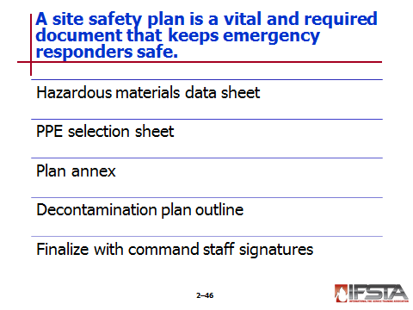
Hazardous materials data sheet – Completed for each substance; should list all known or suspected hazardous substances and concentrations

Personal protective equipment selection sheet – Lists all PPE that will be used and resource documents that suggest the recommendation

Plan annex – Outlines control zones and all monitoring information along with outlined action levels based on reading of monitoring equipment

Decontamination plan outline – Includes setup, location, solutions to be used, and equipment needed for decontamination operations

To finalize, must have signature page so that all key Command Staff can indicate acceptance of plan

IC

Safety Officer

Operations Officer

Haz Mat Branch Officer

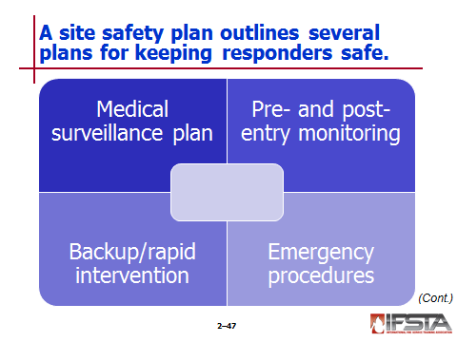
Medical surveillance plan

Should start before incident

Keeps personnel safe and may prevent illnesses and injuries

Requirement of OSHA 29 CFR 1910.120

Four-point system including

Baseline physical

Detailed and comprehensive exam reviewing employee’s health history and any previous chemical exposure

Should include vision and hearing tests and extensive blood work and urinalysis

Should include chest x-ray and EKG

Annual physical used to update medical history of team member

Exposure physical conducted anytime haz mat team member is exposed to chemical

Exit physical when employee’s team ensure ends

Pre- and post-entry medical monitoring

Vital for protection of team members

Ensures that team members are healthy before entering chemical protective clothing

Allows for baseline for post-entry medical surveillance

Gives medical team comparison data to review while emergency responder is in rehab

Pre-entry should include

Record of vital signs including blood pressure, pulse, respirations, body temperature, and weight

Evaluation of skin including rashes, wounds, and open sores

Evaluation of mental status

Outline of medical history including medications, alcohol consumption, medical treatment or diagnosis, and any symptoms of fever, nausea, vomiting, or diarrhea within 72 hours

Documentation of hydration

Post-entry includes

Many evaluation points of pre-entry surveillance

Monitoring of vitals every 5 to 10 minutes until they return to normal range

Monitoring of body weight

Should be developed under consultation with physician; if possible, physician should be present during evaluations

Backup/rapid intervention

Mandated by NFPA® and OSHA

Buddy system – System of organizing personnel into work groups in such a manner that each member has partner

Provides rapid help in event of emergency

Backup personnel – Must be standing by with equipment ready to provide assistance or rescue if needed

Minimum number of personnel necessary for performing tasks in hazardous area – Four; two working in area and two standing by as backup
Ask Students: What type of PPE should backup personnel be wearing?
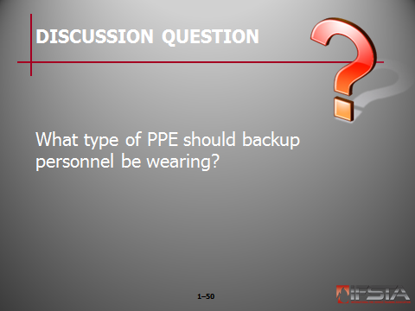
Briefly discuss answers with students. The backup personnel must be dressed in the same level of PPE as entry personnel.

Emergency procedures

Should include

Emergency procedures

Emergency evacuation

Safe refuge procedures

Should be included in any health and safety plan that will be used by on-scene personnel

Should include alternate communication methods should radios fail

Should include emergency evacuation signal

Combination of radio communications, public address system, and air horn blasts

In many jurisdictions, three long blasts of apparatus air horns mean emergency evacuation
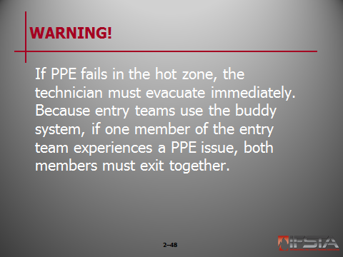
WARNING!: If PPE fails in the hot zone, the technician must evacuate immediately. Because entry teams use the buddy system, if one member of the entry team experiences a PPE issue, both members must exit together.

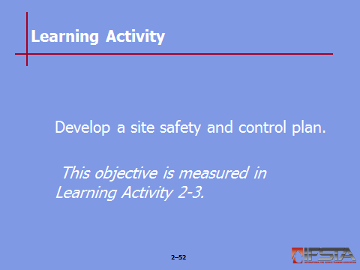
Learning Activity 2-3: Have students complete Learning Activity 2-3 “Develop a site safety and control plan”.

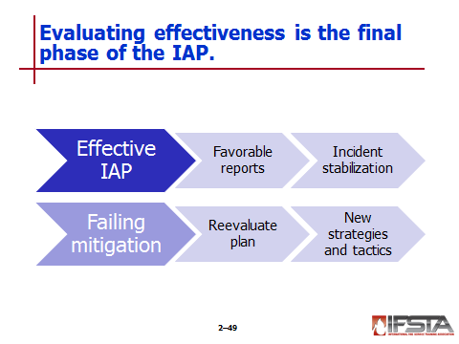
Evaluating Effectiveness

Final aspect of problem-solving process

If IAP is effective, IC should receive favorable progress reports and incident should begin to stabilize

If mitigation efforts are failing or situation is getting worse, plan must be reevaluated and possibly revised

Plan must be reevaluated as new information becomes available and circumstances change

If initial plan is not working, must be changed by selecting new strategies or by changing tactics to achieve them

First responders must communicate status of planned response and progress of actions to IC

Review Question: What items must be included in a site safety plan?
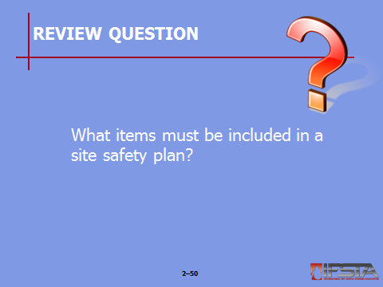
See pp. 102-103 of the manual for answers.

Section VII: Forms and Logs

forms and logs
pp. 106-108 Objective 7 – Describe forms and logs necessary for scene management.

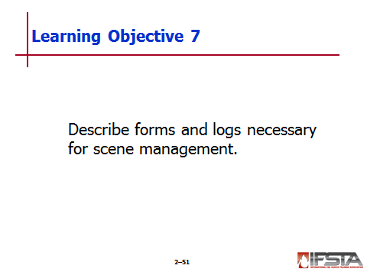
Forms and Logs

Many types for safety and liability reasons

Dictated by AHJ

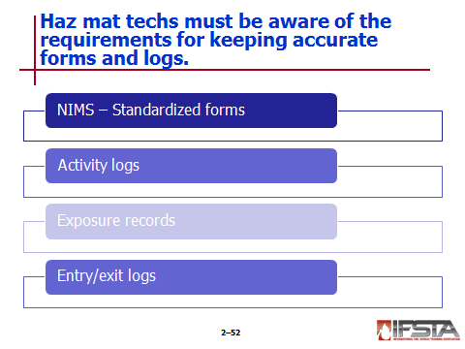
NIMS – Standardized many forms; can be downloaded from FEMA website

ICS 201 Incident Briefing

ICS 202: Incident Objectives

ICS 203: Organization Assignment List

ICS 204: Assignment List

ICS 205: Incident Radio Communications Plan

ICS 206: Medical Plan

ICS 207: Incident Organization Chart

ICS 208: Safety Message/Plan

ICS 211: Incident Check-in List

ICS 214: Activity Log

ICS 215: Operational Planning Worksheet

ICS 215A: Incident Action Plan Safety Analysis

Many will be used for development of IAP

Activity Logs

Running record of events that occurred during incident

Should be filled out by many of Section Chiefs and Leaders within Haz Mat Branch

Should be chronological list that includes

Incident name

Operational period

Unit named/designation

Unit leader

Personnel assigned

Main body – Log of all activity that has occurred

Each entry should include

Time of event

Brief description of each significant occurrence or event during incident

Become timeline during investigation phase and for all required reporting

Exposure Records

Vital record that should be completed by Decontamination Leader or Hazardous Material Safety Officer

Should be kept in conjunction with medical records for employees who have worked in proximity to hazard

Should include

Type of exposure

Length of exposure

Description of PPE used

Type of decontamination used including any decontamination solution

On scene and follow-up medical attention and/or assistance

Must be kept by employer for up to 30 years after employee retirement

Entry/Exit Logs

Maintained by Entry Team Leader

Organized approach to managing personnel entering hot zone and those within decontamination line

Should document

Name of Entry Team Leader

Radio frequency that will be used for entry team activities

Name of each individual who will enter hot zone

Name of each individual serving on backup team

Name of each individual serving on decontamination team

Time each person goes on air and air cylinder gauge reading

Time each person enters decontamination line

Time each person exits decontamination line and time they are off air

Should be reviewed by Haz Mat Safety Officer at conclusion of incident

Must be submitted to Command Staff for documentation retention
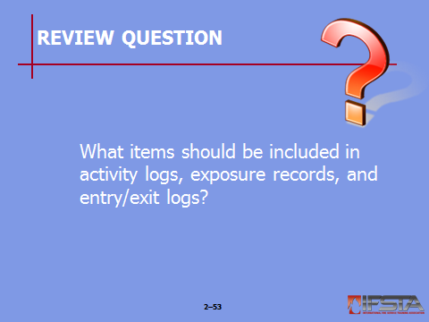
Review Question: What items should be included in activity logs, exposure records, and entry/exit logs?
See pp. 107-108 of the manual for answers.
Section VIII: Learning Activities

Learning Activities
p. 110 Objective 8 – Perform the duties of an assigned function within the ICS.

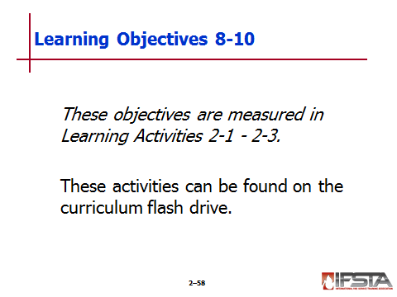
Learning Activity 2-1

For this activity, students will perform the duties of an assigned function within the ICS

This activity can be found in the Learning Activity 2-1 on the curriculum flash drive
p. 111 Objective 9 – Complete emergency response plan reports.

Learning Activity 2-2

For this activity, students will complete emergency response plans reports

This activity can be found in the Learning Activity 2-2 on the curriculum flash drive
p. 112 Objective 10 – Develop a site safety and control plan.

Learning Activity 2-3

For this activity, students will develop a site safety and control plan

This activity can be found in the LA 2-1 on the curriculum flash drive

Section IX: Summary and Review

SUMMARY AND REVIEW

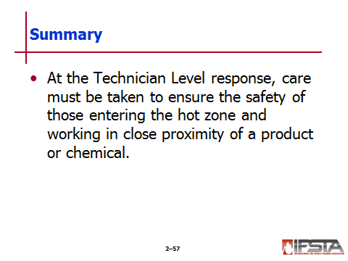
Chapter Summary

At the Technician Level response, care must be taken to ensure the safety of those entering the hot zone and working in close proximity of a product or chemical.

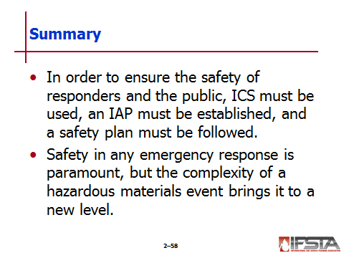
In order to ensure the safety of responders and the public, ICS must be used, an IAP must be established, and a safety plan must be followed.

Safety in any emergency response is paramount, but the complexity of a hazardous materials event brings it to a new level.

Review Questions

What are the roles and responsibilities of the Incident Commander at a haz mat incident? (77)

How do duties of members of the haz mat branch compare with one another? (79-83)

What are some examples of each of the incident levels? (83-84)

What are the response priorities, in order? (86)

What are the steps of the basic four-step problem-solving formula? (86)

What is specified in an incident action plan? (90)

What are the differences between the three response modes? (92-94)

What items must be included in a site safety plan? (102-103)

What items should be included in activity logs, exposure records, and entry/exit logs? (107-108)

