Chapter 1
Introduction and Review of Awareness, Operations, and Technician-Level Competencies

Lesson Goal
After completing this lesson, the student shall be able to describe the competencies for the Awareness-, Operations-, and Technician-Level responders.
Objectives
Upon successful completion of this lesson, the student shall be able to:
1. Describe NFPA® 472 competencies for the Awareness-Level responder. [NFPA® 472, 7.2.1.1]
2. Identify NFPA® 472 competencies for the Operations-Level responder. [NFPA® 472, 7.2.1.1, 7.2.2.1(1-5), 7.2.5.1, 7.2.5.2, 7.2.5.2.2, 7.2.5.3, 7.2.5.4, 7.3.5.5]
3. Explain NFPA® 472 competencies for the Technician-Level responder.

Instructor Information
This is the lesson covering the hazardous materials competencies for Awareness-, Operations-, and Technician-Level personnel. This lesson also describes the problem-solving process and how it relates to hazardous materials incidents.

Important instructor information is provided in shaded boxes throughout the lesson plan. Carefully review the instructor information before presenting the lesson.

Methodology
This lesson uses lecture and discussion. The level of learning is comprehension.

Outline Contents

Section | Outline Pages | Text Pages
Section I: Awareness-Level Competencies | 5 | 10
Section II: Operations-Level Competencies | 33 | 42
Section III: Technician-Level Competencies | 61 | 62
Section IV: Summary and Review | 70 | 70

Audiovisuals
- Visuals 1.1 to 1.80 (PowerPoint® Presentation)
- Easel pad and marker
Evaluation
- Chapter 1 Quiz
- Chapter 1 Test

Presentation Tools
Interactive Objects allow instructors to present information a piece at a time by clicking on hot spots in a larger image.

Each object is labeled in the Lesson Outline and indicated in the PowerPoint® presentation by a RED arrow in the top left corner of the image. This lets instructors know to use the mouse to explore all of the information on the slide.


After all of the information is displayed a reset arrow will appear in the bottom right corner of the image. Instructors can use this to remove the text and quiz students on content just covered or simply move on to the next slide.

To move to the slide after an interactive object, select the Click for next slide arrow on the left side of the slide.

Videos are used as discussion starters or to illustrate a concept or process discussed in the chapter.

These are labeled in the Lesson Outline and indicated in the PowerPoint® presentation by the Click image to play arrow on the left side of the slide.

Section I: Awareness-Level Competencies

Awareness-level competencies
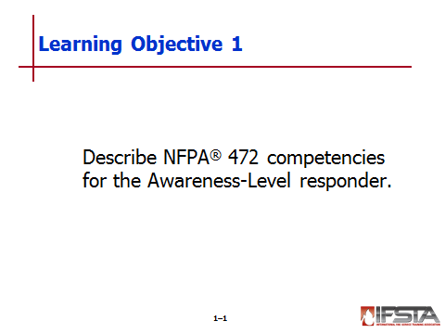
pp. 10-41 Objective 1 – Describe NFPA® 472 competencies for the Awareness-Level responder.

Review Question: What are the three main Awareness-Level competencies?
See p. 10 of the manual for answers.

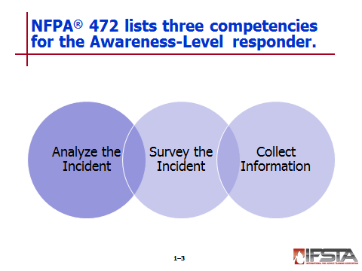
Awareness-Level Competencies

Analyze the incident to detect the possible presence of a hazardous material

Survey the incident from a safe location to identify the chemical’s:

Name

United Nations/North American (UN/NA) number

Type of placard

Other distinctive markings

Collect information from the current edition of the Emergency Response Guidebook (ERG)

Instructor Note: Explain to students that there are many response models that can be used to measure benchmarks during a hazardous materials incident. In this manual, the APIE method will be used. APIE stands for:
• Analyze the incident.
• Plan the initial response.
• Implement the response.
• Evaluate the response.

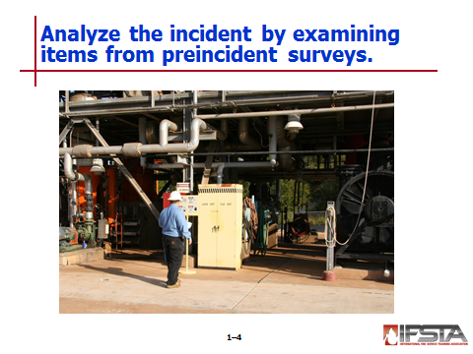
Analyzing the Incident

Occupancy types, locations, and preincident surveys

May provide first clue that hazardous materials may be involved in incident

Items identified during preincident surveys

Exposures

Types, quantities, and locations of hazardous materials in area

Dangers of hazardous materials

Building features

Site characteristics

Possible access/egress difficulties

Twenty-four hour telephone numbers of responsible parties and site experts
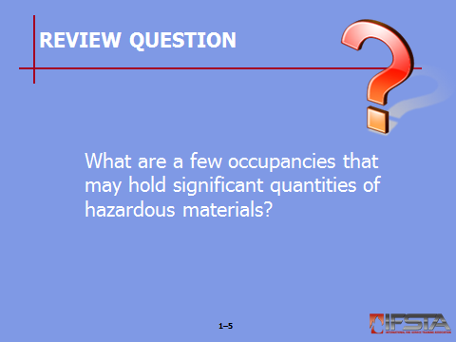
Review Question: What are a few occupancies that may hold significant quantities of hazardous materials?
See pp. 12-13 of the manual for answers.

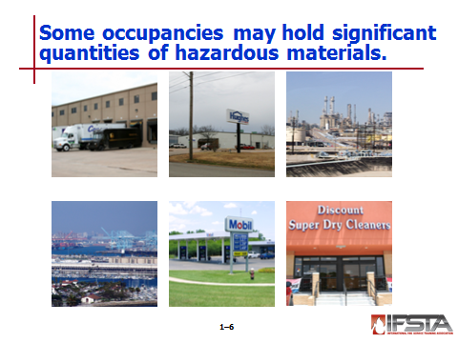
Occupancies that may hold significant quantities of hazardous materials

Fuel storage facilities

Gas/service stations and convenience stores

Paint supply stores

Plant nurseries, garden centers, and agricultural facilities

Pest control and lawn care companies

Medical facilities

Photo processing laboratories

Dry cleaners

Plastics and high-technology factories

Metal plating facilities

Mercantile concerns

Chemistry laboratories in educational facilities

Print shops

Industrial and utility plants

Port shipping facilities

Treatment storage disposal facilities

Residential occupancies are not exempt from danger

First responders should be familiar with types of hazardous materials that come through jurisdiction

Certain occupancies are more likely to be targeted for terrorist attacks

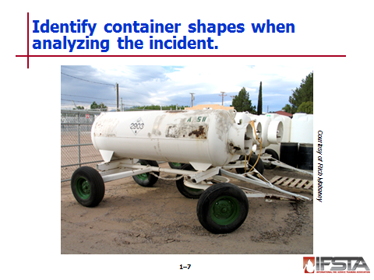
Container shapes

Can alert responders to presence of hazardous materials

Can provide useful information about materials inside

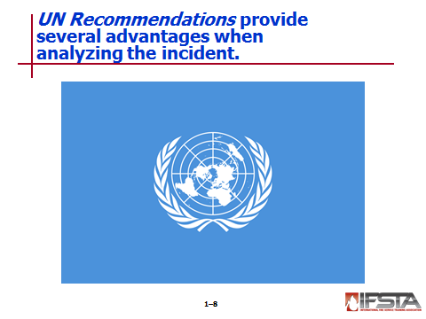
UN Recommendations

Adopted by United States, Canada, and Mexico

Provides a uniform basis for development of harmonized regulations for all modes of transport

Facilitates trade and the safe and efficient transport of hazardous materials

Provides:

Minimum requirements applicable to transport of hazardous materials by all modes of transport

Comprehensive criteria-based classification system for substances that pose significant hazard in transportation

Standards for packaging and multimodal tanks used to transport hazardous materials

System for communicating hazards of substances in transport through hazard communication requirements

Addresses labeling and marking of packages, placarding of tanks and freight units, and documentation and emergency response information required to accompany each shipment
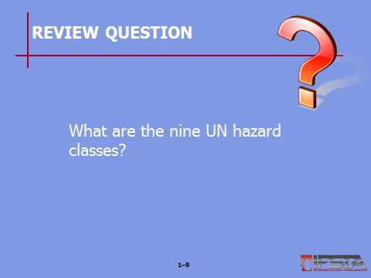
Review Question: What are the nine UN hazard classes?
See pp. 17-18 of the manual for answers.

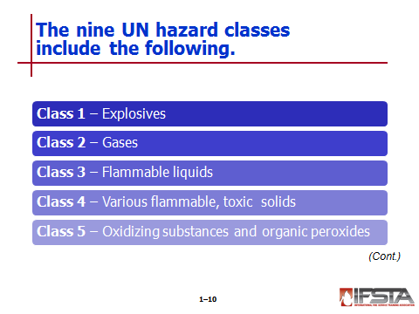
Includes nine hazard classes

Class 1 – Explosives

Class 2 – Gases

Class 3 – Flammable liquids

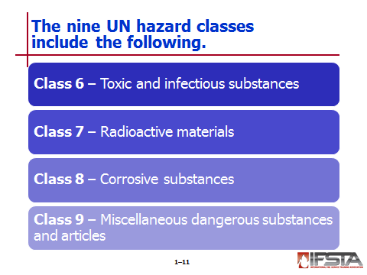
Class 4 – Flammable solids, substances liable to spontaneous combustion, substances that emit flammable or toxic gases on contact with water

Class 5 – Oxidizing substances and organic peroxides

Class 6 – Toxic and infectious substances

Class 7 – Radioactive materials

Class 8 – Corrosive substances

Class 9 – Miscellaneous dangerous substances and articles

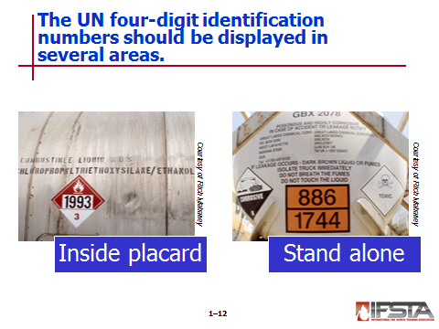
Includes a system of four-digit identification numbers

Displayed on placards, labels, orange panels, and/or markings in association with materials being transported in cargo tanks, portable tanks, tank cars, or other containers and packages

Must be displayed on bulk containers either within placard or stand alone in orange box with black lettering

In North America, must be displayed on:
          - Rail tank cars
          - Cargo tank trucks
          - Portable tanks
          - Other bulk packaging
          - Transport vehicles or freight containers containing large quantities of hazardous materials
          - Certain nonbulk packages

Forms the basis for U.S. Department of Transportation (DOT) regulations

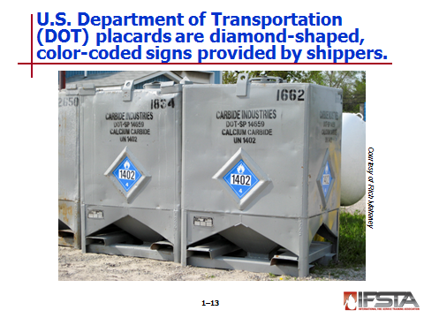
DOT placards and labels

Placards

Diamond-shaped, color-coded signs provided by shippers to identify materials in transportation containers

Different for each of nine hazard classes

Found on:
          - Bulk packages
          - Rail tank cars
          - Cargo tank vehicles
          - Portable tanks
          - Unit load devices containing hazardous materials over 640 cubic feet (18 m³) in capacity
          - Certain nonbulk containers

Required on any container transporting any quantity of the materials listed in Table 1.4 (p. 21 of the manual) or freight containers containing 1,001 pounds (454 kg) aggregate gross weight or more of hazardous materials listed in Table 1.5 (p. 21 of the manual)

Not required when gross weight of any of materials listed in Table 1.5 (p. 21 of the manual) is less than 1,001 pounds (454 kg) for any one freight container
Instructor Note: Refer students to Table 1.6 on pp. 22-27 of the manual for an explanation of the DOT hazard classes and subdivisions, the Hazardous Material Regulation (HMR) references for each, and their association placards.

Instructor Note: Discuss with students the “Placard Information” information box on pp. 19-20 of the manual.

Labels

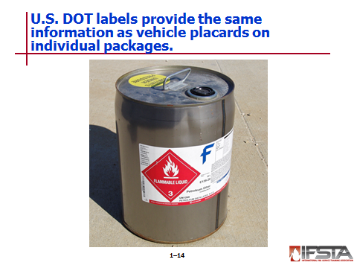
Provide same information as vehicle placards, but are placed on individual packages

3.9-inch (100 mm), square-on-point diamonds

May or may not have written text that identifies hazardous material within packaging
Instructor Note: Refer students to Table 1.7 on pp. 28-29 of the manual for examples of unique DOT labels.

Packages may include primary and secondary label

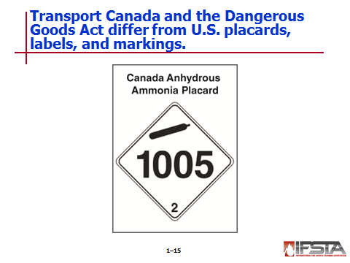
Transport Canada and the Dangerous Goods Act

Govern transportation placards, labels, and markings in Canada

Based on UN Recommendations and have same nine hazard classes

Differences from U.S. placards, labels, and markings

Most Canadian transport placards do not have any signal words on them

Labels and markings may be in both English and French

Canada requires a unique placard for anhydrous ammonia

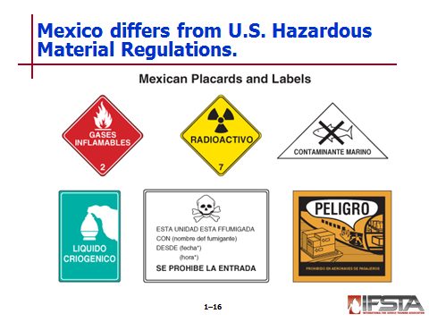
Mexican placards, labels, and markings

Based on UN Recommendations and have same hazard classes and subdivisions

May have text in Spanish

Differences from U.S. Hazardous Material Regulation

Official Mexican standards do not authorize the use of dangerous placard since NOM-004 does not include provisions for its use; however, peligroso (dangerous) placards may still be seen in Mexico

Package markings are consistent except that proper shipping name is provided in Spanish in addition to English

Hot mark used for elevated temperature materials in U.S. is not authorized in Mexico

Mexican regulations do not require marine pollutants mark for surface transportation

Mexican standards incorporate provisions for consumer commodities but do not authorize use of ORM-D description as a package marking

The Mexican standard regarding classification of flammable liquids does not incorporate provisions for combustible liquids

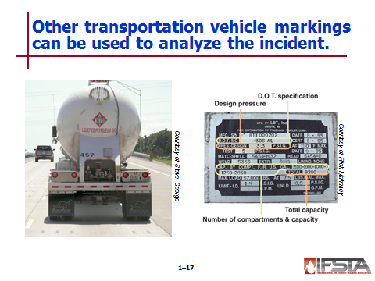
Other transportation vehicle markings

Company names

Logos

Specific tank colors

Stenciled commodity names

Manufacturers’ specification plates

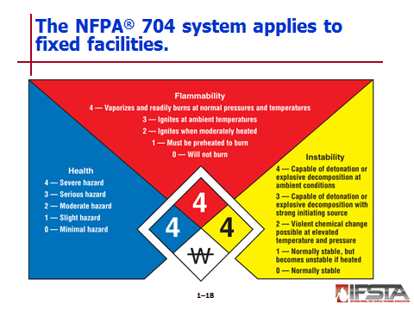
NFPA® 704 system

Provides widely recognized method for indicating presence of hazardous materials at commercial, manufacturing, institutional, and other fixed-storage facilities

Commonly required by local ordinances for all occupancies that contain hazardous materials

Designed to alert emergency responders to health, flammability, instability, and related hazards

NOT designed for certain situations

Transportation

General public use

Nonemergency occupational exposures

Explosives and blasting agents, including commercial explosive materials

Chronic health hazards

Biological agents and other similar hazards

Uses a rating system of numbers from 0 to 4

0 indicates minimal hazard; 4 indicates a severe hazard

Assigned to three categories: health, flammability, and stability

Arranged on a diamond-shaped marker or sign

Health – Blue background

Flammability – Red background

Instability – Yellow background

Special hazards – White background in six o’clock position

Provides very useful information, but has limitations

No specific quantities

No specified location on buildings

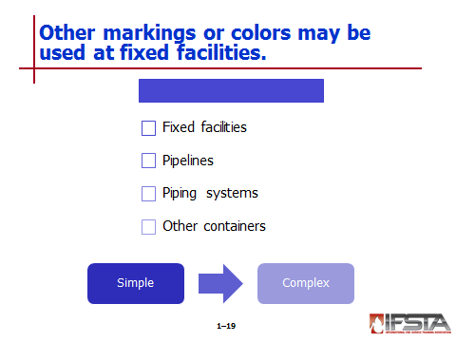
Other markings and colors

May indicate presence of hazardous materials at fixed facilities, on pipelines, on piping systems, and on other containers

May be simple or complicated

May include identification numbers that correspond to site or emergency plans

Common specialized systems used in North America

Common hazardous communication labels

International Organization for Standardization (ISO) safety symbols

Globally Harmonized System symbols

Military markings

Pipeline identifications

Signal words

Chemical Abstracts Service (CAS) numbers

American Petroleum Institute (API) markings

Pesticide labels

Color codes

Written resources

Shipping papers

Included with shipments of hazardous materials

Provided through bill of lading, waybill, etc.

Location and type of paperwork change according to mode of transport
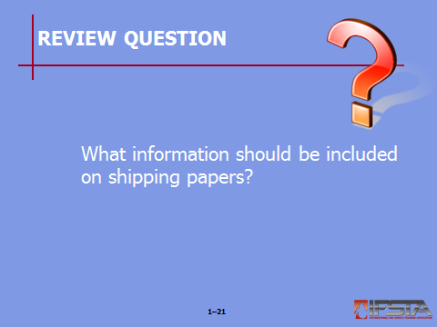
Review Question: What information should be included on shipping papers?
See p. 34 of the manual for answers.

Should include:
          - Identification number (UN or NA)
          - Proper shipping name of material
          - Hazard class represented by material
          - Packing group assigned to material
          - Quantity of material

May be located and examined by responders trained to Operations-Level or higher if deemed safe to do so

Train consists

Should be located with train crew

If crew cannot be located, contact railroad company or engine for train list

Will include count and list of train cars from front to back

Bills of lading

Shipping papers used by trucking industry

Indicate origin, destination, route, and product being carried

Must be placed in cab of every truck tractor

Must be within arm’s reach of driver

Establishes terms of contract between shippers and transportation companies

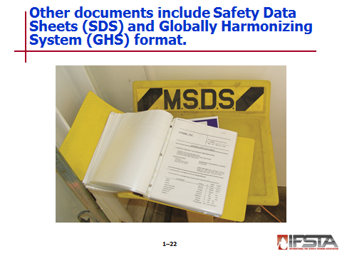
Serves as document of title, contract of carriage, and receipt for goods

Safety data sheets (SDSs)

Detailed information bulletins prepared by manufacturer or importer of a chemical

Provides specific information about product

Often best sources of detailed information about a particular material

Can be acquired from manufacturer of material, supplier, shipper, emergency response center, or facility hazard communication plan

Globally Harmonized System (GHS) format

Specifies minimum information to be provided on SDSs

Used worldwide

Sections

1: Identification

2: Hazard(s) identification

3: Composition/information on ingredients

4: First aid measures

5: Fire fighting measures

6: Accidental release measures

7: Handling and storage

8: Exposure controls/personal protection

9: Physical and chemical properties

10: Stability and reactivity

11: Toxicological information

12: Ecological information

13: Disposal considerations

14: Transport information

15: Regulatory information

16: Other information

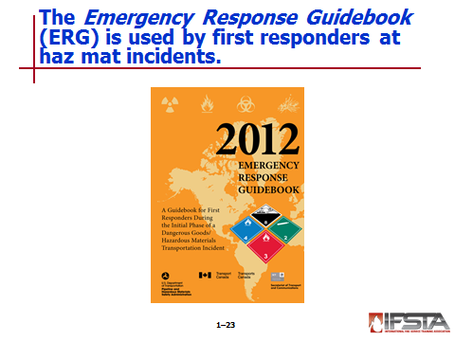
Emergency Response Guidebook (ERG)

Used by firefighters, law enforcement, and other emergency services personnel who may be first to arrive at scene involving dangerous goods/hazardous materials

Aids emergency responders in quickly identifying general or specific hazards of materials involved in emergency incident and protecting themselves and the general public during the initial response phase of the incident

Does not address all possible circumstances that may be associated with a dangerous goods/hazardous materials incident

Primarily designed for use at an incident occurring on highway or railroad

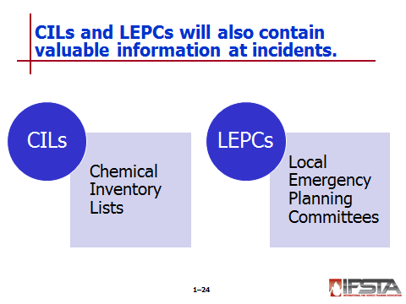
Chemical Inventory Lists (CILs)

Required of all U.S. employers for all hazardous substances

Contain information about locations of materials within a facility

Other documents that may provide information about hazardous materials at facility

Shipping and receiving documents

Inventory records

Risk management and hazardous communication plans

Chemical inventory reports

Local Emergency Planning Committees (LEPCs)

Good source of information

Designed to provide forum for emergency management agencies, responders, industry, and public to work together to evaluate, understand, and communicate chemical hazards in community

Develop appropriate emergency plans in case of accidental release of these chemicals

Senses

May be used with caution in detection of a hazardous material

Vision – Safest to use

Other senses usually require contact too close to be safe
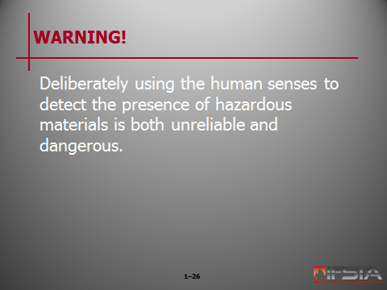
WARNING! Deliberately using the human senses to detect the presence of hazardous materials is both unreliable and dangerous.

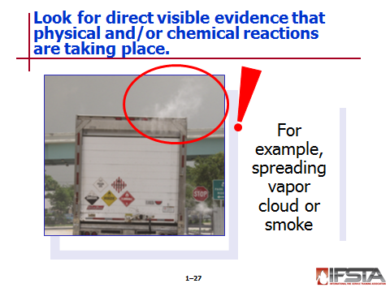
Direct visible evidence that physical and/or chemical actions and reactions are taking place
Interactive slide; use mouse to show all information

Spreading vapor cloud or smoke

Unusual colored smoke

Flames

Changes in vegetation

Container deterioration

Containers bulging

Sick humans

Dead or dying birds, animals, insects, or fish

Discoloration of valves or piping

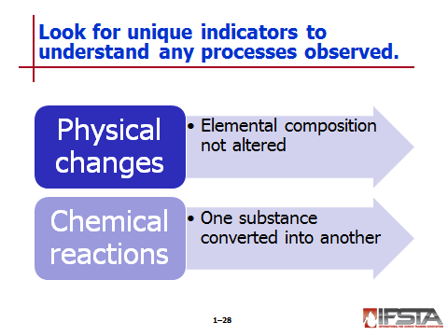
Physical changes

Processes that do not change elemental composition of materials involved

Indications

Rainbow sheen on water surfaces

Wavy vapors over volatile liquid

Frost or ice buildup near a leak

Containers deformed by force of accident

Activated pressure-relief devices

Pinging or popping of heat-exposed vessels

Chemical reactions – Evidence:

Exothermic heat

Unusual or unexpected temperature drop

Extraordinary fire conditions

Peeling or discoloration of container’s finish

Spattering or boiling on unheated materials

Distinctively colored vapor clouds

Smoking or self-igniting materials

Unexpected deterioration of equipment

Peculiar smells

Unexplained changes in ordinary materials

Symptoms of chemical exposure

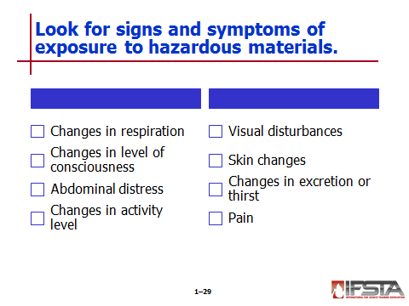
Signs and symptoms of exposure

Changes in respiration

Changes in level of consciousness

Abdominal distress

Change in activity level

Visual disturbances

Skin changes

Changes in excretion or thirst

Pain

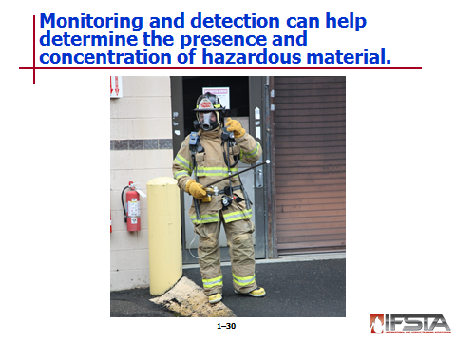
Monitoring and detection

Can be useful in determining presence of hazardous materials as well as concentration(s) present

Can be used to determine scope of incident

Requires actual contact with hazardous material

Outside scope of action for Awareness-Level personnel

Implementing the Planned Response
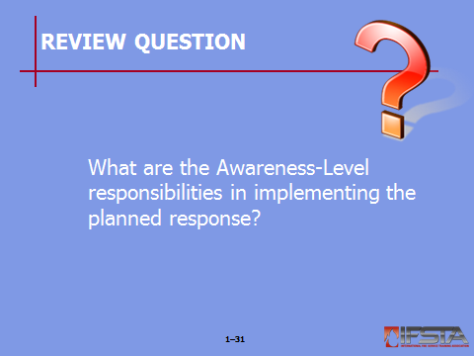
Review Question: What are the Awareness-Level responsibilities in implementing the planned response?
See pp. 38-39 of the manual for answers.

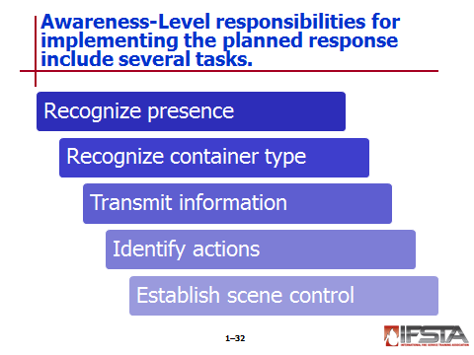
Awareness-Level responsibilities

Recognize presence or potential presence of a hazardous material

Recognize type of container at site and identify material in container if possible

Transmit information to appropriate authority and call for appropriate assistance

Identify actions to protect themselves and others from hazards

Establish scene control by isolating hazardous area, denying entry, and initiating Incident Command System (ICS)

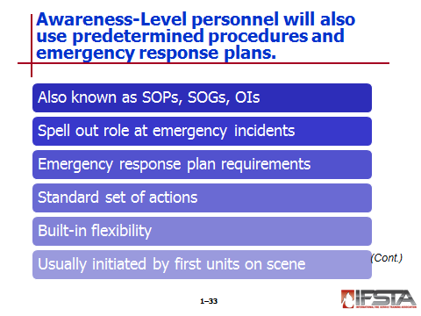
Predetermined procedures and emergency response plans

Also known as standard operating procedures (SOPs), standard operating guidelines (SOGs), or operating instructions (OIs)

Spell out role of Awareness-Level personnel at emergency incidents

Emergency response plans – Required by OSHA 29 CFR 1910.120(q)(2) to cover

Preincident planning and coordination with outside parties

Personnel roles, lines of authority, training, and communication

Emergency recognition and prevention

Safe distances and places of refuge

Site security and control

Evacuation routes and procedures

Decontamination

Emergency medical treatment and first aid

Emergency alerting and response procedures

Critiques of response and follow-up

PPE and emergency response equipment

Provide standard set of actions that are core of every hazardous materials incident plan

Should have built-in flexibility that allows adjustments

Usually initiated by first units on-scene

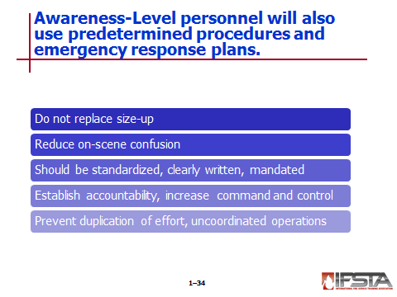
Do not replace size-up decisions based on judgment, evaluation, or command

Reduce on-scene confusion

Should be standardized, clearly written, and mandated to each member of the organization

Establish accountability and increase command and control effectiveness

Prevent duplication of effort and uncoordinated operations

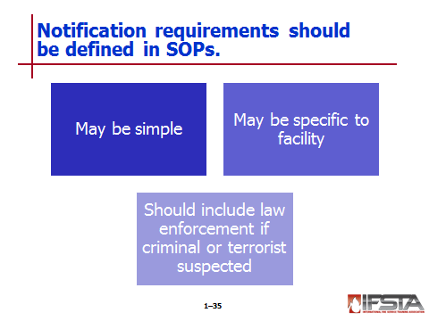
Notification requirements

Should be defined in SOPs

May be as simple as dialing
9-1-1

May be specific to facility

Should include law enforcement if criminal or terrorist activity suspected

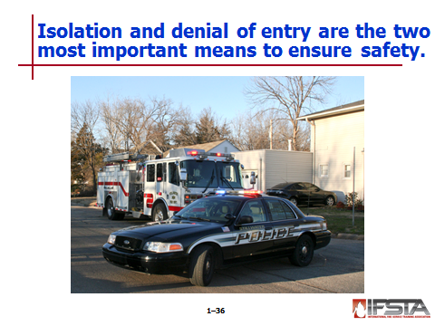
Isolation and denial of entry

Two of most important means by which responders can ensure their own safety and safety of others

Necessary to protect life safety of everyone involved

Prevents spread of hazardous materials through cross contamination

Involves physically securing and maintaining scene by establishing isolation perimeters and denying entry to unauthorized persons

Includes preventing contaminated or potentially contaminated individuals from leaving scene in order to stop spread of hazardous materials

May continue with evacuation, defending in place, or sheltering in place

Isolation perimeter

Boundary established to prevent access by public or unauthorized persons

Can be expanded or reduced as needed

Used to control both access and egress from scene

If inside – Denying entry and exit from building

If outside – Set at surrounding intersections by law enforcement, ropes, cones, or barrier tape

Section II: Operations-Level Competencies

operations-level competencies
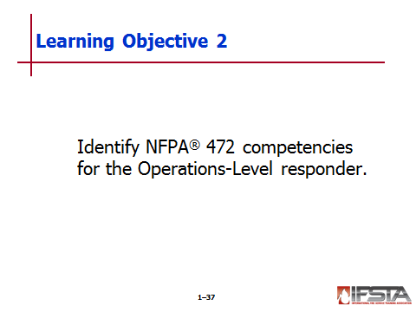
pp. 42-62 Objective 2 – Identify NFPA® 472 competencies for the Operations-Level responder.

Analyzing the Incident

First step in mitigating any emergency incident

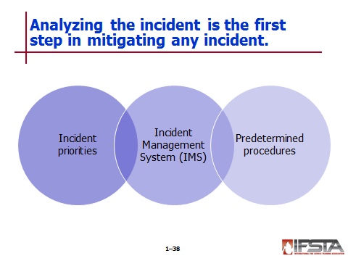
Includes incident priorities, Incident Management System (IMS), and predetermined procedures

Enables first responders to form overall plan of action

Should include identification of hazardous material or hazard class, as well as other factors that have effect on situation

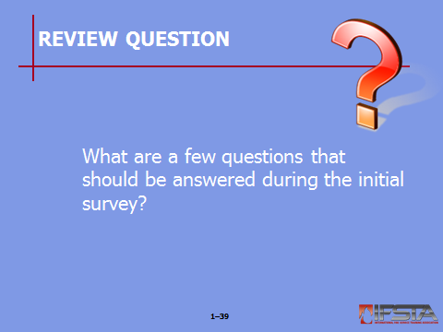
Review Question: What are a few questions that should be answered during the initial survey?
See pp. 42-43 of the manual for answers.

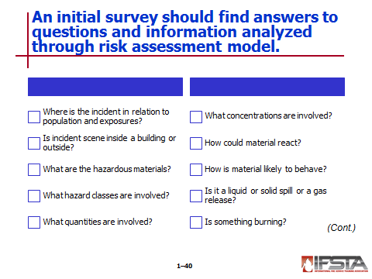
Initial survey should include answers to certain questions

Where is incident scene in relation to population and environmental and property exposures?

Is incident scene inside a building or outside?

What are the hazardous materials?

What hazard classes are involved?

What quantities are involved?

What concentrations are involved?

How could material react?

How is material likely to behave?

Is it a liquid or solid spill or a gas release?

Is something burning?

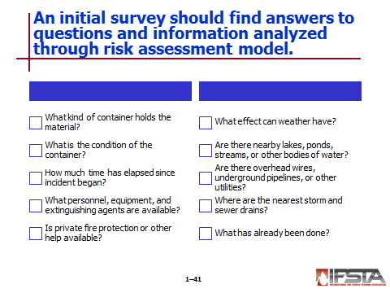
What kind of container holds the material?

What is the condition of container?

How much time has elapsed since incident began?

What personnel, equipment, and extinguishing agents are available?

Is private fire protection or other help available?

What effect can weather have?

Are there nearby lakes, ponds, streams, or other bodies of water?

Are there overhead wires, underground pipelines, or other utilities?

Where are nearest storm and sewer drains?

What has already been done?

Information should be gathered and analyzed through a hazard and risk assessment model such as General Emergency Behavior Model (GEBMO)

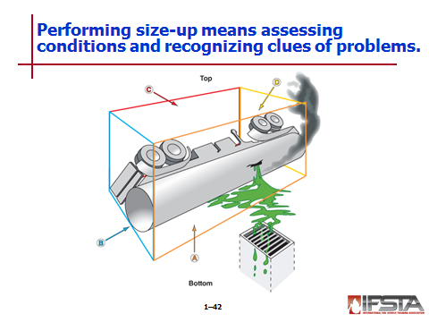
Size-up: Surveying materials and containers involved

Assessment of incident conditions and recognition of clues indicating problems and potential problems presented by an incident

Mental process of considering all available factors that will affect incident during the course of the operation

Used to determine strategies and tactics that are applied to incident during planning and implementation stages

Includes hazard and risk assessment

Must consider all six sides of the incident – Alpha, Bravo, Charlie, Delta, and top and bottom

Frequently complicated by limited information

Not just responsibility of Incident Commander (IC)

Continuing functions that must be performed constantly by all personnel on-scene

May include:

Number and types of injuries

Occupancy type

Type of incident

Product and container information if available

Location of the incident

Equipment and resources responding

Time of day

Weather

Should include evaluation of certain conditions on scene

Unusual signs

Life hazards

Product(s) involved

Container types

Amount of product involved

Product travel or path of fire

Actions already taken by people on-scene

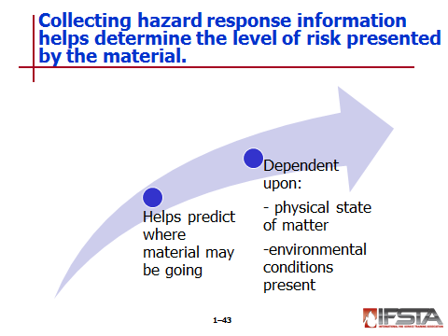
Collecting hazard response information

Assists in determining level of risk presented by material itself

May involve use of ERG, GEBMO, or plume-modeling software

Should help to predict where the hazardous material may be going, given its physical state of matter and environmental conditions present

May include use of monitoring and detection devices

Predicting likely behavior

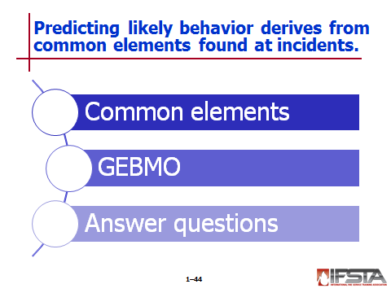
Hazardous materials incidents have common elements

Material or materials presenting hazards to people, environment, or property

Container or containers that have failed or have potential to fail

Exposure or potential exposure to people, environment, and/or property

GEBMO

Helps first responders predict course of incident and establish guidelines for defensive actions

Enables responders to limit effects of a hazardous material

Should include answering certain questions

How long will harmful exposure exist?

What has stressed or is stressing the container?

How will stressed container and its material behave?

What are harmful effects of contained materials?
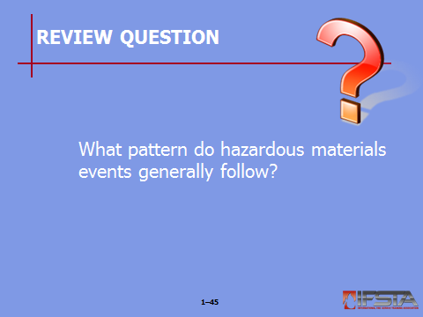
Review Question: What pattern do hazardous materials events generally follow?
See p. 46 of the manual for answers.

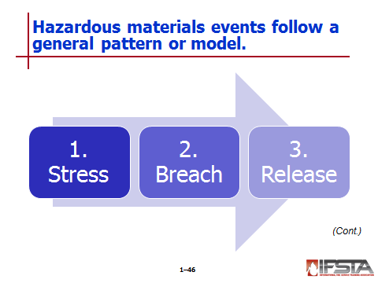
Events follow general pattern or model

Stress

May be thermal, mechanical, or chemical

Type will influence how container will breach or release

Breach

May be partial or total

Based on construction material, type of stress that it is exposed to, and pressure inside container at time that it fails

Release – Always involves product and may involve release of energy and container parts

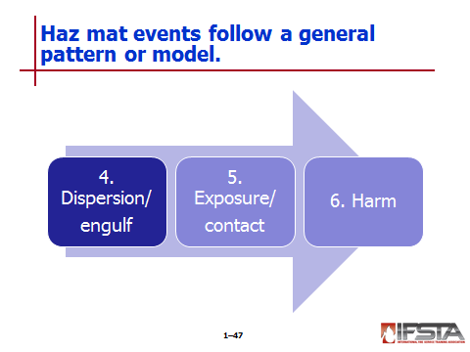
Dispersion/Engulf – Patterns are based on laws of chemistry and physics and characteristics of product

Exposure/Contact – Can be anything in area

Harm – Depends on container, product, energy involved

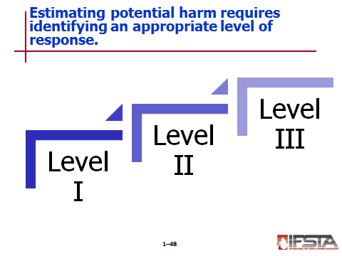
Estimating potential harm

Should include references such as SDSs and ERG to determine health and physical hazards presented by material

Should also include prediction where the hazardous material may be going

May include monitoring and detection devices

Should include definition of level of response, which can identify level of involvement and necessary resources

Level I

Within capabilities of fire or emergency services organization

Least serious and easiest to handle

May pose serious threat to life or property, but not usually

Evacuation is limited to immediate area of incident

Property owner is typically responsible for cleanup and disposal

Level II

Beyond capabilities of first responders on scene

May be beyond capabilities of first response agency/organization having jurisdiction

May require services of formal haz mat response team

Level III

Typically requires resources from state/provincial agencies, federal agencies, and/or private industry

Requires Unified Command

Most serious of all hazardous materials incidents

May require large-scale evacuation

Will most likely not be concluded without assistance of outside agencies

Often requires use of specialists from industry and government, sophisticated sampling and monitoring equipment, specialized leak and spill control techniques, and large-scale decontamination

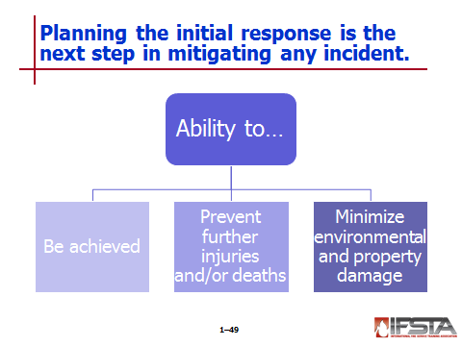
Planning the Initial Response

Includes establishment of strategic goals and tactical objectives; selected based on certain criteria

Ability to be achieved

Ability to prevent further injuries and/or deaths

Ability to minimize environmental and property damage within constraints of safety, time, equipment, and personnel

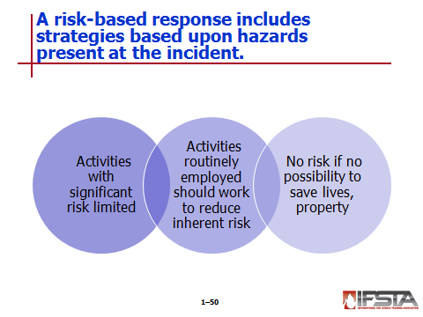
Risk-based response

Strategies are based upon hazards present at the incident

Principles

Activities that present significant risk to safety of members shall be limited to situations where there is potential to save endangered lives

Activities that are routinely employed to protect property shall be recognized as inherent risks to safety of members, and actions shall be taken to reduce or avoid these risks

No risk to safety of members shall be acceptable when there is no possibility to save lives or property

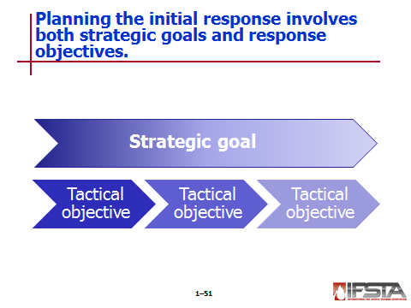
Strategic goals and response objectives

Strategic goals – Broad statements of what must be done to resolve an incident

Tactical objectives – Specific operations done to accomplish strategic goals

Standard strategic goals

Isolation

Notification

Identification

Protection

Rescue

Spill/leak control and confinement

Crime scene and evidence preservation

Fire control

Recovery/termination

Prioritized depending on available resources and particulars of incident

Response options

Selection is based on risk to responders, their level of training, and balance between resources required and those available

May change during the course of an incident

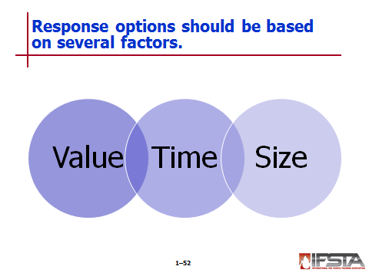
Elements affecting selection

Value – Related directly to incident priorities of life safety, incident stabilization, and property and environmental conservation

Time – Limited window of opportunity exists to intervene before an incident escalates dramatically

Size – Most frequently driven by need to conduct protective action concurrently with incident control operations
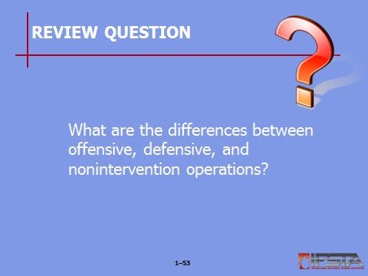
Review Question: What are the differences between offensive, defensive, and nonintervention operations?
See pp. 51-52 of the manual for answers.

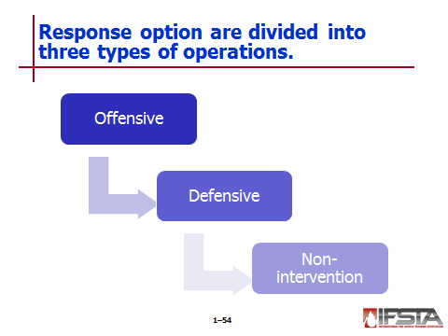
Offensive operations

Those where responders take direct action on material, container, or process equipment involved

May result in contact with material and therefore require responders to wear appropriate chemical-protective clothing and respiratory protection

Some are beyond scope of responsibilities for first responders

Defensive operations

Those in which responders seek to confine the emergency to a given area without directly contacting hazardous materials involved

Selected when one of the following circumstances exists:

If facility or Local Emergency Response Plan (LERP) calls for it based on a preincident evaluation of hazards present at site

If responders have training and equipment necessary to confine incident to area of origin

Nonintervention operations

Those in which responders do not take direct actions on actual problem

Selected when one or more circumstances exist:

Facility or LERP calls for it based on preincident evaluation of hazards present at site

Situation is clearly beyond capabilities of responders

Explosions are imminent

Serious container damage threatens a massive release

Actions to be taken

Initiate IMS

Withdraw to safe distance

Report scene conditions to telecommunications center

Call for additional resources as needed

Isolate hazard area and deny entry

Commence evacuation where needed

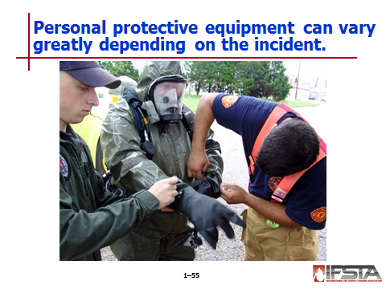
PPE requirements

May include anything from standard fire fighting protective clothing to chemical-protective clothing or body armor

Protects skin, eyes, face, hands, feet, body, head, hearing and respiratory system against a variety of hazardous materials

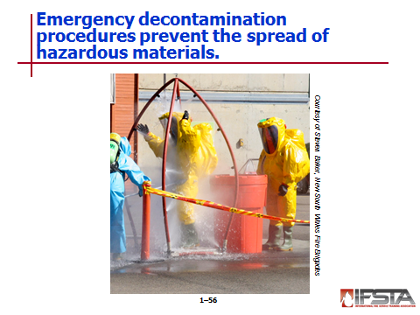
Emergency decontamination procedures

Process of removing hazardous materials to prevent spread of contaminants beyond a specific area and reduce contamination to levels that are no longer harmful

Essential activity that must be considered at any hazardous materials or terrorism incident to ensure safety of emergency responders and public

Minimize harmful exposures and reduce or eliminate spread of contaminants

Performed at haz mat/WMD incidents to remove hazardous materials from responders, victims, PPE, tools, equipment, and anything else that has been contaminated

Required of anything that passes through hot zone

Provides victims with psychological reassurance

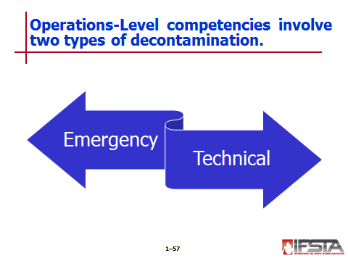
Emergency decontamination

Purpose – Remove threatening contaminant from victim as quickly as possible

No regard for environment or property protection

May be necessary for both victims and rescuers

Instances

Failure of protective clothing

Accidental contamination of emergency responders

Heat illness or other injury suffered by emergency workers in the hot zone

Immediate medical attention is required

Has limitations

Technical decontamination

Uses chemical or physical methods to thoroughly remove or neutralize contaminants from responders’ PPE and equipment

Used on incident victims in situations that are not life-threatening

Can be performed by Operations-Level responders under guidance of haz mat technician, SOPs, or allied professional

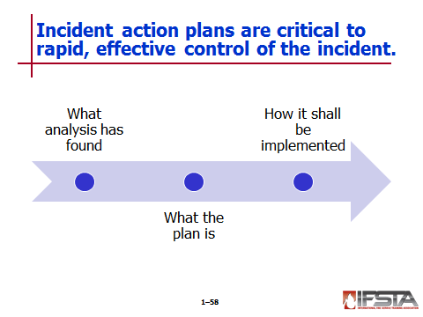
Incident action plans

Critical to rapid, effective control of emergency operations

Well thought out, organized course of events developed to address all phases of incident control within specified time frame that allows least negative action to continue

Not necessary for short-term, routine operations

Start by identifying strategy that will achieve a solution to problems faced; tactics are then selected to achieve strategy

Provide for necessary support resources such as water supply, utility control, or SCBA cylinder filling

Essentially tie entire problem-solving process together by stating what analysis has found, what plan is, and how it shall be implemented
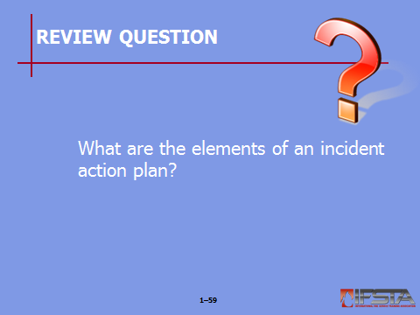
Review Question: What are the elements of an incident action plan?
See pp. 55-56 of the manual for answers.

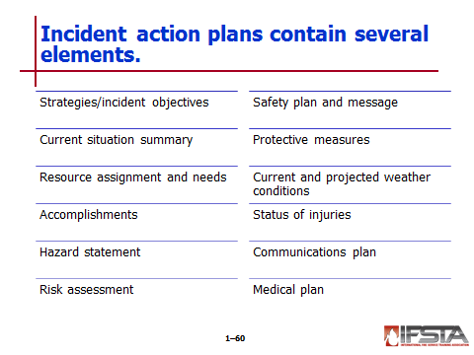
Elements

Strategies/incident objectives

Current situation summary

Resource assignment and needs

Accomplishments

Hazard statement

Risk assessment

Safety plan and message

Protective measures

Current and projected weather conditions

Status of injuries

Communications plan

Medical plan

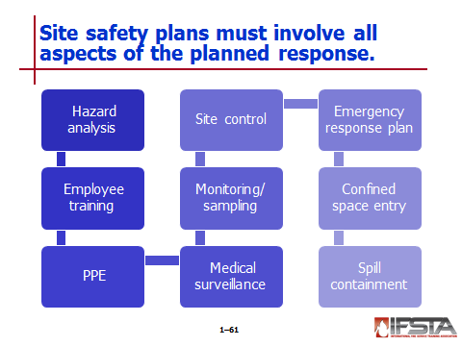
Site safety plans

Required by 29 CFR 1910.120(b)(4)(ii)

Must encompass all aspects of response

Should include, at a minimum

Hazard analysis for each site task and operation found in work plan

Employee training assignments to ensure compliance with 29 CFR 1910.120 regulation

Personal protective equipment requirement for each specific task

Medical surveillance requirements

Frequency and types of air monitoring, personnel monitoring and environmental sampling techniques and instruments to be used

Site control measures

An emergency response plan

Confined space entry procedures

A spill containment program

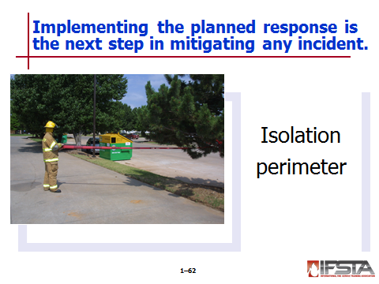
Implementing the Planned Response

Takes place after incident has been surveyed and haz mat response personnel have analyzed data and different response options in planning phase

Establishing and enforcing control procedures

Isolation perimeter

May be composed of inner and outer perimeter

May be expanded or reduced in size as needed

Determined by outcome of on-site risk assessment or size-up done by IC

Used to control access and egress from the incident

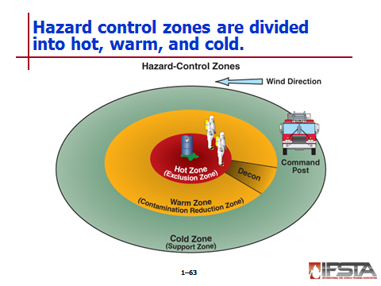
Hazard control zones

Hot zone

Area surrounding incident that is potentially very dangerous

May be contaminated by chemical warfare agents or may have potential to become contaminated by a released hazardous material

Work performed is limited to highly trained and equipped personnel

Has established access and egress points to ensure accountability and designated PPE

Extends far enough to prevent those outside zone from suffering ill effects from released material, explosion, or other threat

Warm zone

Area adjoining hot zone and extending to cold zone

A buffer between hot and cold zones

Where decontamination occurs

May be considered to be part of the crime scene

Requires PPE, perhaps at a reduced level from hot zone

Cold zone

Surrounds warm zone

Used to carry out all logistical support functions of incident

Does not require personal protective clothing

Includes command post, donning/doffing area, backup teams, research teams, logistical support, criminal investigation teams, triage/treatment/
rehab, transportation areas, and staging area

Establishing control zones

May be different for each response agency

May change as evidence is processed

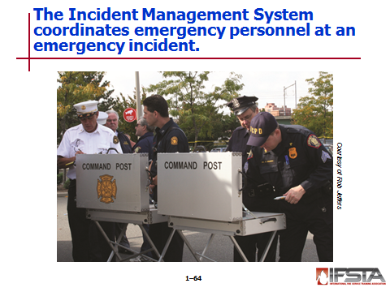
Initiating the Incident Management System

Forms framework for control and coordination structure that enables emergency personnel to turn chaos into order and effectively manage any emergency incident

Any response organizations in the U.S. that receives any type of federal funding are required to use National Incident Management System – Incident Command System (NIMS-ICS)

Command

Established by first person on scene or ranking individual of first company on scene

Maintained until higher ranking or more extensively trained responder arrives on the scene

Can be assumed only by someone having IMS training and trained to at least the Operations-Level

Transferring command

Person accepting must be capable of assuming command and be willing to accept responsibility

Can be accomplished over the radio

Can only be transferred to someone who is on scene

May take place numerous times as a large incident comes under control

Must include as clear a picture of the incident as possible; should be acknowledged by repeating information

Must be as smooth and efficient as possible

Must be announced to avoid confusion
Instructor Note: Reiterate to students that there is only one IC.

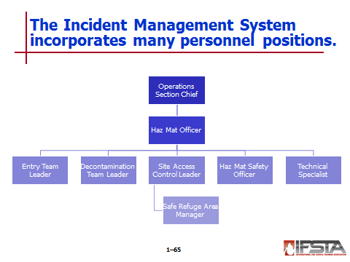
IMS positions

Hazardous Materials Officer (Branch Director/Group Supervisor)

Entry Team Leader

Decontamination Team Leader

Site Access Control Leader

Hazardous Materials Safety Officer

Technical Specialist (Hazardous Materials Reference/Science Technical Specialist)

Safe Refuge Area Manager

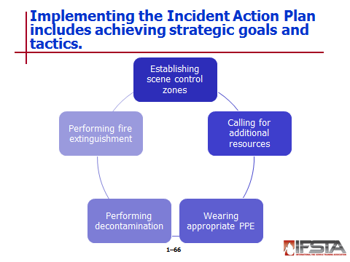
Implementing the Incident Action Plan

Includes achievement of strategic goals and tactics

Tactics

Two categories – Confinement or containment

Establishing scene control zones

Calling for additional resources

Wearing appropriate PPE

Performing decontamination

Performing fire extinguishment

Must include contact between IC and officers and crew

If cannot be achieved, may need to be reassessed

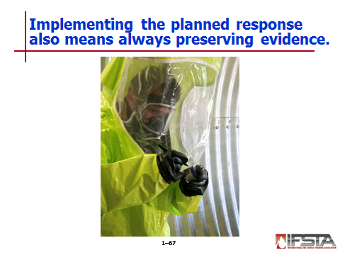
Preserving evidence

Must include establishment of security perimeter with access control point

Must include control, identification, and removal of persons

To aid in securing and protecting the scene, responders should:

Prevent individuals from altering or destroying physical evidence by restricting movement, location, and activity while ensuring and maintaining safety at the scene

Identify all individuals at the scene who may be suspects or witnesses and secure and separate them

Determine if bystanders are witnesses

Exclude unauthorized and nonessential personnel from scene

Take note of any type of evidence; taking special care to document and protect transient and trace evidence

Consult with law enforcement and/or evidence technicians before disturbing transient or trace evidence

Document any items within perimeter that have been disturbed or moved by emergency responders

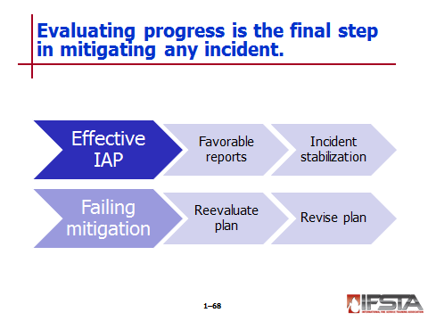
Evaluating Progress

Final aspect of problem-solving process

If IAP is effective, IC should receive favorable progress reports and incident should stabilize

If mitigation efforts are failing, plan must be reevaluated and revised

Section III: Technician-Level Competencies

technician-level competencies
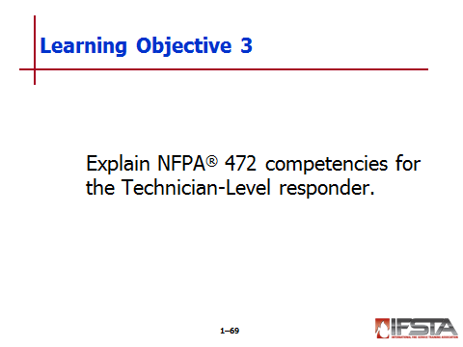
pp. 62-70 Objective 3 – Explain NFPA® 472 competencies for the Technician-Level responder.
Review Question: What are the NFPA® 472 competencies for the Technician-Level responder?
See pp. 62-69 of the manual for answers.

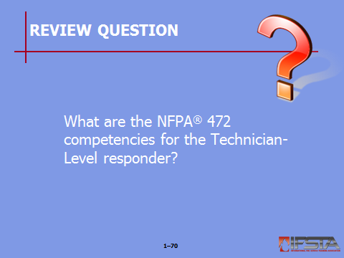
Training

Must come in phases

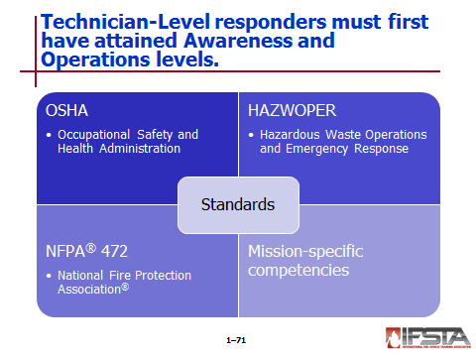
Must be gained in Awareness and Operations Levels first

OSHA standards

Occupational Safety and Health Administration (OSHA)

Outlines training requirements for employees who work with chemicals

Establishes various standards

Legally enforces standards

Hazardous Waste Operations and Emergency Response (HAZWOPER)

Broken down into 17 paragraphs

Addresses subjects such as medical monitoring and health and safety plans

Paragraph Q refers to emergency response

Development of Emergency Response Plan

Procedures for handling emergency response

Skilled support personnel

Specialist employees

Training

Trainers

Refresher training

Medical surveillance

Chemical protective clothing

Postemergency response operations

NFPA® standards

NFPA® 472 outlines competencies relating to haz mat incidents

Technician-Level competencies included in NFPA® 472

Technician-Level Responders

Incident Commanders

Specialist Employees

Hazardous Materials Officers

Hazardous Materials Safety Officers

Hazardous Materials Technicians with a Tank Car Specialty

Hazardous Materials Technicians with a Cargo Tank Specialty

Hazardous Materials Technicians with an Intermodal Tank Specialty

Hazardous Materials Technicians with a Marine Tank and Non-Tank Vessel Specialty

Hazardous Materials Technicians with a Flammable Liquids Bulk Storage Specialty

Hazardous Materials Technicians with a Flammable Gases Bulk Storage Specialty

Hazardous Materials Technicians with a Radioactive Material Specialty

Mission-specific competencies

Outlined in NFPA® 472

Optional proficiencies that allow community and AHJ to match a task with requirements to perform those tasks

Over and above core competencies of each response level

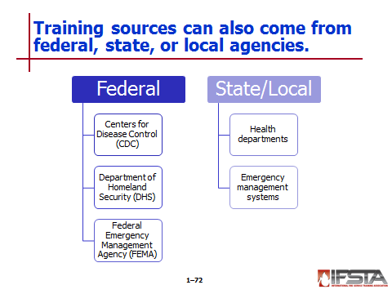
Training sources

Federal agencies

Centers for Disease Control and Prevention (CDC)

Department of Homeland Security (DHS)

Federal Emergency Management Agency (FEMA)

State and local agencies

State and local health departments

State and local emergency management departments

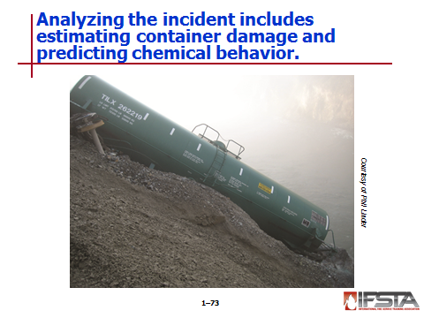
Analyzing the Incident

Estimating container damage

Requires a knowledge of containers, their potential contents, and associated hazards

Technicians should know:

Container identification

Container construction features

Container’s typical contents

Capacity estimation

Common leak points

Predicting behavior

Requires understanding of chemical and physical properties of substances

Requires general knowledge of chemistry and the associated properties of substances

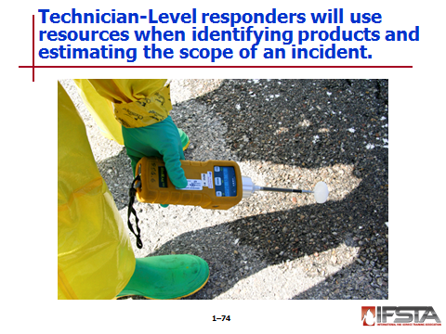
Resources – Assist responders with product identification

Estimating scope

Requires understanding of chemical and physical properties of a product

Determined through use of chemical reference manuals and databases

Planning the Initial Response

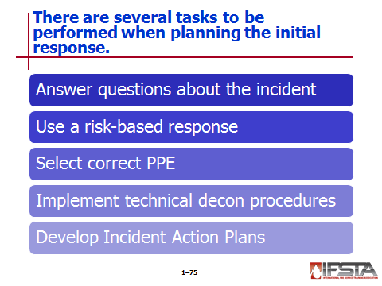
Requires answers to certain questions

What response option will be used?

Will mitigation be done offensively or defensively?

What equipment and PPE will be needed to support chosen option?

What decontamination process will be used?

Using risk-based response

Should be taken with regards to considering protective clothing options, control measures, and decontamination options

Variety of models to choose from

Selecting PPE – Critical at Technician Level because of offensive work

Implementing technical decontamination procedures

Required when leaving hazard area

Different levels and methods

Developing Incident Action Plans

Required before implementing a response plan

May be in writing

Must be developed with incident and hazards in mind

Response

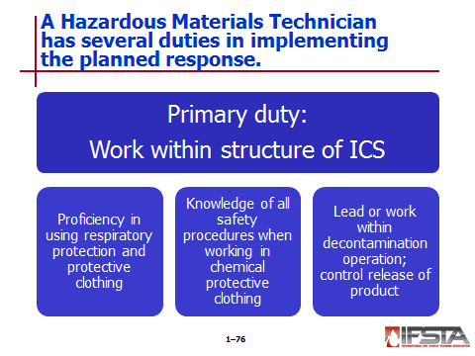
Duties of hazardous materials technician

May be diverse, based on chosen response model and area of responsibility the technician is assigned

Primary duty – To work within structure of Incident Command System

Proficiency in use of respiratory protection and protective clothing

Knowledge of certain safety procedures

Actions necessary when there is a loss of air supply

Actions necessary when there is a loss of suit integrity

Actions necessary when there may be a responder down in the hot zone

Lead or work within a decontamination operation

Product control

Primary objective of hazardous materials technician

Includes selection and utilization of proper tools, equipment, and materials

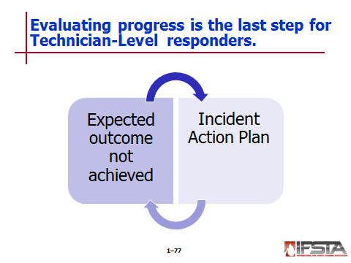
Evaluating Progress

Last phase of process

Ensures that progress is being made and that desired outcome will be achieved

If determines that expected outcome may not be realized, IC must refer back to IAP and begin problem-solving process again

Includes effectiveness of decontamination process

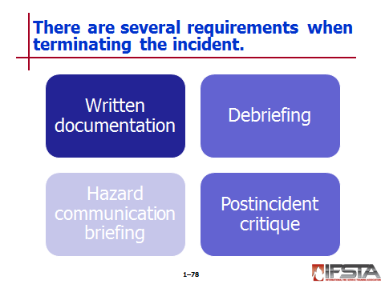
Terminating the Incident

Written documentation

Debriefing

Hazard communication briefing

Provides information to personnel concerning signs and symptoms of overexposure to hazardous material(s) involved in incident

Must be thoroughly documented

Includes

Identity of material involved

Potential adverse effects of exposure to the material

Actions to be taken for further decontamination

Signs and symptoms of an exposure

Mechanism by which a responder can obtain medical evaluation and treatment

Exposure documentation procedures

Postincident critique

Required by OSHA Title 29 CFR 1910.120

Identifies operational deficiencies and learning from mistakes

Needs to occur as soon as possible after incident and involve all responders

Documented to identify those in attendance as well as any operational deficiencies that were identified

Section IV: Summary and Review

summary and review

Chapter Summary

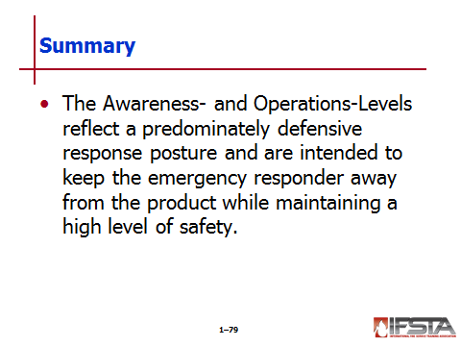
The Awareness- and Operations-Levels reflect a predominately defensive response posture and are intended to keep the emergency responder away from the product while maintaining a high level of safety.

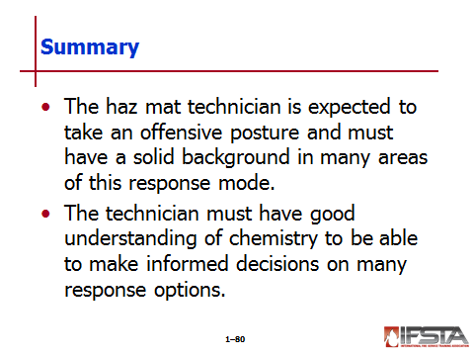
The haz mat technician is expected to take an offensive posture and must have a solid background in many areas of this response mode.

Review Questions

What are the three main Awareness-Level competencies? (10)

What are a few occupancies that may hold significant quantities of hazardous materials? (12-13)

What are the nine UN hazard classes? (17-18)

What information should be included on shipping papers? (34)

What are the Awareness-Level responsibilities in implementing the planned response? (38-39)

What are a few questions that should be answered during the initial survey? (42-43)

What pattern do hazardous materials events generally follow? (46)

What are the differences between offensive, defensive, and nonintervention operations? (51-52)

What are the elements of an incident action plan? (55-56)

What are the NFPA® 472 competencies for the Technician-Level responder? (62-69)

