Chapter 12
Incident Demobilization
and Termination

Lesson Goal
After completing this lesson, the student shall be able to explain incident demobilization and describe the steps for terminating the emergency phase of an incident.
Objectives
Upon successful completion of this lesson, the student shall be able to:
1. Define demobilization.
2. Explain the importance of incident termination. [NFPA® 472, 7.6.1, 7.6.2, 7.6.3(1, 4-5, 7, 10)]

Instructor Information
This is the lesson covering demobilization and termination activities of a hazardous materials incident. This chapter discusses the importance of incident termination, and the various documents needed to terminate an incident.

Important instructor information is provided in shaded boxes throughout the lesson plan. Carefully review the instructor information before presenting the lesson.

Methodology
This lesson uses lecture and discussion. The level of learning is comprehension.

Outline Contents

Section | Outline Pages | Text Pages
Section I: Demobilization | 5 | 585
Section II: Incident Termination | 7 | 586
Section III: Summary and Review | 17 | 593

Audiovisuals
- Visuals 12.1 to 12.18 (PowerPoint® Presentation)
Evaluation
- Chapter 12 Quiz
- Chapter 12 Test

Presentation Tools
Interactive Objects allow instructors to present information a piece at a time by clicking on hot spots in a larger image.


Each object is labeled in the Lesson Outline and indicated in the PowerPoint® presentation by a RED arrow in the top left corner of the image. This lets instructors know to use the mouse to explore all of the information on the slide.


After all of the information is displayed, a reset arrow will appear in the bottom right corner of the image. Instructors can use this to remove the text and quiz students on content just covered or simply move on to the next slide.

To move to the slide after an interactive object, select the Click for next slide arrow on the left side of the slide.

Videos are used as discussion starters or to illustrate a concept or process discussed in the chapter.

These are labeled in the Lesson Outline and indicated in the PowerPoint® presentation by the Click image to play arrow on the left side of the slide.

Section I: Demobilization

Demobilization
pp. 585-586 Objective 1 – Define demobilization.

Demobilization

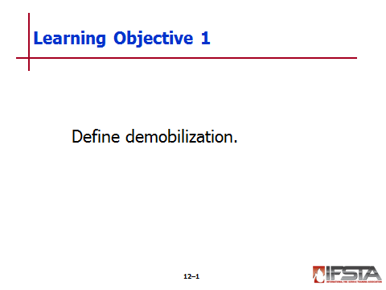
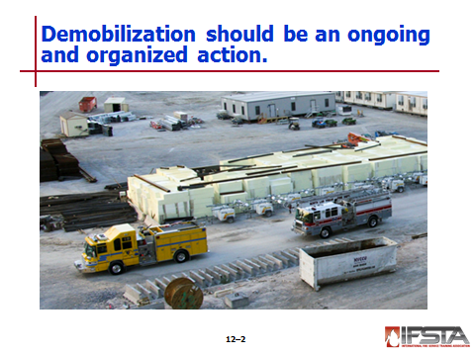
Performed by Incident Commander (IC) for resources and equipment no longer needed

Allows personnel to be rehabbed and units to be restocked and put back in service

Should begin at beginning of incident

Should be conducted in organized manner; can eliminate waste and potential fiscal and legal impacts

Should be conducted according to department policies and procedures

Differs based on size of incident

Small – Resources may be released to finish work shifts

Larger – Resources may have to be demobilized based on work schedules or jurisdictional rules

Must be conducted in concert with IC and Incident Management team

Incident Commander – Approves resource orders and demobilization

Operations Section – Identifies operational resources that are, or may become, excess

Planning Section – Develops and implements demobilization plan

Logistics Section – Implements transportation inspection program and handles special transportation needs

Finance/Administration Section – Processes claims, time records, incident costs, and assist in release priorities
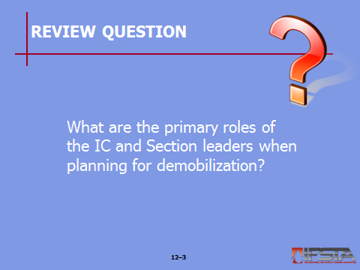
Review Question: What are the primary roles of the IC and Section leaders when planning for demobilization?
See pp. 585-586 of the manual for answers.

Section II: Incident Termination

incident termination
pp. 586-592 Objective 2 – Explain the importance of incident termination.

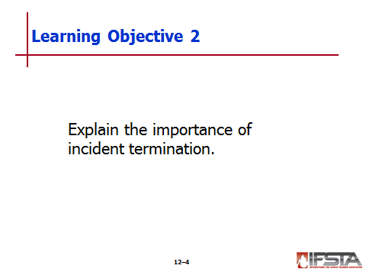
Incident Termination

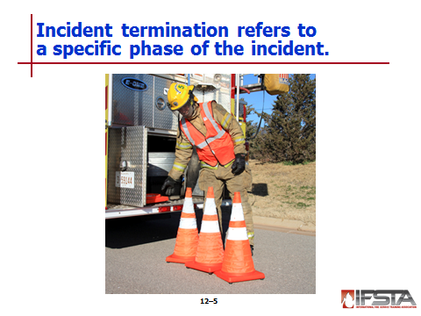
Phase of incident where emergency response activities are near completion and recovery operations start to take precedence

Must include determination as to who will be assuming responsibility for cleanup
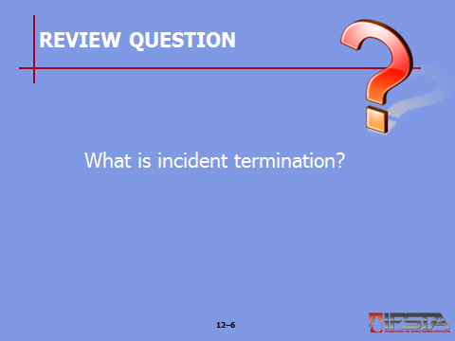
Review Question: What is incident termination?
See pp. 586-587 of the manual for answers.

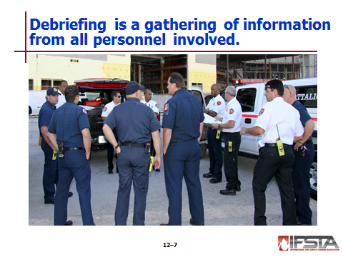
Debriefing

Gathering of information from all personnel involved in incident operations

Most effective means – Group discussion

Objectives and topics should include

Who responded to the incident?

What operations took place?

When did operations take place?

Were operations successful?

Were there any injuries and what treatment was provided?

Should include evaluation of accuracy of Site Safety Plan

Ensure that all aspects of plan were in place at appropriate times

Ensure that plan covered all expected issues with anticipated outcomes

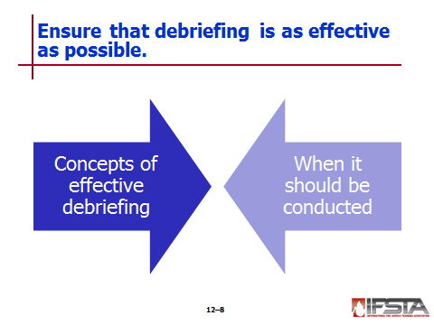
Concepts of an effective debriefing

Should start as soon as emergency phase of incident has concluded

Should include

List of all personnel and agencies involved

Listing of all substances involved

Any exposures including people, equipment, or environmental factors

Signs and symptoms from exposure

Secondary decontamination procedures

Status of equipment

Problems or issues with equipment and/or personnel

Incident organization

Timeline of incident

Any other pertinent information

Should be conducted in area free from distractions

Not always possible on-scene

Consider environment – Extreme cold or heat can impact results

Should be led by facilitator such as haz mat team leader, company officer, or chief officer

Should be conducted by someone who is able to facilitate good dialogue between participants

Limit overall time – Should be concise and organized

When to conduct a debriefing

As soon as reasonably possible at conclusion of incident

May not be possible to debrief with everyone involved at same time; however, each responder must be interviewed

At larger incidents, may not be possible to interview everyone on scene; debrief Section leaders to pass on to personnel
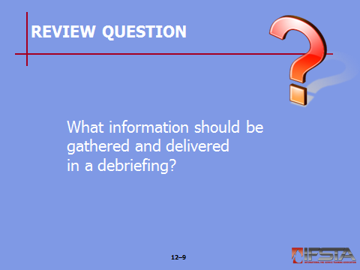
Review Question: What information should be gathered and delivered in a debriefing?
See pp. 587-589 of the manual for answers.

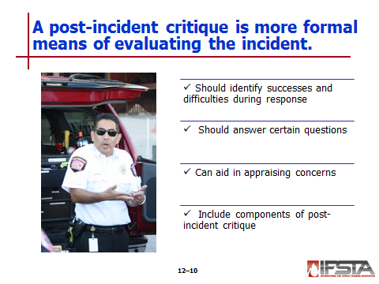
Post-Incident Critique

More formal means of evaluating all events that took place during incident

Critical function of IC

Should be conducted in order to identify successes or difficulties encountered during response

Should answer questions

What did we do right?

What did we do wrong?

What can we do differently in the future?

Can aid in appraising concerns

Personnel and public safety

Information and data management

Interagency cooperation

Overall function of Incident Management System (IMS)

Effectiveness of any operational techniques

Public notification

Components of a post-incident critique

Should concentrate on all aspects – What was a success, what was a failure, and what improvements can be made to succeed in future

Key components

Direction

Participation

Solutions

Should be led by single individual

Typical elements

Review of response

Input from key personnel

Lessons learned

Not a finger-pointing session with blame or criticism

Must be positive event and allow for free-flow of information
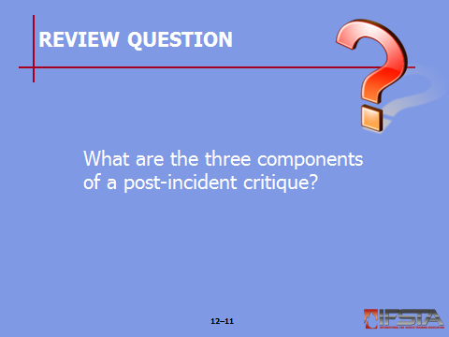
Review Question: What are the three components of a post-incident critique?
See pp. 589-590 of the manual for answers.

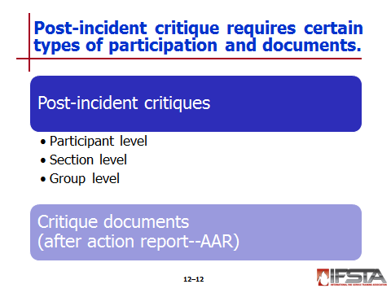
Post-incident critique participation

Participant level critique

Key personnel will be able to make individual statements relevant to activities at incident

Participants should concentrate on major issues they feel warrant a discussion

Section level critique

Structured review of emergency operations

Through group spokesperson, each operational section discusses challenges and unanticipated events

Section spokesperson may also discuss recommendations on how section could improve performance

Group level critique

Allows for wider and more open forum

Open dialogue encouraged

Facilitator should reinforce constructive comments

All important points should be recorded and documented

Critique documents (After Action Report)

Concise report generated from notes taken during critique proceedings

Delivers lessons learned from incident and any recommendations for improvement that may be appropriate for future responses

Serves as vital role and should be shared with other organizations so that lessons learned may be of benefit to others

Essential learning tool for not only the department involved, but others as well

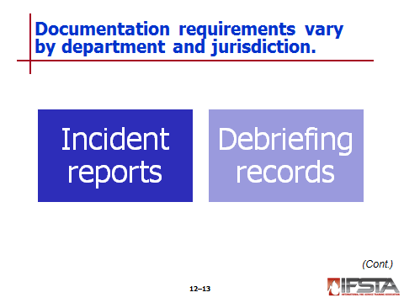
Documentation – Requirements vary by department policy and state/federal laws
Instructor Note: Discuss the Information Box “Commonly Required Regulatory Reports in the United States” on p. 591 of the manual.

Incident reports

National Fire Incident Reporting System (NFIRS)

National system sponsored by U.S. Fire Administration

Primary response record for fire-based response

Supplies supplemental record for reporting hazardous materials incidents

Should be forwarded to lead state fire agency and then on to U.S. Fire Administration

Debriefing records

Serve as chronological account for incident

Should include any follow-up records on response personnel if problems arise at later date

Should include

All written documentation

Photographs

Video and audio tapes

Computer-generated reports
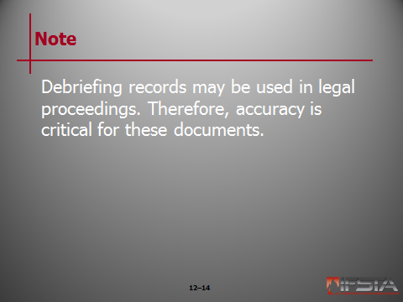
Note: Debriefing records may be used in legal proceedings. Therefore, accuracy is critical for these documents.

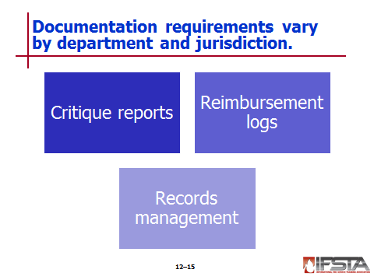
Critique records

Can be used to increase safety of on-scene operations

Can be useful for planning, training, and prioritizing hazards

Should be reviewed after incident to ensure specific issues have been rectified and operational procedures have been adjusted to allow for organized and safe operation

Reimbursement logs

Should be maintained in event any equipment used during incident is eligible for reimbursement

Schedule established by FEMA

Vital component in determining eligibility for any type of reimbursement

Records management

Vital due to complexity of haz mat incidents

Permanent record for health and safety of responders

May be used for both criminal and civil court proceedings

Various records and logs should be maintained and secured

Activity logs

Exposure records

Hot zone entry and exit logs

Personal protective equipment logs

Any local, state, and federal regulatory reports

All should be completed and filed in timely manner

Haz mat incident reports must be secured and maintained for length of employee’s tenure, plus thirty years
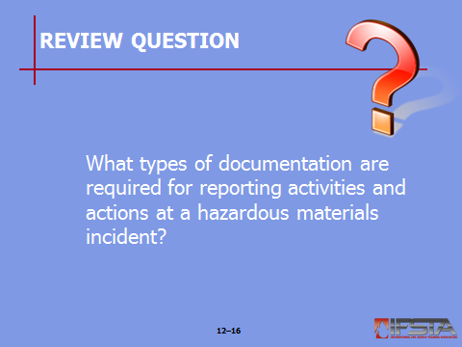
Review Question: What types of documentation are required for reporting activities and actions at a hazardous materials incident?
See pp. 590-592 of the manual for answers.

Section III: Summary and Review

summary and review

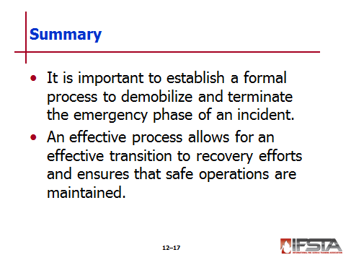
Chapter Summary

It is important to establish a formal process to demobilize and terminate the emergency phase of an incident.

An effective process allows for an effective transition to recovery efforts and ensures that safe operations are maintained.

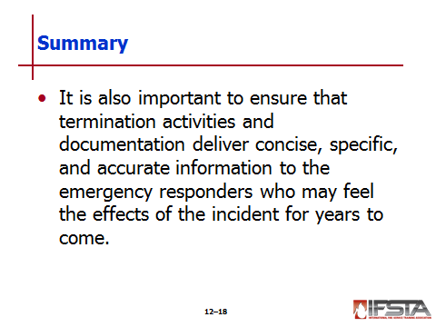
It is also important to ensure that termination activities and documentation deliver concise, specific, and accurate information to the emergency responders who may feel the effects of the incident for years to come.

Review Questions

What are the primary roles of the IC and Section leaders when planning for demobilization? (585-586)

What is incident termination? (586-587)

What information should be gathered and delivered in a debriefing? (587-589)

What are the three components of a post-incident critique? (589-590)

What types of documentation are required for reporting activities and actions at a hazardous materials incident? (590-592)

