Chapter 6
Hazard and Response Information

Lesson Goal
After completing this lesson, the student shall be able to describe the functions of a technical research specialist and identify the various kinds of references and resources that may be used in identifying hazardous materials and determining proper response.
Objectives
Upon successful completion of this lesson, the student shall be able to:
1. Describe the job functions of a technical research specialist. [NFPA® 472, 7.3.3.4.5]
2. Explain the basic principles of chemical research.
3. Identify various written technical references. [NFPA® 472, 7.2.2.1(3)]
4. Identify various electronic technical resources. [NFPA® 472, 7.2.2.1(1)]
5. Describe other technical information centers and specialists. [NFPA® 472, 7.2.2.1(4, 5)]
6. Determine characteristics of hazardous materials. [Learning Activity 6-1]

Instructor Information
This is the lesson covering hazard and response information. This lesson describes the functions of a technical research specialist. The lesson also covers written technical references and electronic technical resources. In addition, the lesson describes information centers and specialists that may be beneficial in determining hazardous materials response.

Important instructor information is provided in shaded boxes throughout the lesson plan. Carefully review the instructor information before presenting the lesson.

This lesson includes an activity that assists students in utilizing written and digital information regarding hazardous materials. The activity is developed for the student to gather information regarding a specific hazardous material and fill out the proper safety plan forms. This activity will cover learning objective 6.

Methodology
This lesson uses lecture, discussion, and a group learning activity. The level of learning is application.
Outline Contents

Section | Outline Pages | Text Pages
Section I: Introduction to the Technical Research Job Function | 5 | 226
Section II: Research | 10 | 231
Section III: Written Technical References | 17 | 235
Section IV: Electronic Technical Resources | 36 | 244
Section V: Technical Information Centers and Specialists | 42 | 248
Section VII: Learning Activities | 48 | 252
Section VII: Summary and Review | 48 | 251

Audiovisuals
- Visuals 6.1 to 6.57 (PowerPoint® Presentation)
Evaluation
- Chapter 6 Quiz
- Chapter 6 Test
- Learning Activity 6-1
Presentation Tools
Interactive Objects allow instructors to present information a piece at a time by clicking on hot spots in a larger image.

Each object is labeled in the Lesson Outline and indicated in the PowerPoint® presentation by a RED arrow in the top left corner of the image. This lets instructors know to use the mouse to explore all of the information on the slide.


After all of the information is displayed a reset arrow will appear in the bottom right corner of the image. Instructors can use this to remove the text and quiz students on content just covered or simply move on to the next slide.

To move to the slide after an interactive object, select the Click for next slide arrow on the left side of the slide.

Videos are used as discussion starters or to illustrate a concept or process discussed in the chapter.

These are labeled in the Lesson Outline and indicated in the PowerPoint® presentation by the Click image to play arrow on the left side of the slide.

Section I: Introduction to the Technical Research Job Function

introduction to the technical research job function
pp. 226-231 Objective 1 – Describe the job functions of a technical research specialist.


Research Specialist Responsibilities

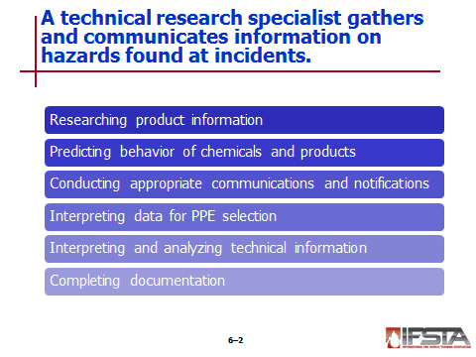
Researching product information

Predicting behavior of chemicals and containers

Conducting appropriate communications and notifications

Interpreting data for PPE selection

Interpreting and analyzing technical information

Completing documentation

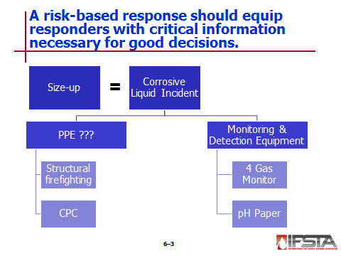
Risk-Based Response

Uses information, science, and technology to mitigate hazardous materials incident

Key – To equip responders with critical information that is needed to make good decisions

Vital element – Product identification

Hierarchy of decisions needed to protect responders; starts with strong, thorough size-up

Quick and efficient way to “thin slice” information and make educated, lifesaving decisions

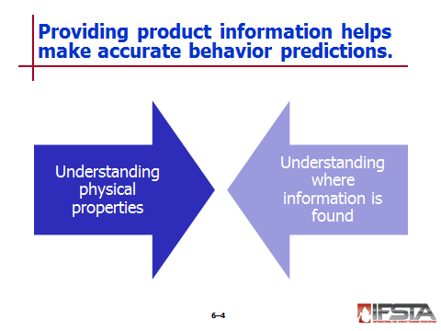
Product Information and Behavior Prediction

Allows haz mat technician to make well-informed decisions based on known chemical and physical properties of product or products involved

Key components

Understanding physical properties of chemical

Understanding where information can be found

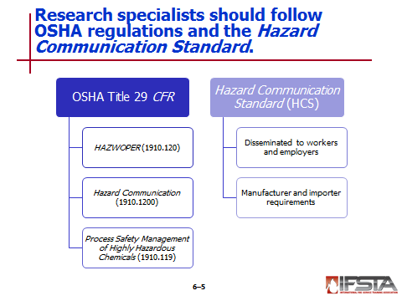
U.S. Hazard Communication

U.S. OSHA issues regulations relating to worker safety under Title 29 CFR

HAZWOPER regulation (29 CFR 1910.120)

Hazard Communication regulation (29 CFR 1910.1200)

Process Safety Management of Highly Hazardous Chemicals regulation (29 CFR 1910.119)

Hazard Communication Standard (HCS)

Designed to ensure that information regarding chemical hazards and associated protective measures

Disseminated to workers and employers

Require chemical manufacturers and importers to

Evaluate hazards of chemicals they produce or import

Provide information about chemical through labels on shipped containers and safety data sheets (SDSs, formerly called material safety data sheets or MSDSs)
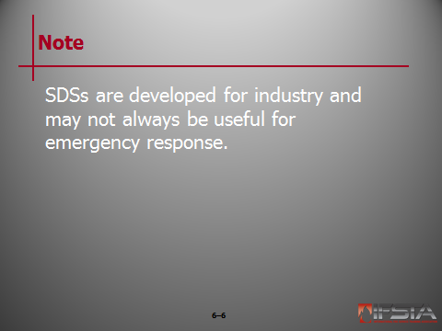
Note: SDSs are developed for industry and may not always be useful for emergency response.

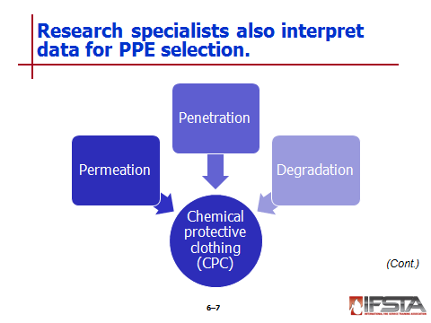
Data Interpretation for PPE Selection

Chemical protective clothing (CPC) is subject to factors such as permeation, penetration, and degradation

Provided in product documentation

Documentation does not provide information on other hazards
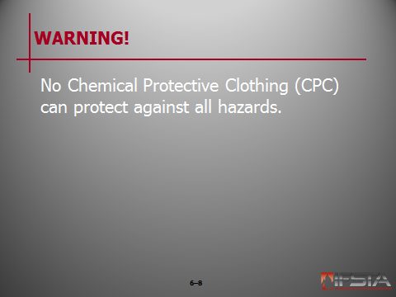
WARNING! No Chemical Protective Clothing (CPC) can protect against all hazards.

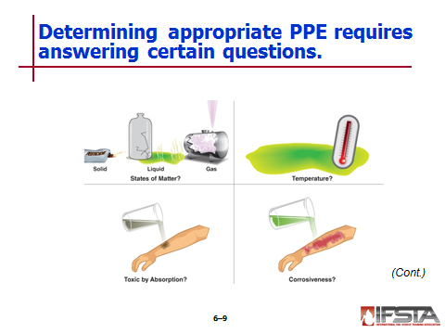
When determining appropriate PPE, answer the following questions

What is the product’s state of matter?

What is the product’s temperature?

Is it toxic by skin absorption?

Is it corrosive?

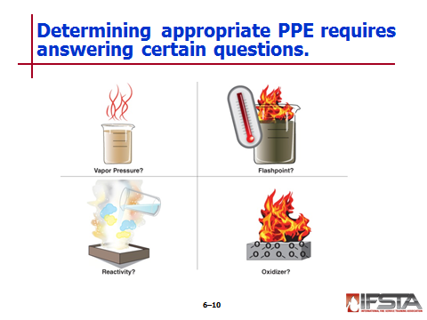
What is the vapor pressure?

What is the flash point?

Does the reactive properties?

Is it an oxidizer?

Is it radioactive?

Questions can be answered by

Performing product monitoring

Researching chemical and physical properties of material,

Contacting technical specialist

Note: It is not always possible to determine exactly what the product is.

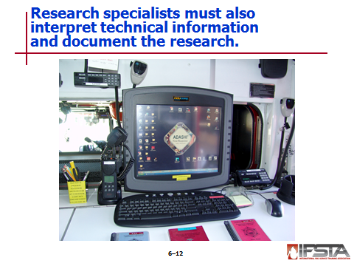
Interpretation of Technical Information

Wide range of reference materials exist

Unique reference materials include

Chemical engineers

Industrial hygienists

United States Coast Guard

The Association of American Railroads

Documentation of Research

Critical at hazardous materials incidents

Must be accurate

Will be used for

Conducting hazard assessment concerning overall health of general public and emergency responders

Determining PPE and respiratory protection

Aiding decisions about chemical monitoring

Must be organized

Review Question: What are the responsibilities of a technical research specialist at a haz mat incident?
See p. 227 of the manual for answers.
Section II: Research

research
pp. 231-235 Objective 2 – Explain the basic principles of chemical research.

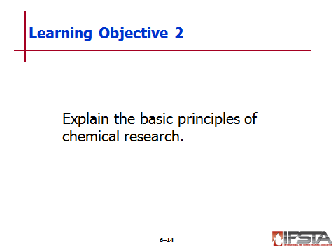
Research

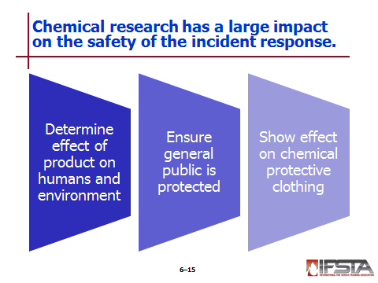
Has huge bearing on safety of incident

By understanding product’s physical and hazardous properties

Making informed decisions about protective actions

Can help determine what effects product will have on humans and environment

Allows responders to ensure that general public is protected

Can show effect that product will have on chemical protective clothing

Chemical Assessment – In order of priority, the following should be analyzed

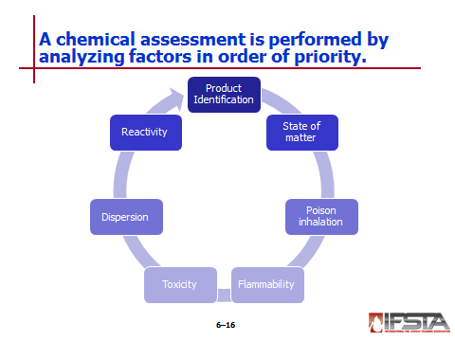
Product identification
Interactive slide; use mouse to show all information

First priority

Elements assisting in locating product hazard information

Product name

Synonyms

DOT placard or label

UN/NA identification number

CAS number

NFPA® 704 marking

State of matter – Due to dispersion characteristics has significant impact on personal protection and tactical operations

Poison inhalation hazards – Due to toxicity and dispersion characteristics, present substantial life-safety threat; must be protected against accordingly

Flammability hazards

Have significant effects on personal protection and tactical options

During research, obtain critical points

Flashpoint

Ignition temperature

Flammable or explosive limits

Toxicity hazards

Require consideration of routes of entry and degree of toxicity, as well as physical characteristics affecting dispersion

Affect decisions about PPE and tactical options

During research, obtain critical points

Carcinogen

Teratogen

Mutagen

Route of entry

TWV-TWA

TLV-STEL

TLV-C

IDLH

Corrosivity/contact hazard

Ionizing radiation

Dispersion characteristics

Method and pattern will affect exposure protection, selection of PPE, and control tactics

Key characteristics that should be researched

Vapor pressure

Boiling point

Vapor density

Specific gravity

Water solubility

Reactivity characteristics

Substances may react with other materials present or those introduced by response personnel

Key characteristics that should be researched

Air reactivity

Water reactivity

Incompatibility

Polymerization

Temperature sensitivity

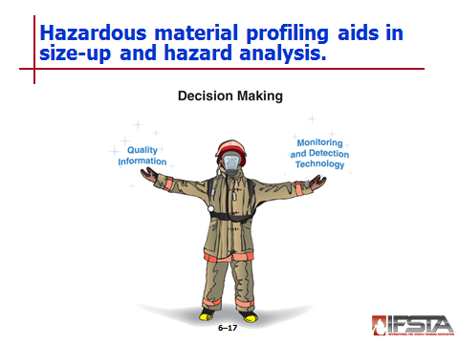
Hazardous Material Profiling

Efficient tool for size-up and hazard analysis

Provides haz mat technician with organized approach to understanding physical and hazardous characteristics of product

Allows for response that is well-informed and risk-based

Identifies physical behaviors of product and associated hazards

Should be performed using quality information that can be validated by monitoring and detection technology

Essential that correct information be profiled

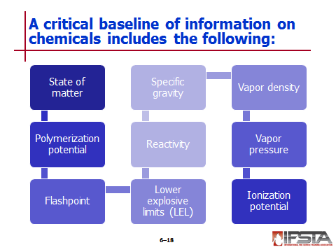
Critical baseline information

State of matter – Physical form a chemical or product will be found in at normal temperatures and pressures

Polymerization potential – Chemical that has ability to polymerize will not be able to be controlled by initial response crews

Flashpoint – Volatile liquids will produce vapors that may ignite

Lower explosive limits (LEL) – Concerns about possible ignition sources must be addressed if product is flammable

Reactivity – Product may have flammable and corrosive by-products if it does react

Specific gravity – Weight of substance compared to weight of equal volume of water at given temperature

Vapor density – Weight of given volume of pure vapor or gas compared to weight of equal volume of dry air at same temperature and pressure

Vapor pressure

Pressure at which vapor is in equilibrium with liquid phase for given temperature

Liquids that have greater tendency to evaporate have higher vapor pressures for given temperature

Ionization potential – Energy required to completely remove electron from atom

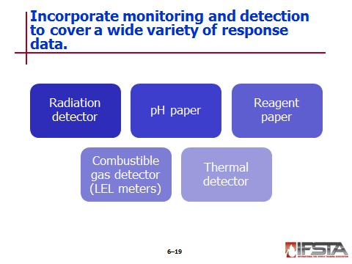
Should incorporate monitoring and detection equipment; must cover broad spectrum of response data

Radiation detectors

Any radiation reading above normal background levels are concern

Retreat immediately if elevated levels are detected

pH paper – Can be used to detect corrosive vapors in air, as well as to determine pH of those vapors

Reagent paper – Used to detect numerous substances

Combustible gas detectors (LEL meters)

Detect flammable atmospheres

May be stand-alone meters or contained within traditional four- or five-gas meter with other oxygen and toxicity sensors

Thermal detectors – Used to determine if chemical reaction or polymerization is taking place

Ongoing process; as new information gathered, response objectives should be developed
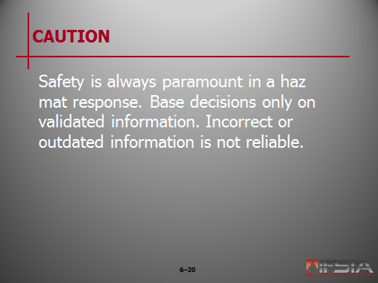
CAUTION: Safety is always paramount in a haz mat response. Base decisions only on validated information. Incorrect or outdated information is not reliable.

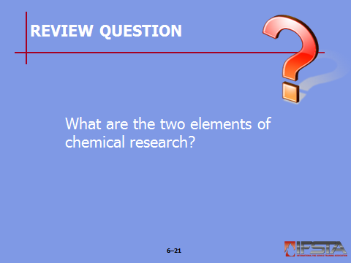
Review Question: What are the two elements of chemical research?
See p. 231 of the manual for answers.

Section III: Written Technical References

written technical references
pp. 235-243 Objective 3 – Identify various written technical references.

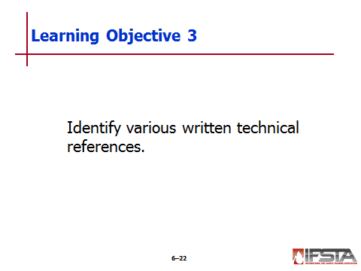
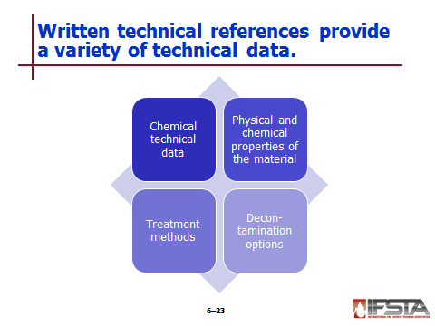
Written Technical References

Provide haz mat technician with technical data on host chemical

May suggest response options

Provide information that includes

Chemical technical data

Physical and chemical properties of material

Treatment methods

Decontamination options

MUST use most current edition of any reference

Each begins with

Basic description of how manual is organized

Use of references and acronyms

Glossary of terms

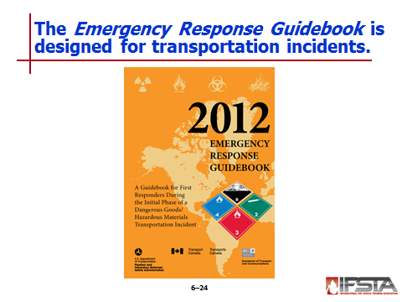
Reference Manuals

Emergency Response Guidebook (ERG)

Primarily designed for use at transportation incidents involving hazardous materials

Intended to be starting point for research

Provides only general information on included chemicals

Provides

Quick guide to assist emergency responders in identifying chemical

Very general information on how to protect themselves and others while more specific information is acquired

Special information such as polymerization hazards

Cross-references based on UN/NA numbers or actual spelling of chemical

Primary identification means – Should only be used at onset of incident

Does not supply specific information – Can still be used to gather beneficial information on response

Quick reference to determine if material in transport is radioactive or corrosive

May be quickest way to determine if product will polymerize

Also establishes initial isolation distances based on involved product’s state of matter

Solids – 75 ft. (25 m)

Liquids – 150 ft. (50 m)

Gases – 330 ft. (100 m)

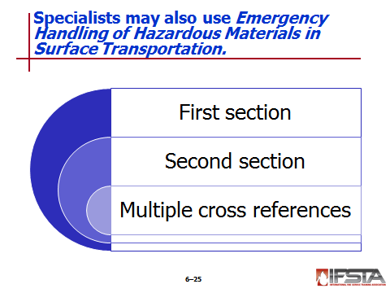
Emergency Handling of Hazardous Materials in Surface Transportation

Developed by Association of American Railroads and Bureau of Explosives

First section

General information on approaching haz mat incident

Product identification

Response information for each DOT hazard class

Second section – Commodity-specific emergency response information for each hazardous material regulated by U.S. DOT, Transport Canada, and International Maritime Organization

Contains multiple cross-references

DOT UN/NA numbers and page references for many commonly shipped materials

Seven digit haz mat code referred to as standard transportation commodity code (STCC)

All seven digit haz mat codes, description of product assigned to code, and page number

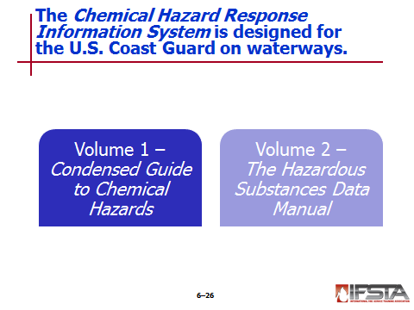
Chemical Hazards Response Information System (CHRIS)

Designed to provide information needed by U.S. Coast Guard personnel responsible for decision-making for incidents involving waterways

Volume 1

The Condensed Guide to Chemical Hazards

Good resource for first responders on scene of haz mat incident

Contains information specific to each hazardous material that may be encountered

Only useful if material has been properly identified

Volume 2

The Hazardous Substances Data Manual

One of most useful references when responding to water-based spills and waste sites

Contains information on hazardous materials commonly shipped in large volume by water

Used regularly by port security personnel

Easily understood

May be used as quick reference to determine needed actions to safeguard life and property
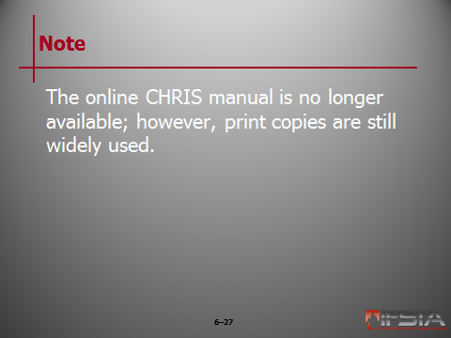
Note: The online CHRIS manual is no longer available; however, print copies are still widely used.

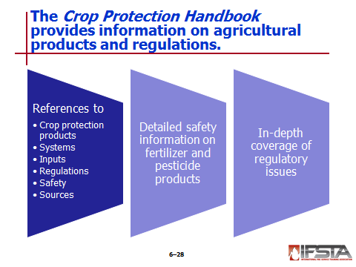
Crop Protection Handbook

Formerly known as Farm Chemicals Handbook

Important reference to crop protection products, systems, inputs, regulations, safety, and sources

Contains detailed technical and safety information on thousands of fertilizer and pesticide products

Contains in-depth coverage of regulatory issues

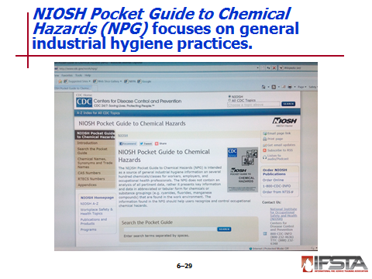
NIOSH Pocket Guide to Chemical Hazards (NPG)

Prepared by National Institute for Occupational Safety and Health (NIOSH)

Based on NIOSH and OSHA guidelines for chemical hazards

Based on NIOSH criteria documents and recognized references in field of industrial hygiene, occupational medicine, and toxicology

Presented in table format

Intended to provide quick information on general industrial hygiene practices

Includes

Chemical names, synonyms, trade names, CAS, RTECS, and DOT ID and Guide numbers

Chemical structure/formula, conversion factors

NIOSH Recommended Exposure Limits (RELs)

OSHA Permissible Exposure Limits (PELs)

NIOSH Immediately Dangerous to Life and Health values (IDLHs)

Physical description and chemical and physical properties of agents

Measurement methods

Personal protection and sanitation recommendations

Respirator selection recommendations

Incompatibilities and reactivities of agents

Exposure routes, symptoms, target organs, and first aid information

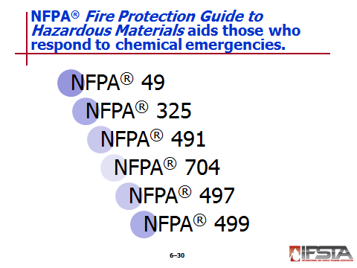
NFPA® Fire Protection Guide to Hazardous Materials

Produced by National Fire Protection Association® (NFPA®)

Provides good information on properties of hazardous chemicals

Important for those who use chemical sin industry and those who respond to chemical emergencies including fires, accidental spills, and transportation accidents

Composed of six NFPA® documents

NFPA® 49, Hazardous Chemicals Data

Provides information on over 300 chemicals

Provides specific information on health, fire, and reactivity data

Arranged alphabetically by DOT shipping names

NFPA® 325, Guide to Fire Hazard Properties of Flammable Liquids, Gases, and Volatile Solids – Provides fire hazard properties for over 1,300 flammable substances

NFPA® 491, Hazardous Chemical Reactions – Includes information on over 3,500 mixtures of two or more chemicals that may be potentially dangerous at moderate or elevated temperatures

NFPA® 704, Standard System for the Identification of the Hazards of Materials for Emergency Response

Provides degrees of health, flammability, and reactivity for many of common industry chemicals

Newest edition also includes information on aerosol products

NFPA® 497, Recommended Practice for the Classification of Flammable Liquids, Gases, or Vapors and of Hazardous (Classified) Locations for Electrical Installations in Chemical Process Areas

Includes information on certain flammable gases and vapors, flammable liquids, and combustible liquids

For purposes of selecting appropriate electrical equipment in hazardous locations

NFPA® 499, Recommended Practice for the Classification of Combustible Dusts and of Hazardous (Classified) Locations for Electrical Installations in Chemical Process Areas

Provides information about certain combustible dusts

For purposes of selecting appropriate electrical equipment in hazardous locations

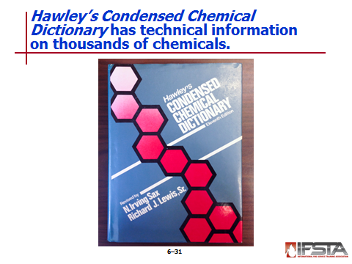
Hawley’s Condensed Chemical Dictionary (CCD)

Compilation of technical information and descriptions that cover thousands of chemicals

Organized so that it offers three types of information

Technical descriptions of chemicals and processes

Expanded definitions of chemicals and terminology

Descriptions and/or identification of trade names

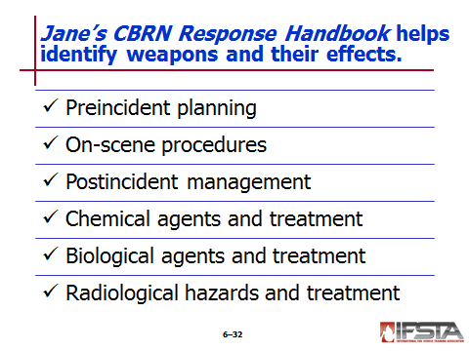
Jane’s CBRN Response Handbook

Expanded version of Jane’s Chem-Bio Handbook

Field reference guide that allows responders to quickly identify chemical, biological, or radiological weapons and their effects

Contents include information about

Preincident planning

On-scene procedures

Postincident management

Chemical agents and treatment

Biological agents and treatment

Radiological hazards and treatment

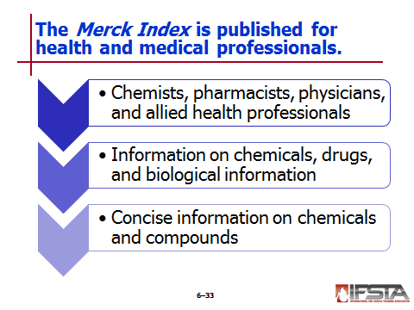
Merck Index

Publication intended to serve chemists, pharmacists, physicians, and other allied health professionals

Offers emergency responder vital information on chemicals, drugs, and biological information

Supplies concise information on thousands of chemicals and compounds

Records contain

Chemical, common, generic, and systematic names

Trademarks and associated companies

CAS registry numbers

Molecular formulas, weights, and percentage compositions

Capsule statements identifying compound classes and scientific significance

Chemical, biomedical, and patent literature references

Physical and toxicity data

Therapeutic and commercial uses

Caution and hazard information

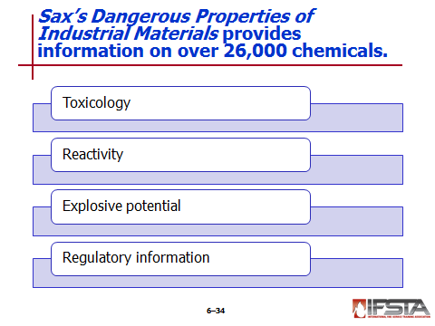
Sax’s Dangerous Properties of Industrial Materials

Multiple volume reference set

Provides hazard information for over 26,000 chemicals

Provides relevant information on

Toxicology

Reactivity

Explosive potential

Regulatory information

First volume – CAS number and synonym cross index

Remaining volumes contain

Dangerous Properties of Industrial Materials (DPIM) codes

Hazard ratings

Entry name

CAS numbers

DOT (UN/NA) numbers

Molecular formula

Line structure formula

Material descriptions

Toxicology data

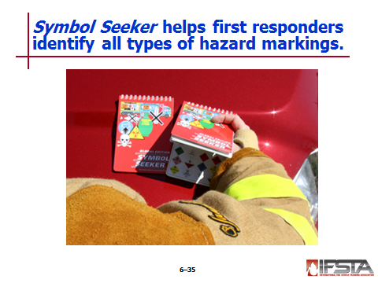
Symbol Seeker

Publication that helps first responders identify extensive number of international hazard markings

Provides means of identifying hazardous materials in any mode of transportation or on any fixed facility

Does not offer specific information on chemical, substance, or product

Intended for use in identification of material

Marking systems include

Haz mat marking systems

Nuclear and radioactive marking systems

Biohazard marking systems

Ordinance and weapon marking systems

Marking systems specific to individual countries

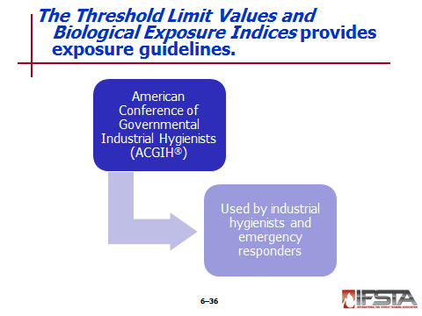
The Threshold Limit Values and Biological Exposure Indices (TLVs® and BEIs®)

Published by American Conference of Governmental Industrial Hygienists (ACGIH®)

Designed for use by industrial hygienists and emergency responders

Provide occupational exposure guidelines for hundreds of chemical substances and physical agents

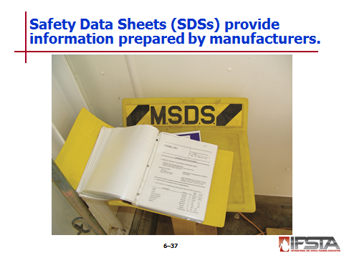
Safety Data Sheets (SDSs)

Detailed information bulletins prepared by manufacturer or importer of chemical

Provide specific information about product

Once called material safety data sheets (MSDSs)

Mandated by U.S. OSHA and Canadian authorities

Both countries converting to Globally Harmonized System (GHS) SDS format

May still be encountered

Often good sources of detailed information about particular material

Can be acquired from manufacturer, supplier, shipper, emergency response center, or facility hazard communication plan

Sometimes attached to shipping papers and containers

GHS for Hazard Classification and communication specifies minimum information

Must include following sections

1: Identification

2: Hazard(s) identification

3: Composition/information on ingredients

4: First aid measures

5: Fire fighting measures

6: Accidental release measures

7: Handling and storage

8: Exposure controls/personal protection

9: Physical and chemical properties

10: Stability and reactivity

11: Toxicological information

12: Ecological information

13: Disposal considerations

14: Transport information

15: Regulatory information

16: Other information

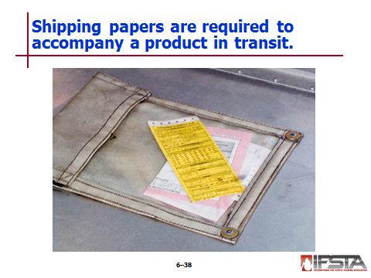
Shipping Papers

Required to accompany a product in transit, regardless of means of transportation

Can be reliable means of product identification

In U.S.

Legally required by 49 CFR 172.604

Must include

Proper chemical name

Four digit hazard classification (UN/NA) number

Package types

Total quantity of product being shipped

24-hour emergency contact number

HM-181 – Contains new requirements and scaled system

1 for high hazard

2 for medium hazard

3 for low hazard

Must include Standard Transportation Commodity Code (STCC)

If hazardous, preceded by number 49

If hazardous waste, preceded by number 48

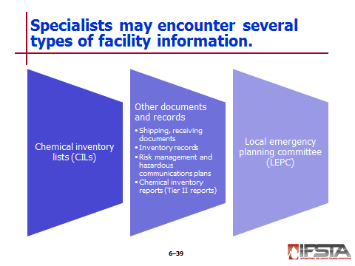
Facility Documents

Chemical Inventory Lists (CILs)

Required of U.S. employers by Hazard Communication Standard (HCS)

Usually contain information about locations of materials within facility

Useful tools identifying containers that may have damaged or missing labels or markings

Other useful documents or records

Shipping and receiving documents

Inventory records

Risk management and hazardous communication plans

Chemical inventory reports (known as Tier II reports)

Local Emergency Planning Committee (LEPC)

Develop emergency response plans – Good source of information

Designed to provide forum for emergency management agencies, responders, industry, and public to work together to evaluate, understand, and communicate chemical hazards in community

Designed to develop appropriate emergency plans in case of accidental release of these chemicals

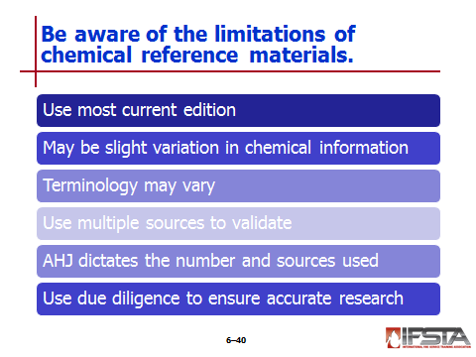
Limitations

Use most current edition of reference to ensure information is up to date

Due to different testing methods, slight variations to chemical information may exist within written references

Terminology may also vary between references

Because of variations, use multiple sources to determine validity of information

AHJ will dictate number and type of sources used

Responders should use due diligence to ensure product is thoroughly researched
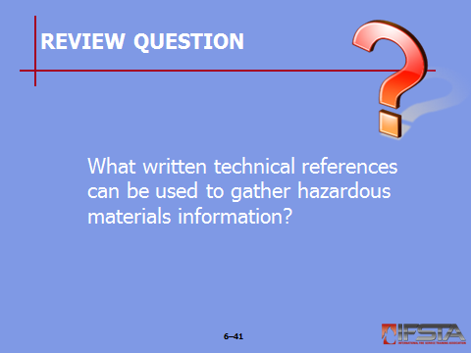
Review Question: What written technical references can be used to gather hazardous materials information?
See pp. 236-243 of the manual for answers.

Section IV: Electronic Technical Resources

electronic technical resources
pp. 244-248 Objective 4 – Identify various electronic technical resources.

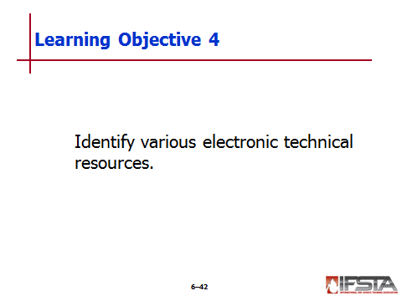
Electronic Technical Resources

Most common written resources and references now available in electronic format

Have added benefit of search features that allow information to be accessed in more efficient manner than print resources

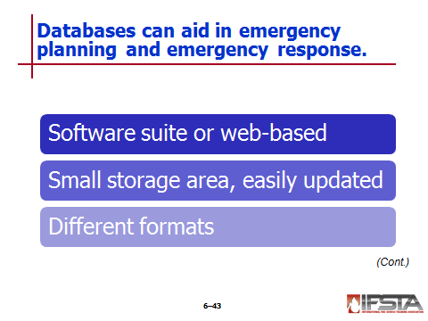
Chemical Databases

Some available in software suite; others web-based

Beneficial because do not require large areas for storage; can be easily updated

Formatted differently – Review to decide which are most productive for organization

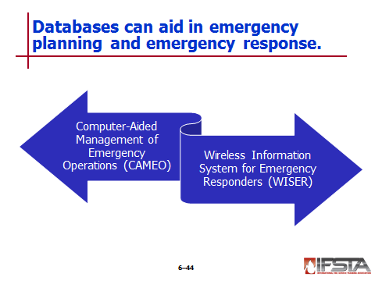
Computer-Aided Management of Emergency Operations (CAMEO)

Designed by National Oceanic and Atmospheric Administration (NOAA)

System of software applications that assists emergency responders in development of safety response plans

Can be used to access, store, and evaluate information critical in emergency response

Database and information management tools

Extensive chemical database

Chemical datasheets

Physical properties

Health hazards

Air and water reactive information

Fire fighting information

UN/NA datasheet – Provides information from ERG and shipping information from Hazardous Materials Table

Mapping application

Mapping Applications for Response, Planning, and Local Operational Tasks (MARPLOT)

Allows users to visualize data and display information on computer maps

May be printed individually or on area maps

Dispersion modeling program

ALOHA

Used for evaluating release of hazardous chemical vapors

Allows user to estimate potential harm to area based on

Toxicological and physical characteristics of chemical

Atmospheric conditions

Any other specific circumstances that may be affecting release

Wireless Information System for Emergency Responders (WISER)

Designed for use by first responders at hazardous materials incidents

Brings wide range of information to responder

Develops database from series of relevant sources

References chemical data consolidated from core set of reference manuals

Emergency Response Guidebook

Chemical Hazards Response Information System

NFPA® Fire Protection Guide to Hazardous Materials

NIOSH Pocket Guide to Chemical Hazards

EPA Integrated Risk Information System (IRIS)

POISINDEX® Information System

TOMES® Information System

ACGIH Guidelines for Selection of Chemical Protective Clothing

ACGIH® TLVs® and BEIs®

Emergency Handling of Hazardous Materials in Surface Transportation

Available in different formats depending on operating system

May be downloaded free of charge

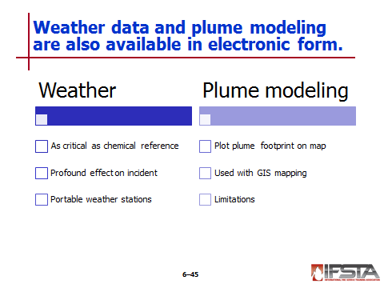
Weather Data

Just as critical as chemical reference manuals

Must be correctly interpreted

Can have profound effect

Humidity

Atmospheric pressure

Temperature

Precipitation

Wind speed and direction

More readily available than ever

Portable weather stations

Allow for more exact weather information within Command Post

Many can provide

Barometric pressure

Temperature

Wind speed and direction

Relative humidity

Plume Modeling

Variety of programs available

U.S. EPA – Visual Plumes

Many provide user with ability to plot plume footprint on map

Many can be used in conjunction with preexisting GIS mapping systems

Limitations

Model must be matched with material

Forecasts any have single event errors

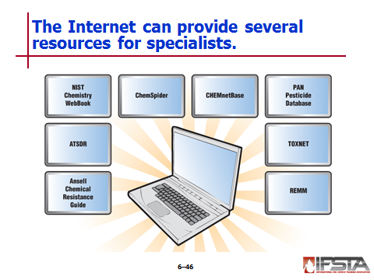
Internet Resources

Ansell Chemical Resistance Guide

Agency for Toxic Substances and Disease Registry (ATSDR)

NIST Chemistry WebBook

ChemSpider

CHEMnetBASE

Pesticide Action Network (PAN) Pesticide Database

Toxicology Data Network (TOXNET)

Radiation Emergency Medical Management (REMM)


Note: Internet addresses change frequently and therefore are not provided in this text. A simple internet search of the listed databases will provide the most current information.

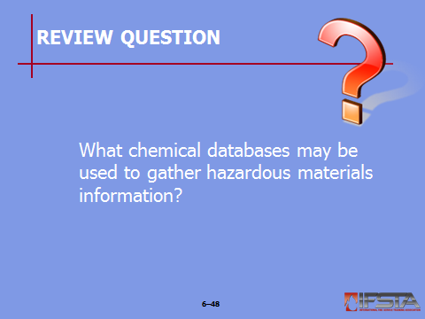
Review Question: What chemical databases may be used to gather hazardous materials information?
See pp. 244-246 of the manual for answers.

Section V: Technical Information Centers and Specialists

technical information centers and specialists
pp. 248-251 Objective 5 – Describe other technical information centers and specialists.

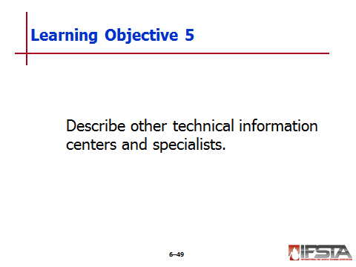
Emergency Response Centers

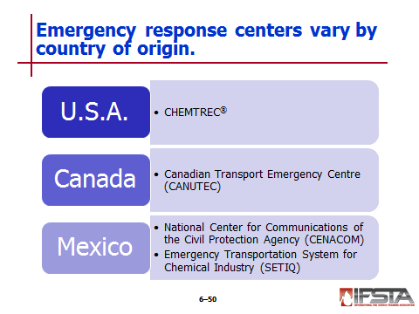
CHEMTREC®

Established by U.S. chemical industry

Public service hotline for emergency responders

Provides information and assistance for emergency incidents involving chemicals and hazardous materials

Staffed with experts who provide 24-hour assistance to emergency responders dealing with haz mat emergencies

Canadian Transport Emergency Centre (CANUTEC)

Operated by Transport Canada

National, bilingual advisory center

Part of Transportation of Dangerous Goods Directorate

Has scientific data bank on chemicals manufactured, stored, and transported in Canada

Staffed by professional scientist who specialize in emergency response and are experienced in interpreting technical information and providing advice

Mexican response centers

National Center for Communications of the Civil Protection Agency (CENACOM)

Emergency Transportation System for Chemical Industry (SETIQ)

Operated by National Association of Chemical Industries

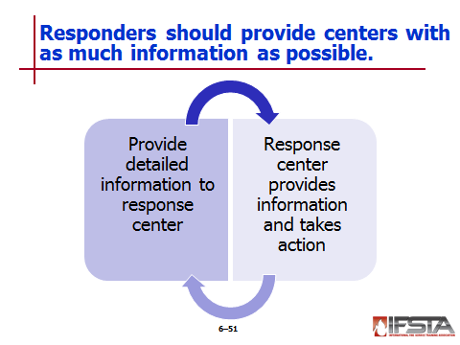
Emergency responders should provide center with as much information as possible

Caller’s name, callback telephone number, and FAX number

Location and nature of problem

Name and identification number of material(s) involved

Shipper/consignee/point of origin

Carrier name, railcar reporting marks, or truck number

Container type and size

Quantity of material transported/released

Local conditions

Injuries, exposures, current conditions involving spills, leaks, fires, explosions, and vapor clouds

Local emergency services that have been notified

The emergency response center will do the following

Confirm that a chemical emergency exists

Record details electronically and in written form

Provide immediate technical assistance to caller

Contact shipper of material or other experts

Provide shipper/manufacturer with caller’s name and callback number so that shipper/manufacture can deal directly with party involved

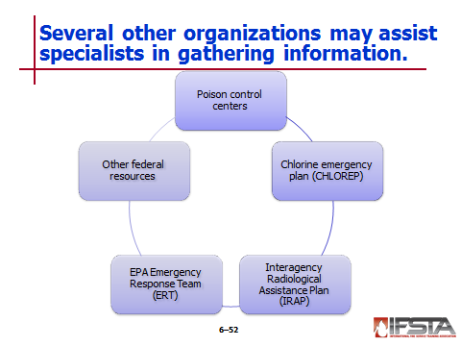
Poison Control Centers

Provide free 24-hour advice to anyone located in fifty states, Puerto Rico, Micronesia, American Samoa, and Guam

Provide poison expertise in treatment advice by phone

Can be reached by calling 1-800-222-1222

Chlorine Emergency Plan (CHLOREP)

Developed by Chlorine Institute to assist in handling of chlorine emergencies in U.S. and Canada

Operated through CHEMTREC®

Notifies nearest manufacturer in accordance with mutual aid plan

Manufacturer will contact someone within command structure to determine if response team is needed

Interagency Radiological Assistance Plan (IRAP)

Designed to assist when responding to radiological emergencies

Operated under U.S. Federal Department of Energy

Works closely with other federal, state, military, and regional agencies

If necessary, will contact and work with Nuclear Regulatory Commission

Main responsibilities

Assess hazards

Keep public informed

Recommend emergency action to command team to minimize hazards

EPA Emergency Response Team (ERT)

Established under National Contingency Plan

Objective – To act as or advise On-Scene Coordinator and Regional Response Teams on environmental issues related to

Spill containment

Cleanup

Damage assessment

Provides expertise in

Biology

Chemistry

Hydrology

Engineering of environmental emergencies

Provides support to full range of emergency response actions

Can bring in special equipment and experienced responders

Can provide On-Scene Coordinator or lead responder with advice

Other Federal Resources

Department of Homeland Security (DHS)

Department of Energy (DOE)

Department of Justice (DOJ)

Military assets
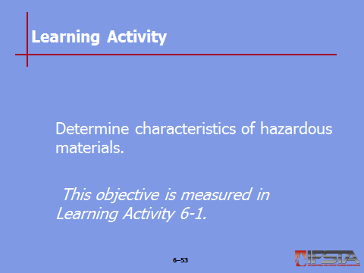
Learning Activity 6-1: Have students complete Learning Activity 6-1 “Determine characteristics of hazardous materials.”

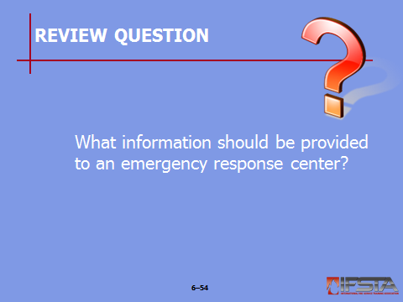
Review Question: What information that should be provided to an emergency response center?
See p. 249 of the manual for answers.

Section VI: Learning Activities

Learning Activities
p. 252 Objective 6 – Determine characteristics of hazardous materials.

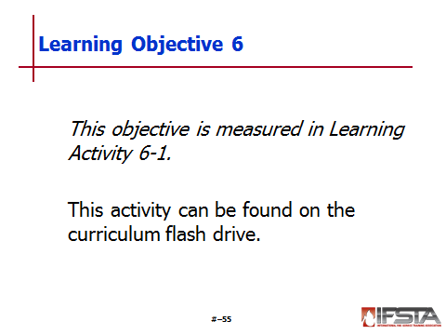
Learning Activity 6-1

For this activity, students will determine characteristics of hazardous materials

This activity can be found in Learning Activity 6-1 on the curriculum flash drive

Section VII: Summary and Review

SUMMARY AND REVIEW

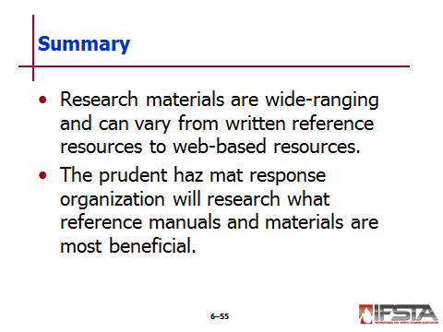
Chapter Summary

Research materials are wide-ranging and can vary from written reference resources to web-based resources.

The prudent haz mat response organization will research what reference manuals and materials are most beneficial.

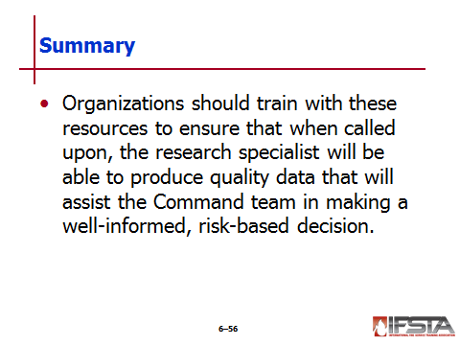
Organizations should train with these resources to ensure that when called upon, the research specialist will be able to produce quality data that will assist the Command team in making a well-informed, risk-based decision.

Review Questions

What are the responsibilities of a technical research specialist at a haz mat incident? (227)

What are the two elements of chemical research? (231)

What written technical references can be used to gather hazardous materials information? (236-243)

What chemical databases may be used to gather hazardous materials information? (244-246)

What information that should be provided to an emergency response center? (249)

