Chapter 5
Exposure Assessment and Toxicology

Lesson Goal
After completing this lesson, the student shall be able to explain exposure and define the limits and values of radiological and biological exposure. The student will also define the relationship between risk and harm, and discuss the documentation requirements when exposed to a hazardous materials situation.
Objectives
Upon successful completion of this lesson, the student shall be able to:
1. Explain exposure. [NFPA® 472, 7.2.2.4]
2. Describe elements of toxicology. [NFPA® 472, 7.2.2.2(11, 14-15), 7.2.5.2.1(5-8)]
3. Define radiological and biological limits and values. [NFPA® 472, 7.2.5.2.1(1-4, 9-14)]
4. Differentiate between risk and harm.
5. Explain medical monitoring and exposure reporting. [NFPA® 472, 7.6.3(3, 6)]

Instructor Information
This is the lesson covering exposure and toxicology. This lesson describes exposure to hazardous materials, and discusses dose and concentration limits. The lesson also covers the relationship between risk and reward, and defines a risk/benefit analysis. Finally, the lesson explains the documentation requirements when responders may become exposed to a hazardous material.

Important instructor information is provided in shaded boxes throughout the lesson plan. Carefully review the instructor information before presenting the lesson.

Methodology
This lesson uses lecture and discussion. The level of learning is comprehension.
Outline Contents

Section | Outline Pages | Text Pages
Section I: Exposure | 5 | 204-207
Section II: Toxicology | 9 | 207-210
Section III: Radiological and Biological Limits and Values | 12 | 210-216
Section IV: Risk vs. Harm | 18 | 216-218
Section V: Medical Monitoring and Exposure Reporting | 20 | 218-220
Section VI: Summary and Review | 24 | 220

Audiovisuals
- Visuals 5.1 to 5.31 (PowerPoint® Presentation)
Evaluation
- Chapter 5 Quiz
- Chapter 5 Test
Presentation Tools
Interactive Objects allow instructors to present information a piece at a time by clicking on hot spots in a larger image.

Each object is labeled in the Lesson Outline and indicated in the PowerPoint® presentation by a RED arrow in the top left corner of the image. This lets instructors know to use the mouse to explore all of the information on the slide.


After all of the information is displayed a reset arrow will appear in the bottom right corner of the image. Instructors can use this to remove the text and quiz students on content just covered or simply move on to the next slide.

To move to the slide after an interactive object, select the Click for next slide arrow on the left side of the slide.

Videos are used as discussion starters or to illustrate a concept or process discussed in the chapter.

These are labeled in the Lesson Outline and indicated in the PowerPoint® presentation by the Click image to play arrow on the left side of the slide.

Section I: Exposure

exposure
pp. 204-207 Objective 1 – Explain exposure.

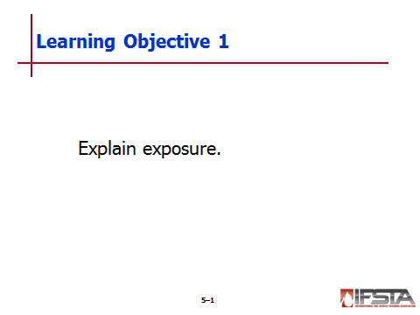
Routes of Entry

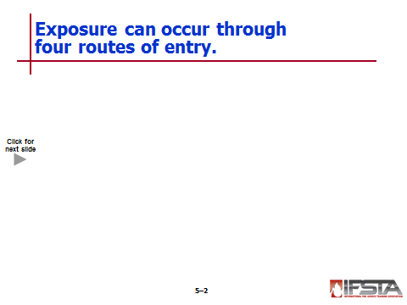
Inhalation

Taking in materials by breathing through nose or mouth

Can occur with hazardous vapors, smoke, gases, liquid aerosols, fumes, and suspended dusts

Requires respiratory protection

Most common route of exposure for responders and civilians

Ingestion

Taking in materials through mouth by means other than simple inhalation

Can be caused by poor hygiene with handling hazardous material

Examples

Chemical residue on hands that can be transferred to food and then ingested while eating

Particles of insoluble materials that can become trapped in mucous membranes and ingested after being cleared from respiratory tract

Absorption

Taking in materials through skin or eyes

Materials pass easily through mucous membranes or areas of body where skin is thinnest

Areas of concern

Eyes

Nose

Mouth

Wrists

Neck

Ears

Hands

Groin

Underarms

Many poisons are easily absorbed into the body

Others can enter body easily through touching contaminated finger to one’s eye

Injection

Taking in materials through puncture in skin

Protection must be consideration when dealing with any sort of contaminated objects easily capable of cutting or puncturing skin

Examples

Broken glass

Nails

Sharp metal edges

Tools like utility knives
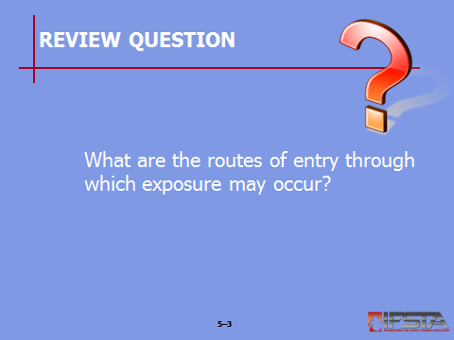
Review Question: What are the routes of entry through which exposure may occur?
See p. 204 of the manual for answers.

Contamination vs. Exposure
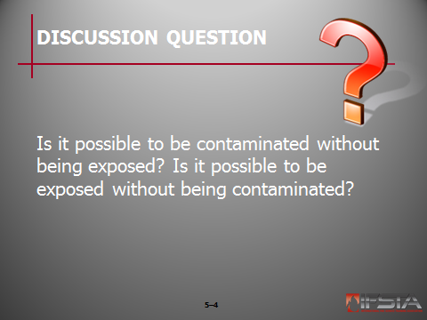
Ask Students: Is it possible to be contaminated without being exposed? Is it possible to be exposed without being contaminated?
Briefly discuss answers with students. Explain that the answer to both questions is yes. While the terms are often used interchangeably, it is important for responders to understand the difference between the two.

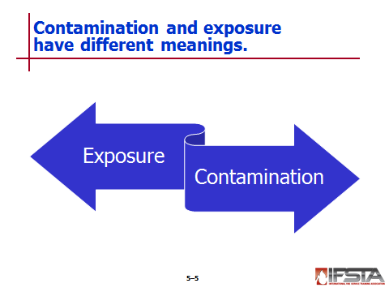
Exposure

Individual can be exposed to product in number of settings without being aware

Occurs when toxic or infectious substance is in direct contact with human body or is introduced into human body

Contamination

Result of direct contact with product

Occurs when product adheres to or wets clothing or part of the human body

Person is considered to be contaminated if in course of working with liquid chemical or solid product, product spills and contacts worker’s clothing

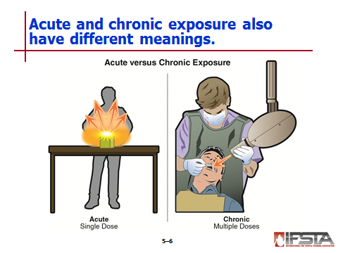
Acute vs. Chronic Exposure

Acute exposure — Single exposure over relatively short period of time to high level of dangerous product

Chronic exposure — Exposure over longer duration
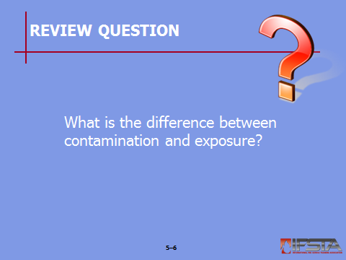
Review Question: What is the difference between contamination and exposure?
See p. 205 of the manual for answers.

Section II: Toxicology

toxicology
pp. 207-210 Objective 2 – Describe elements of toxicology.

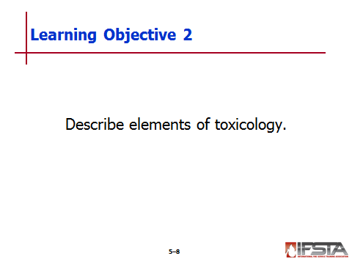
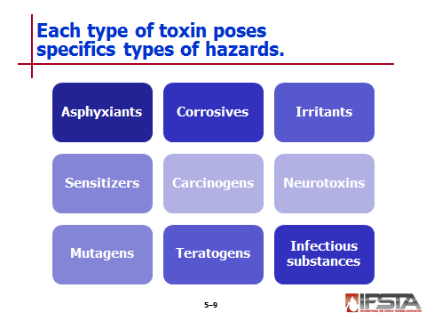
Categories – Have specific hazards; can have catastrophic effect on different body systems

Asphyxiants

Corrosives

Irritants

Sensitizers

Carcinogens

Neurotoxins

Mutagens

Teratogens

Infectious substances
Instructor Note: Remind students that while it is very important to understand toxicology and how to protect oneself, the key to a safe response is preventing an exposure altogether.

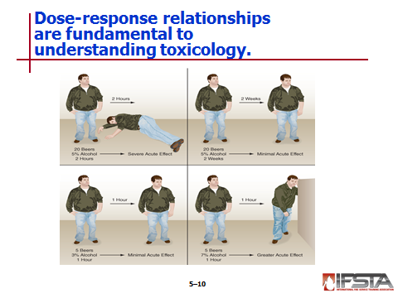
Dose-Response Relationships

Biological response, in both type and intensity, to given dose of chemical

Fundamental component in toxicology

Quantitative relationship between dose of chemical and biological effects produced by that chemical

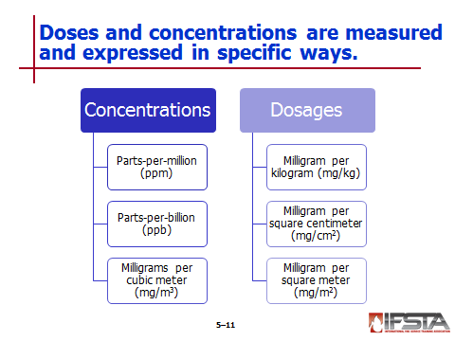
Measuring and Expressing Dose and Concentration

Concentrations

Parts-per-million (ppm)

Expression of concentration of gas or vapor that can be found in air

Expressed as parts (by volume) of gas or vapor in a million parts of air

Can also define concentration of particular substance in liquid or solid

Parts-per-billion (ppb)

Expression of concentration of gas or vapor that can be found in air

Usually used to express extremely low concentrations of unusually toxic gases or vapors

Defines concentration of particular substance in liquid or solid

Milligrams per cubic meter (mg/m³) — Used to express concentration of substances including dusts or mists in air

Dosages

Milligram per kilogram (mg/kg) — Denotes quantity (in milligrams of weight) of a substance per kilogram of body weight

Milligram per square centimeter (mg/cm²) — Denotes quantity (in milligrams of weight) of a substance per square centimeter of body surface area

Milligram per square meter (mg/m²) — Denotes quantity (in milligrams of weight) of a substance per square meter body surface area

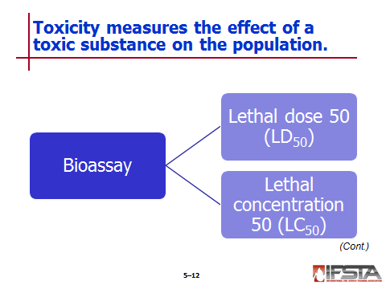
Toxicity

One way to study effects of toxic substance on population is to study how that substance affects population’s demographics

Measured using bioassays to measure death rate in sample population

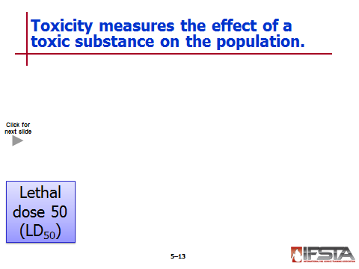
Lethal dose 50 (LD₅₀) — Dose of solid or liquid toxic substance, measured in milligrams of toxic substance per kilogram of body weight, that would kill 50% of exposed sample population

Lethal concentration 50 (LC₅₀) — Concentration of toxic gaseous substance, measured in terms of parts per million (ppm) in air, that could kill 50% of exposed sample population
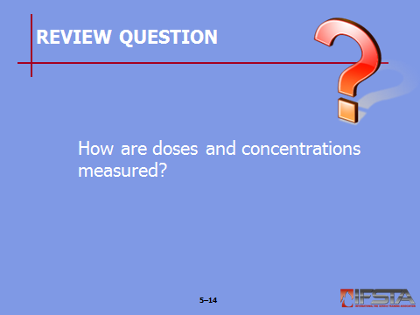
Review Question: How are doses and concentrations measured?
See p. 208 of the manual for answers.

Section III: Radiological and Biological Limits and Values

radiological and biological limits and values
pp. 210-216 Objective 3 – Define radiological and biological limits and values.

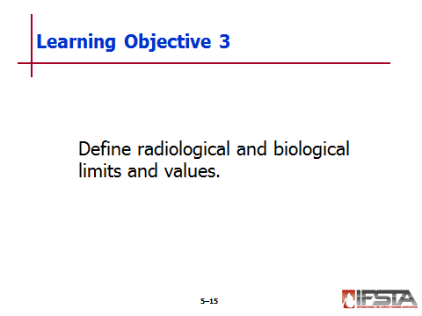
Exposure Limits

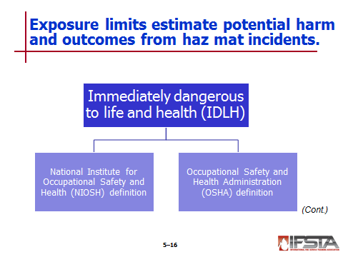
Expressed in several different terms

Used to estimate potential harm and outcomes at hazardous materials incidents

Immediately dangerous to life and health (IDLH)

National Institute for Occupational Safety and Health (NIOSH) definition

Atmosphere concentration of any toxic, corrosive, or asphyxiating substance that poses immediate threat to life

It can cause irreversible or delayed adverse health effects and interfere with individual’s ability to escape from dangerous atmosphere

Occupational Safety and Health Administration (OSHA) definition — Atmosphere that poses an immediate threat to life, would cause irreversible adverse health effects, or would impair an individual’s ability to escape from dangerous atmosphere

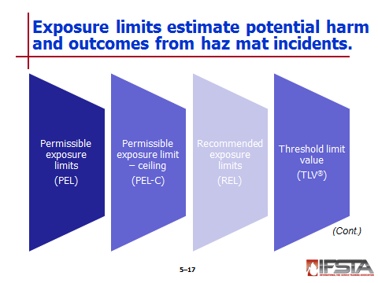
Other exposure limits

Permissible exposure limits (PEL)

Maximum concentration to which majority of healthy adults can be exposed over 40-hour workweek without suffering adverse effects

Reported as 8-hour time-weighted average (TWA) unless otherwise noted

Permissible exposure limit – ceiling (PEL-C) – Maximum concentration to which employee may be exposed at any time

Recommended exposure limits (REL) – Recommendations provided by NIOSH and based on 10-hour time-weighted average

Threshold limit value (TLV®)

Value provided by American Conference of Governmental Industrial Hygienists (ACGIH)®

Occupational exposure value in which it is believe nearly all workers can be exposed day after day for working lifetime without ill effects

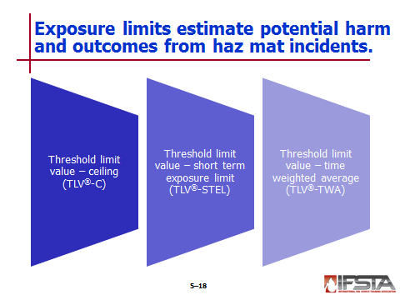
Threshold limit value – ceiling (TLV®-C) — Concentration that should not be exceeded for any time period, even instantaneously

Threshold limit value – short term exposure limit (TLV®-STEL)

Defined as maximum concentration for continuous 15-minute exposure period

Calculated on daily basis as four 15-minute continuous work periods with minimum of 60-minute period between each exposure provided the TWA is not exceeded

Threshold limit value – time weighted average (TLV®-TWA) — Allowable time-weighted average concentration when employee is exposed for 8 hours per day, 40 hours per week
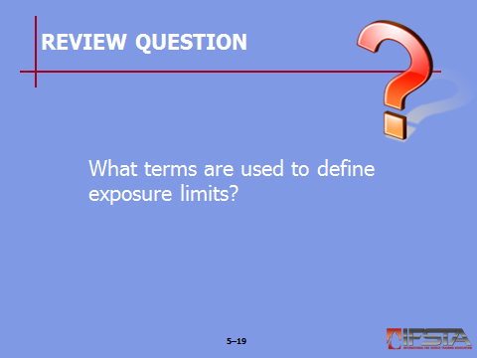
Review Question: What terms are used to define exposure limits?
See pp. 211-215 of the manual for answers.

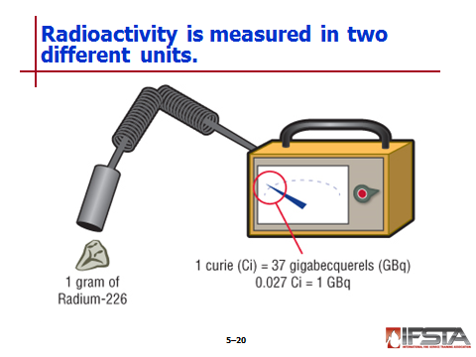
Radiological Limits and Values

Measuring radioactivity

Curies (Ci)

Represent large amount of activity

Part of English System

Commonly used in U.S.

Becquerels (Bq)

Represent small amount of activity

Part of International System of Units (SI)

Commonly used in other parts of the world

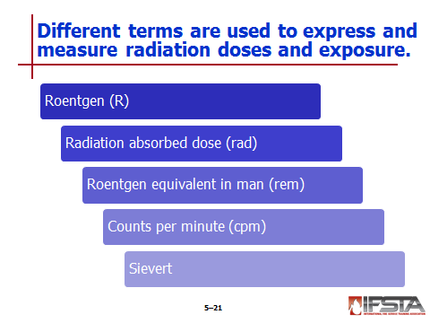
Measuring radiation dose and exposure

Found on dosimeters and radiation survey meters

Roentgen (R)

Used for measuring exposure

Applied only to gamma and X-ray radiation

Used on most U.S. dosimeters

Expressed in R per hour (R/hr)

Used on radiation survey meters

Radiation absorbed dose (rad)

Used to measure amount of radiation energy absorbed by material

Applies to any material and all types of radiation

Does NOT take into account potential effect that different types of radiation have on human body

Roentgen equivalent in man (rem)

Used for absorbed dose equivalence as pertaining to human body and is applied to all types of radiation

Takes into account energy absorbed and biological effects on body due to different types of radiation

Used to set dose limits for emergency responders

Counts per minute (cpm)

Number of atoms in quantity of radioactive material that is detected to have decayed in one minute

Aggregate measurement of radioactive decay at certain point

Can be converted into Roentgen when used with conversion factor and type of material is known

Sievert

SI term used for derived unit or dose of radiation

Incorporates quality factors for biological effectiveness of different types of ionizing radiation

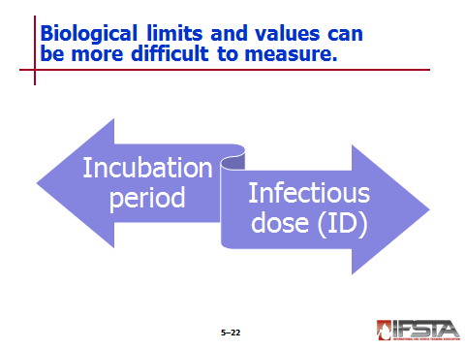
Biological Limits and Values

Can be difficult to mitigate based on fact that emergency responder may not know they are present

Incubation period — Time from exposure to biological agent to appearance of symptoms in infected person

Infectious dose (ID) — Amount of pathogen required to cause infection in host

Section IV: Risk vs. Harm

risk vs. harm
pp. 216-218 Objective 4 – Differentiate between risk and harm.
Instructor Note: Refer students to the scenarios in the information box on p. 216 of the manual. Discuss the correlation between risk and reward in each of the scenarios.

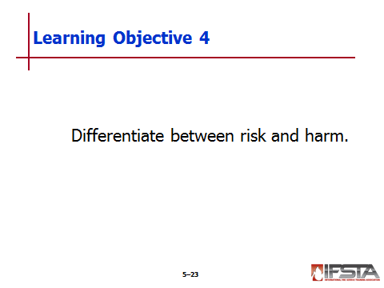
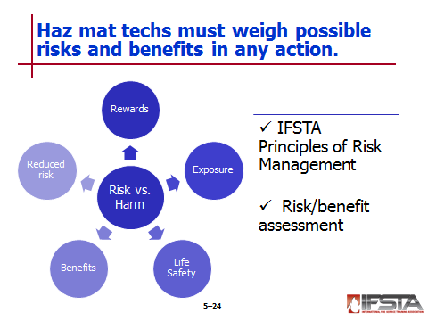
Risk vs. Harm

Risk should match reward

Life safety is always serious concern

Exposure is rare; injuries and fatalities are result of BLEVEs and exposure to fire

In emergency response situation, questions should be asked

What risk am I taking?

What benefit (saving a life or stopping a leak) can I expect to achieve?

If risks outweigh benefits, responder should look for ways to reduce risk

IFSTA Principles of Risk Management

Activities that present significant risk to safety of members shall be limited to situations where there is a potential to save endangered lives

Activities that are routinely employed to protect property shall be recognized as inherent risks to safety of members, and actions shall be taken to avoid these risks

No risk to safety of members shall be acceptable when there is no possibility to save lives or property

Risk/benefit assessment – Members must carefully evaluate incident, including victim viability and available resources
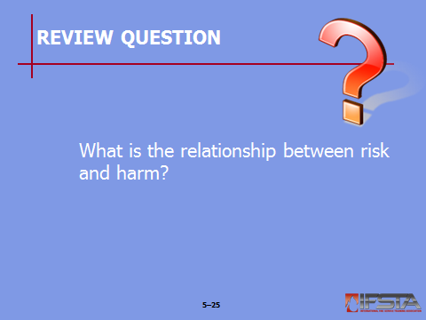
Review Question: What is the relationship between risk and harm?
See p. 217 of the manual for answers.

Section V: Medical Monitoring and Exposure Reporting

medical Monitoring and exposure reporting
pp. 218-220 Objective 5 – Explain medical monitoring and exposure reporting.

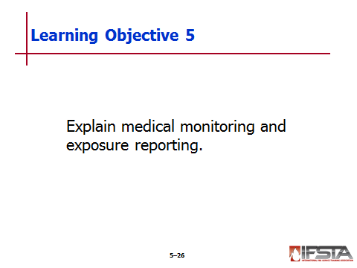
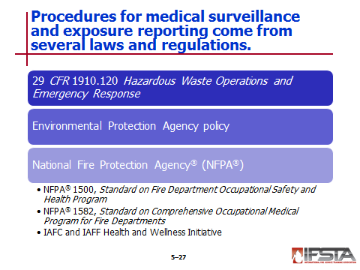
Medical Monitoring and Exposure Reporting

Haz mat team members and emergency responders have right to medical surveillance

Several to ensure surveillance

29 CFR 1910.120 Hazardous Waste Operations and Emergency Response

Environmental Protection Agency policy

National Fire Protection Agency® (NFPA®)

NFPA® 1500, Standard on Fire Department Occupational Safety and Health Program

NFPA® 1582, Standard on Comprehensive Occupational Medical Program for Fire Departments

IAFC and IAFF Health and Wellness Initiative

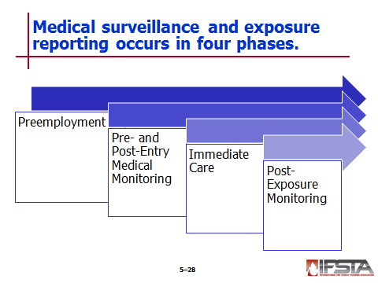
Preemployment

Creates baseline information – Vital to accurately track well-being of response personnel

Should look for items such as

Total physical evaluation

Body composition

Laboratory tests and screenings

Vision tests

Hearing evaluation

Lung function (spirometry)

Electrocardiogram (ECG/EKG)

Cancer screening

Immunizations and infectious disease screening

Does not end after physical evaluation; periodic examinations should be part of safety plan

Pre- and Post-Entry Medical Monitoring

Essential component of haz mat technician health and welfare

Pre-entry baseline important to recognize possible signs and symptoms of exposure, contamination, or heat-related illnesses

At a minimum, should include

Baseline vitals including heart rate and blood pressure

Body temperature

Respiratory rate

Oxygen saturation

Body weight

Pupil size and reaction

Post-entry does not conclude at end of incident; may continue for few days to ensure personnel are safe

Immediate Care

Should be available to treat responders should they require medical attention

Should include identification of hospitals equipped to handle haz mat, chemical and toxicological emergencies

Post-Exposure Monitoring

Necessary even if responder is not feeling symptoms of exposure

If responder is treated for exposure to chemical or toxic substance, additional testing may be required

Documentation is vitally important

Should be completed in all cases if confirmed or suspected exposure

Should be in writing

Should be completed and reviewed by supervisor and affected employee

Must be maintained for length of employment for employee plus additional 30 years
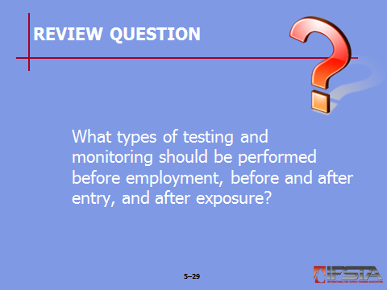
Review Question: What types of testing and monitoring should be performed before employment, before and after entry, and after exposure?
See pp. 218-220 of the manual for answers.

Section VI: Summary and Review

SUMMARY AND REVIEW

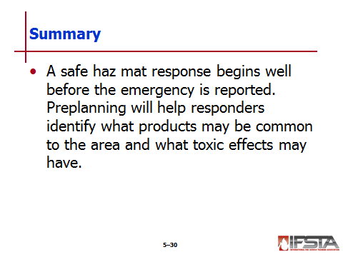
Chapter Summary

A safe haz mat response begins well before the emergency is reported. Preplanning will help responders identify what products may be common to the area, and what toxic effects may have.

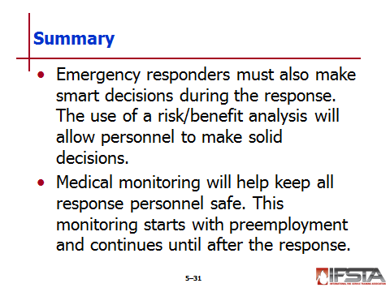
Emergency responders must also make smart decisions during the response. The use of a risk/benefit analysis will allow personnel to make better decisions.

Medical monitoring will help keep all response personnel safe. This monitoring starts with pre-employment and continues until after the response.

Review Questions

What are the routes of entry through which exposure may occur? (204)

What is the difference between contamination and exposure? (205)

How are doses and concentrations measured? (208)

What terms are used to define exposure limits? (211-215)

What is the relationship between risk and harm? (217)

What types of testing and monitoring should be performed before employment, before and after entry, and after exposure? (218-220)

