Chapter 3
Chemical and Physical Properties

Lesson Goal
After completing this lesson, the student shall be able to describe the chemical and physical properties attributed to most hazardous materials, and discuss how these can affect a hazardous materials incident.
Objectives
Upon successful completion of this lesson, the student shall be able to:
1. Describe the physical states of matter. [NFPA® 472, 7.2.2.2(36); 7.2.2.3]
2. Identify the physical properties of a material. [NFPA 472, 7.2.2.2(45, 50, 53)]
3. Define temperature and pressure. [NFPA® 472, 7.2.2.2(16-19, 48, 51)]
4. Explain aggressive materials. [NFPA 472, 7.2.2.2(1, 34, 46)]
5. Explain phase changes. [NFPA® 472, 7.2.2.2(6, 12, 22, 27-28, 37, 42, 47, 54)]
6. Describe the effect that mixing materials can have on physical properties. [NFPA® 472, 7.2.2.2(10-11, 29, 43-44), 7.2.4.1]

Instructor Information
This is the lesson covering the chemical and physical properties of hazardous materials. This lesson covers various physical changes, including temperature and pressure, and phase changes of various materials.

Important instructor information is provided in shaded boxes throughout the lesson plan. Carefully review the instructor information before presenting the lesson.

Methodology
This lesson uses lecture and discussion. The level of learning is comprehension.

Outline Contents

Section | Outline Pages | Text Pages
Section I: Physical States | 5 | 118
Section II: Physical Properties of a Material | 11 | 123
Section III: Temperature and Pressure | 15 | 128
Section IV: Aggressive Materials | 19 | 131
Section V: Phase Changes and Related Properties | 23 | 134
Section VI: Mixing Materials | 27 | 138
Section VII: Summary and Review | 30 | 140

Audiovisuals
- Visuals 3.1 to 3.37 (PowerPoint® Presentation)
- Easel pad and marker
Evaluation
- Chapter 3 Quiz
- Chapter 3 Test

Presentation Tools
Interactive Objects allow instructors to present information a piece at a time by clicking on hot spots in a larger image.

Each object is labeled in the Lesson Outline and indicated in the PowerPoint® presentation by a RED arrow in the top left corner of the image. This lets instructors know to use the mouse to explore all of the information on the slide.


After all of the information is displayed a reset arrow will appear in the bottom right corner of the image. Instructors can use this to remove the text and quiz students on content just covered or simply move on to the next slide.

To move to the slide after an interactive object, select the Click for next slide arrow on the left side of the slide.

Videos are used as discussion starters or to illustrate a concept or process discussed in the chapter.

These are labeled in the Lesson Outline and indicated in the PowerPoint® presentation by the Click image to play arrow on the left side of the slide.

Section I: Physical States

physical states
pp. 118-123 Objective 1 – Describe the physical states of matter.

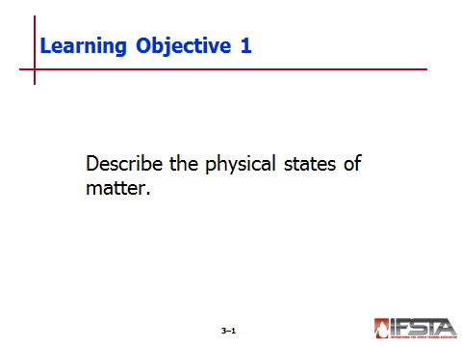
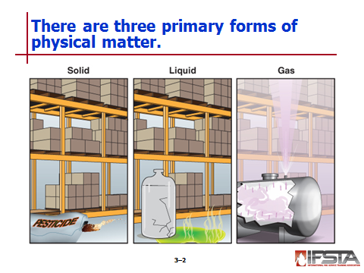
Physical States

Three primary forms: solid, liquid, gas

Determined at normal temperatures and pressures
Instructor Note: For the purpose of discussion in this chapter, we will consider normal temperatures to be between 68° and 77°F (20°C and 25°C) and the pressure to be atmospheric pressure (14.7 psi).

Should be identified as early as possible at haz mat incident

Will indicate how mobile material may become

Can help determine if there will be far-reaching hazardous properties

Sub-characteristics

Vapor – Gaseous phase of material that may normally be solid or liquid

Aerosol – Microscopic particles that may be solid or liquid

Dust – Airborne solid particles that may be 1.0-50 microns in diameter

Mist – Aerosol of liquid particles suspended in air

Fog – Visible aerosol of liquid formed by condensation

Largely dependent on temperature of substance

May change if temperature changes
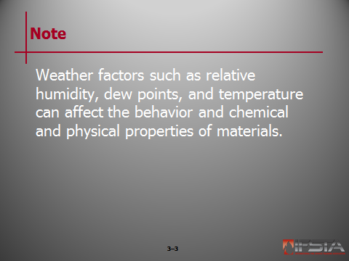
Note: Weather factors such as relative humidity, dew points, and temperature can affect the behavior and chemical and physical properties of materials.

Controlled by strength of intermolecular attraction

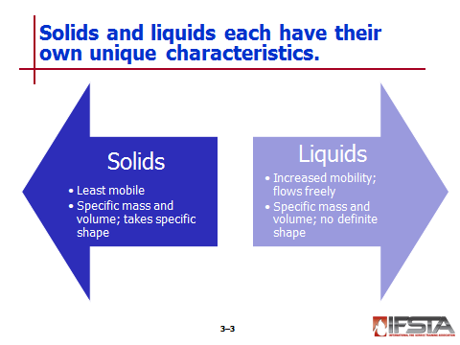
Solids

Least mobile of three states of matter

Has specific mass and volume, and will take on specific shape

May have ability to become airborne and travel with air movement and currents

Liquids

Pose unique challenges

More difficult to deal with than solid

Have ability to take on characteristics of gas

Increases mobility

Increases challenges faced

Flow freely because molecules are not tightly bound

Have specific mass and volume, but no definitive shape

Will take on shape of container

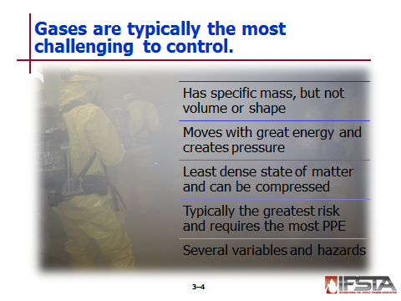
Gases

Typically most challenging to control

Have specific mass but no specific volume or shape

Will expand to fill any given volume

Move with great deal of energy, creating pressure

Least dense of three states of matter

Have ability to be compressed

Will sometimes take liquid form when cooled

Typically greatest risk to emergency responders

Often require greatest level of PPE

Variables and hazards

May or may not have an odor

May be colorless, odorless, and/or tasteless

May be toxic, corrosive, or flammable

May be under extremely high pressure in excess of 15,000 psi (103 421.36 kPa)

May be extremely cold upon release and may have very large expansion ratio if liquefied

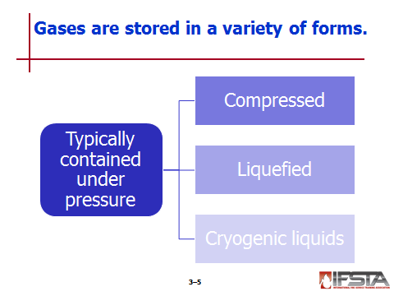
Will typically be contained under pressure

Measured as force per unit area

Calculated by dividing force by area on which force acts

Units – Atmospheres (atm), Pascals (Pa), bar, torr

1 atm = Average pressure found at sea level

1 atm = 760 mmHg = 407 in H2O = 14.7 psi = 101 kPa = 1 torr

1 bar = 14.5 psi

1 ft H₂O = 0.43 psi

Compressed gases

Compounds and mixtures in gaseous form shipped in pressurized cylinders at ambient temperatures

Have pressures ranging from a few psi (kPa) to 15,000 psi (103 350 kPa)

Defined by U.S. DOT as having absolute pressure exceeding 40 psi (275 kPa) at 70°F (21°C)

Liquefied gases

Those kept under pressure and at cool temperature

Cannot be liquefied by pressure alone if above critical temperature

Cryogenic liquids

Liquefied gases at very low temperatures

Defined by U.S. DOT as refrigerated liquid having boiling point lower than -130°F (-90°C) at 14.7 psi (101 kPa)

Remain liquid at low temperatures and have large expansion ratios

Unique hazards

Vaporizing liquid of gas released from pressurized cylinder may displace oxygen, causing asphyxiation

Extreme cold may cause severe frostbite and destruction of exposed body tissue

Extreme cold may cause metals to become brittle, leading to failure of container, supporting structures, or other exposed metal parts

Rapid expansion can lead to buildup of extremely high pressure and violent failure of pressurized equipment

Some pressurized gases may generate large static-electric charges when released, leading to potential to ignite flammable atmospheres

Some possess unique reactive hazards beyond hazards associated with same materials at ambient temperatures
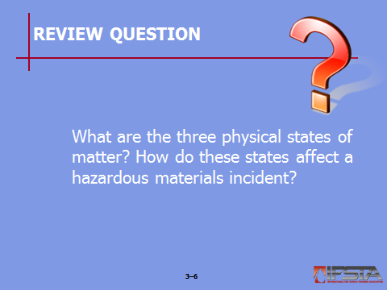
Review Question: What are the three physical states of matter? How do these states affect a hazardous materials incident?
See p. 118 of the manual for answers.

Section II: Physical Properties of a Material

physical properties of a material
pp. 123-128 Objective 2 – Identify the physical properties of a material.

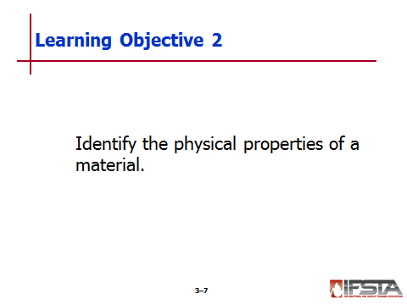
Physical Properties of a Material

Materials are characterized by their properties

Description will normally appear on safety data sheet (SDS)
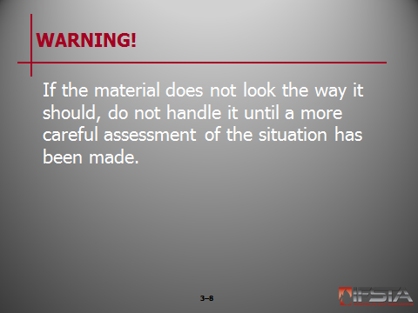
WARNING! If the material does not look the way it should, do not handle it until a more careful assessment of the situation has been made.

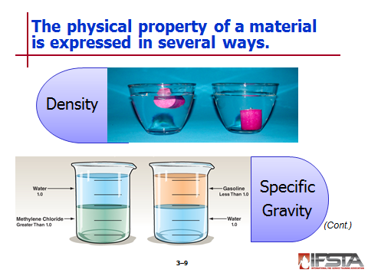
Density

Measure of how heavy a unit volume of a substance is, or mass of known volume

Changes with temperature

Useful to determine how heavy material is

Usually given in units of g/ml

More useful for haz mat response – Pounds per gallon

Multiply g/ml time 8.34 to find pounds per gallon

Specific Gravity

Weight of solid or liquid

Can be determined by dividing density of substance by density of water

Water – Specific gravity equal to 1

If material has specific gravity less than 1, it is lighter than water and should float

If material has specific gravity greater than 1, it will sink

Usually expressed at certain temperature, because varies depending on temperature

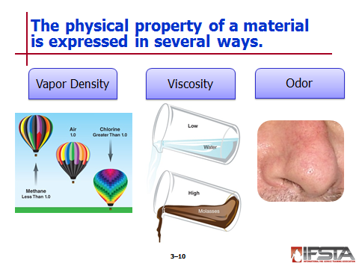
Vapor Density

Ratio of density of pure gas or vapor to density of air

Density of air – Equal to 1

If material has vapor density less than 1, it is lighter than air and will rise

If material has vapor density greater than 1, it is heavier than air and will sink

NIOSH – RgasD

Relative gas density

Similar to vapor density

Relative density of gases referenced to air

If not listed in reference manual, can be estimated

Divide molecular weight of material by average molecular weight (MW) of air (29)

Not exact, but more than adequate for first responders

If MW is greater than 29, it will sink

If MW is less than 29, it will rise

Must also address temperature of vapor

Hot vapors will rise, but will sink once they have cooled

Cold vapors are very dense and tend to rise when warm
Instructor Note: Refer students to Table 3.1 on p. 126 of the manual for a list of materials that are known to be lighter and heavier than air.

Viscosity

Measure of thickness or flowability of liquid at given temperature

Determines ease that product will flow

Greatly affected by temperature

Sometimes used in wet-chemistry kits to determine product hazards

Odor

Expression of how chemicals smell

Can sometimes help identify a material

Odor threshold – Concentration (in air) at which “average person” can smell particular compound

Should never be used to define areas of safety
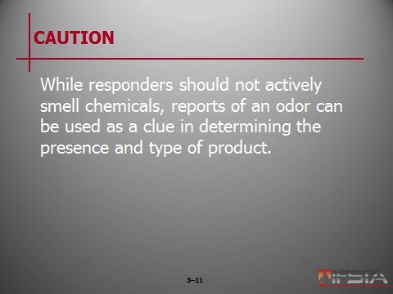
CAUTION: While responders should not actively smell chemicals, reports of an odor can be used as a clue in determining the presence and type of product.

Instructor Note: Refer students to Table 3.2 on p. 128 of the manual for a list of combustible chemicals and their odor thresholds in parts-per-million.

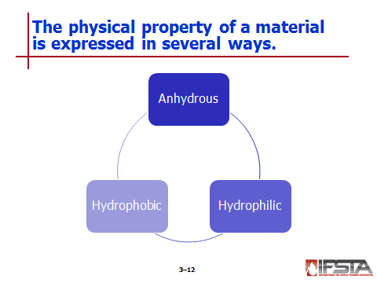
Other Physical Properties

Anhydrous – “Dry” or without water

Hydrophobic – Repels water

Hydrophilic – Absorbs water
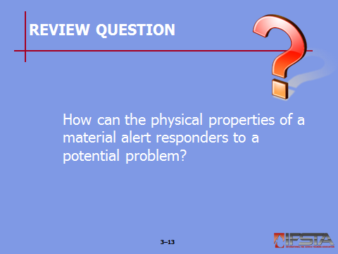
Review Question: How can the physical properties of a material alert responders to a potential problem?
See pp. 123-128 of the manual for answers.

Section III: Temperature and Pressure

temperature and pressure
pp. 128-131 Objective 3 – Define temperature and pressure.

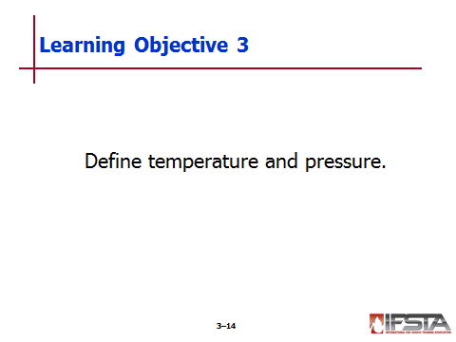
Temperature

Scale measure of heat energy – Increase of heat in object causes movement of molecules in object to increase

Important in determining how material will react

Common measurements

Celsius (°C)

Fahrenheit (°F)

Others – Kelvin (K), Rankin (°Ra)

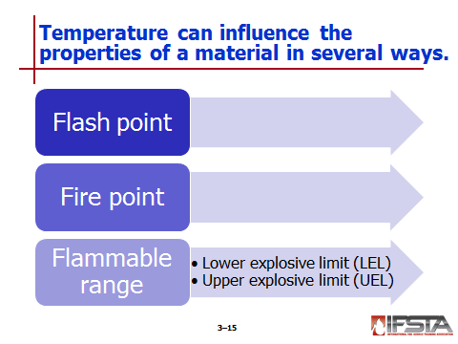
Flash points

Minimum temperature at which substance must be heated to produce vapor concentration in which spark of flame can cause instantaneous flash in vapor space

Flammable liquids

NFPA definition – Products that have a flash point above 100°F (30°C)

U.S. DOT definition – Product having flash point below 141°F (60°C)

Expressed in terms of temperature of liquid being tested

Can be affected by molecular weight

Fire point

Minimum temperature to which substance must be heated so it produces enough vapor to support sustained combustion

Generally few degrees above flash point

Flammable range

Percentage of gas or vapor concentration in air that will burn or explode if ignited

Lower explosive limit (LEL)

Lowest concentration (or lowest percentage of substance in air) that will produce flash of fire when ignition source is present

At lower concentrations, mixture is too lean to burn

Upper explosive limit (UEL)

Highest concentration (or highest percentage of substance in air) that will produce flash of fire when ignition source is present

At higher concentrations, mixture is too rich to burn
Instructor Note: Refer students to Table 3.3 on p. 130 of the manual for a discussion of flammable ranges of common chemicals.

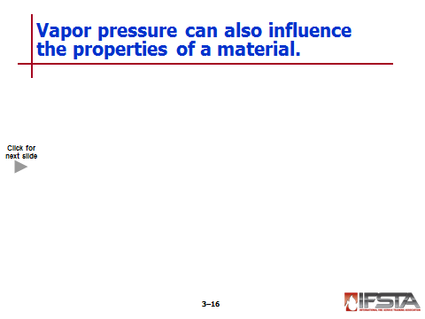
Pressure

Can affect physical state and state change of material

In absence, only solids and gases exist

Can control different variables

Vapor pressure

Measurement of ability of material to evaporate or change from liquid to vapor or gaseous state

Substances

With high vapor pressure – Volatile and give off significant amounts of vapor

With vapor pressure over 760 mmHg – Gases under normal conditions

With low boing points – High vapor pressure

Increases with temperature

Can be reduced by venting container

Vapor expansion

Ratio of how much vapor is created in relation to volume of original liquid or solid when material volatilizes or evaporates

Some compounds shipped as liquids under pressure or as cryogenic liquids will expand at several hundred times original volume

Other Variables

Molecular weight (MW) – Can impact state of product

Polarity

Can affect physical properties of material

Atoms, molecules, and atoms have decreased distance between each other, increasing viscosity of liquid

Ionic bonding – Strongest form; produces most pronounced effect
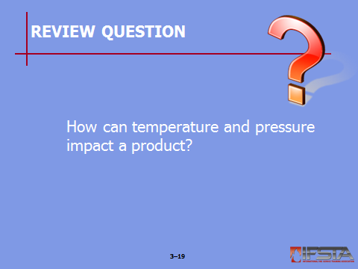
Review Question: How can temperature and pressure impact a product?
See pp. 128-131 of the manual for answers.

Section IV: Aggressive Materials

aggressive materials
pp. 131-133 Objective 4 – Explain aggressive materials.

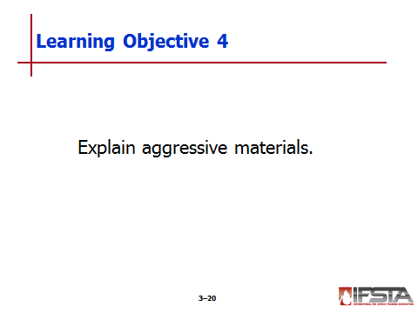
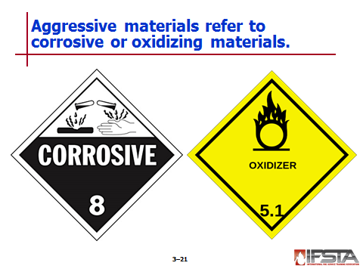
Aggressive Materials

Terms referring to corrosive or oxidizing materials

Often react with spill control products

Will generally destroy human and animal tissue

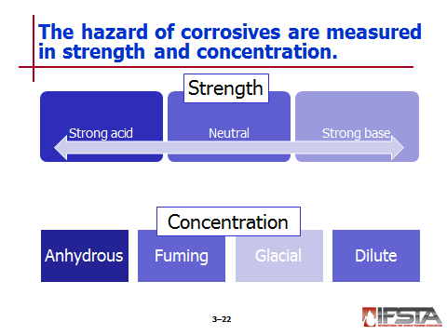
Corrosives

Degree of hazard linked to two measurements

Strength

Intrinsic chemical nature; ability to ionize in water

Measure on pH scale

pH 0-3 = Strong acid

pH 4-9 = Neutral

pH 10-14 = Strong base

Concentration

Amount of acid or base in water

Expressed in percentage, molarity, or normality

Anhydrous – Inorganic compound that does not contain water either absorbed on surface or as water of crystallization

Fuming – Highly active liquid that involves visible, smoke-like emanations in contact with air or moisture in air; usually pure but have higher concentration than concentrate acids

Glacial – Applies to acids that have freezing point slightly below room temperature when in highly concentrated state

Dilute – Solution containing less than 10% concentration in water

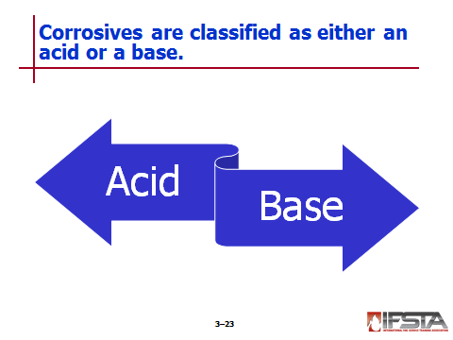
Acids

Materials that dissolve in water to produce hydrogen or hydronium ions

Most are liquids

Strength depends on how loosely hydrogen atoms are held and how well material ionizes in water

Concentration expressed in percentage of total volume in water and molarity

Percentages above 35% - Concentrated acidic solutions

Percentages less than 10% - Dilute
Instructor Note: Refer students to Table 3.4 on p. 133 of the manual for some common acids and their characteristics.

Can react with some metals to produce hydrogen gas and salts

Bases

Materials that produce hydroxide ions when dissolved in water

Most exist in solid state until mixed with water

Cause tissue damage by chemically converting fat into alcohols, salts, and soaps

Break down proteins

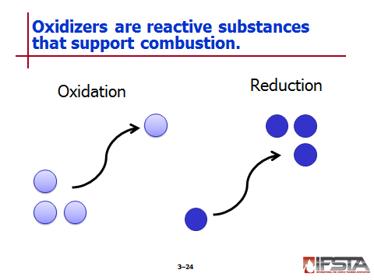
Oxidizers

Contain two or more covalently bonded oxygen atoms and/or halogen atoms

Include a variety of materials

Examples

Halogens

Oxygen

Peroxide salts

Nitrates

Oxysalts

Oxyacids

Organic peroxides

Organic peroxy acids

Reactive and support combustion through release of oxygen, heat, or both

Oxidation – Removal or loss of electron during reaction

Reduction – Opposite of oxidation; in process, material will give up or donate electron
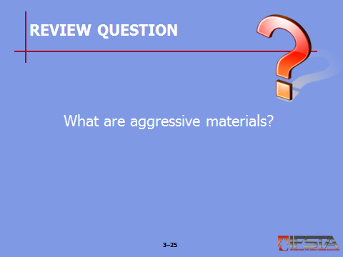
Review Question: What are aggressive materials?
See pp. 131-132 of the manual for answers.

Section V: Phase Changes and Related Properties

phase changes and related properties
pp. 134-137 Objective 5 – Explain phase changes.

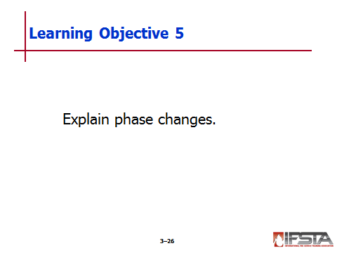
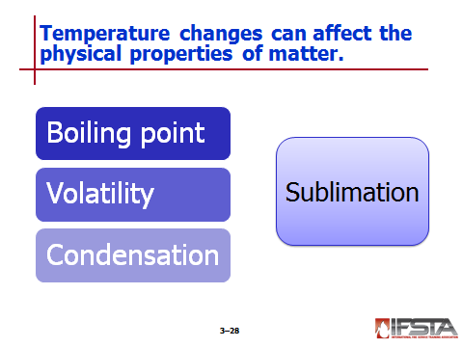
Temperature Changes

Can change matter’s state, but does not change chemical composition

Influence both range of hazards and potential countermeasures

Melting and freezing

Melting point

Temperature at which solid turns into liquid

Critical property to analyze for emergency response

Freezing point

Temperature at which liquid will solidify or crystallize

Typically same as melting point

Boiling and condensation

Boiling point

Temperature at which vapor pressure of liquid is equal to atmospheric pressure around liquid

Defined as temperature at which boiling occurs under pressure of 1 bar

Heat of vaporization – Amount of energy required to convert or vaporize saturated liquid into vapor

Different depending on location – Water boils at different temperatures in different altitudes

May change through process of evaporation

Surface phenomenon in which molecules located near liquid’s edge escape into atmosphere as vapor

Evaporation rate – Speed at which some material changes from liquid to gas; affected by temperature

Volatility

Another term for evaporation rate

Usually reported as comparative value versus another compound

Condensation

Formed when temperature of liquid drops below boiling point and vapors produced start to cool

Conversion of vapor into liquid as it is cooled down to, or below, liquid’s boiling point

Sublimation

Occurrence where material transforms from solid into vapor without passing through liquid state

Example – Dry ice

Critical points

Critical temperature – Minimum temperature above which gas cannot be liquefied no matter how much pressure is applied

Critical pressure – Pressure necessary to liquefy a gas

Autoignition temperature – Lowest temperature at which substance will ignite in air when there is no ignition source

Self-accelerating decomposition temperature (SADT) – Temperature above which decomposition of unstable substance continues unimpeded, regardless of ambient or external temperature

Maximum safe storage temperature (MSST) – Maximum safe temperature at which product can be stored; well below SADT

Polymerization – Special chemical reaction in which small compounds called monomers react with themselves to form larger molecules called polymers

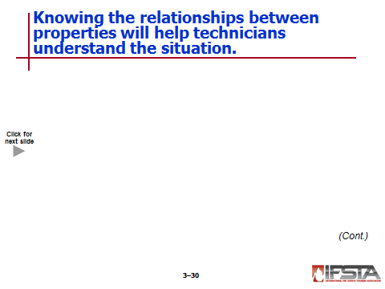
Relationships of Physical Properties

Temperature and pressure

Directly proportional to one another

Called Gay-Lussac’s Law

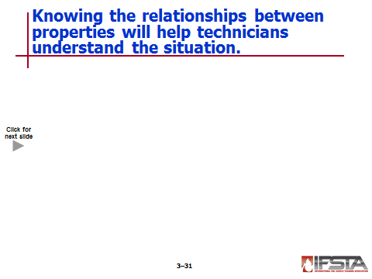
Understanding how properties interrelate can help technicians understand product and situation
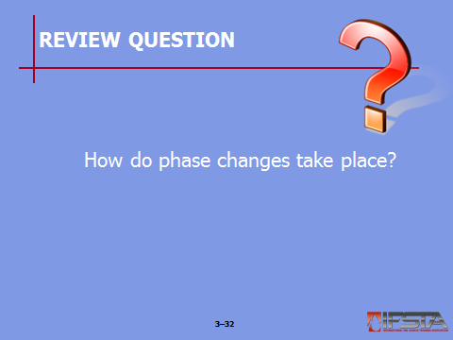
Review Question: How do phase changes take place?
See p. 134 of the manual for answers.

Section VI: Mixing Materials

mixing materials
pp. 138-140 Objective 6 – Describe the effect that mixing materials can have on physical properties.

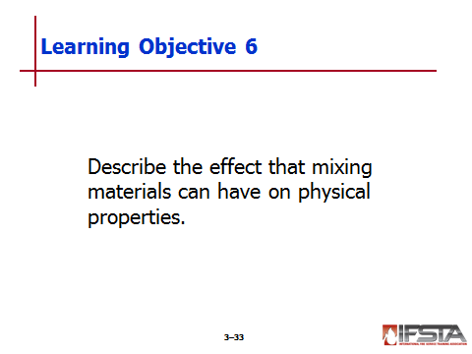
Mixing Materials

Can be dangerous if not done correctly

Takes understanding of primary products and end product

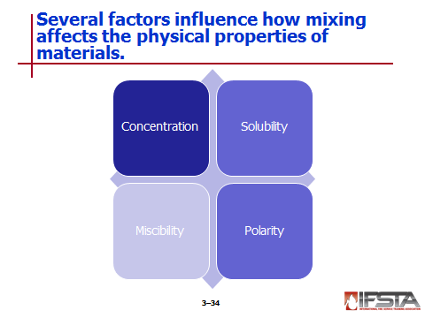
Concentration

Amount of each component in a mixture

Usually expressed in percentages

Parts per million (ppm)

Parts per billion (ppb)

Milligrams per cubic meter (mg/m³)

Will usually have significant impact on hazard

Low concentrations typically less hazardous than high concentration

Solubility

Describes how well a material will dissolve in a liquid

Related to polarity of solute relative to polarity of solvent

Readily available – In tables and on SDSs

Can be useful in determining spill clean up methods and extinguishing agents

When nonwater-soluble liquid combines with water, liquids remain separate

When water-soluble liquid combines with water, liquids mix easily

Solubility limit

Any liquid that is soluble but not completely miscible

Usually expressed as percentages

Degrees of solubility

Negligible – Less than 0.1%

Slight – 0.1 to 1.0%

Moderate – 1 to 10%

Appreciable – Greater than 10%

Complete – Soluble at all proportions

Slurry

When material cannot totally dissolve in water

Suspension of insoluble particles usually in water

Miscibility

When liquid or gas completely dissolves in another liquid or gas

Implies that materials have ability to mix in any combination or concentration to form uniform blend with each other

Immiscible – Two liquids will not mix or dissolve in each other

Polarity

Reflection of how strongly one atom attracts the electrons of another atom in covalent bond

Polar materials

Have affinity for other polar materials

Water – Highly polar, so other polar materials dissolve or are soluble in water

Hydrocarbons

Nonpolar

Do not dissolve in water

Some molecules have both polar and nonpolar areas

Solids

If molecules are polar, soluble in polar solvents

Polar solids not miscible with water
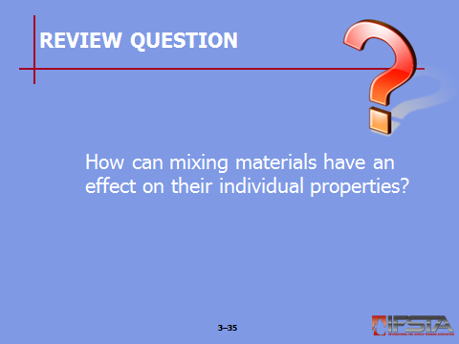
Review Question: How can mixing materials have an effect on their individual properties?
See pp. 138-139 of the manual for answers.

Section VII: Summary and Review

summary and review

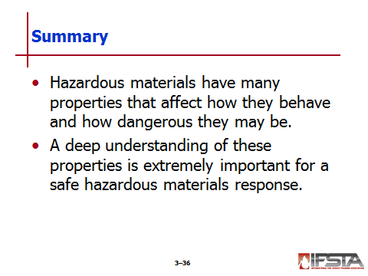
Chapter Summary

Hazardous materials have many properties that affect how they behave and how dangerous they may be.

A deep understanding of these properties is extremely important for a safe hazardous materials response.

Review Questions

What are the three physical states of matter? How do these states affect a hazardous materials incident? (118)

How can the physical properties of a material alert responders to a potential problem? (123-128)

How can temperature and pressure impact a product? (128-131)

What are aggressive materials? (131-132)

How do phase changes take place? (134)

How can mixing materials have an effect on their individual properties? (138-139)

